1

**Classification of Materials**

Solid materials have been grouped based on chemical and atomic structure to three basic categories:

1. Metals
2. Ceramics
3. Polymers
4. Composites
5. Advanced materials

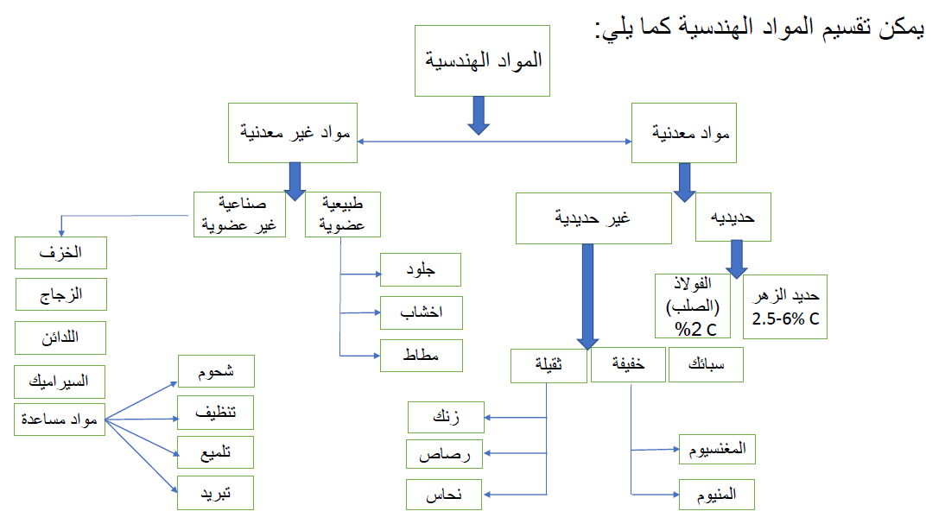

1. **Metals**

Composed of one or more metallic elements (e.g., iron(Fe) , aluminum (Al) , copper (Cu) , titanium (Ti) , gold (Au) , and nickel (Ni)), and small amounts of nonmetallic elements (e.g., carbon (C), nitrogen (N), and oxygen (O)). The properties of this materials are:

1. Atoms are arranged in very regular manner.
2. Stiff and strong.
3. Ductile (i.e., large deformation without fracture).
4. Good conductors for electricity and heat.
5. Not transparent to visible light.
6. Some of the metals have desirable magnetic properties (i.e., Fe, Co, and Ni).
7. **Ceramics**

Ceramics are compounds between metallic and nonmetallic elements (e.g oxides, nitrides, and carbides. For example, aluminum oxide (or alumina, Al2O3), silicon dioxide (or silica, SiO2), silicon carbide (SiC), silicon nitride (Si3N4).

Al2O3

+

O

Al

**→**

Metallic Nonmetallic

The properties of the ceramics materials are:

1. Stiff and Very hard
2. Brittleness (lack of ductility)
3. Highly susceptible to fracture
4. Transparent, translucent, or opaque
5. Some of ceramics exhibit magnetic behavior
6. **Polymers**

Polymers include the plastic and rubber materials, many of them are organic compounds, chemically based on C, H , and other non-metallic elements (i.e., O, N, and Si). Such as Polyethylene (PE), nylon (polyamides) , poly vinyl chloride (PVC), polycarbonate (PC), polystyrene (PS), and silicone rubber.

Properties of polymers are:

1. Very large molecular structures

2. Low densities

3. Not stiff

4. Ductile

5. Inert chemically

6. Tendency to soften and decompose at modest temperatures

7. Low electrical conductivities and nonmagnetic

**4. Composites**

A composite materials composed of two (or more) individual materials (metals, ceramics, and polymers). The design goal of composite is to achieve combination of properties that is not displayed by any single material, and also to incorporate the best characteristics of each of the component materials.

Examples:

A. **GFRP**, glass fibers are mixed with polymeric material.

Glass fibers + polymeric material → GFRP

Properties of the composite materials:

1. Stiff (but brittle)

2. Strong.

3. Low density.

B. **CFRP** , Carbon fiber–reinforced polymer

Carbon fibers + Polymer → CFRP

Stiffer and stronger than GFRP, but more expensive, used in some aircraft and aerospace applications and automobile.

**5.Advanced Materials**

These advanced materials are normally expensive, included semiconductors, biomaterials, and materials of the future (smart materials and nano-engineered materials). Materials are utilized in high-technology applications (electronic equipment, computers, fiber-optic systems, spacecraft, and aircraft.

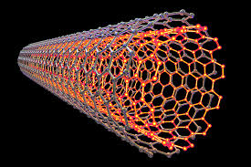

Nano materials