1

**Ionic bond, inter-atomic distance attraction forces between atoms, coordination number, covalent bond, and Metallic bond.**

**Bonding Forces**

Understanding of physical properties of materials is enhanced by learning of the interatomic forces that bind the atoms together. when there is large distance between the atoms , interactions are negligible, because there is no influence on each other; however, when the separation distances is small , each atom exerts forces on the other.

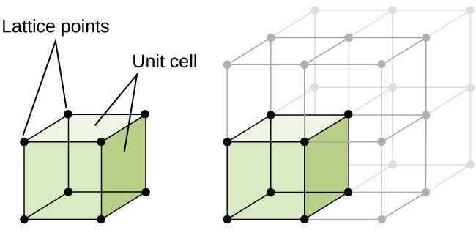

Figure 1 illustrate unit cell of the element

These forces are of two types:

**Attractive force** (FA): depends on the particular type of bonding that exists between the two atoms.

**Repulsive force** (FR): depends on the interatomic distance (r), arise from interactions between the negatively charged electron clouds for the two atoms.

Figure 2is illustrate plot of FA and FR versus *r*.

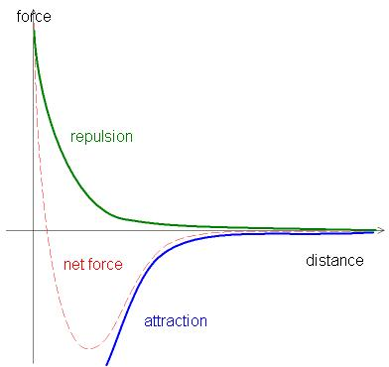

Figure 2 dependence of repulsive, attractive, and net forces on interatomic separation for two isolated atoms.

The net force FN between the two atoms is just the sum of both attractive and repulsive components; that is,



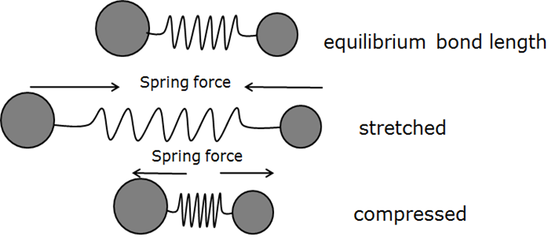

Equilibrium توازن

Repulsion تنافر

Figure 3 Repulsive, attractive, and equilibrium between two atoms

FN also function of the interatomic separation. When FA and FRbalance, or become equal, there is no net force; that is:

FA + FR=0 equilibrium state

This forces give potential energies as a function of interatomic separation for two atoms. **Bonding energy** is the energy required to separate these two atoms to an infinite separation.

Bonding energies, which generally range between 600 and 1500 kJ/mol, are relatively large, as reflected in high melting temperatures as illustrate in table 1.

Materials having large bonding energies typically also have high melting temperatures, solid substances are formed for large bonding energies, whereas gaseous state have small energies; liquids prevail when the energies are of intermediate magnitude.

Three different types of **primary** or chemical **bond** are found in solids

* Ionic bond
* Covalent bond
* Metallic bond

Their nature of the bond depends on the electron structures of the constituent atoms. The bonding arises from tendency of atoms to assume stable electron structures, like those of the inert gases, by completely filling the outermost electron shell.

Also there are secondary or physical forces in many solid materials; they are weaker than the primary ones, but nonetheless influence the physical properties of some materials.

**Primary Interatomic Bonds**

1. **Ionic bond**

Ionic bonding always found in compounds composed of metallic and nonmetallic elements. Valence electrons of metallic element atoms transfer to nonmetallic atoms easily, all the atoms acquire stable or inert gas state and become ions. Example of that sodium chloride (NaCl) is the classic ionic material. Transfer valence 3s electron of sodium atom to chlorine atom (Figure 4a), the chlorine ion acquires a net negative charge, and Ionic bonding is formed as illustrated schematically in Figure 4b.



Figure 4 Schematic representations of (a) the formation of Na+ and Cl− ions and (b) ionic bonding in sodium chloride (NaCl).

**Table 1** Bonding Energies andMelting Temperaturesfor Various Substances



1. **covalent bond**

A second bonding type, covalent bonding, is found in materials whose atoms have small differences in electronegativity. For these materials, stable electron configurations are assumed by the sharing of electrons between adjacent atoms. Two covalently bonded atoms will each contribute at least one electron to the bond. Covalent bonding is schematically illustrated in Figure 5 for a molecule of hydrogen (H2). The hydrogen atom has a single 1*s* electron.



Figure 5 Schematic representation of covalent

bonding in a molecule of hydrogen (H2).

Many nonmetallic elemental molecules (e.g., Cl2, F2), as well as molecules containing dissimilar atoms, such as CH4, H2O, HNO3, and HF, are covalently bonded.

**Table 2** Bonding Energies andMelting Temperaturesfor Various Substances



Covalent bonds may be very strong, as in diamond, which is very hard and has a very high melting temperature, >3550°C (6400°F), or they may be very weak, as with bismuth, which melts at about 270°C (518°F).

Electrons participating in covalent bonds are tightly bound to the bonding atoms, and most covalently bonded materials are electrical insulators, or, in some cases, semiconductors. Mechanical behaviors of these materials vary widely: some are relatively strong, others are weak; some fail in a brittle manner, others experience significant deformation before failure.

1. **Metallic bond**

Metallic bonding, primary bonding, is found in metals and their alloys, valence electrons are not bound to any particular atom in the solid and are more or less free to drift throughout the entire metal. They may be thought of as part to the metal , or forming a “sea of electrons” or an “electron cloud.”



Figure 6 Schematic illustration of metallic bonding.

Figure 6 illustrates metallic bonding. Bonding energies and melting temperatures for several metals are listed in Table 3. Bonding may be weak or strong; energies range from 62 kJ/mol for mercury to 850 kJ/mol for tungsten.

**Table 3** Bonding Energies andMelting Temperaturesfor Various Substances





Their respective melting temperatures are −39°C and 3414°C (−39°F and 6177°F). Metallic bonding is found in the periodic table for Group IA and IIA elements and, in fact, for all elemental metals. Metals are good conductors of both electricity and heat as a consequence of their free electrons

1. **MIXED BONDING**

Sometimes it is illustrative to represent the four bonding types—ionic, covalent, metallic, and van der Waals. Three mixed bond types: covalent–ionic, covalent–metallic, and metallic–ionic

1. **Inter-atomic distance, Coordination number and Atomic Packing Factor**

Two other important characteristics of a crystal structure are the **coordination number** and the **atomic packing factor (*APF*).** Coordination number refer to the number of nearest neighbors atoms to certain central atom. For metals, each atom has the same number of nearest-neighbor atoms, which is the coordination number.

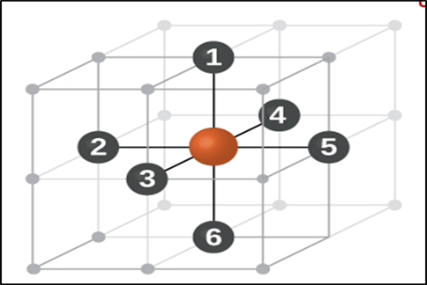

**Figure 6 illustrate Coordination number**

How to Compute coordination number and APF?

Example/ for SCC

Coordination number:

Nearest atoms number for any atom in unit cell is 6

Determine APF



Number of atoms in unit cell= +

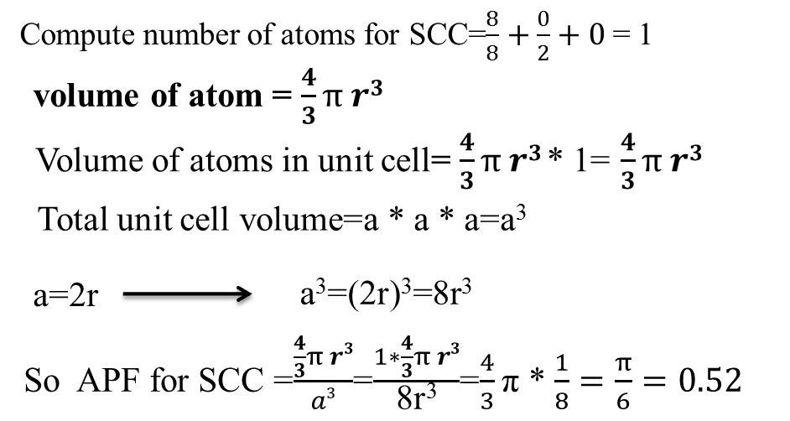

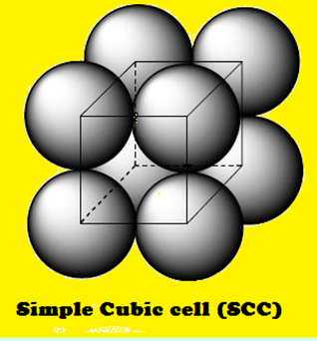





a



Find coordination number and APF for BCC and FCC?

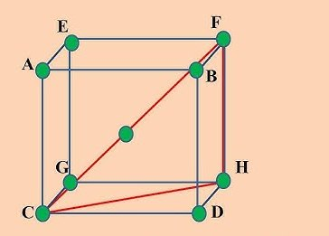 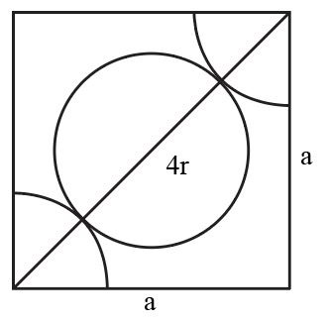

BCC FCC

