1

**Bravais lattice, Miller index, crystalline Planes, X-ray diffraction.**

1. **Bravais lattice**

Uniform arrangement of atoms, molecules or ions which builds a 3-dimensional structure of a crystal, and arrangement of atoms inside a unit cell. Example of Bravais Lattice is **Sodium Chloride (NaCl) Crystal Structure** which also called table salt is a great example of Face-Centered cubic lattice. In this Crystal structure, sodium ions (Na) and Chlorine ions (Cl) are present in a cubic structure.

Each bravais lattice has its specific unit cell.

**1.1 Types of Lattice System**

Unit cells are mainly divided into 2 parts:

* Primitive → contain points at the corners example: Simple Lattice (SC)
* Centered → centered unit cell example: (BCC , FCC , hcp)

Lattice systems gives a different view of Bravais lattice. These are 7 bravais lattice systems which are given in figure 1:

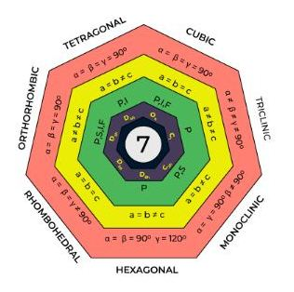

Figure 1 bravais lattice systems

Table 1 Lattice Parameter Relationships for the Seven Crystal Systems

| Lattice System Name | Lattice Type | Angles between faces | Edge length | Example of material |
| --- | --- | --- | --- | --- |
| Cubic Lattice System | Primitive, BCC, FCC | a = b = c= 90° | x=y=z | Copper, Silver etc |
| Hexagonal Lattice System | Primitive | a= 120°, b= c= 90° | x=y ≠ z | Graphite |
| Tetragonal Lattice System | Primitive, BCC | a = b= c = 90° | x=y ≠ z | SnO2 |
| Orthorhombic Lattice System | Primitive, BCC, FCC, Edge centered | a = b = c = 90° | x ≠ y ≠ z | K2SO4 |
| Monoclinic Lattice System | Primitive, edge centered | a ≠ 90°, b = c = 90° | x = y ≠ z | Gypsum |
| Triclinic Lattice System | Primitive | a ≠ b ≠ c = 90° | x ≠ y ≠ z | k2Cr2O7 |
| Rhombohedral Lattice | Primitive | a= b= c ≠ 90° | x=y=z | Sb, As |

**Example of bravais lattice: (Triclinic Lattice System)**

This lattice has 1 lattice point per unit cell(Simple-triclinic lattice). It has no equal edges and angles.

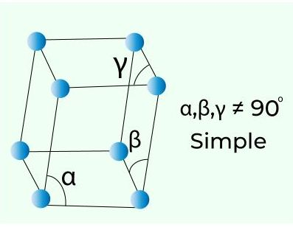

Figure 2 Simple-triclinic lattice

**Question about Bravais Lattice**

**Q/** Identify the types of Bravais lattice for the below crystal structures:

1. Iron(Fe) (ii) Diamond

Answer:

1. Iron (Fe): Body-Centered Cubic (BCC)

(ii) Diamond: Face-Centered Cubic (FCC)

**1.2 Miller index**

Crystallographic planes are specified by three Miller indices as (hkl) that refer to inter-planar spacing for planes of Miller indices h, k, and l. The orientations of planes for a crystal structure are represented in a similar manner. Unit cell is the basis, with the three-axis coordinate system as represented in Figure 3.



Figure 3 Simple-triclinic lattice

Any two planes parallel to each other are equivalent and have identical indices. How to determine the h, k, and l index numbers? as follows:

1. If the plane passes through the selected origin, parallel plane must be constructed within the unit cell by appropriate translation, or new origin must be established at the corner of another unit cell.
2. At this point, the plane either intersects or parallels each of the three axes. The coordinate for the intersection of the crystallographic plane with each of the axes is determined. These intercepts for the x, y, and z axes will be designed by A, B, and C, respectively.

3. The reciprocals of these numbers are taken. A plane that parallels an axis is considered to have an infinite intercept and therefore a zero index.

4. The reciprocals of the intercepts are then normalized in terms of (i.e., multiplied by) their respective a, b, and c lattice parameters. That is,



If necessary, these three numbers are changed to the set of smallest integers by multiplication or by division by a common factor.

6. Finally, the integer indices, not separated by commas, are enclosed within parentheses, thus: (hkl). The h, k, and l integers correspond to the normalized intercept reciprocals referenced to the x, y, and z axes, respectively.

In summary, the h, k, and l indices may be determined using the following equations:



In these expressions, *n* is the factor that may be required to reduce *h, k,* and *l* to integers. An intercept on the negative side of the origin is indicated by a bar or minus sign positioned over the appropriate index.

Question : Determine the Miller indices for the plane shown in the figure 4.

Answer: (*a*) (001), (*b*) (110), and (*c*) (111) (d) (0 1ـ 2).



 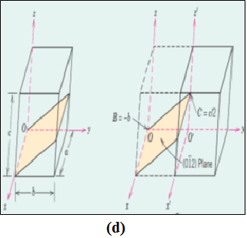

Figure 4 Representations of a series each of the (a) (001), (b) (110), and (c)(111) (d) (0 1ـ 2) crystallographic planes.

1. **Linear and Planar Densities**

**2.1 Linear Density**

Linear density in the sense that equivalent directions have identical linear densities. Linear density (LD) is defined as the number of atoms per unit length whose centers lie on the direction vector for a specific crystallographic direction; that is,



The units of linear density are reciprocal length (e.g., nm−1, m−1).

linear density for FCC is:





Figure 5 (a) FCC unit cell with the [110] direction indicated. (b) The bottom face-plane of FCC unit cell shown the atomic spacing in the [110] direction.

* 1. **Planar Density**

The corresponding parameter for crystallographic planes is planar density, and planes having the same planar density values are also equivalent. In an analogous manner, planar density (PD) is taken as the number of atoms per unit area that are centered on a particular crystallographic plane, or:



The units for planar density are reciprocal area (e.g., nm−2, m−2).

Thus, the area of this planar region is (4*R*)(2*R*√2) = 8*R*2√2, and the planar density is determined as follows:





Figure 6

1. **X-ray diffraction**

Much of our understanding regarding the atomic and molecular arrangements in solids has resulted from x-ray diffraction investigations; furthermore, x-rays are still very important in developing new materials.

**3.1 The Diffraction Phenomenon**

Diffractionoccurs when a wave encounters a series of regularly spaced obstacles that (1) are capable of scattering the wave, and (2) have spacing that are comparable in magnitude to the wavelength. Furthermore, diffraction is a consequence of specific phase relationships established between two or more waves that have been scattered by the obstacles.



Figure 7 The wave

**3.2 Bragg’s Law**

X-rays are a form of electromagnetic radiation that have high energies and short wavelengths—wavelengths on the order of the atomic spacings for solids. When a beam of x-rays impinges on a solid material, a portion of this beam is scattered in all directions by the electrons associated with each atom or ion that lies within the beam’s path. Let us now examine the necessary conditions for diffraction of x-rays by a periodic arrangement of atoms.



**Figure 8** Diffraction of x-rays by planes of atoms (*A*–*A*ʹ and *B*–*B*ʹ).

From the figure, Bragg’s Law is:

n𝜆 = 2dhkl sin 𝜃

**3.3 Interplanar Spacing for Planes**

The magnitude of the distance between two adjacent and parallel planes of atoms (i.e., the interplanar spacing *dhkl*) is a function of the Miller indices (*h*, *k*, and *l*) as well as the lattice parameter(s). For example, for crystal structures that have cubic symmetry:

 a = unit cell edge length

Bragg’s law equation is a necessary but not sufficient condition for diffraction by real crystals. It specifies when diffraction will occur for unit cells having atoms positioned only at cell corners. However, atoms situated at other sites (e.g., face and interior unit cell positions as with FCC and BCC) act as extra scattering centers, which can produce out-of-phase scattering at certain Bragg angles.



Figure 9 Schematic diagram of an x-ray diffracto-meter; T = x-ray source, S = specimen, C = detector, and O = the axis around which the specimen and detector rotate.

**Example**

For BCC iron, compute **(a)** the interplanar spacing and **(b)** the diffraction angle for the (220) set of planes. The lattice parameter for Fe is 0.2866 nm. Assume that monochromatic radiation having a wavelength of 0.1790 nm is used, and the order of reflection is 1.

***Solution***

1. The value of the interplanar spacing dhklis determined using Equation 3.21, with *a* = 0.2866 nm, and *h* = 2, *k* = 2, and *l* = 0 because we are considering the (220) planes. Therefore,



1. The value of 𝜃 may now be computed using Equation 3.20, with *n* = 1 because this is a first order reflection:



The diffraction angle is 2𝜃, or

