

AL Mustaqbal University

College of Education

Department of English Language

Real Listening & Speaking

By

Iltifat Aliwi Al-husseini

1st class

8/1/2025

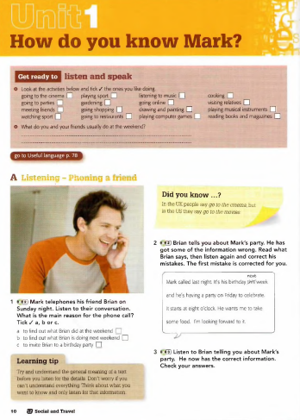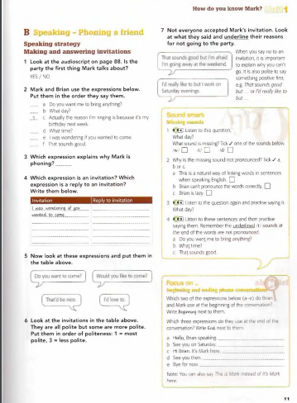

Unit 1

2 (Mark = American)

Brian: Hello, Brian speaking.

Mark: Hi Brian. It's Mark here.

Brian: Hi Mark. How are you?

Mark: I'm fine. How are you?

Brian Fine.

Mark: I haven't caught you at a bad time, have 1?

Brian: No, no. I was just watching TV.

Mark: Oh good. Have you had a good weekend?

Brian: Yeah, I went to the cinema with some friends yesterday. I haven't done much today.

Just at home... watching TV. Yeah, it's been good. What about you?

Mark: Yeah not too bad. Hey, actually the reason I'm ringing is because it's my birthday next week

Brian: Oh OK, yeah.

Mark: and um I thought I might have a few people round at the weekend to celebrate and

I was wondering if you wanted to come.

Brian: That sounds good. What day?

Mark: Saturday, Saturday night.

Brian: Saturday. Yeah, yeah. I don't have any plans for next Saturday. Great. What time?

Mark: Um, about 7.30.

Brian: OK. But I don't think I can get there till 8 o'clock.

Mark: No problem.

Brian Do you want me to bring anything?

Mark: No nothing. I'll get the food and everything.

Brian: OK. Do you want anything special for your birthday?

Mark: No. No you don't have to buy a birthday present. Just come along and help me celebrate. That's all.

Brian: OK. That sounds great.

Mark: See you on Saturday.

Brian: Cool. See you then.

Mark: Bye for now.

Brian: Bye.

