**Name:** Class: 1st year

Subject: Listening& Speaking

Group: Time: 1 Hour

Monthly Exam 2024-2025(A)

**Q1/Write down what you have memorized from this dialogue(Have you got a headache?).**

**Q2/ Answer both (A) and (B)**

**A/ Match the pictures to the expressions**

1. 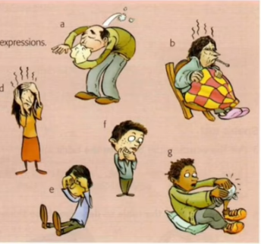**I have got a terrible headache…..**

C

B

1. **My throat is really sore……**

A

1. **I can’t stop sneezing…..**
2. **I’ve got a temperature…..**

E

1. **I’ve got sore eyes…..**

F

D

1. **I’ve got bad cough …..**
2. **I’ve got a swollen knee …..**

**B/ Match the symptoms with the remedies.**

|  |  |
| --- | --- |
| **toothache** | **Cough mixture** |
| **Sore throat** | **painkillers** |
| **Swollen knee** | **drops** |
| **Sore eyes** | **lozenges** |
| **cough** | **ice** |

**Best wishes**

Head of Department Examiners

Asst. Prof. Dr. Salam Hassan Al-Assadi M.A. Rasha Ehsan

M.A. Iltifat Aliwi Al-Husseini