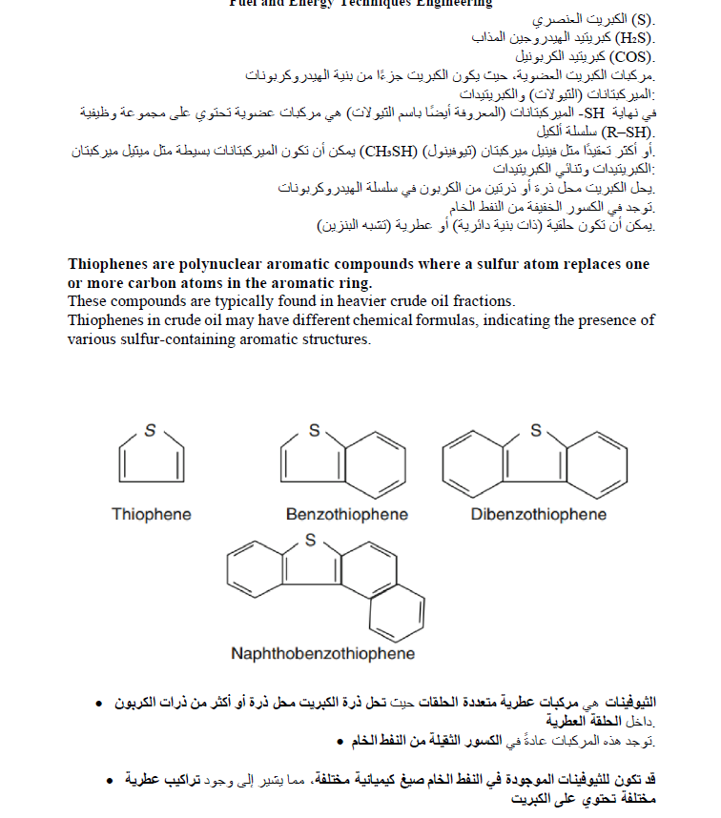



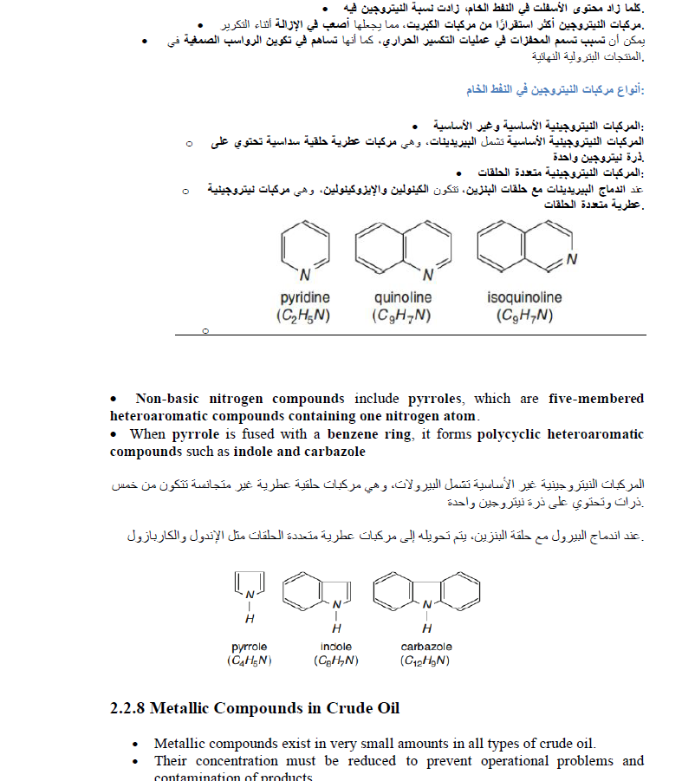

.**تقليل قابلية المعالجة في عمليات التكرير** 3.

