1

**Solid solution and combination type diagram, Iron-carbon face diagram**

1. **Binary Alloy**

In general, binary alloys can be classified into the following types:

**1.1 Simple eutectic type**

The two components are soluble in each other in the liquid state but are completely insoluble in each other in the solid state, example: salt (sodium chloride NaCl) and water solution, total solubility of the salt in water (liquid phase) and total insolubility separate salt crystals from ice crystals (solid state). Other example carbon steels(figure 1).

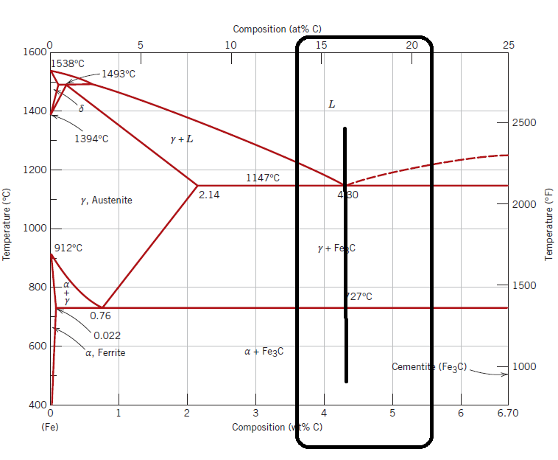

Figure 1 Illustrate eutectic region

**1.2 Solid solution type**

The two components are completely soluble in each other both in the liquid state and in the solid state, for example (Cu-Ni) alloy.



Figure 2 Illustrate (Cu-Ni) alloy

This type divided according to atomic size:

* Substitution solid solution: similar sizes(not more than 15% difference)(Cu-Ni).
* Interstitial solid solution: alloying element size smaller than matrix metal size, example (WC), and carbon in iron.

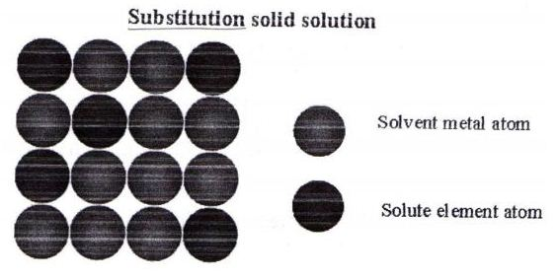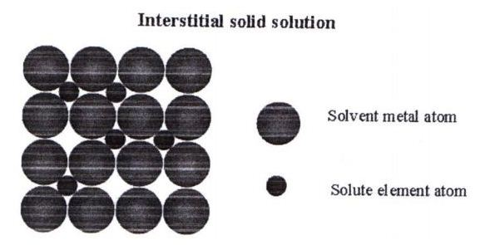

-a- -b-

Figure 3 a-Substitution solid solution, b-Interstitial solid solution

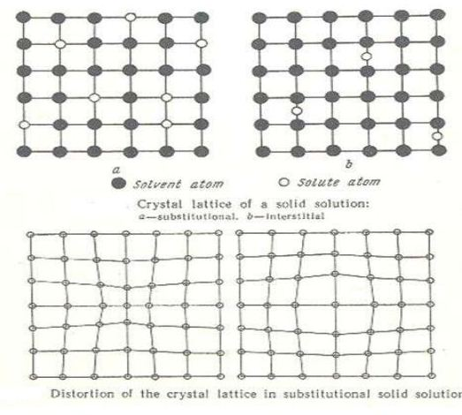

Figure 4 Distortion of the substitution and interstitial solid solution

**1.3 Combination type**

The two components are completely soluble in liquid state and partially soluble in solid state. Example: Lead(Pb)-Tin(Sn) alloy (solder) (Figure 5).

(left side) Pb (solvent) + Sn (solute) → solid solution α (Pb)

(right side) Sn (solvent) + Pb (solute) → solid solution β (Sn)

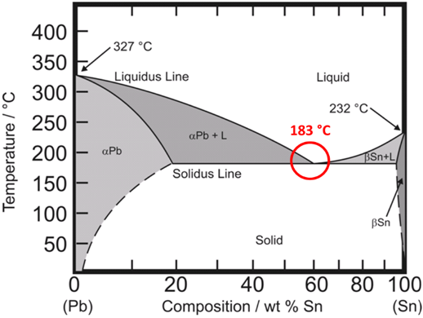

Figure 5 Lead(Pb)-Tin(Sn) alloy

1. **Iron-Carbon Phase Diagram**

The iron-carbon phase diagram is widely used to understand the different phases of steel and cast iron (figure 6) . Both steel and cast iron are mix of iron and carbon (up to 6.67). Also, both alloys contain small amount of trace elements. Steels are iron–carbon alloys that may contain appreciable concentrations of other alloying elements. Plain carbon steels contain only residual concentrations of impurities other than carbon and a little manganese.

Iron-carbon phase diagram is plotted with the carbon concentrations by weight on the X-axis and the temperature scale on the Y-axis. The carbon in iron is an interstitial impurity. The alloy may form face-center cubic (FCC-γ phase) lattice or a body-center cubic (BCC-α phase) lattice.



Figure 6 The iron–iron carbide phase diagram.

**2.1 Types of Ferrous Alloys on the Phase Diagram**

The weight percentage scale on the X-axis of iron-carbon phase diagram goes from 0% up to 6.67% Carbon, from 0.008% up to 2.14% carbon content, the iron-carbon alloy is called steel. There are different types of ferrous alloys as follows:

* **Pure iron /** maximum carbon content up to 0.008% weight of Carbon.
* **Low-Carbon Steels/** contain less than 0.25 wt%C , unresponsive to heat treatments intended to form martensite; soft and weak but have outstanding ductility and toughness; machinable, weldable, and strengthening by cold work. Microstructures consist of ferrite and pearlite, and, of all steels, are the least expensive to produce. One group of low-carbon alloys are high-strength low-alloy steels (HSLA). Also contain elements such as copper, vanadium, nickel, and molybdenum, possess higher strengths than the plain low-carbon steels.
* **Medium-Carbon Steels**

It has carbon concentrations between (0.25 - 0.60 wt%), heat-treated by austenitizing, quenching, and then tempering to improve their mechanical properties, utilized in tempered condition, having microstructures of tempered martensite. The plain medium-carbon steels have low hardenabilities.

* **High-Carbon Steels**

It has carbon concentrations between (0.60 - 1.4) wt%c , hardest, strongest, and least ductile of the carbon steels, used in hardened and tempered condition, exist some elements such as chromium, vanadium, tungsten, and molybdenum, with carbon form very hard and wear-resistant carbide compounds (e.g., Cr23C6, V4C3, and WC). These steels are used as cutting tools and dies for forming and shaping materials, as well as in knives, razors, hacksaw blades, springs, and high-strength wire.

* 1. **Eutectoid, Hypo-eutectoid and Hypereutectoid Alloys**

A [eutectoid](https://www.metallurgyfordummies.com/what-is-sputter-deposition.html) alloy (figure 7b) is similar in behavior to eutectic alloy, but the phase change occurs, not from a liquid, but from solid solution and separate the constituents into different crystal phases, for example, eutectoid steel contains 0.77% carbon.

**Hypo-eutectoid** **Alloys** (figure 7a), for binary alloys that have concentration of solute less than the eutectoid composition, such as plain carbon steels have carbon from (0.022 to 0.77 wt%C).

**Hypereutectoid Alloys** (figure 7c) for a binary alloys that have concentration of solute greater than the eutectoid composition, such as plain carbon steels have carbon from (0.76 and 2.14 wt% C).



Figure 7 Microstructures for a- hypoeutectoid (Fe–C) alloy, b- eutectoid (Fe–C) of composition (0.76 wt% C), c-hypereutectoid (Fe–C) alloy (0.76 - 2.14 wt% C)

**2.3 Stainless Steels**

The stainless steels are highly resistant to corrosion (rusting) in variety of environments. Their predominant alloying element is chromium (at least 11 wt% Cr) . Corrosion resistance may also be enhanced by nickel and molybdenum additions. Stainless steels are divided into three classes according to predominant phase constituent of the microstructure—(martensitic, ferritic, or austenitic).

**2.4 Cast Irons**

Cast irons are class of ferrous alloys with carbon contents above 2.14 wt%; in practice, however, most cast irons contain between 3.0 and 4.5 wt% C and, in addition, other alloying elements. The alloys become completely liquid at temperatures between approximately 1150°C and 1300°C (2100°F and 2350°F), which is considerably lower than for steels. Thus, they are easily melted and amenable to casting. Furthermore, some cast irons are very brittle, and casting is the most convenient fabrication technique. Cementite (Fe3C) is a metastable compound, and under some circumstances it can be made to dissociate or decompose to form α-ferrite and graphite, according to the reaction:



**2.5 Gray Iron**

Gray cast irons have carbon between 2.5 and 4.0 wt% and silicon contents between (1.0 and 3.0) wt%. For most of cast irons, the graphite exists in the form of flakes, which are normally surrounded by an α-ferrite or pearlite matrix; the microstructure of typical gray iron is shown in Figure . Because of these graphite flakes, a fractured surface takes on a gray appearance—hence its name.