**Lec.7 PHYSIOLOGY Dr. Hanadi Hadi Al Khafaji**

**Cardiovascular System (CVS)**

**Function:** to provide an adequate supply of oxygen and nutrients to all cells of the body and carry away the waste products of their metabolism.

The cardiovascular system includes: (a) heart, (b) arteries, (c) capillaries and (d) veins.

Circulatory system has been divided into two functionally opposite parts:

l. Systemic circulation (greater circulation) -passing through the tissues.

2. Pulmonary circulation (lesser circulation)-passing through the lungs.

The two systems again meet in the heart.

**The Heart:**

* The heart rests obliquely in the thoracic cavity. The anterior surface of the heart faces the sternum, the posterior surface-the base of the cone faces the vertebral column and the inferior or diaphragmatic surface rests on the diaphragm.
* The heart has got four chambers; two ventricles and two atria: both right and left. The two left chambers are separated from the two right ones, by a continuous partition, the atrial portion of which is called the inter-atrial septum (fibrous).
* The ventricular part is known as the inter-ventricular septum (upper one-fourth fibrous, lower three-fourths muscular).
* The four chambers of heart perform four different functions:
  + From the left ventricle arises the aorta, carrying oxygenated blood to the tissues.
  + From the right ventricle, which is less muscular than the left, arises the pulmonary trunk, carrying reduced blood to the lungs.
  + The right atrium receives all the venous blood from the body through three veins; the inferior and the superior venae cavae, and the coronary sinus.
  + The left atrium receives all the oxygenated blood from the lungs through pulmonary veins.
* The systemic circulation begins in the left ventricle and ends in the right atrium.
* The pulmonary circulation starts in the right ventricle and ends in the left atrium.
* The right half of the heart is concerned with reduced blood, while the left half with oxygenated blood.
  + The left ventricle propels oxygenated blood to the tissues. Here, it gives up oxygen and becomes reduced. The reduced blood comes back to the heart through the veins and is received by the right atrium.
  + From the right atrium it passes into the right ventricle, which then propels it into the lungs. Here, it becomes re-oxygenated, and is returned to the left atrium through the pulmonary veins.
  + From here it enters the left ventricle and is pumped out into the greater circulation again. In this way circulation goes on.
* Systole means contraction. Diastole means relaxation.

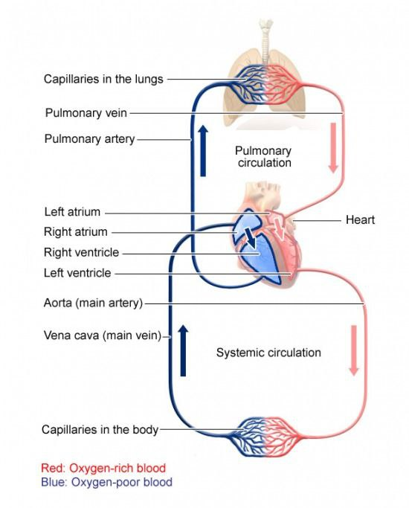

**Valves of the Heart:** they preventany admixture between arterial and venous blood. In other words, circulation must be strictly one way.

There are four sets of valves in the heart.

• The right atrio-ventricular opening is guarded by tricuspid valve.

• The left opening is guarded by the mitral or bicuspid valve.

• The openings of the aorta and pulmonary artery are guarded by semilunar valves (three cusps).

* The atrio-ventricular (AV) valves open towards the ventricles and close towards the atria.
* The semilunar (SL) valves open away from the ventricles and close towards the ventricles.

So that when atria contract, atrio-ventricular valves open and blood passes into the ventricles. When ventricles contract, atrio-ventricular valves close, but semilunar valves open. This prevents regurgitation of blood into the atria but allows it to flow out of the ventricles. In this way circulation becomes one way.

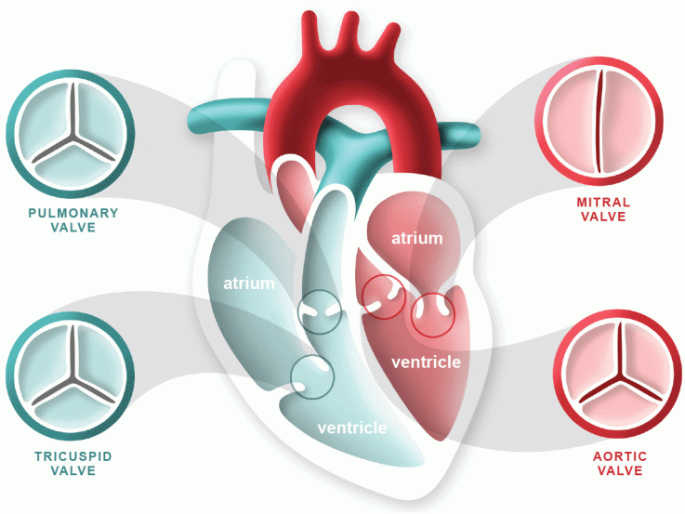

Layers of the Heart Wall:

1. The epicardium: the outer thin layer of connective tissue and fat serving as an additional layer of protection for the heart.
2. The myocardium: the middle layer consisting of muscle tissue. Cells of the cardiac muscles are called cardiomyocytes that receive nervous stimulation from the sinoatrial (SA) and atrioventricular (AV) nodes via the Purkinje fibers.

Cardiomyocytes have a single nucleus in the center of the cell, which helps to distinguish them from skeletal muscle cells that have multiple nuclei dispersed in the periphery of the cell.

1. The endocardium : the inner layer consisting of endothelial cell that provide a smooth non-adherenet surface for blood collection and pumping and may help contractility.

**Arteries**:

* Arteries are vessels which carries blood away from the heart.
* They have three layers;

1. the outer layer is made-up of fibrous tissue (collagen) and elastic tissue (tunica adventitia or externa),
2. the middle layer of plain muscles and a network of elastic fibers (tunica media)
3. the inner layer of endothelium surrounded by an elastic layer (tunica intima or interna).

* The two outer layers are very thick, because it has to withstand considerable blood pressure.
* A special system of vessels-the vasa vasorum-arises from the adjacent small arteries and passes into the arterial wall to supply blood to the layers of large arteries and veins.
* **Arterioles** are the smaller arteries which carry blood to the capillary bed.
* Pressure and flow of the vascular systems are principally maintained through modifying the lumen of the arterioles.

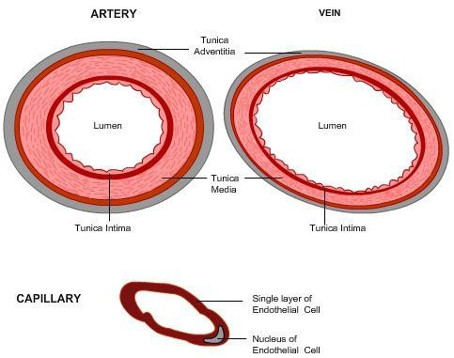

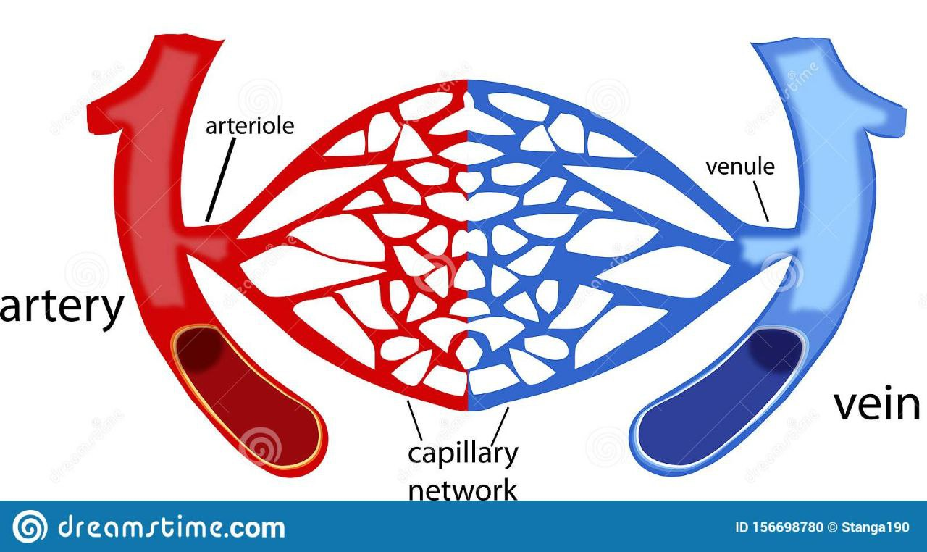

**Veins:**

* In veins all the three layers are present but the intima and media are comparatively thinner than those of arteries and this is only due to reduction of muscular and elastic components.
* Though the walls are very thin yet the vessels are very strong due to presence of connective tissue components.
* Structures of the veins differ from one place to another. Some veins do not possess smooth muscle. These are the cerebral veins, meningeal veins, retinal veins, etc.
* Valves are present in most of the veins particularly of those of the lower limb. These valves prevent backflow from the heart.
* Venules are very small branches that collect the blood from the capillary beds in various organs, then they unite to form veins, which return the blood to the heart.

**Capillaries:**

* The smallest and most numerous of the blood vessels.
* They form the connection between the arterioles and the venules.
* The primary function of capillaries is the exchange of materials between the blood and tissue cells.
* They are composed of only the tunica intima, consisting of a thin wall of endothelial cells.
* The average diameter of the capillaries is 7-9 µm.

**Special Junctional Tissues:**

* Cardiac muscle consists essentially of certain specialized structures which are responsible for initiation and transmission of cardiac impulses at a higher rate than the rest of the muscle.
* Those specialized cardiac tissues are collectively known as the junctional tissues of heart.
* They comprise the following structures;

(a) Sino-atrial (SA) node,

(b) Atrio-ventricular (AV) node,

(c) bundle of His (atrio-ventricular bundle),

(d) the right and left branches of the bundle ending,

(e) Purkinje fibers.

* Sino-atrial node is situated at the junction of superior vena cava and the right atrium.

It generates the normal cardiac impulse at the rate of 70 to 80 per minute in the adult and acts

as the pacemaker of heart.

* Atrio-ventricular node is situated in the right atrium at the posterior part of the inter-atrial septum close to the opening of the coronary sinus.
* Bundle of His: it is a collection of cells that carry electrical signals from the AV node to the bundle branches.
* Bundle branch: the function of bundle branch is to conduct the atrial impulse into the ventricles.
* Purkinje fibers arise from the branches of the bundle of His. Main function of these fibers is to conduct impulse quickly to every part of the ventricular muscle fiber.
* Conduction: The impulse originated at the SA node spreads over the atria and reaches the AV node through the inter-nodal fibers. The AV node transmits the impulse through the bundle of His and its branches to the ventricles. From the apex of the heart through the Purkinje fibers the impulse is conducted to the base.