**2. Enteric Gram-negative rods: *Escherichia coli***

**- The general characteristics of Enterobacteriaceae**

* **Gram-negative** bacilli.
* Found as commensals in the intestinal tract of mammals.
* They are also referred to as **coliforms** or **enteric** bacteria.
* **Aerobic** and **facultative** **anaerobic** growth.
* Optimal growth normally at **37 C˚**.
* Grow readily on **simple** media.
* **Ferment** wide range of **carbohydrates**.
* **According to the Lactose fermantation they are classified into:**
* **Lactose fermenter Fermentation** of **lactose** to **produce** **pink** **colonies** on MacConkey’s agar is characteristic of ***Escherichia***, ***Enterobacter*** and ***Klebsiella***.
* **Non-lactose fermenter *Salmonella***, ***Shigella***, ***Serratia***, ***Proteus*** and ***Yersinia*** **do not** ferment **lactose** and form **pale** شاحب **colonies** on MacConkey’s agar.
* **Late Lactose fermenters**, *Shigella sonnei*.
* **Oxidase**-**negative**.
* Some are **motile (**Motile except *Shigella* and *Klebsiella* ).
* **Bile** tolerant and grow readily on **bile**-**salt** containing media, e.g. **MacConkey’s** agar.
* **Some** of them produce **urease.** (which splits urea with release of ammonia).
* **Some** of them produce **Hydrogene sulphide.**
* 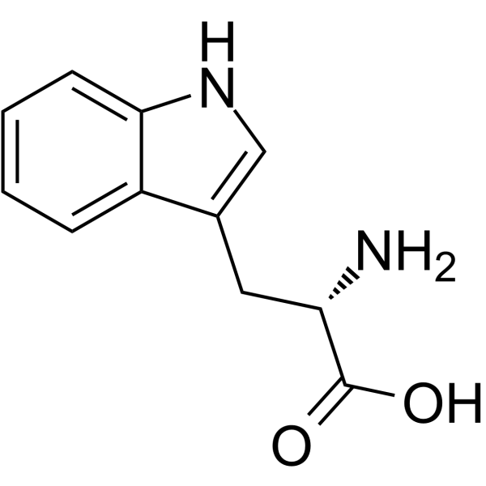**Some** of them **decarboxylase amino-acids.**
* **Some** of them **derive** the **indole ring** from the amino acid tryptophan .
* **None-spore forming.**
* **None acid fast.**
* **Ferment** glucose with **acid** production
* **Reduce** **nitrates** into **nitrites**
* Non-capsulated except *Klebsiella*
* Non-fastidious

Enterobacteriaceae possess a variety of **antigens**:

* **lipopolysaccharide** somatic antigen(‘O’),
* **flagellar** antigen(‘H’)
* **capsular** **polysaccharide** (‘K’) antigens.

***Escherichia coli***

**Morphology**

* *E. coli* is Gram-negative (-ve) rod-shaped bacteria.
* It is 1-3 x 0.4-0.7 µm in size and 0.6 to 0.7 µm in volume.
* It is arranged singly or in pairs.
* It is motile due to **peritrichous** flagella (see classification of flagella ).
* Some **strains** are **non-motile**.هذا استثناء نادر
* **Some strains** may be **fimbriated**. The fimbriae are of type 1 (hemagglutinating & mannose-sensitive) and are present in both motile and non-motile strains.
* **Some strains** of *E. coli* isolated from extra-intestinal infections have a **polysaccharide** capsule.
* They are non-sporing.
* They have a thin cell wall with only 1 or 2 layers of peptidoglycan.
* They are facultative anaerobes.
* Growth occurs over a wide range of temperatures from 15-45°C.

**Antigenic Structure and Pathogenicity**

* Specific **fimbriae** (**adhesins**) facilitate **adherence** to **mucosal** **surfaces** and **colonization** of the **intestinal** and **urinary** tracts.
* *E. coli* possesses 4 antigens; H, O, K and F.

1. **Flagellar or (H) Antigen**

* Heat and alcohol labile **protein**
* Present on the flagella
* Genus specific
* Present as monophasic
* 75 ‘H’ antigens have been recognized

1. **Somatic or (O) Antigen**

* **Heat stable**, resistant to **boiling**.
* Occur on the surface of the outer membrane
* An integral part of the cell wall
* 173 ‘O’ antigens have been recognized

1. **Capsular or (K) Antigen**

* Heat labile
* Acidic polysaccharide (polysaccharides that contain carboxyl groups, phosphate groups and/or sulfuric ester groups) antigen presents in the envelope
* Boiling removes the K antigen
* Inhibit phagocytosis
* 103 ‘K’ antigens have been recognized

1. **Fimbrial or (F ) Antigen**

* Heat labile proteins
* Present in the fimbriae
* K88, K99 antigens
* The **heat stable** **lipopolysaccharide** (**endotoxin**) “in the cell wall is liberated when Gram-negative bacteria lyse”, resulting in production of **inflammatory** **mediators** and **complement** **activation “** plasma proteins that can be activated directly by pathogens or indirectly by pathogen-bound antibody”. This results in **endotoxic** **shock** and **intravascular** **coagulopathy**.
* **Different** **protein** **toxins** (**exotoxins**) produced by *E. coli*.
* **Verocytotoxin-producing E. coli (VTEC), also known as (Shiga toxin-producing *E. coli*** )(**STEC**) particularly the **O157:H7** serotype, are an **important** cause of **diarrhoea** and **hemolytic** **uremic** **syndrome** (HUS).
* **Enteropathogenic** (EPEC): cause of **infantile** **diarrhoea**, **non-invasive**.
* **Enterotoxigenic** (ETEC): **travelers’** **diarrhoea**, **non**-**invasive**.
* **Enteroinvasive** (EIEC): causes **dysentery**-**like** illness.
* **Enteroaggregative** (EAEC): **watery** **diarrhoea** **without** fever.

**تم حذف التفاصيل الخاصة بكل نوع**

**Pathogenicity of *E. coli***

**Most** infections (with the **exception** of **neonatal** **meningitis** and **gastroenteritis**) are **endogenous**; that is, the *E. coli* that are part of the patient’s normal microbial flora are able to establish infection when the patient’s defenses are compromised (e.g., through trauma or immune suppression).

This organism is associated with a variety of diseases, including **gastroenteritis** and **extra**-**intestinal** **infections** such as **UTIs**, **meningitis**, and **sepsis**.

**Clinical Feature of *E. coli***

**1. Gastroenteritis**

**2. Urinary Tract Infection**

**3. Sepsis**

**4. Meningitis**

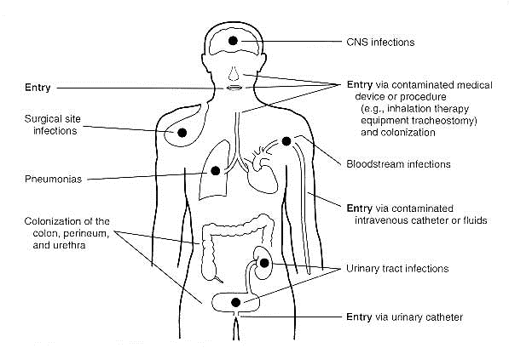

**Laboratory Diagnosis**

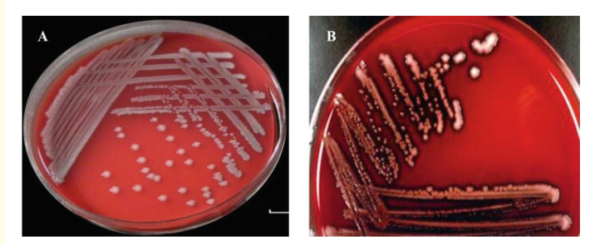

***E. coli* on Blood Agar**

1. Colonies are big, circular, gray, and moist.  
2. Non-hemolytic colonies (gamma-hemolysis) (Above Figure) OR Beta (β)hemolytic (Below Figure) colonies are formed.

3. Many pathogenic strains are haemolytic on blood agar.

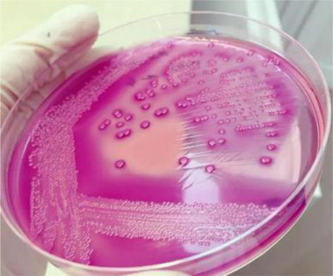

***E. coli* on MacConkey Agar**

1. Colonies are **circular**, **moist**, **smooth**, and of **entire** margin.

2. Colonies appear **flat** and **pink**.

3. They are **lactose** fermenting colonies.

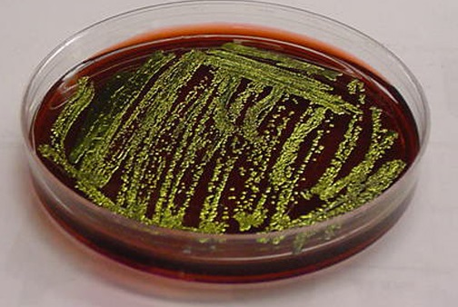

***E. coli* on Eosin Methylene Blue (EMB) Agar**

1. **Green** **Metallic** sheen colonies are formed.

**تم الاعتماد على الأوساط شائعة الاستعمال**

***E. coli* Biochemical Characters,**

- **Glucose**, **Lactose**, **Mannitol**, **Maltose** fermented with **Acid** and **Gas**.

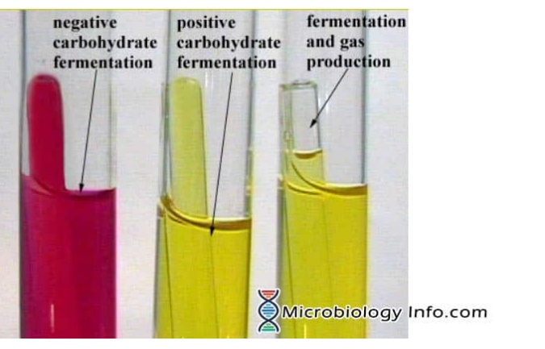

- Indole (+ve)

- Methyl Red (+ve)

- Voges Proskauer (-ve)

- Citrate (-ve)

- Urease not produced.

- H2S (-ve)

- Motility test (+ve)

