**Haemophilus**

**أ. م. د. عصام جمعة ناصر**

**General Characteristics**

The genus *Haemophilus* contains significant genetic diversity. Members of the genus are small, nonmotile, pleomorphic gram-negative bacilli. The cells are typically coccobacillary or short rods. Species of the genus Haemophilus require protoporphyrin IX (a metabolic intermediate of the hemin biosynthetic pathway), referred to as X factor and V factor, nicotine adenine dinucleotide (NAD), or nicotine adenine dinucleotide phosphate (NADP) for in vitro growth. Haemophilus spp. are facultative anaerobes enhanced in a 5% to 7% CO 2-enriched atmosphere. The morphologic and physiologic features of individual species are presented in the discussion of laboratory diagnosis.

**Epidemiology**

As presented in Table 1, except for *Haemophilus ducreyi, Haemophilus* spp. normally inhabit the upper respiratory tract of humans. Asymptomatic colonization with *Haemophilus influenzae* type b is rare. Although *H. ducreyi* is only found in humans, the organism is not part of our normal microbiota, and its presence in clinical specimens indicates infection.

**TABLES-1**

|  |  |  |
| --- | --- | --- |
| Organism | Habitat (Reservoir) | Mode of Transmission |
| *Haemophilus influenzae* | Normal microbiota: upper respiratory tract | Person-toperson: respiratory dropletsEndogenous strains |
| *Haemophilus ducreyi* | Not part of normal human microbiota; only found in humans during infection | Person-toperson: sexual contact |
| Other Haemophilus spp.Haemophilus parainfluenzaeHaemophilus parahaemolyticus | Normal microbiota: upper respiratory tract | Endogenous strains |

**Pathogenesis and Spectrum of Disease**

Production of a capsule and factors that mediate bacterial attachment to human epithelial cells are the primary virulence factors associated with *Haemophilus* spp. In general, infections caused by *H. influenzae* are often systemic and life-threatening, whereas infections caused by nontypeable (do not have a capsule) strains are usually localized. Most serious infections caused by *H. influenzae* type b are biotypes I and II.

Most *H. influenzae* infections are now caused by nontypeable strains (NTHi). Transmission is often via respiratory secretions. The organism is able to gain access to sterile sites from colonization in the upper respiratory tract. Clinical infections include otitis media (ear infection), sinusitis, bronchitis, pneumonia, and conjunctivitis. Immunodeficiencies and chronic respiratory problems such as chronic obstructive pulmonary disease may predispose an individual to infection with NTHi.

**Chancroid** is the sexually transmitted disease caused by *H. ducreyi* . The initial symptom is the development of a painful genital ulcer and inguinal lymphadenopathy.

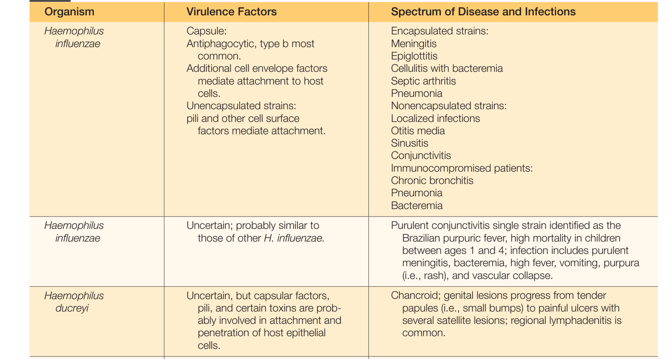**TABLES-2**

**Laboratory Diagnosis**

**Specimens**

Specimens consist of expectorated sputum and other types of respiratory specimens, pus, blood, and spinal fluid for smears and cultures depending on the source of the infection.

**Direct Observation**

To increase the sensitivity of direct Gram stain examination of body fluid specimens, especially CSF, specimens may be centrifuged (2000 rpm for 10 minutes), and the smear is prepared from the pellet deposited in the bottom of the tube. Gram stains of the smears from clinical specimens must be examined carefully. *Haemophilus* spp. stain a pale pink and may be difficult to detect in the pink background of proteinaceous material often found in clinical specimens.

**Antigen Detection**

*H. influenzae* type b capsular polysaccharide in clinical specimens, such as CSF and urine, can be detected directly using commercially available particle agglutination assays.

**Molecular Methods**

Rapid screening procedures are very useful for patient therapy and evaluating outbreaks and have been developed for detection from CSF, plasma, serum, and whole blood. A polymerase chain reaction (PCR) for *H. influenzae* capsular types a and f has been developed.

**Incubation Conditions and Duration**

Most strains of *Haemophilus* spp. are able to grow aerobically and anaerobically (facultative anaerobes). Growth is stimulated by 5% to 10% carbon dioxide (CO2). It is recommended that cultures be incubated in a candle jar, CO2 pouch, or CO2 incubator.

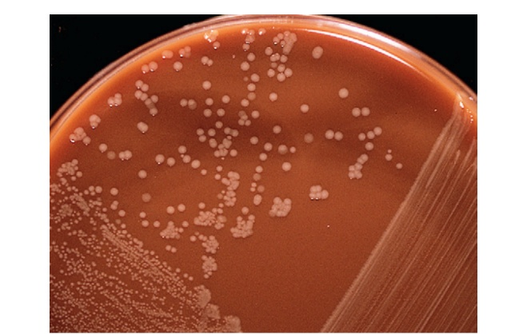

**FIGURE1***Example of Haemophilus* influenzae growing on chocolate (CHOC) agar. Notice the tan mucoid colonies characteristic of encapsulated strains

**Cultivation / Media of Choice**

Haemophilus spp. typically grow on chocolate agar as smooth, flat or convex, buff or slightly yellow colonies. Chocolate agar provides hemin (X factor) and NAD (V factor), necessary for the growth of Haemophilus spp. Most strains will not grow on 5% sheep blood agar, which contains protoporphyrin IX but not NAD. Several bacterial species, including Staphylococcus aureus, produce NAD as a metabolic byproduct. Therefore, tiny colonies of Haemophilus spp. may be seen growing on sheep blood agar very close to colonies of bacteria capable of producing V factor; this is known as the **satellite phenomenon.**

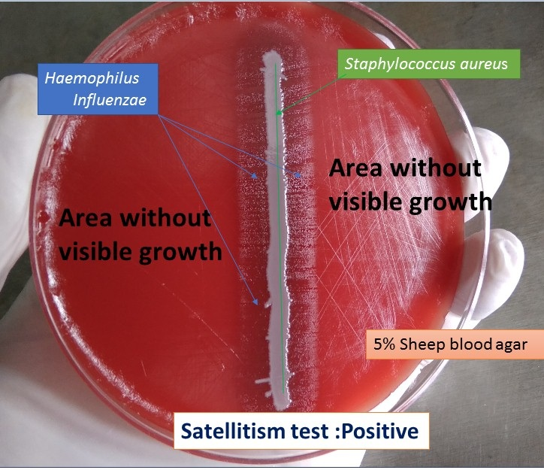

**FIGURE 2  *Haemophilus influenzae satellite phenomenon***

**Treatment**

Invasive *H. influenzae* infection often requires hospitalization. The current recommended treatment of life-threatening illness caused by *H. influenzae* is cefotaxime or ceftriaxone. Alternative drugs include trimethoprim-sulfamethoxazole, imipenem, and ciprofloxacin.