***Klebsiella***

The genus was originally divided into 3 main species based on biochemical reactions. Today, 7 species with demonstrated similarities in DNA homology are known. These are (1) *Klebsiella pneumoniae*, (2) *Klebsiella ozaenae*, (3) *Klebsiella rhinoscleromatis*, (4) *Klebsiella oxytoca*, (5) *Klebsiella planticola*, (6) *Klebsiella terrigena*, and (7) *Klebsiella ornithinolytica*

***Klebsiella pneumoniae***

**General characteristics:**

* *K. pneumoniae* is typically colonizes **human** **mucosal** surfaces of the **oropharynx** and **gastrointestinal** (GI) tract. It is recorded to be associated with **pneumonia** in the alcoholic and diabetic patient population. *K. pneumoniae* is also a well-known cause of **community**-**acquired** pneumonia.
* It is mostly commonly isolated **Gram-negative**, **non-motile** bacteria possesses a **polysaccharide** **capsule**, which **protects** **against** **phagocytosis** and antibiotics and makes the colonies **moist** and **mucoid**. has a distinctive “**yeasty**” odor.

**Antigenic Structure**

Members of the genus *Klebsiella* form large capsules consisting of **polysaccharides** **(K antigens)** covering the **somatic** (O or H) antigens and can be identified by capsular swelling tests with specific antisera.

**Cultural and biochemical characteristics**

*Klebsiella*species exhibit **mucoid** growth, large polysaccharide capsules Table 3.1 and Figure 3.1, and **lack of motility**, and they usually give **positive** **test** results for **lysine** **decarboxylase** and **citrate**. *Klebsiella*, species usually give positive **Voges-Proskauer** reactions Table 3.2.

**Table 3.1 Cultural Characteristics of *Klebsiella pneumoniae* on some laboratory media**

| **Cultural Characteristics** | **Nutrient Agar Medium (NAM)** | **MacConkey Agar medium** | **Blood Agar Medium** | **EMB Agar medium** |
| --- | --- | --- | --- | --- |
| **Shape** | Circular | Circular | Circular | Circular |
| **Size** | 2-3 mm | 2-3 mm | 2-3 mm | 2-3 mm |
| **Elevation** | Dome-shaped | Convex | Dome-shaped | Convex |
| **Surface** | Mucoid | Mucoid | Mucoid | Mucoid |
| **Color** | Greyish white | Pink – Red | Greyish white | Pink – Purple |
| **Structure** | Translucent–Opaque | Opaque | Translucent–Opaque | Translucent–Opaque |
| **Hemolysis** | ----- | ----- | γ-Hemolysis (Non-hemolytic) | ----- |

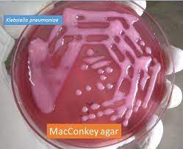 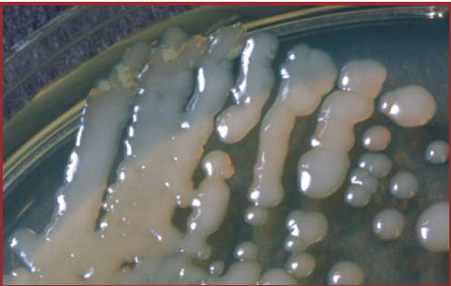

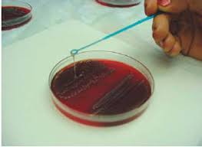 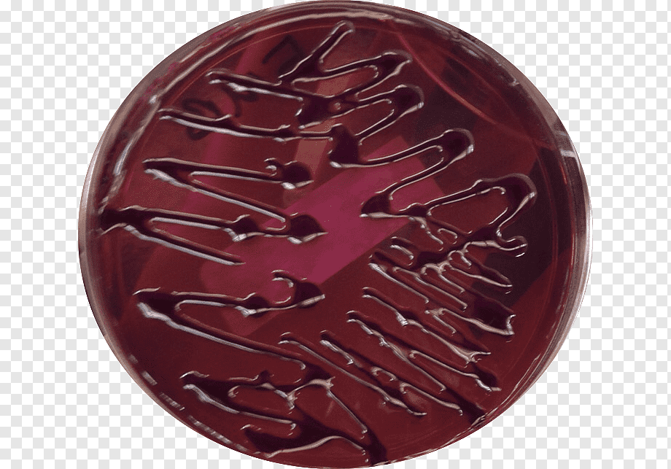

**Figure 3.1 *Klebsiella pneumoniae* Growing on MacConkey, Nutrient, Blood and Eiosin Methylene Blue agar plates respectively.**

**Table 3.2 Biochemical tests of *Klebsiella* *pneumoniae***

|  |  |
| --- | --- |
| **Characteristics** | **Klebsiella pneumoniae** |
| Capsule | +ve |
| Catalase | +ve |
| Citrate | +ve |
| Gelatin Hydrolysis | -ve |
| Gram Staining | -ve |
| H2S | -ve |
| Indole | -ve |
| Motility | -ve |
| MR (Methyl Red) | -ve |
| Nitrate Reduction | +ve |
| Oxidase | -ve |
| Pigment | -ve |
| Shape | Rod |
| Spore | -ve |
| TSIA (Triple Sugar Iron Agar) | A/A |
| Urease | +ve |
| VP (Voges Proskauer) | +ve |

**Pathogenesis and Clinical Findings**

*Klebsiella* species are present in the nasopharynx and feces of about 5% of normal individuals. The most commonly isolates species are *K. pneumoniae* and *K. oxytoca*. While *K. pneumoniae* may be isolated more frequently than *K. oxytoca* by clinical laboratories, both species are important human pathogens.

* *K. pneumoniae* can produce a **lobar pneumonia**, the production of “**currant** **jelly**” sputum.
* *Klebsiella* species also cause **urinary tract infections**, **wound** and **soft tissue infections**, and **bacteremia**/sepsis.
* *K. pneumoniae* has emerged as a cause of **community-acquired pyogenic liver abscess.**
* *Klebsiella* species responsible for **hospital-acquired infections**.
* *Klebsiella granulomatis* (formerly *Calymmatobacterium* *granulomatis*) causes a **chronic genital ulcerative disease**, and is thought to be a **sexually transmitted disease**.

**Proteus, Morganella and Providencia**

* Normal flora of the GI tract (except Providencia).
* Non-lactose ferment
* **All motile**, with Proteus **swarming** (Figure 3.2) motility with **peritrichous** flagella, **non-spore** forming,
* **Phenylalanine** **Deaminase** Test Positive (PA+**Phenylalanine Agar**)
* Lysine deamination + (LIA (**Lysine Iron Agar**) Lysine Iron Agar (LIA) is used to **differentiate** enteric bacilli based on their ability to **decarboxylate** or **deaminate** lysine and produce **hydrogen** **sulfide** (H2S). LIA also is used in combination with **Triple Sugar Iron Agar** to identify members of *Salmonella* and *Shigella* R/A)
* **Urea**se production was positive for most members and it's **strongly** + for **Proteus**
* TSI variable for every genus
* Indole test positive except ***P. mirabilis* is -ve**

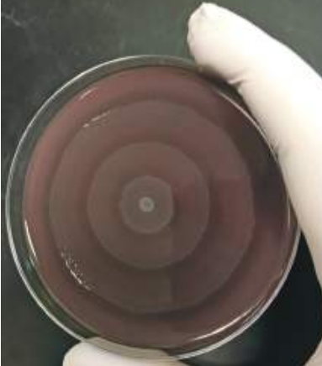**Proteus species**

* *P. mirabilis* and *P. vulgaris* are widely recognized human pathogens.
* The **spot-indole test** is useful for differentiation between the two most common Proteus species: is *P. vulgaris* indole **positive**, whereas *P. mirabilis* is **negative**.
* Isolated from urine, wounds, and ear and rarely from bacteremia
* Both produce **swarming** (Rauss phenomenon) colonies on **non-selective media** and have a distinctive “**burned** **chocolate**” odor

**Figure 3.2 Swarming phenominon of *Proteus* species**

* Both are **strongly** **urease** **positive**
* Both are **phenylalanine** **deaminase** **positive**

**The swarming of Proteus can be inhibited by:**

* **Increasing** the concentration of **agar** from 1-2% to 6%.
* **Incorporation** of **sodium azide**, **boric** **acid**, or **chloral** **hydrate** in the medium.
* The addition of **growth** **inhibitors** like **sulphonamides** to the medium.
* Addition of **Teepol** (a surface-active agent), which is present in **Teepol Lactose agar** medium.

**Table 3.3: Culture Characteristics of *Proteus vulgaris***

| **Cultural Characteristics** | **Nutrient Agar Medium (NAM)** | **MacConkey Agar medium** | **Blood Agar Medium** | **EMB Agar medium** |
| --- | --- | --- | --- | --- |
| **Shape** | Irregular (due to swarming) | Circular | Irregular (due to swarming) | Circular |
| **Size** | 1-2 mm | 2-3 mm | 1-2 mm | 2-3 mm |
| **Elevation** | Effuse | Low Convex | Effuse | Effuse |
| **Surface** | Glistening | Smooth | Glistening | Glistening |
| **Color** | Greyish white | Colorless or Pale colored | Greyish white | Colorless |
| **Structure** | Translucent | Transparent | Translucent –Opaque | Transparent |
| **Hemolysis** | ----- | ----- | γ-Hemolysis (Non-hemolytic) | ----- |

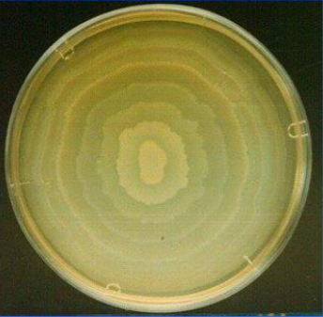 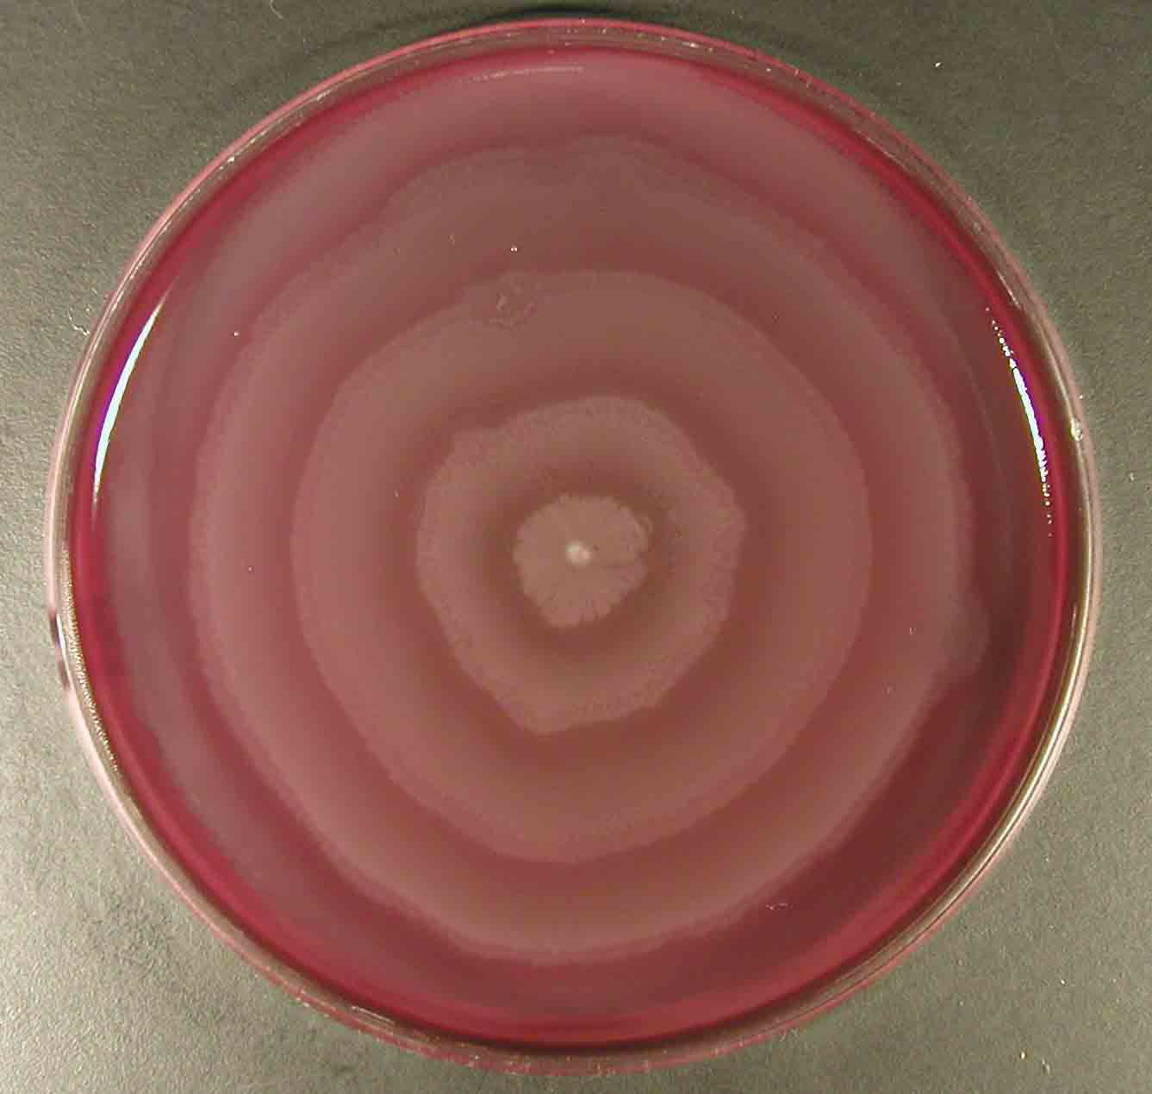 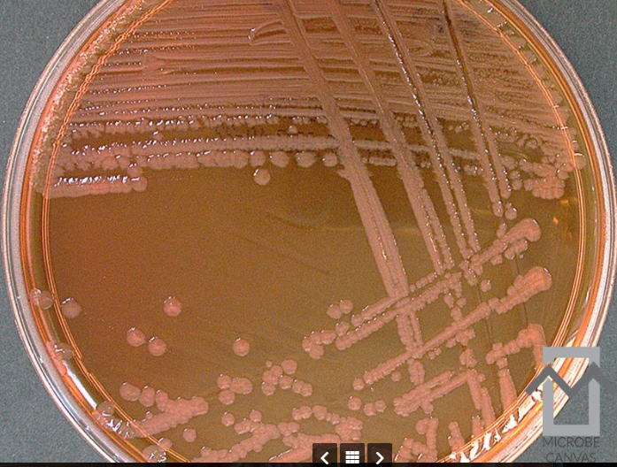

[**https://www.slideserve.com/yardley-carver/shigella-proteus**](https://www.slideserve.com/yardley-carver/shigella-proteus)

[**https://www.med.muni.cz/mikroblg/atlas/atlas/bacteriology/proteus/atlas_en.html**](https://www.med.muni.cz/mikroblg/atlas/atlas/bacteriology/proteus/atlas_en.html)

[**https://microbe-canvas.com/Bacteria/gram-negative-rods/facultative-anaerobic-3/catalase-positive-3/oxidase-negative/colistin-resistant/proteus-vulgaris.html**](https://microbe-canvas.com/Bacteria/gram-negative-rods/facultative-anaerobic-3/catalase-positive-3/oxidase-negative/colistin-resistant/proteus-vulgaris.html)

**Antigenic Structure**

The Proteus possess **thermostable**, somatic (O), and **thermolabile** flagellar (H) antigens upon which, several serotypes have been recognized.

**Pathogenicity and Pathogenesis**

The two species to most commonly produce infections in humans are ***P. mirabilis*** and ***P. vulgaris***. Both species produce **urease**, resulting in rapid **hydrolysis** of **urea** with liberation of **ammonia**.

* Thus, in urinary tract infections with *Proteus* species, the urine becomes **alkaline**, promoting **stone** formation and making **acidification** virtually impossible.
* The rapid **motility** of Proteus may also contribute to its **invasion** of the urinary tract.
* *P. mirabilis* causes urinary tract infections and occasionally other infections, such as **bloodstream** infection (frequently secondary due to a UTI) and respiratory tract infections.
* *P. vulgaris* is probably more frequently implicated in **wound** and **soft tissue infections** than UTIs.

**Biochemical tests and identification**

| **Basic Characteristics** | **Properties (Proteus mirabilis)** |
| --- | --- |
| Capsule | Negative (-ve) |
| Catalase | Positive (+ve) |
| Citrate | Positive (+ve) |
| Flagella | Positive (+ve) |
| Gas from Glucose | Positive (+ve) |
| Gelatin Hydrolysis | Positive (+ve) |
| Gram Staining | Negative (-ve) |
| H2S | Positive (+ve) |
| Indole | Negative (-ve) |
| Motility | Positive (+ve) |
| MR (Methyl Red) | Positive (+ve) |
| Nitrate Reduction | Positive (+ve) |
| Oxidase | Negative (-ve) |
| Pigment | Negative (-ve) |
| Shape | Rods |
| Spore | Negative (-ve) |
| Urease | Positive (+ve) |
| VP (Voges Proskauer) | Negative (-ve) |
| **Fermentation of** | |
| Glucose | Positive (+ve) |
| Lactose | Negative (-ve) |
| **Enzymatic Reactions** | |
| Acetate Utilization | Negative (-ve) |
| Esculin Hydrolysis | Negative (-ve) |
| Lipase | Positive (+ve) |
| Lysine decarboxylases | Negative (-ve) |
| Phenylalanine Deaminase | Positive (+ve) |
| Tryptophan Deaminase | Negative (-ve) |