**Spirochetes**

The spirochetes are **long**, **slender**, **helically** **coiled**, **spiral**, or **corkscrew** shaped bacilli. *T. pallidum* has an **outer** **sheath**. Inside the sheath is the outer membrane, which contains peptidoglycan and maintains the structural integrity of the organisms. **Endoflagella** (**axial filaments**) are the **flagella-like organelles** in the **periplasmic** space coated by the outer membrane. The endoflagella begin at each end of the organism and wind around it, extending to and **overlappingيتشابك** at the **midpoint**. Inside the endoflagella is the inner membrane (cytoplasmic membrane) that provides osmotic stability and covers the protoplasmic cylinder. A series of cytoplasmic tubules (body fibrils) are inside the cell near the inner membrane. Treponemes reproduce by **transverse** **fission**.

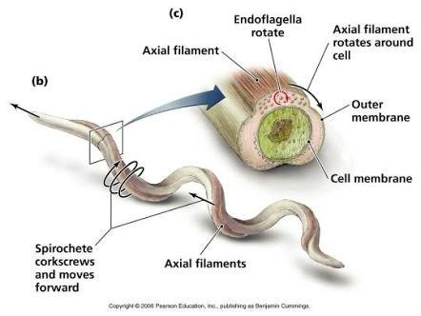

***TREPONEMA PALLIDUM* AND SYPHILIS**

**Morphology and Identification**

**A. Typical Organisms**: *T. pallidum* are **slender** spirals measuring about 0.2 μm in width and 5–15 μm in length. The spiral **coils** are **regularly** **spaced** at a distance of 1 μm from one another. The organisms are **actively** **motile**, rotating steadilyتدور بثبات around their endoflagella even after attaching to cells by their tapered endsنهايات مستدقة. The **long** **axis** of the spiral is ordinarily straight but may sometimes bendينحني so that the organism forms a complete circle for moments at a time, returning then to its normal straight position. The spirals are so **thin** that they are not readily seen unless **immunofluorescent** stain or **dark**-**field** illumination is used. They do not stain well with **aniline** **dyes**, but they can be seen in tissues when stained by a **silver** **impregnation** method.

**B. Culture** Pathogenic *T. pallidum* has never been cultured continuously on artificial media, in fertile eggs, or in tissue culture.

In proper suspending fluids and in the presence of reducing substances, *T. pallidum* may remain motile for 3–6 days at 25°C. In whole blood or plasma stored at 4°C, organisms remain viable for at least 24 hours, which is of potential importance in blood transfusions.

**Antigenic Structure**:

* The outer membrane
* The peptidoglycan–cytoplasmic membrane complex.
* Membrane proteins are present that contain covalently bound lipids at their amino terminals.
* The lipids appear to anchor the proteins to the cytoplasmic or outer membranes.
* The endoflagella are in the periplasmic space.
* *T. pallidum* has hyaluronidase.
* The endoflagella are composed of three core proteins that are homologous to other bacterial flagellin proteins plus an unrelated sheath protein.
* Cardiolipin is an important component of the treponemal antigens.

**Pathogenesis, Pathology, and Clinical Findings**

**Acquired Syphilis**:

* Natural infection with *T. pallidum* is limited to the human host.
* Human infection is usually transmitted by sexual contact, and the infectious lesion is on the skin or mucous membranes of genitalia.
* *T. pallidum* can probably penetrate intact mucous membranes, or the organisms may enter through a break in the epidermis.
* Spirochetes multiply locally at the site of entry, and some spread to nearby lymph nodes and then reach the bloodstream. Within 2–10 weeks after infection, a papule develops at the site of infection and breaks down to form an ulcer with a clean, hard base (“hard chancre”). e. t. c.

**B. Congenital Syphilis** A pregnant woman with syphilis can transmit *T.* *pallidum* to the fetus through the placenta beginning in the 10th–15th weeks of gestation.

**Diagnostic Laboratory Tests**

**A. Specimens**: Specimens include tissue fluid expressed from early surface lesions for demonstration of spirochetes by either dark-field microscopy or immunofluorescence; such specimens can also be tested by nucleic acid amplification. Blood can be obtained for serologic tests; cerebrospinal fluid (CSF) is useful for Venereal Disease Research Laboratory.

**B. Dark-Field Examination** A drop of tissue fluid or exudate is placed on a slide, and a coverslip is pressed over it to make a thin layer.

C. Immunofluorescence Tissue fluid or exudate is spread on a glass slide, air-dried, and sent to the laboratory.

**D. Serologic Tests for Syphilis** These tests use either nontreponemal or treponemal antigens.

