**Chlamydia**

Order: Chlamydiales

Family Chlamydiaceae.

They are:

* **obligate intracellular bacteria** (like viruses)
* require biochemical resources of eukaryotic host cells to fuel their metabolism for growth and replication.
* *Chlamydia* spp. are similar to Gram-negative bacilli in that they have **lipopolysaccharide** (LPS) as a component of the cell wall. The chlamydial LPS, however, has little endotoxic activity.
* They have a major outer membrane protein (MOMP) that is very **diverse**.
* Chlamydiae have a unique developmental **life cycle**,
* an **intracellular**, **replicative** **form**, the **reticulate** **body** (RB),
* an **extracellular**, **metabolically** **inert**, **infective** form, the **elementary** **body** (EB).

The EB **cannot** **live** long periods of time outside of a host cell. The EB **transforms** into an RB after infecting a host cell. **Within** **vacuoles**, the RB divides via **binary** **fission**. The vacuole **enlarges** and becomes an **intracytoplasmic** **inclusion** as the number of RB rises. The RB then **transform** **back** into EB, which are then discharged from the host cell **48** to **72** hours after infection. There is evidence that, in addition to the replicative cycle associated with acute chlamydial infections, Chlamydia can persist in **vitro** in an abnormal form.

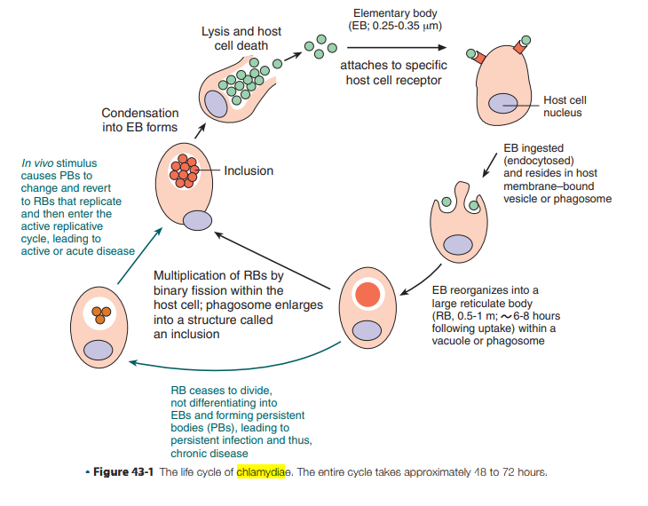

**Differential Characteristics Among Chlamydiae That Cause Human Disease**

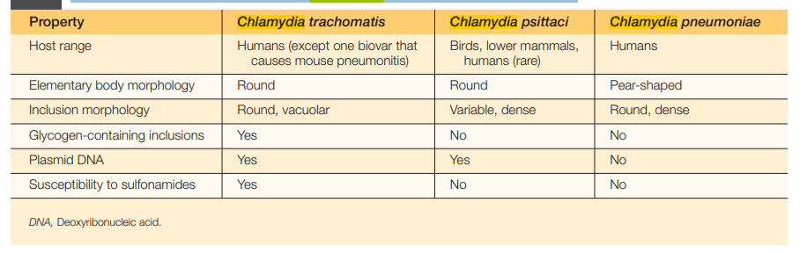

***Chlamydia* *trachomatis***

**General Characteristics** *C. trachomatis* infects humans almost exclusively and is responsible for various clinical syndromes. Based on major outer membrane protein (MOMP) antigenic differences, *C. trachomatis* is divided into **18** different **serovars** that are associated with different primary clinical syndromes.

**Spectrum of Disease**

* **Trachoma** is manifested by a **chronic** **inflammation** of the **conjunctiva** and remains a major cause of preventable blindness worldwide.
* **Lymphogranuloma** **venereum** (LGV) is a sexually transmitted disease.
* **Oculo-genital** **Infections** *C. trachomatis* can cause acute inclusion conjunctivitis in adults and newborns. The organism is acquired when contaminated genital secretions get into the eyes via fingers or during passage of the neonate through the birth canal.
* **Perinatal** **Infections** Approximately one fourth to one half of infants born to females infected with *C. trachomatis* develop inclusion conjunctivitis. Usually, the incubation period is 5 to 12 days after birth, but it may be as long as 6 weeks

**Laboratory Diagnosis**

1. **Indirect method:** **Culture**: Several different **cell lines** have been used to isolate *C. trachomatis* in cell culture, including **McCoy,** **HeLa**, and **monkey** **kidney** cells; **cycloheximide**-treated McCoy cells are commonly used. After shaking the clinical specimens with 5-mm glass beads, centrifugation of the specimen onto the cell monolayer (usually growing on a coverslip in the bottom of a vial, commonly called a “shell vial”) facilitates adherence of elementary bodies. After 48 to 72 hours of incubation, monolayers are stained with a fluorescein labeled monoclonal antibody.
2. **Direct Detection Methods**

* **Cytologic Examination**. Cytologic examination of cell scrapings from the conjunctiva of newborns or persons with ocular trachoma can be used to detect *C. trachomatis* inclusions, usually after Giemsa staining.
* **Antigen Detection and Nucleic Acid Hybridization**. To circumvent the shortcomings of cell culture, antigen detection methods are commercially available.