**Mycoplasma**

Mycoplasmas are the smallest prokaryotes capable of binary fission, and they grow, albeit slowly, on inanimate media. There are more than 200 species of these cell wall-free bacteria considered to be parasite living within eukaryotic cells. They cause both human and animal diseases and are normal commensals of the human mucous membranes, including the oral cavity.

**Characteristics of Mycoplasma**

1. Not seen with Gram stain because it lacks peptidoglycan cell wall
2. Plastic , pleomorphic shape (neither rods nor cocci)
3. Cell membrane is a sterol- containing lipid bilayer
4. Colonies may have fried egg appearance
5. Rarely cultured for diagnostic purposes .

**Mycoplasma pneumoniae , causes:**

* **Primary atypical pneumonia**

Primary atypical pneumonia ( lower respiratory tract disease ) takes the form of fever, non-productive cough, severe headache, weakness and tiredness; it is an important cause of community-acquired pneumonia. The acute illness lasts for about 2 weeks, but in a majority, the symptoms last longer.

M. pneumoniae may cause skin rashes and ulcerations of both the oral and vaginal mucosa. These appear as maculopapular, vesicular or erythematous eruptions. The skin lesions, which often affect the extremities, have a target or iris appearance (target lesions). In the oral mucosa, erythematous patches may appear first, quickly becoming bullous and erosive. This leads to extensive blood encrustations, especially the labial lesions. When the oral ulceration is associated with the skin rash and conjunctivitis,

* **mucocutaneous eruptions, including the oral mucosa**
* **haemolytic anaemia.**

**Virulence factors:**

* P1 membrane-associated protein ( pneumoniae)
* Movement of cilia ceases (ciliostasis)
* Peroxide and superoxide
* Superantigen ( pneumoniae)

**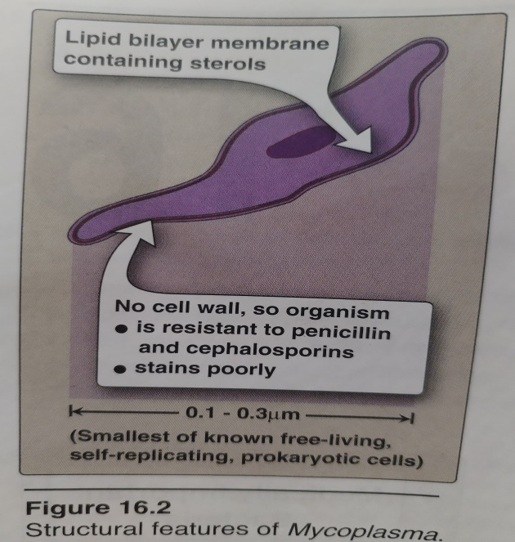**

**Laboratory identification**

* Direct microscopic examination of clinical material for *M.pneumoniae* of limited value.
* Sputum samples or throat swabs can be cultured on special media , isolation of the organism usually requires eight to fifteen days .
* Serologic tests .

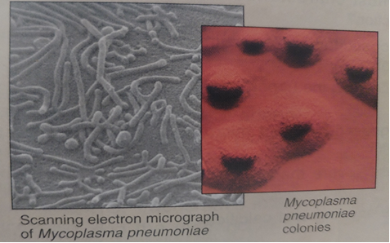

**Rickettsia**

Rickettsiae are coccobacilli smaller but similar to Gram- negative bacteria resembling them structurally and metabolically; they do not stain with Gram stain. They, like Chlamydia and viruses, are obligate intracellular parasites. The best-known human rickettsial disease is typhus, which spreads wildly in conditions of malnutrition and poverty.

**Characteristics of Rickettsia**

1. Small ,rod-like or coccobacillary , with a multilayered outer cell wall resembling that of Gram- negative bacteria
2. able to infect many species, including arthropods, birds and mammals; members of the genus are transmitted to humans via bites of infected arthropods
3. obligate intracellular parasites , grow only inside living host cell
4. visible by light microscope when stains are used (e.g., Giemsa)
5. Doxycycline is the drug of choice for treatment

**Rickettsial diseases**

|  |  |
| --- | --- |
| 1. Typhusan acute febrile illness, now rare, with a maculopapular rash transmitted by the rat flea; the fatality rate is frequently high as a result of haemorrhagic complications 2. spotted fevers Rocky Mountain spotted fever and other tick-borne fevers. 3. Louseborne (epidemic ) typhus | .trashed-1706458385-IMG_20231229_190832 |

**Laboratory identification**

* Not routinely culture because of obligate intracellularity
* Serological Test
* Detected by immunofluorescence or histochemical procedures on some clinical samples.

