**Lecture two: Anticoagulants used in hematology laboratory**

Anticoagulants are the Chemical substances that prevent the blood from clotting when mixed with inappropriate concentration with the Blood Specimen. ***Anticoagulant materials in the laboratory Uses***:

Every anticoagulant is added in fixed proportion to blood

-They used for obtain plasma.

-Its uses only in vitro (outside of the body).

-They are toxic

**Action:** their act to stop blood-clotting mechanism in vitro.

**Common Anticoagulant Materials**

The common anticoagulant materials, which used in the daily lab’s work for hematological purposes, some are the following:

1. EDTA= (Ethtylene diamine tetra-acetic acid)
2. Sodium Citrate: (Na3C6H507.2H20)
3. Buffered citrate (sodium citrate and citric acid)
4. Heparin. And Wintroub
5. Oxalates
6. Sodium floride

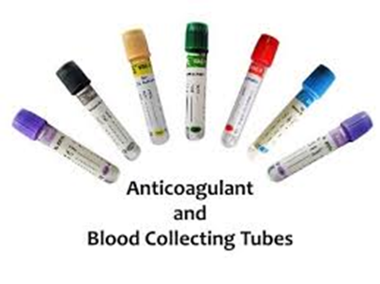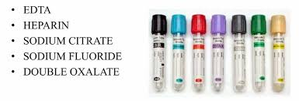

**VARIOUS TYPES OF ANTICOAGULANTS WITH VACUTAINER COLOR CODES**

**1.EDTA – ETHYLENE DIAMMINE TETRAACETIC ACID**

**EDTA Is a standard hematology anticoagulant because of its**

* very effective and complete anticoagulation
* lack of effect on the size (morphology) or number of blood cells in the specimen.

**Mechanism of action of EDTA :** This anticoagulant removes free calcium ions, which is essential for coagulation by chelating them .It is effective when used as about 1.2 mg/ml of blood.

**Advantages of EDTA**

* It gives better preservation to the cellular morphology of blood cells when observed even after 3 hours of blood collection.
* It can be used for platelets counting as it inhibits the clumping of platelets.
* Uses of EDTA : Following tests are commonly done by using EDTA as an anticoagulant –

1. Complete Blood Count (CBC),
2. PBS ,
3. Platelet count,
4. Red cell Indices, Hemoglobin estimation, Hematocrit or Packed Cell Volume estimation Differential Leukocyte Count,
5. ESR by wintrobes method
6. and HbA1C test

**Disadvantages of EDTA**

* Not used for coagulation studies because it destroys factor V and VIII.(as it chalets calcium)
* Occurs Platelets sataletism with neutrophils
* Occurs Platelet aggregation
* Excess of EDTA in the blood may lead to shrinkage of RBCs & WBCs. , degenerative changes in the blood cells,decrease in Packed Cell Volume (PCV) & Increase in MCHC (Mean Cell Hemoglobin Concentration).
* It activates naturally occurring anti-platelet auto-antibodies which cause the platelet adherence to Neutrophils.

**2**. **TRI-SODIUM CITRATE**

**Sodium Citrate Chemical Action**:

-The anticoagulant removes the free Calcium ions by binding to them to form calcium citrate complex.

**Sodium Citrate USES**  OR ( Advantiges):

1. The anticoagulant of choice in coagulation studies. **PT, TT and PTT**
2. ESR by Westergren Method

**Sodium Citrate Disadvantiges:**

**Citrated blood cannot be used for Packed Cell Volume (PCV), Hemoglobin (Hb) Estimation, Total Leukocyte Count TLC, and Differential Leukocyte Count (DLC) because citrate is used as a solution and it alters the concentration of blood.**

**3.** **BIOLOGICAL / NATURAL ANTICOAGULANT – HEPARIN**

1. **an excellent natural anticoagulant**
2. **sources extracted from mammalian liver or pancreas.**
3. **more expensive than the artificial ones and has a temporary effect of only 24/ hours.**
4. **Prevents clotting by inactivating thrombin, thus preventing conversion of fibrinogen to fibrin.**
5. **used in the proportion of 0.1-0.2mg of the dry salt for 1ml of blood.**
6. **Heparin does not alter the size of the red cells;**
7. **The heparinized blood specimen is commonly used to Blood sample without hemolysis , blood gases especially the Arterial Blood Gas Analysis, Erythrocyte Sedimentation Rate (ESR), Red cell enzyme estimation , Packed Cell Volume (PCV), Osmotic Fragility Test (OFT), Immunophenotyping and other Hematological tests**
8. **Not recommended for cell counting because of its clumping effect on platelets leucocytes**

**4. OXALATES**

They can be used as **Single oxalates** as Sodium Oxalate or Potassium Oxalate or Ammonium oxalate but are commonly used as **Double Oxalates** because when used alone the **Potassium oxalate**, when used at a concentration of 2mg/ml of blood causes the Shrinkage of Red Blood Cells (RBCs) whereas the **Ammonium oxalate** may cause the Swelling of Red blood cells when used at concentration of 2mg/ml.

**Oxalates – Mechanism of Action**

It acts as a **chelating agent** and binds with the calcium ions present in the blood and forms **insoluble precipitates of Calcium Oxalates.**

*Remember that the Potassium oxalate and Ammonium Oxalate should be used in a ratio 2:3 and at a concentration of 2mg/ml of blood.*

**Uses of Oxalates :** It can be used for the Blood chemistry, Packed cell volume (PCV), Erythrocyte Sedimentation Rate (ESR), Total Leukocyte Count (TLC), Specific gravity etc.

1. **SODIUM FLUORIDE:**

It is the anticoagulant of choice for the estimation of blood sugar.



