Lacture 3

***Endocrine system:***

**Is the collection of glands with internal secretion that produce hormones**.

The endocrine system affects almost every organ and cell in the body.

***Hormones:***

Biologically active molecules that regulate metabolism, growth and development, tissue function, sexual function, reproduction, sleep, and mood, among other things.

**Types of the endocrine system:**

The endocrine system is made up of the: [pituitary gland](https://www.livescience.com/58885-pituitary-gland.html).

1. [Thyroid gland](https://www.livescience.com/58771-thyroid-gland-facts.html).
2. [Parathyroid glands](https://www.livescience.com/58980-parathyroid-glands.html).
3. [Adrenal glands](https://www.livescience.com/59039-adrenal-glands.html).
4. [Pancreas](https://www.livescience.com/44662-pancreas.html).
5. [Ovaries (in females)](https://www.livescience.com/54922-what-is-ovulation.html) and [testicles (in males)](https://www.livescience.com/58838-testicle-facts.html).

**The mechanism of action of hormones:**

For the hormone to reach its specific effect the presence of **receptors on the cells of the target tissue** is required. The presence or absence of specific receptors is responsible for ensuring that the effect of the hormone is **targeted**. If the cell does not express the receptor, it cannot respond to the presence of hormone even at un physiologically high concentrations. Conversely if the cell has expressed the receptor, it specifically reacts even at a very low concentration.

The location of the receptor depends on the **nature of the hormone**. We distinguish three types of receptors:

1. **Membrane receptors**.
2. **Cytoplasmic receptors**.
3. **Nuclear receptors.**

**Pituitary gland :**

This is the "**master" gland** of the endocrine system. It uses information it gets from the

brain to "tell" other glands in the body what to do.

It makes many different important hormones, including:

1- **Growth hormone** (GH ,or somatotropin).

This hormone promoting overall tissue and organ growth. Some of growth hormone’s actions, including growth of cartilage and bones and protein synthesis in muscles

1. **Thyroid-stimulating hormone** (TSH, or thyrotropin).TSH stimulates the thyroid gland to produce and secrete thyroxine (tetraiodothyronine, or T 4) and triiodothyronine (T 3).
2. **Adrenocorticotropic hormone** (ACTH, or corticotropin).
3. Follicle-stimulating hormone (FSH, or folliculotropin).

FSH stimulates the growth of ovarian follicles in females and the production of sperm cells in the testes of males.

**Luteinizing hormone** (**LH**,or luteotropin).This hormone and **FSH** are collectively called **gonadotropic hormones**.

**In females**, **LH stimulates ovulation** and the conversion of the ovulated ovarian follicle into an. **In males, LH stimulates the secretion of male sex hormones** (mainly testosterone)

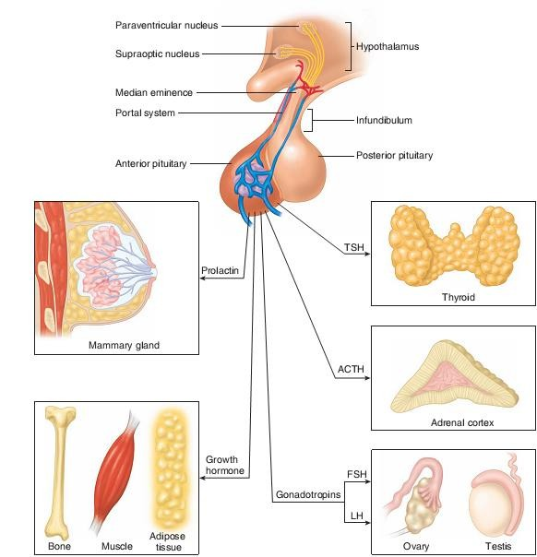

1. **Prolactin** (**PRL**).This hormone is **secreted in both males and females**. Its best known function is the **stimulation of milk production by the mammary glands of women after the birth of a baby.**

**Adrenal glands:**

The adrenal cortex and adrenal medulla are structurally and functionally different.

**The adrenal medulla:**

**secretes catecholamine hormones, which complement the sympathetic nervous system in the “fight-or-flight” reaction.**

**The** adrenal cortex:

**secretes steroid hormones that participate in the regulation of mineral and energy balance**.

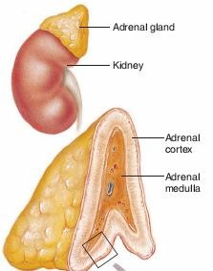

**Pancreas and other endocrine glands:**

The pancreatic islets secrete two hormones:

1. insulin which promotes the lowering of blood glucose and the storage of energy in the form of glycogen
2. Glucagon has antagonistic effects that raise the blood glucose concentration. The pancreas is both an endocrine and an exocrine gland.

The gross structure of this gland and its exocrine functions in digestion. The endocrine portion of the pancreas consists of :

**scattered clusters of cells called the pancreatic islets or islets of Langerhans**.

The human pancreas contains approximately one **million islets**, which are most common in the body and tail of the pancreas.

**Pancreatic Islets (Islets of Langerhans**) :

On a microscopic level, the most conspicuous cells in the islets are the **alpha** and **beta**

cells .

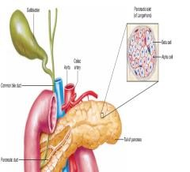

**The alpha cells secrete the hormone**



**The beta cells secrete insulin**. A human islet contains about 50% beta cells, **35% to 40% alpha cells**, and **10% to 15% delta cells,** which secrete the hormone somatostatin.

**The effect of insulin hormone:**

Insulin is the only hormone that acts to lower the blood glucose concentration.

After a **carbohydrate** meal or sugary drink, **the plasma glucose level rises**.

* 1. This rise in plasma glucose stimulates the **beta cells** of the islets to **secrete increased amounts of insulin**.
  2. Insulin then binds to its receptors in the plasma membrane of its **target cells**.
  3. Through the action of signaling molecules, causes intracellular vesicles containing GLU T4 carrier proteins to translocate to the plasma membrane.
  4. These carrier proteins promote the facilitated diffusion of glucose into the cells of insulin’s tar-get organs—primarily the skeletal muscles, liver, and adipose tissue.
  5. Insulin indirectly stimulates the activity of the enzyme glycogen synthetase in skeletal muscles and liver, which promotes the conversion of intracellular glucose into glycogen. Insulin thereby causes glucose to leave the plasma and enter the target cells, where it is converted into the energy storage molecules of glycogen (in skeletal muscles and liver) and fat (in adipose tissue).

**Glucagon:**

Secreted by the alpha cells of the pancreatic islets, acts antagonistically to insulin-it promotes effects that raise the plasma glucose concentration. Glucagon secretion is stimulated by a fall in the plasma glucose concentration and insulin secretion that occurs when a person is fasting. Under these conditions, glucagon stimulates the liver to hydrolyze glycogen into glucose (a process called glycogenolysis), allowing the **liver to secrete glucose** into the **blood**.