**Grammar: Present Continuous (Unit 2)**

**Focus: Actions happening now.**

**Vocabulary: Actions and Activities (Unit 2)**

**Reading: "Simple or Continuous?" (Unit 2)**

**Unit 4**

**4.1 Starter**

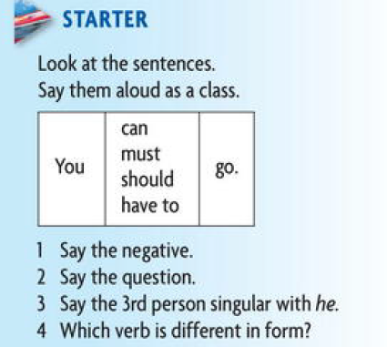

**4.2 Grammar  
4.2.1 Grammar Spot**   
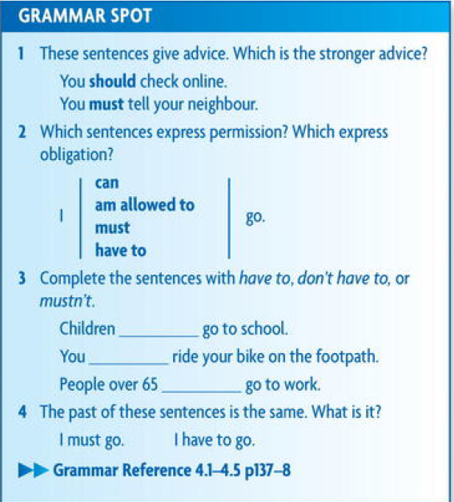

**4.2.2 Reader Replay**

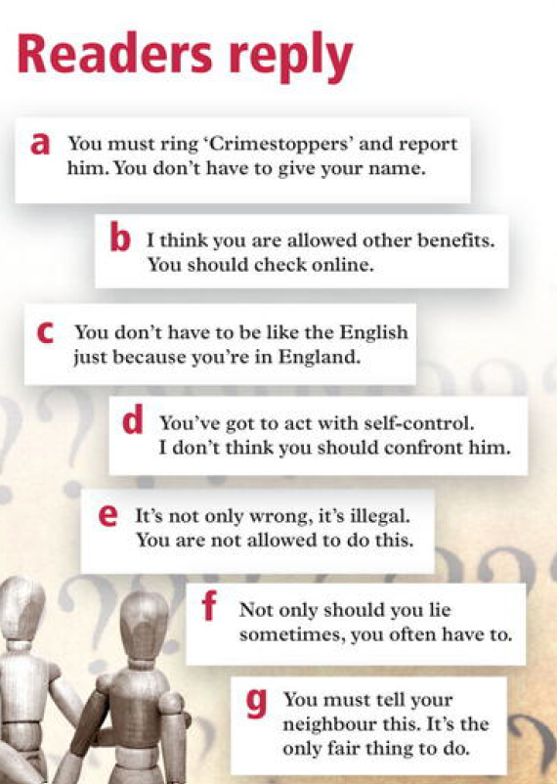

**4.2.3. Discussing Grammar**   
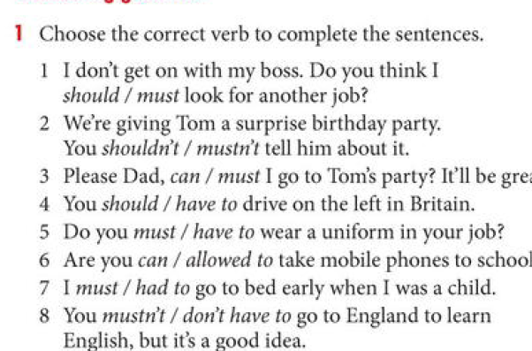

**Answers**   
Discussing grammar  
1 . I don't get on with my boss. Do you think ?

should look for another job?

2. We're giving Tom a surprise birthday party.

You mustn't tell him about it.  
3 . Please Dad, can I go to Tom's party? It'll be great.

4 . You have to drive on the left in Britain.

5. Do you have to wear a uniform in your job?

6. Are you allowed to take mobile phones to school?

7 . I had to go to bed early when I was a child.

8. You don't have to go to England to learn English,

but it's a good idea.

**4.3 Spoken English**

**SPOKEN ENGLISH Have got to**  
1. Have got to means the same as have to but is used more in spoken English.

Look at these examples from Millie, Richard, and Frank.  
 They've got to employ bodyguards.  
 You've got to give meaning to life by what you do.

You've got to look for the good in people.  
  
2. Complete the conversations with 've got to /'s got to.

1. 'Isn't your mum away at the moment?

" Yeah, so Dad 's got to " do all the cooking.

2. Where's my briefcase? I------------- go to work >   
 It's where you left it. In the hall.

3. 'Mum, why can't I go out now?

" You -------------- tidy your room first.

4. " Won't you be late for work?  
 " Oh, goodness. Look at the time. I -------------------------------- go now. Bye!"

**4.4. Literal and idiomatic meaning   
4.4.1**

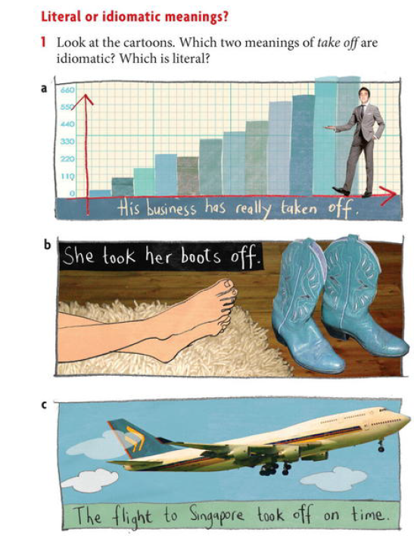

**4.4.2 other idiomatic and literal   
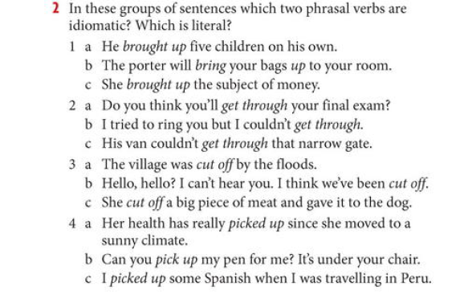**

**4.4. 3**Complete the phrasal verbs in the questions with one of the words in the box. Then ask and answer the questions with a partner.  
**with up to after**1 . Who do you take -------------------------- in your family?  
2. Do you get on well -------------------------- both your parents?  
3. Have you recently taken --------------------- any new sports or hobbies?

4. Do you often look ----------------------- words in your dictionary?  
5. Are you looking forward, ------------------ going on holiday soon?  
6 . Do you pick ----------- foreign languages easily?  
7. Have you got any bad habits that you  
want to give ?

**Answers**   
Phrasal verbs  
1 . A / Who do you take after in your family?

B /Mmm... I don't think I take after anyone in

particular. Mind you the older I get, the more I think I'm like my mother. Humh...!  
2. A / Do you get on well with both your parents?

B / Yes, I do. Most of the time. I do a lot of stuff with my dad. Football and things  
3 . A / Have you recently taken up any new sports or hobbies?  
 B / Me? No! My life's too busy already!  
4 . A / Do you often look up words in your dictionary?  
 B / Sometimes, if I'm really stuck.  
5 . A / Are you looking forward to going on holiday soon?  
 B / I wish! I've just been on holiday so I've got to wait till Christmas now.  
6 . A / Do you pick up foreign languages easily?

B / Well, I picked up Italian quite easily when I was living in Milan but I already knew French, so I think that helped a bit.  
7. A / Have you got any bad habits that you want to give up?

B/ Yes, I bite my nails. I just can't stop and I'm a teacher so I have to hide my hands from the kids 'cos I don't want to set a bad example.

**4.5 Every day English   
Polite request and Offers   
- Match the lines in A with the line in B , who is talking to who?   
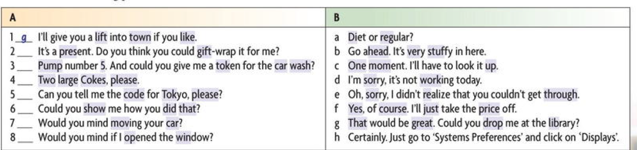**

**4.6 Writing : Mother Teresa   
4.6.1 Read the Early years of Mother tTresa and then compare sentences in column A with Column B**

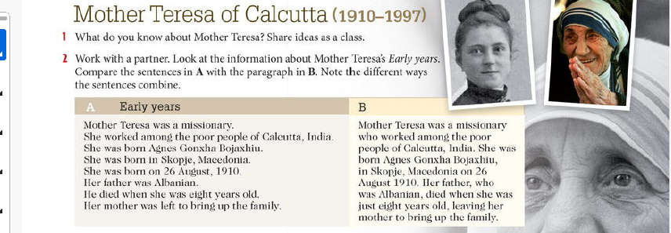

**4.6.2 Read sentences in column A to complete the paragraph in B  
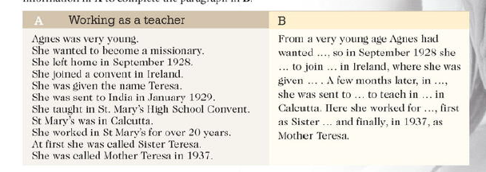**

**4.7. Homework no. 4   
4.7.1 Read the following text about Lasers and answer below questions :  
1. Read this text to check your answers to Task 1.  
Lasers (Light Amplification by Stimulated Emission of Radiation)**

are devices which amplify light and produce beams of light which

are very intense, directional, and pure in colour. They can be solid

state, gas, semiconductor, or liquid.  
5. When lasers were invented in 1960, some people thought they

could be used as 'death rays'. In the 1980s, the United States

experimented with lasers as a defence against nuclear missiles.

Nowadays, they are used to identify targets. But apart from military

uses, they have many applications in engineering.

**10. communications, medicine, and the arts**.  
  
In engineering, powerful laser beams can be focused on a small

area. These beams can heat, melt, or vaporize material in a very

precise way. They can be used for drilling diamonds, cutting

complex shapes in materials from plastics to steel, for spot welding

15. and for surfacing techniques, such as hardening aircraft engine

turbine blades. Laser beams can also be used to measure and align

structures.  
Lasers are ideal for communications in space. Laser light can carry

many more information channels than microwaves because of its

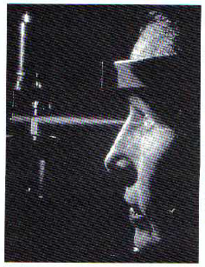20. high frequency. In addition, it can travel long distances without  
losing signal strength. Lasers can

also be used for information

recording and reading. Compact

discs are read by lasers.  
25. In medicine, laser beams can treat

damaged tissue in a fraction of a

second without harming healthy

tissue. They can be used in very

precise eye operations.  
In the arts, lasers can provide

fantastic displays of light. Pop

concerts are often accompanied by

laser displays.

**2. Complete this table of laser applications using information from the text opposite. You may also add any applications you know of which are not included in the text.**  
**Engineering Communications Medicine Arts**  
  
drilling diamonds treating damaged tissue  
cutting complex information  
shapes recording and reading

**3. Put each of these examples in the correct column.**  
carbon blocks a power tool  
aluminium alloy a ball bearing  
carbon fibre a concrete beam   
a gas burner a diesel boat  
roller bearings a spring balance  
a circuit board a plastic tube  
a plastic pipe steel sheets  
magnesium alloy

|  |  |  |
| --- | --- | --- |
| **uses** | **is made of** | **contains** |
|  |  |  |
|  |  |  |
|  |  |  |
|  |  |  |
|  |  |  |
|  |  |  |
|  |  |  |
|  |  |  |