1

**[ Toturial Sheet ]**

**Q1. The maximum peak-to-peak voltage of an AM wave is 16 mV and the minimum peak-to-peak voltage is 4 mV. Calculate the modulation factor.**

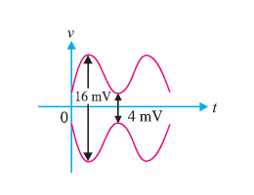

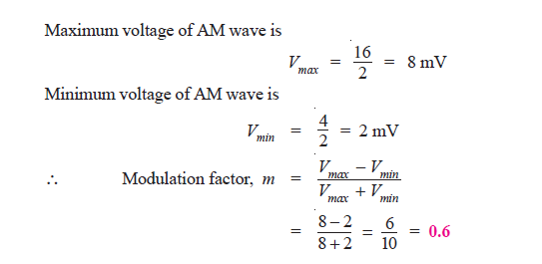

**Q2. A carrier of 100V and 1200 kHz is modulated by a 50 V, 1000 Hz sine wave signal. Find the modulation factor.**



**Q3. An AM wave is represented by the expression :**  
**[ v = 5 (1 + 0.6 cos 6280 t) sin 211 × 104 t volts ]**  
**(i) What are the minimum and maximum amplitudes of the AM wave?**  
**(ii) What frequency components are contained in the modulated wave and what is the amplitude** **of each component?**

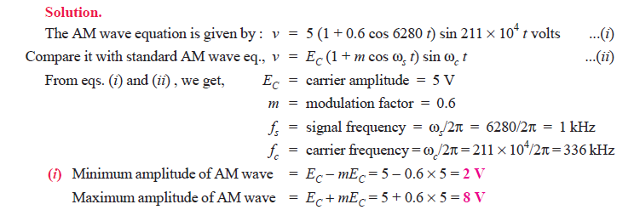

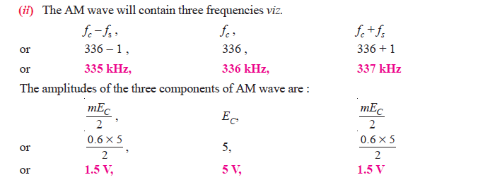

**Q4. A sinusoidal carrier voltage of frequency 1 MHz and amplitude 100 volts is amplitude modulated by the sinusoidal voltage of frequency 5 kHz producing 50% modulation. Calculate the frequency and amplitude of lower and upper sideband terms.**

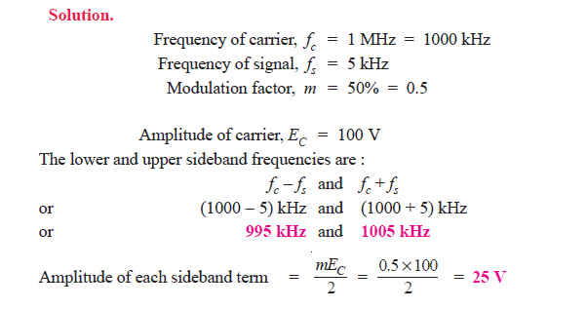

**Q5.A carrier wave of frequency 10 MHz and peak value 10V is amplitude modulated by a 5- kHz sine wave of amplitude 6V. Determine (i) modulation factor (ii) sideband frequencies and (iii) amplitude of sideband components. Draw the frequency spectrum.**

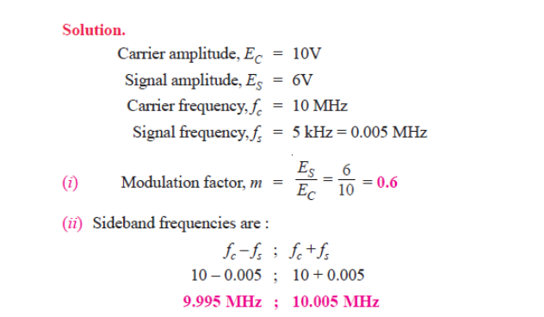

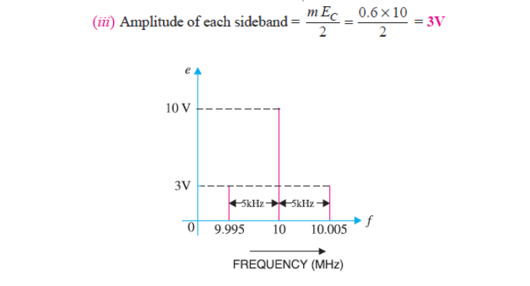

**Q6. A carrier wave of 500 watts is subjected to 100% amplitude modulation. Determine :** **(i) power in sidebands (ii) power of the modulated wave.**

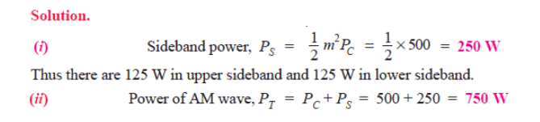

**Q7. A 50 kW carrier is to be modulated to a level of (i) 80% (ii) 10%. What is the total sideband power in each case ?**

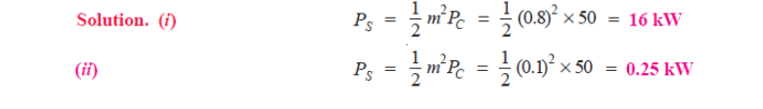

**Q8. A 40kW carrier is to be modulated to a level of 100%.**  
**(i) What is the carrier power after modulation?**  
**(ii) How much audio power is required if the efficiency of the modulated RF amplifier is 72%?**

**Solution :** (i) Since the carrier itself is unaffected by the modulating signal, there is no change in the carrier power level.

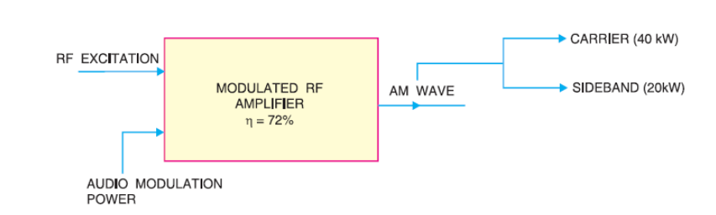

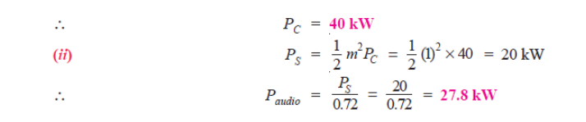

**Q9. An audio signal of 1 kHz is used to modulate a carrier of 500 kHz. Determine (i) sideband frequencies (ii) bandwidth required.**

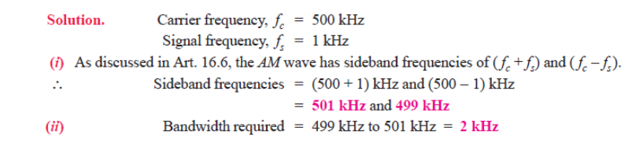

**Q10. The load current in the transmitting antenna of an unmodulated AM transmitter is 8A. What will be the antenna current when modulation is 40%?**

