**Analog Communication**

**Second Stage**

**2024-2025**

**Experiment No. : 1**

**Experiment Name:**

**Amplitude Modulation And De-modulation**

M.Sc. Aya Althahab Eng. Zainab Fhayer

*Amplitude Modulation and Demodulation*

## Object :

To Study an amplitude modulated signal, Comparing the modulated signal and the demodulated wave envelope.

## -Tools :-

Computer by using **Maltisim** program

- function generator , resistor , capacitor , channel oscilloscope , divider , multiplier summer , DC-power

**THEORY:**

Amplitude modulated signal can be represented by the following equation:

V (t)= Vc (1+ Vm (t)) COS Wc t

Where Vm (t) is the message signal that is modulating the carrier Vc COS Wct . For simplicity, let us assume that the message signal is a monotone given by the following equation:

Vm (t)= Vm COS Wmt

The amplitude modulated signal can now be written

as: V (t)=Vc(1+Vm COS Wm t) COS Wct

=Vc COS Wc t +Vc Vm /2 {COS(Wc-Wm)t+ COS(Wc+Wm)t}

The following figure shows the modulated signal in both time and frequency domains.

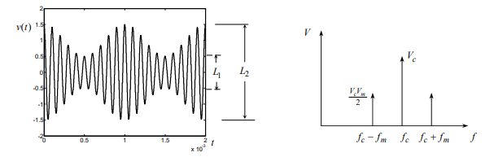

Amplitude Modulation is the process of changing the amplitude of the radio frequency (RF) carrier wave by the amplitude variations of modulating signal”

The carrier amplitude varied linearly by the modulating signal which usually

consists of a range of a audio frequencies. The frequency of the carrier is not

affected

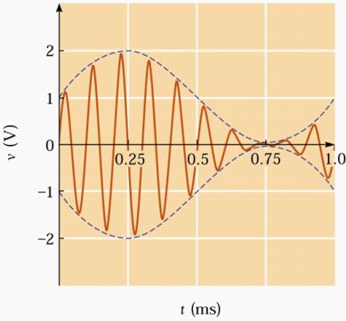

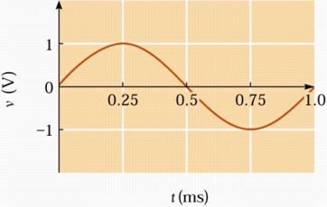 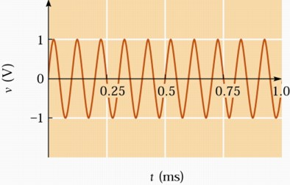

**Demodulation** is the reverse process (to modulation) to recover the message signal *m*(*t*) or *d*(*t*) at the receiver.

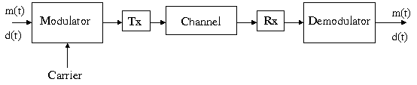

1. **Fundamentals of Analog Communications**

Analog Communication is an information transmitting mechanism, i.e. music, voice, and video using broadcast radio, or cellular radio, and broadcast television. The significant invention made by Marconi in 1895 was a radio. Later, the foundation of Trans-Atlantic Communication Systems had been taken place. Although digital communications systems are much more efficient, cost-saving, more reliable, some communication systems are still analog.

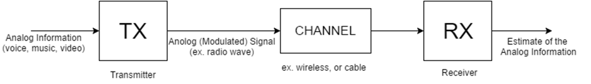

**Figure 1: Basics of Analog Communications**

Analog communication techniques can be summarized as:

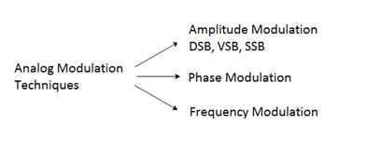

**figure 2: Analog Modulation Techniques**

### Demodulation

For AM demodulation, we will examine the Square-Law and Envelope Detector techniques.

### Demodulation by Squaring

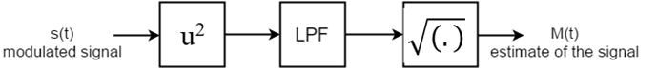

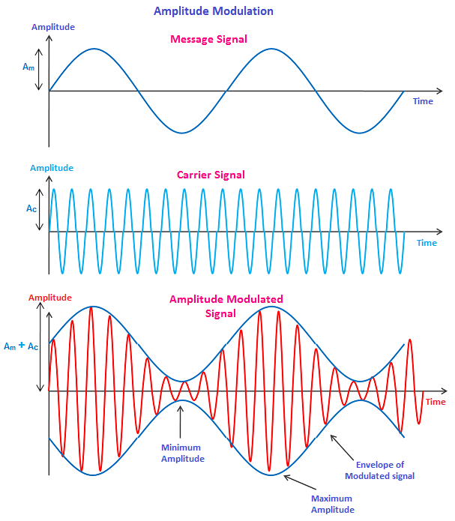

**Practical Part :**

By using **MULTISIM** connect the circuit of Amplitude Modulation show in a figure (1&2)

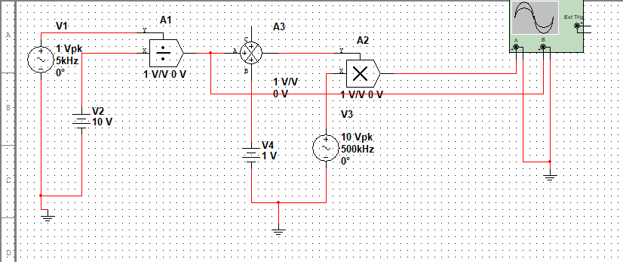

**(1)**

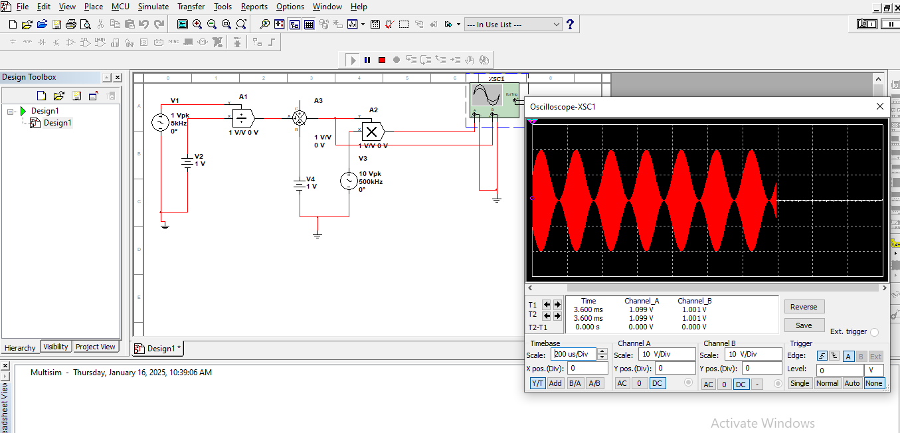

**(2)**

**Amplitude Demodulation**

