**Phonetics and Phonology**

**Assistant lecturer . Estabraq Waleed AL-Rikabi**

**The organs of speech**

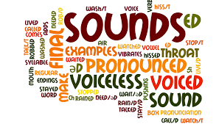

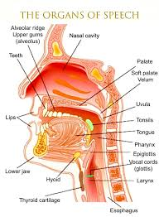

**The organs of speech**

The organs of speech (articulators)are classified in to two groups according to their movement.

1. **Movable (Active/Non-stationary)organs.**

1. Tongue

2. Lips

3. Soft palate (Velum)

4. Vocal folds

1. **immovable (Passive/ Stationary) organs**

5. Teeth

6. Alveolar ridge

7. Hard palate

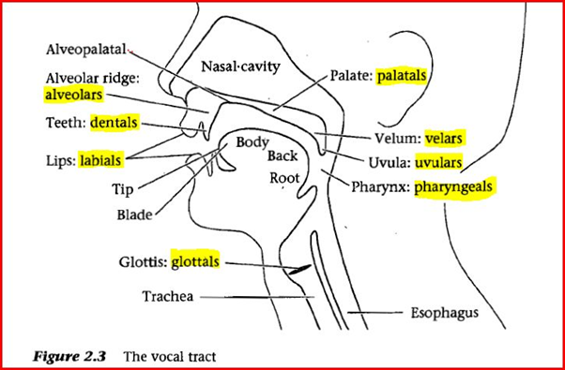

**The Tongue**

The tongue is the most important organ of speech because:

1. It has the greatest variety of movement.

2. It takes part in the production of most of the sounds, since it is made of muscles which help to produce sounds by their movement forwards, backwards, up and down.

**Parts of the tongue:**

1. Tip

2. Blade

3. Front

4. Back

5. Root

**Functions of the tongue**

1. It is used to produce consonants either by blocking or by narrowing the air stream through which the air has to go

**For example** **/k, g/**are produced by blocking the air stream, while**/ s, z /** are produced by narrowing the air stream.

1. It is used to produce vowels by raising or lowering the front and the back of the tongue to alter the shape of the mouth.

**The Lips**

They are moveable organs of speech which include the upper and lower lips. Lips can take the following positions to produce

the sounds mentioned:

1. Closed /p, m,b/
2. Spread /I, i:/
3. Neutral / e, 3:/
4. Open /o:/
5. Open rounded /0/
6. Close rounded / o:/
7. Lip-Teeth / f, v/

***Functions of the lips***

They are used to produce :

1. The consonants /p,m,b/ by closing the lips tightly.

And /w/ by bringing the lips close enough , to narrow the air passage.

1. The fricatives /f,v/ by putting the lower lip very close to the upper front teeth.
2. The rounded vowels /u, u: , ɒ , ɔ:/ and the

Unrounded vowels /æ , е , ɪ , i: , ʌ , ə , ʒ:/

1. The sounds /æ , а:/ by opening the lips widely

***The palate***

It is the roof of the mouth. It consists of the:

1. Alveolar ridge
2. Hard palate
3. Soft palate ( velum)
4. **The Alveolar Ridge**

It is that part of the gum, immediately behind the upper front teeth. It is an immovable organ of speech. It is important in producing consonants such as: /l,d,n,t,s,z/

**Functions of the Alveolar ridge:**

1. It serves as a point of contact with the tip or blade of the tongue to produce: /I,d, n,t/.
2. B. It serves as a point where the breath stream is narrowed by the tip and blade of the tongue to produce: [5,2,1,3/.
3. **The hard palate**

It is that part which comes immediately after the alveolar ridge. It is an immovable and bony area. It is used to produce the sounds: /ʃ.Ʒ.ʧ,ʤ /.

**Functions of the Hard palate:-**

It is used to narrow the air passage, by raising the front of the tongue, to a point near the hard palate to produce: /ʃ.Ʒ,ʧ,ʤ/.

1. **The Soft Palate**

It is that organ of speech that comes at the end of the oral cavity, immediately after the hard palate. It is movable; it can be raised or lowered. If raised, it closes the way to the nasal cavity and forces the air to the oral cavity. lf lowered, it forces the air to go to the nasal cavity. The consonants produced in this area are:/ k,ŋ,g/.

**Functions of the Soft palate:**

1. It serves as a point of contact with the back of the tongue to produce :/ k,ŋ, g/.
2. When we lower the soft palate, it touches the back of the tongue, so the air is forced to go to the nasal cavity to produce the nasal sound/ ŋ/.
3. When we raise the soft palate, it touches the back wall of the pharynx, and it forces the air to go to the oral cavity to produce all consonants except / m,n,ŋ/.

***The vocal folds***

They are two small bands of elastic tissue, extending horizontally across the width of the larynx. The space between the vocal folds is called the glottis, Thus they can take up several positions.

***The Teeth***

They are immovable organs of speech.

The lower teeth are not important in speech, except that if they are missing, certain sounds like/ s, z/ will be difficult to make.

The upper front teeth have the following functions:

1. Producing /ð,ϴ/ by bringing the tip of the tongue near the upper front teeth to narrow the air passage.
2. Producing / f,v/ by bringing the lower lip very close to the upper front teeth to narrow the air passage