Al-Mustaqbal University

College of Administrative Sciences

Department of Business Administration

(1st class)

مادة اللغة الانكليزية

Iltifat Al-Husseini

(Tenses )

***Tenses***

Tenses are a fundamental aspect of grammar that help convey the timing of actions or events. Understanding how to use tenses properly is crucial for effective communication, as it allows speakers and writers to express time-related details clearly. They refer to the way verbs are used to indicate the time of an action or event. They show whether an action happens in the present, the past, or the future. Tenses also tell us if the action is complete, ongoing, or habitual.

***Main Aims of Tenses:***

The primary aim of tenses is to show when an action or event takes place — whether in the past, present, or future.

Tenses help convey whether an action is ongoing, completed, or habitual. This helps provide clarity about whether something is in progress, has already finished, or regularly happens.

Correctly using tenses ensures that the listener or reader can easily grasp the temporal context, leading to better understanding of the message being conveyed

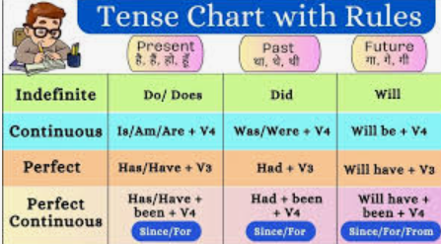

Present tense: Describes actions happening now or regularly. (e.g., She eats lunch every day.)

Past tense: Describes actions that have already happened. (e.g., She ate lunch yesterday.)

Future tense: Describes actions that will happen. (e.g., She will eat lunch tomorrow.)

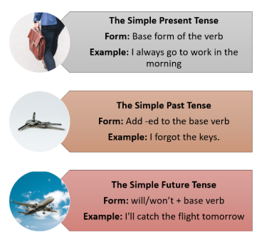

1-Complete the text, using the verbs in the table.

|  |  |  |  |  |
| --- | --- | --- | --- | --- |
| ‘m enjoying A | 'm going to B | Live C | Started D | Come E |
| 'm studying F | Can G | Speak H | Went K |  |

1. My name's Maurizio Celi. I **'m from** Bologna, a city in the north of Italy. I'm a student at the University of Bologna.
2. I **'m studying** modern languages - English and Russian. I also know a little Spanish, so I **can** speak four languages.
3. I **'m enjoying** the course a lot, but it's really hard work.
4. The course **started** three years ago.
5. I **live** at home with my parents and my sister. My brother **went** to work in the United States last year.
6. After I graduate, I **'m going to** work as a translator. I hope so, anyway.

The Past Simple tense is used to describe actions or events that happened and were completed at a specific point in the past. It is one of the most common tenses in English for talking about things that have already occurred.

The Past Simple tense is especially useful when you want to tell a story, explain past experiences, or talk about a finished action that happened at a particular time, such as yesterday, last week, or in 2000.

The Past Simple tense is used to talk about actions that were completed at a specific time in the past, I saw a movie yesterday. (The action is finished and happened in the past, with no impact on now.)

Structure:

Positive: Subject + verb (past form)

Example: She visited the museum.

Negative: Subject + did not (didn't) + verb (base form)

Example: She didn't visit the museum.

Question: Did + subject + verb (base form)?

Example: Did she visit the museum?

The Past Simple tense is used to talk about actions that were completed and finished at a specific time in the past.

* I saw a movie yesterday. (The action is finished and happened in the past, with no impact on now.)
* She graduated last year. (The event is over and has no current effect.)

Positive Sentences:

She visited her aunt last weekend.

I watched a movie last night.

They played football yesterday.

We traveled to New York last summer.

He finished his homework before dinner.

Negative Sentences (using "did not" or "didn't"):

She didn’t visit her aunt last weekend.

I didn’t watch a movie last night.

They didn’t play football yesterday.

We didn’t travel to New York last summer.

He didn’t finish his homework before dinner.

Questions (using "Did" at the beginning):

Did she visit her aunt last weekend?

Did you watch a movie last night?

Did they play football yesterday?

Did you travel to New York last summer?

Did he finish his homework before dinner?

Conclusion

In conclusion, tenses play a critical role in language by helping to specify the timing and nature of actions or events. They guide us in distinguishing between actions that are happening now, have already happened, or will occur in the future. By mastering the use of tenses, individuals can communicate more precisely, ensuring that their messages are understood in the intended temporal context.