# Environmental Pollution

## Introduction

Developmental activities such as construction, transportation, and manufacturing not only deplete natural resources but also produce large amounts of waste that leads to pollution of air, water, and soil. Untreated or improperly treated waste is a major cause of pollution in the environment. In this lesson, you will study the major causes of pollution, their effects on our environment, and the various measures that can be taken to control such pollution.

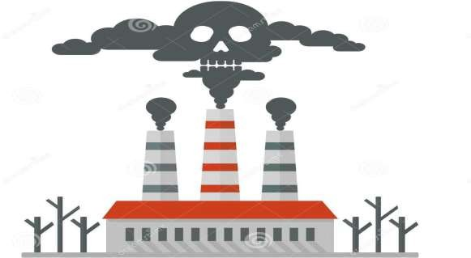

### The Environment Definition:

The term Environment has been defined: “Environment Protection Act to include water, air, land and inter- relationship between water, air, land, and human beings, other living creatures, plants, microorganisms and property.”

The term environment includes two components; the first is Non-living or Physical (air, water, land), and the second is Living or Biological (animals, plants, as well as human beings), and the inter-relationship between them.

The sum total of all surroundings of a living organism, including natural forces and other living things, which provide conditions for development and growth as well as danger and damage.

### Elements of Environment

The environment consists broadly of two components-Non-living or Physical and Living or Biological.

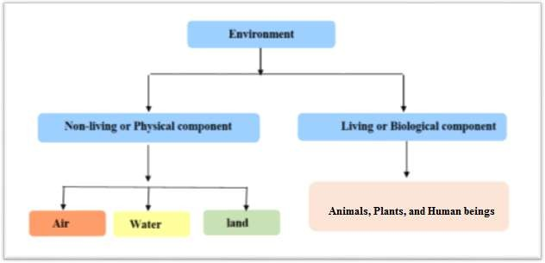

### Pollution and Pollutants

Human activities directly or indirectly affect the environment adversely. A stone crusher adds a lot of suspended particulate matter and noise into the atmosphere. Automobiles emit from their tail pipes oxides of nitrogen, sulphur dioxide, carbon dioxide, carbon monoxide and a complex mixture of unburnt hydrocarbons and black soot which pollute the atmosphere. Domestic sewage and run off from agricultural fields, laden with pesticides.

**Pollution** is defined as the addition of undesirable material into the environment as a result of human activities. The agents which cause environmental pollution are called pollutants. Pollutants may be defined as physical, chemical, or biological substance unintentionally released into the environment which is directly or indirectly harmful to humans and other living organisms.

### Classification of Pollutants

1. **Classification based on environment:**
   1. Air pollution
   2. Water pollution
   3. Soil pollution

### Classification based on nature of pollutants

* 1. Chemical pollution
  2. Noise pollution
  3. Pollution by radio activity.

## Air Pollution:

Air pollution consists of gaseous, liquid, or solid substances that, when present in sufficient concentration, for a sufficient time, and under certain conditions, tend to interfere with human comfort, health or welfare, and cause environmental damage. Air pollution causes acid rain, ozone depletion, photochemical smog, and other such phenomena.

The substances causing air pollution are collectively known as **air pollutants**. They may be solid, liquid or gaseous in nature. Pollutants are classified as primary and secondary air pollutants. **Primary pollutants** are those which are emitted directly to atmosphere, whereas, **secondary pollutants** are formed through chemical reactions and various combinations of the primary pollutants. These pollutants originate from the following four types of sources:

1. **Point sources,** which include facilities such as factories and electric power plants.
2. **Mobile sources,** which include cars and trucks but also lawn mowers, airplanes, and anything else that moves and releases pollutants into the air.
3. **Biogenic sources,** which include trees and vegetation, gas seeps, and microbial activity.
4. **Area sources,** which consist of smaller stationary sources such as dry cleaners and degreasing operations.

### Combustion

Combustion = burning something

#### For example: -

* + Burning gasoline in automobiles
  + Burning diesel fuel in trucks
  + Burning “residual oil” (bunker fuel) in ships
  + Burning coal in power plants
  + Burning natural gas (methane, CH4) in power plants
  + Burning wood and other biomass in wildfires & controlled burns

### Air Pollution from Fuel Combustion

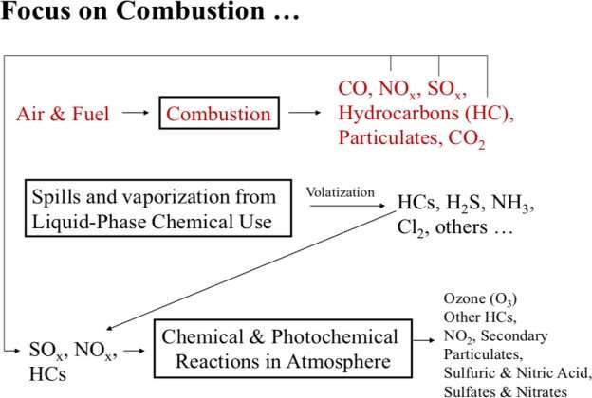

* + 1. **Internal combustion engines:**

Internal combustion engines are devices that generate work using the products of combustion as the working fluid rather than as a heat transfer medium. Carbon monoxide, nitrogen oxides, and hydrocarbons are released when fuel is burned in an **internal combustion engine** and when **air**/fuel residuals are emitted through the vehicle tailpipe. Motor vehicle **pollution** also contributes **to** the formation of acid rain and adds **to** the greenhouse gases that **cause** climate change.

There are three major types of internal combustion engines in use today:

* + - 1. The spark ignition engine.
      2. The diesel engine.
      3. The gas turbine.

### Diesel Exhaust:

Diesel exhaust is produced when an engine burns diesel fuel. It is a complex mixture of thousands of gases and fine particles (commonly known as soot) that contains more than 40 toxic air contaminants.

These include many known or suspected cancer-causing substances, such as benzene, arsenic and formaldehyde. It also contains other harmful pollutants, including nitrogen oxides.

### Evaporative Emissions from Engines Occur in Several Ways:

1. **Diurnal:** (Emissions while Parked and Engine is Cool)- Even when the vehicle is parked for long periods of time, gasoline evaporation occurs as the temperature rises during the day, heating the fuel tank and venting gasoline vapors.
2. **Running Losses:** The hot engine and exhaust system can vaporize gasoline when the car is running.
3. **Hot Soak:** soak (Cooling Down) - The engine remains hot for a period of time after the vehicle is turned off, and gasoline evaporation continues when the car is parked while cooling down.
4. **Refueling:** Gasoline vapors escape from the vehicle’s fuel tank while the tank is being filled.

### Emissions Pollutants from Internal Consumption Engines:

#### Hydrocarbons:

Hydrocarbon emissions result when fuel molecules in the engine do not burn or burn only partially. Hydrocarbons react in the presence of nitrogen oxides and sunlight to form ground-level ozone, a major component of smog. Ozone irritates the eyes, damages the lungs, and aggravates respiratory problems.

#### Nitrogen Oxides (NOx):

Under the high pressure and temperature conditions in an engine, nitrogen and oxygen atoms in the air react to form various nitrogen oxides, collectively known as NOx. Nitrogen oxides, like hydrocarbons, are precursors to the formation of ozone. They also contribute to the formation of acid rain.

N2 + O2 = NO + N N + O2 = NO + O

#### Carbon Monoxide:

Carbon monoxide (CO) is a product of incomplete combustion and occurs when carbon in the fuel is partially oxidized rather than fully oxidized to carbon dioxide (CO). Carbon monoxide reduces the flow of oxygen in the blood stream and is particularly dangerous to persons with heart disease.

#### Carbon Dioxide:

Carbon dioxide does not directly impair human health, but it is a “greenhouse gas” that traps the earth’s heat and contributes to the potential for global warming. Evaporative Emissions Hydrocarbon pollutants also escape into the air through fuel evaporation.

#### Sulfur Oxides:

During the combustion process, essentially all the sulfur in the fuel is oxidized to SO2. The oxidation of SO2 gives sulfur trioxide (SO3), which reacts with water to give sulfuric acid (H2SO4), a contributor to acid precipitation. Sulfuric acid reacts with basic substances to give sulfates, which are fine particulates that contribute to PM-10 and visibility reduction. Sulfur oxide emissions also contribute to corrosion of the engine parts.

#### Lead (Pb):

The largest source of Pb in the atmosphere has been from leaded gasoline combustion. Other airborne sources include combustion of solid waste, coal, and oils, emissions from iron and steel production and lead smelters, and tobacco smoke. Exposure to Pb can affect the blood, kidneys, and nervous, immune, cardiovascular, and reproductive systems.

#### Smoke and Particulate Matter:

White, blue, and black smoke may be emitted from engines. Liquid particulates appear as **white smoke** in the exhaust during an engine cold start, idling, or low load operation. **Blue smoke** is emitted when oil leaks or burning. The primary constituent of **black smoke** is agglomerated carbon particles (soot) formed in regions of the combustion mixtures that are oxygen deficient.

* + **Solid particles** in the air are classified by their size, their capacity of sedimentation and the possibility to penetrate the organisms, as following:

1. Particles larger than 10 µm are deposited after the law of gravity with a uniform accelerated motion, also known as dust.
2. Particles between 10 µm and 0.1 µm that are deposited after Stokes law, consisting mainly of ash and black smoke from burning fuel results.
3. Particles smaller than 0.1 µm that are deposited and move after Brownian movement law.

### Factors Affecting Emission Rates

The vehicular emissions are due to a variety of factors. The emissions vary according to the environment, fuel quality, vehicle, etc. Fuel adulteration and overloading also cause higher amount of emissions. The emissions from vehicles depend on the following factors:

1. **Travel related factors:** The number of trips, distance travelled and driving mode are the major travel related factors affecting emissions.
2. **Highway Network Related Factors:** These include the geometric design features of the highway such as grade.
3. **Vehicle Related Factors:** Vehicle related factors include the engine sizes, horsepower and weight of the vehicle.
4. **Ambient Temperature:** Evaporative emissions are higher at high temperatures.
5. **Type of engine:** Two stroke petrol engines emit more amounts of pollutants than the four stroke diesel engines.
6. **Urbanization:** Congestion is higher in urban areas, and hence emissions are also higher.

### The health effects of diesel exhaust?

1. As we breathe, the toxic gases and small particles of diesel exhaust are drawn into the lungs. The microscopic particles in diesel exhaust are small enough to penetrate deep into the lungs, where they contribute to a range of health problems.
2. Diesel exhausts have the potential to contribute to mutations in cells that can lead to cancer.
3. Diesel exhaust can irritate the eyes, nose, throat and lungs, and it can cause coughs, headaches, light-headedness and nausea.
4. Diesel engines are a major source of fine-particle pollution.
   * The elderly and people with emphysema, asthma, and chronic heart and lung disease are especially sensitive to fine-particle pollution.
   * Because children’s lungs and respiratory systems are still developing, they are also more susceptible than healthy adults to fine particles. Exposure to fine particles is associated with increased frequency of childhood illnesses and can also reduce lung function in children.

### Emissions from the Oil & Natural Gas Industry

High levels of carcinogens have been determined from industrial air emissions. Unsafe emissions may be due to improper production process, poor maintenance practices and internal operational process problems. Many of the chemicals discharged in to the atmosphere during the leakage periods were found particularly sever to children.

The oil and gas industry is the largest industrial source of emissions of volatile organic compounds (VOCs), a group of chemicals that contribute to the formation of ground-level ozone (smog). Exposure to ozone is linked to a wide range of health effects, including aggravated asthma and premature death.

The oil and natural gas industry also is a significant source of emissions of methane, a greenhouse gas that is more than 20 times as potent as carbon dioxide. Emissions of air toxics such as CO, CO2, SO2, NOx, benzene, ethylbenzene, and n-hexane, also come from this industry. Air toxics are pollutants known, or suspected of causing cancer and other serious health effects.

### Some Causes of Industrial Air pollution

1. **Burning of Fossil Fuels:** Fossil fuel is a natural fuel such as coal or gas, formed in the geological past from the remains of living organisms by exposure to heat and pressure in the Earth's crust over millions of years.

When fossil fuels, especially coal, are burned for energy, many impurities are released, including sulfur dioxide and nitrogen oxides. When these pollutants disperse through the atmosphere or dissolve in rainwater, they cause the phenomenon of acid rain. Acid rain is a term referring to a mixture of wet and dry deposition (deposited material) from the atmosphere containing higher than normal amounts of nitric acid (HNO3) and sulfuric acid (H2SO4). Acid rain from air pollution damages vegetation, causes changes in soil chemistry and pollutes waterways.

1. **Exhaust from factories and industries:** Manufacturing industries release large amount of carbon monoxide, hydrocarbons, organic compounds, and chemicals into the air thereby depleting the quality of air.

Petroleum refineries also release hydrocarbons and various other chemicals that pollute the air and also cause land pollution. Oil refineries cause smog and air pollution. Oil refineries emit various chemicals every day. These include metals like lead which makes it hard for children to learn. They also include very small dust particles called PM10, that get deep into our lungs and harms our ability to breathe.

1. **Mining operations:** Mining operations like drilling, blasting, hauling, collection, and transportation are the major sources of emissions and air pollution. Mining is a process wherein minerals below the earth are extracted using large equipment. Some of the nonfuel minerals mined, such as stone, which is a nonmetallic or industrial mineral, can be used directly from the earth. Metallic minerals, which are also nonfuel minerals, conversely, are usually combined in nature with other materials as ores. These ores must be treated, generally with chemicals or heat to produce the metal. Dust and coal particles stirred up during the mining process, as well as soot released during coal transport, contributes to emissions and respiratory problems.
2. **Industrial chimney wastes:** Better dispersion of pollutants emitted by tall chimneys leads to better dilution in the air and thus lower local concentrations of pollutants. This has however led to pollution being dispersed more widely and to transboundary air pollution. Air pollutants spread on the largest area, through designed chimneys depends on several points:
   1. **Desired height of chimney.**
   2. **The speed throwing pollutants from the chimney.**
   3. **The wind speeds.**
   4. **The physical properties of pollutants.**

### Solutions for Air Pollution

1. **Use public mode of transportation:** Encourage people to use more public modes of transportation to reduce pollution.
2. **Conserve energy:** Switch off fans and lights to reduce consumption of electricity. Large amount of fossil fuels is burnt to produce electricity. You can save the environment from degradation by reducing the amount of fossil fuels to be burned.
3. **Understand the concept of Reduce, Reuse and Recycle:** Do not throw away items and reuse them for some other purpose.
4. **Emphasis on clean energy resources:** Clean energy technologies like solar, wind and geothermal are on high these days. Governments of various countries have been providing grants to consumers who are interested in installing solar panels for their home. This will go a long way to curb air pollution.
5. Ensure that houses, schools, restaurants and playgrounds are not located on busy streets.
6. Plant trees along busy streets as they remove particulates, carbon dioxide and absorb noise.
7. Industries and waste disposal sites should be situated outside the city preferably on the downwind of the city.

### Examples:

#### Emissions Calculations Using Fuel Analysis:

Fuel analysis can be used to predict emissions based on the application of mass balance. The presence of certain elements in fuels may be used to predict their presence in emission streams. These include toxic elements such as metals found in coal; as well as other elements such as sulfur, that may be converted to other compounds during the combustion process.

The basic equation used in fuel analysis emission calculations is:

#### Equation ER = R * PC * (MWp/MWf)

Where:

ER = pollutant emission rate R = fuel flow rate (lb/hr) PC = pollutant concentration in fuel (%/100)

MWp = molecular weight of pollutant emitted (lb/lb-mole) MWf = molecular weight of pollutant in fuel (lb/lb-mole)

**Example 1**

Calculate the SO2 emissions from the combustion of oil based on fuel analysis results and the fuel flow information.

fuel flow rate R = 46,000 lbs/hr percent sulfur (% S) in fuel = 1.17

For every pound of sulfur (MW = 32 g) burned, 2 lb of SO2 (MW = 64 g) are emitted.

ER = R * PC * (MWp/MWf)

= (46,000) * (1.17/100) * (64/32)

= 1,076 lbs SO2/hr

#### 2.9.2 Calculating the Source Specific Emission Factor

An emission factor is the amount of pollutant emitted per activity. Activities are typically expressed in terms of material usage, e.g., tons of coal or gallons of oil fired. The basic equation used in emission factor calculations is:





**Example 2:**

A Company operates a boiler that has an SO2 emission rate (ER) of 51 lbs/hr. During the stack test, the coal firing rate was 6.7 tons/year. Calculate the SO2 emission factor (EF).

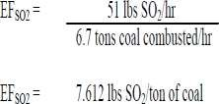

#### 2.9.3. Determining the Annual Mass Emission Rate

The annual mass emission rate is the product of the source specific emission factor multiplied by an annual activity rate. Some examples of an annual activity rate are tons of coal combusted per year or gallons of paint applied per year.

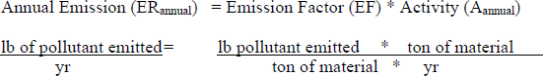

**Example 3**

A Company burns 41,000 tons of coal during the year. What is the annual mass emission rate (ER) of SO2?

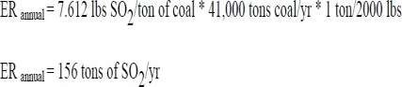

#### 2.9.4 Converting mg/m3 to ppm (or ppb) and ppm (or ppb) to mg/m3

X (mg/m3) = Y ppm

𝑪 𝒎𝒈/𝒎³=𝑪 𝒑𝒑𝒎× 𝑴 (𝒈𝒎𝒐𝒍𝒆)×𝑷 (𝒂𝒕𝒎) / 𝑻 (𝑲°)× R (𝑳.𝒂𝒕𝒎 / 𝒎𝒐𝒍𝒆. 𝑲)

𝑪𝒑𝒑𝒎=(𝒎𝒈𝒎3) ×𝑻 (𝑲°) × R (𝑳.𝒂𝒕𝒎 / 𝒎𝒐𝒍𝒆. 𝑲) / 𝑴𝑾 (𝒈𝒎𝒐𝒍𝒆)×𝑷 (𝒂𝒕𝒎)

Where

C= pollutant concentration in the desired units. MW= molecular weight of the pollutant in g/mole P= pressure of air (atm)…. P(atm)= p(mmHg)/760 T= temperature of air (K) 0.08205𝑳 𝒂𝒕𝒎 𝑲 𝒎𝒐𝒍𝒆= R, the ideal gas constant R, the ideal gas constant

**Example 4:**

The ozone (O3) level in Denver, Colorado, atmosphere was reported to be 2.50 ppm (2.50 µL/L).

Express this in mg/m3 at ambient conditions of 37 Cº and 772 mm Hg.

#### Solution: -

2.5 ppm = 2500 ppb

MW (O3) = 3×16 g/mol = 48 g/mol

P (atm) = 722mmHg × 1 𝑎𝑡𝑚 760 𝑚𝑚𝐻𝑔 = 0.95 atm T (kº) = 37 Cº + 273 = 310 Kº

**So.: -** 𝐶 𝑚𝑔𝑚**³=**𝐶 𝑝𝑝𝑚**×MW (**𝑔𝑚𝑜𝑙𝑒**)×**𝑃 **(**𝑎𝑡𝑚**) /** 𝑇 **(°**𝐾**) × 0.08205** 𝐿 𝑎𝑡𝑚**/**𝐾 𝑚𝑜𝑙𝑒

𝐶 𝑚𝑔𝑚**³** = 2.50 𝑝𝑝m ×48 𝑔𝑚𝑜𝑙𝑒 ×0.95 𝑎𝑡𝑚 / 310 𝑘° × 0.08205 𝐿 𝑎𝑡𝑚/𝑘 𝑚𝑜𝑙𝑒

𝐶 𝑚𝑔𝑚**³**= 4.56

#### 2.9.5. Converting ACFM TO SCFM

The volume of a gas varies with changes in pressure and temperature. In order to simplify comparison of gases, chemists adopted a set of standard conditions of temperature and pressure. The volume of a gas or volume flow rate of a gas at one temperature and pressure can be converted to its volume or volume flow rate at standard conditions by using the ideal gas equation which relates pressure, volume, and temperature. According to the ideal gas law:

#### Qstd = Qº (Tstd/Tº) (Pº/Pstd)

Where:

Qstd = gas flow rate at standard temperature and pressure Qo = gas flow rate at actual conditions

Pstd = pressure at standard conditions is 29.92 inches Hg or 1 atmosphere Tstd = temperature at standard conditions is 70 Fº

Po = pressure at actual conditions (inches Hg) To = temperature at actual conditions (Fº)



#### 2.9.6. Converting SCFM TO DSCFM

Certain processes will generate moisture in the stack gas

#### Qdscfm = Qscfm * (1-% moisture)

This approach can only be used for exhaust flows < 5% moisture

For Combustion Sources: When direct measurements of stack gas flow rate are not available, Q can be calculated using fuel factors (Fd factors):

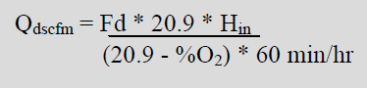

Where:

Fd = fuel factor, dry basis

%O2 = measured oxygen concentration, dry basis expressed as a percentage Hin = heat input rate in MMBtu/hr



Where:

R = mass fuel rate in lbs/hr

HHV = higher heating value of the fuel in Btu/lb

The average Fd factors are provided in EPA Reference Test Method 19 for different fuels and are shown in Table 1. Also, in Table 1 are the higher heating values (HHV) of fuel.

#### Table 1.0 - Fuel Factors and Higher Heating Values

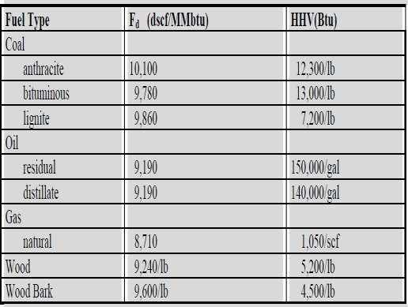

**Example 5**

Company A operates a distillate oil-fired boiler. The fuel rate is 20 gallons of oil per hour. The percent O2 in their exhaust gas is 2.1%. Determine the stack gas flow rate Qdscfm.

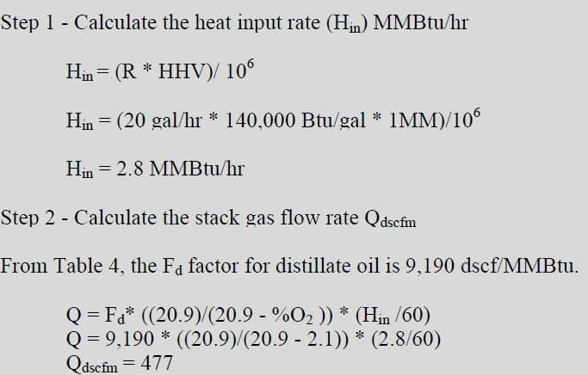

## Water Pollution

Water pollution is one of the most serious environmental problems. Water pollution is caused by a variety of human activities such as industrial, agricultural and domestic. Agricultural run off related to excess fertilizers and pesticides, industrial effluents with toxic substances and sewage water with human and animal wastes pollute our water thoroughly.

### Water on earth occurs in three forms:

1. As a vapour we see it as clouds, mist and steam.
2. As a fluid we see water as rain, in streams, lakes, dams, wetlands and the seas.
3. As a solid we see water as ice in glaciers, hail, snow and frost.

Water is a combination of oxygen and hydrogen (H2O), but as you get different types of animals and plants, you also get different types of water. The difference between the types of water depends on the substances that are dissolved or suspended in the water.

### Types of Water

Ten Basic Types of Water:

#### Hard Water:

This is saturated with calcium, iron, magnesium, and many other inorganic minerals. All water in lakes, rivers, on the ground, in deep wells, is classified as hard water. (Many city systems take water from rivers or lakes, or reservoirs supplied with mountain water; they erroneously call their supplies "soft water" but it is soft only in comparison with water which is harder.

#### Boiled Water:

Boiling helps remove some of the germs, but concentrates the inorganic minerals. Boiling tap water does not make it cleaner. It makes it safer to drink because as others said, it kills the microorganisms in the water.

#### Raw Water:

This has not been boiled. Raw water may be hard (as calcium hardened water) or soft as rain water. Raw water describes any water that has not been treated to remove bacteria and other contaminants. Raw water contains millions of germs and viruses in every densely inhabited drop. Some of these viruses and bacteria may adversely affect the thyroid gland, the liver and other vital body organs.

Raw water comes from a variety of locations, including both surface and subsurface sources. Surface sources include ponds, lakes, and other water bodies. Subsurface water sources include springs and wells located underground, which often require drilling or pumping to access.

#### Rain Water

This has been condensed from the clouds. The first drop is distilled water. But when it falls as rain, it picks up germs, dust, smoke, minerals, strontium 90, lead and many other atmospheric chemicals. By the time rain water reaches the earth it is so saturated with dust and pollutants it may be yellowish in color. If we had no air pollution, we would have far less pollution in our drinking water.

#### Snow Water

This is frozen rain. Freezing does not eliminate any germs. All snowflakes have hardened mineral deposits. Melt the cleanest snow and you will find it saturated with dirt, inorganic minerals, germs and viruses.

#### Filtered Water

This water has passed through a fine strainer, called a filter. Some calcium and other solid substances are kept in the filter. Each pore of the finest filter is large enough for a million viruses to seep through in a few moments. A home filter usually only picks up suspended solids and is effective for the time, maybe only for hours, until it is filled up. Then it is ineffective even for removing suspended solids, and at the same time becomes a breeding ground for bacteria.

#### Soft Water

This water is soft in comparison with water which is harder. It may contain many trace minerals and chemicals, viruses and bacteria. It is not to be confused with "softened water." Soft water may be classified as water which is harder than distilled water.

#### Reverse Osmosis

This is a system of water purification which allows pre-filtered water to be forced through a semi- permeable membrane to separate impurities from our drinking water. However, this membrane allows only certain molecules to pass through providing the water pressure is exactly constant. The membrane also allows some iron and nitrate molecules to pass through.

#### De-ionized Water: Deionization ("DI Water" or "Demineralization") Simple means the removal of ions

Deionization removes minerals and ions, both cations (positively charged ions) and anions (negatively charged ions), through a chemical process. DI uses specially manufactured ion-exchange resins which exchange hydrogen ions and hydroxide ions for dissolved minerals, which are then recombined to form water (this leaves DI in an unbalanced condition and with an electrical charge.) DI does not significantly remove uncharged organic molecules, viruses or bacteria. Because deionized water is unbalanced, it goes after any dissolvable or absorbable ions on contact trying to return to a balanced state.

#### Distilled Water

Distillation purifies liquid by boiling it, capturing the steam and then condensing the vapors. The condensed vapors are then returned to their liquid state finishing the distillation process. Solids and other contaminants, salt being the most important, remain in the original container with just pure water being reduced to vapor. It takes approximately five gallons of water to create one gallon of distilled water.

### Types of water uses:

1. **Municipal/public supply.**
2. **Domestic and commercial.**
3. **Industrial and mining.**
4. **Agricultural.**
5. **Thermoelectric power.**

* The average per capita (per person) use can vary greatly between communities for any number of reasons, including:

1. **Climate differences.**
2. **The mix of domestic, commercial, and industrial uses.**
3. **Household sizes.**
4. **Public uses.**
5. **Income brackets.**
6. **Age and condition of distribution system.**

**1 . Municipal/ public supply:**

Typical categories of residential water use include normal household uses such as:

1. Drinking and cooking.
2. Bathing.
3. Toilet flushing.
4. Washing clothes and dishes.
5. Watering lawns and gardens.
6. Maintaining swimming pools.
7. Washing cars.

#### Domestic/Commercial:

Domestic water use includes everyday uses that take place in residential homes, whereas commercial water uses are those which take place in office buildings, hotels, restaurants,

civilian and military institutions, public and private golf courses, and other nonindustrial commercial facilities.

#### Industrial and Mining:

Industrial water uses, estimated to be 8 percent of total freshwater use for all off stream categories, include cooling in factories and washing and rinsing in manufacturing processes. Some of the major water-use industries include mining, steel, paper and associated products, and chemicals and associated products. Water for both industrial and mining uses comes from public supplies, surface sources, and ground water.

#### Agricultural:

Agricultural water use can be divided between irrigation and livestock. Irrigation includes all water applied to farm or horticultural crops; livestock incorporates water used for livestock, dairies, feedlots, fish farms, and other farm needs.

#### Thermoelectric Power Generation:

This final category includes water used for the production of energy from fossil fuels, nuclear energy, or geothermal energy. Most water withdrawn for thermoelectric power production is used for condenser and reactor cooling. More than 99 percent of the water used for thermoelectric power production comes from self-supplied surface water, less than

0.2 percent from public supplies.

### Sources of Water Pollution:

There are two main sources of water pollution: point sources and non-point sources.

1. When pollutants are discharged from a specific location such as a drain pipe carrying industrial effluents discharged directly into a water body it represents **Point Source pollution. Point Sources** include factories, wastewater treatment facilities, septic systems, and other sources that are clearly discharging pollutants into water sources.
2. **Non-Point Sources** are more difficult to identify, because they cannot be traced back to a

particular location. Non-point sources include discharge of pollutants from diffused sources or from a larger area such as run off from agricultural fields, grazing lands, construction sites, abandoned mines and pits, roads and streets, sediment, fertilizer, chemicals and animal wastes from farms, construction sites and mines. Landfills can also be a non-point source of pollution, if substances leach from the landfill into water supplies.

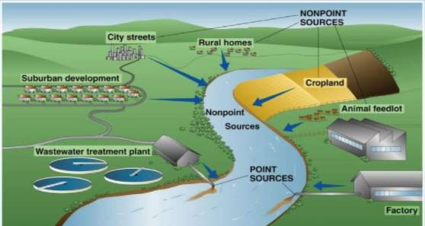

### The United States Environmental Protection Agency (EPA) divides water pollution into the following six categories:

1. **Biodegradable waste consists mainly of human and animal waste**. When biodegradable waste enters a water supply, the waste provides an energy source (organic carbon) for bacteria. Organic carbon is converted to carbon dioxide and water, which can cause atmospheric pollution and acid rain; this form of pollution is far more widespread and problematic than other forms of pollutants, such as radioactive waste. If there is a large supply of organic matter in the water, oxygen-consuming (aerobic) bacteria multiply quickly, consume all available oxygen, and kill all aquatic life.
2. **Plant nutrients**, such as phosphates and nitrates, enter the water through sewage, and livestock and fertilizer runoff. Phosphates and nitrates are also found in industrial

wastes. Though these chemicals are natural, 80 percent of nitrates and 75 percent of phosphates in water are human-added. When there is too much nitrogen or phosphorus in a water supply (0.3 parts per million for nitrogen and 0.01 parts per million for phosphorus), algae begin to develop. When algae blooms, the water can turn green and cloudy, feel slimy, and smell bad. Weeds start to grow and bacteria spread. Decomposing plants use up the oxygen in the water, disrupting the aquatic life, reducing biodiversity, and even killing aquatic life.

This process, called **eutrophication**, is a natural process, but generally occurs over thousands of years. Eutrophication allows a lake to age and become more nutrient-rich; without nutrient pollution.

1. **Heat can be a source of pollution in water.** As the water temperature increases, the amount of dissolved oxygen decreases. Thermal pollution can be natural, in the case of hot springs and shallow ponds in the summertime, or human-made, through the discharge of water that has been used to cool power plants or other industrial equipment. Fish and plants require certain temperatures and oxygen levels to survive, so thermal pollution often reduces the aquatic life diversity in the water.
2. **Sediment is one of the most common sources of water pollution.** Sediment consists of mineral or organic solid matter that is washed or blown from land into water sources. Sediment pollution is difficult to identify, because it comes from non-point sources, such as construction, agricultural and livestock operations, logging, flooding, and city runoff. Sediment can cause large problems, as it can clog municipal water systems, smother aquatic life, and cause water to become increasingly turbid. And, turbid water can cause thermal pollution, because cloudy water absorbs more solar radiation.
3. **Hazardous and toxic chemicals** are usually human-made materials that are not used or disposed of properly. Point sources of chemical pollution include industrial discharges and oil spills. The Oil Pollution fact sheet includes more detailed information about oil spills, as well as other sources of oil pollution. Non-point sources of chemical pollution include runoff from paved roads and pesticide runoff. Many people think industries produce the greatest amount of chemical pollution. But domestic and personal use of chemicals can significantly contribute to chemical pollution. Household cleaners, dyes, paints and solvents are also toxic, and can accumulate when poured down drains or flushed down the toilet.
4. **Radioactive pollutants** include wastewater discharges from factories, hospitals and uranium mines. These pollutants can also come from natural isotopes, such as radon and Uranium which is highly toxic chemical. The nuclear waste that is produced by radioactive material needs to be disposed off to prevent any nuclear accident. Nuclear waste can have serious environmental hazards if not disposed off properly. Radioactive pollutants can be dangerous, and it takes many years until radioactive substances are no longer considered dangerous.

#### Other Pollutants:

* + **Mining activities:** Mining is the process of crushing the rock and extracting coal and other minerals from underground. These elements when extracted in the raw form contains harmful chemicals and can increase the amount of toxic elements when mixed up with water which may result in health problems. Mining activities emit several metal wastes and sulphides from the rocks and is harmful for the water.Water-pollution problems caused by mining include acid mine drainage, metal contamination, and increased sediment levels in streams. Sources can include active or abandoned surface and underground mines, processing plants, waste- disposal areas, haulage roads, or **tailings** ponds.
  + **Accidental Oil leakage:** Oil spill pose a huge concern as large amount of oil enters into the sea and does not dissolve with water; there by opens problem for local marine wildlife such as fish, birds and sea otters. For e.g.: a ship carrying large quantity of oil may spill oil if met with an accident and can cause varying damage to species in the ocean depending on the quantity of oil spill, size of ocean, toxicity of pollutant.
  + **Underground storage leakage:** Transportation of coal and other petroleum products through underground pipes is well known. Accidentals leakage may happen anytime and may cause damage to environment and result in soil erosion.

### Effect of industrial activity and energy production on the water pollution

The water after it is used once for industrial purpose cannot be reused for the same purpose without treatment. Such water which emerges out after use from industries is called as the industrial effluents. Industrial activities are a significant and growing cause of poor water quality. Industry and energy production use accounts for nearly 20 percent of total global

water withdrawals, and this water is typically returned to its source in a degraded condition. Industrial wastewater can contain a number of different pollutants, including:

1. Microbiological contaminants like bacteria, viruses, and protozoa.
2. Chemicals from industrial activities like solvents and organic and inorganic pesticides, polychlorinated biphenyls (PCBs), asbestos.
3. Metals such as lead, mercury, zinc, copper, and many others.
4. Nutrients such as phosphorus and nitrogen.
5. Suspended matter including particulates and sediments.
6. Temperature changes through the discharge of warm cooling-water effluent.
7. Pharmaceuticals and personal care products.

The production of energy also has significant effects on water quality mostly because of the vast quantities of water required for power-plant cooling and the extensive risk of contamination during the search for and production of fossil fuels. There are three major effects of concern:

1. The production of vast quantities of contaminated groundwater during the drilling of oil and gas wells.
2. The withdrawal of water for power plant cooling that reduces water available for ecosystems; and
3. The heating and subsequent discharge of cooling water, which raises the ambient water temperature in rivers, streams, and lakes, with effects on natural ecosystems.

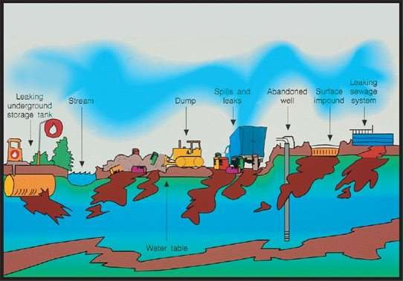

### Wastewater Pollution and Some Control Processes of Wastewater

Wastewater can be defined as any water or liquid that contains impurities or pollutants.

#### Origin of Wastewater

Wastewater can be classified by their origin as: domestic wastewater and industrial wastewater.

1. Domestic wastewater: that is collected and discharged from residential and commercial established.
2. Industrial wastewater: is formed at industrial plants where water is used for various processes and washing rinsing of equipment.

Waste water generated by household activity, industries or garbage landfills is called sewage which is classified as the municipal water pollution. Sewage contains solid matters in the form of suspended colloidal and dissolved organic matter, detergent, mineral matter, nutrients and gases. Sewage is one of the major causes of water borne diseases and therefore the treatment of sewage is one of the important tasks. For a long time, treatment of municipal waste in the form of sewage involved mainly of the removal of suspended solids, oxygen demanding materials and harmful bacteria. Now the disposal of the solid residue from sewage has been improved by applying municipal treatment processes.

### The objectives of wastewater treatment:

The objective of wastewater treatment is to reduce the concentration of specific pollutants in water to the level where the treated water will meet the acceptable quality standards and will not adversely affect the environment. The specific processes needed for wastewater treatment vary according to both how the water was used and where the wastewater will be discharged.

### Overview of Waste Water Treatment

The treatment of waste water is carried out in the following four stages: 1. Preliminary Treatment 2. Primary treatment 3. Secondary treatment, and 4. Tertiary treatment. The diagram below shows the wastewater treatment processes.

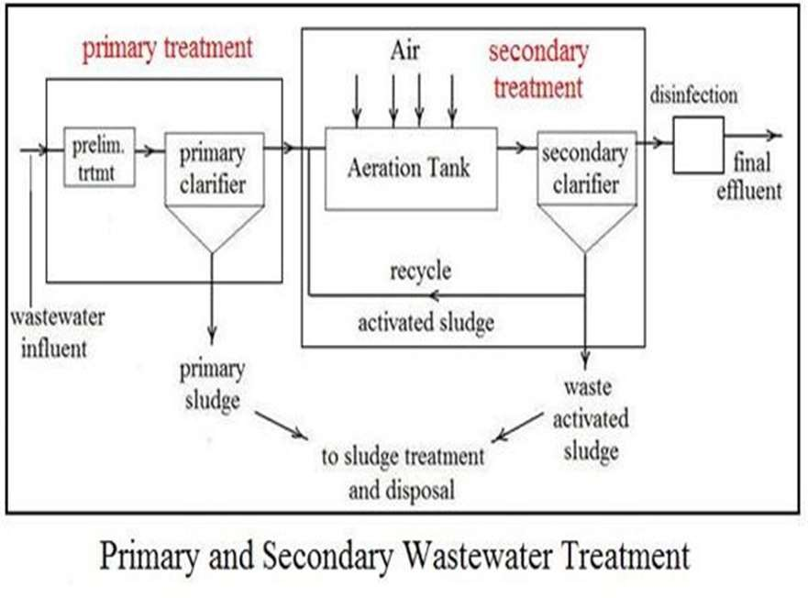

### Wastewater Treatment Processes

#### Preliminary Treatment:

As wastewater enters a treatment facility, it typically flows through a step called preliminary treatment. A screen removes large floating objects, such as rags, cans, bottles and sticks that may clog pumps, small pipes, and down stream processes. The screens vary from coarse to fine and are constructed with parallel steel or iron bars, while others may be made from mesh screens with much smaller openings.

#### Primary Treatment:

When the waste water is to be dumped off into a river or flowing steam, the treatment is carried out by sedimentation, coagulation and filtration. This is known as primary treatment. If the water is required for drinking purposes, it has to undergo further treatment called secondary and tertiary treatments.

#### The following steps are performed to do primary treatment of water:

* + - * 1. **Sedimentation:** This step is carried out in large tanks specially built for this purpose in sewage treatment plant. The polluted water is allowed to settle so that silt, clay and other matter settle to be bottom and water is slowly allowed to move out. Fine particles do not settle and are thus required to be removed in the next step.
        2. **Coagulation:** Fine particles and colloidal suspension are combined into large particles by a process called coagulation. This step is carried out by the addition of special chemicals called coagulants (flocculants) such as potash alum. The large particles either settle to the bottom or are moved in the next step.
        3. **Filtration:** Suspended particles, flocculants, bacteria and other organisms are filtered by passing the water through a bed of sand or finely divided coal or through some fibrous materials. The total impurities collected in these steps are called sludge. It is used as a valuable fertilizer. On composting (i.e. the action of anaerobic bacteria), it releases sludge gas. It consists mainly of methane gas which is used for cooking purposes.

#### Secondary or Biological Treatment:

The water after primary treatment is not fit for drinking purposes and has to undergo further treatment. This is done through secondary or biological treatment. A commonly used method is to allow polluted water to spread over a large bed of stones and gravel so that the growth of different microorganisms needing nutrients and oxygen is encouraged. Over a period of time a fast-moving food chain is set up. For example, bacteria consume organic matter from the polluted water; protozoa live on bacteria. This process involves the following steps:

* + - * 1. **Softening:** By this treatment undesirable cations of calcium and magnesium are removed from hard waters. Either water is treated with lime and soda ash to precipitate Ca2+ ions as carbonates or it is passed through cation exchangers. This makes water soft.
        2. **Aeration:** In this process, soft water is exposed to air by forcing air through it to add oxygen to water. This encourages bacterial decomposition of organic matter into harmless products such as carbon dioxide and water. The addition of oxygen reduces carbon dioxide and sulphide. The water is as yet not fit for drinking purposes. The pathogenic and other microorganisms need to be killed. This is done in the next treatment.

#### Tertiary Treatment:

The tertiary treatment is actually disinfecting water. Disinfection is carried out to kill harmful microorganisms that may be present in the water supply and to prevent microorganisms regrowing in the distribution systems. Good public health owes a lot to the disinfection of water supplies. Without disinfection, waterborne disease becomes a problem, causing high infant mortality rates and low life expectancy. These are some advantages of the disinfection process:

* Effectiveness in killing a range of microorganisms.
* Potential to form possibly harmful disinfection byproducts.
* Ability of the disinfecting agent to remain effective in the water throughout the distribution system.
* Safety and ease of handling chemicals and equipment.
* Cost effectiveness.

For example, of disinfectants (Chlorine) is the most commonly used disinfectant used for killing bacteria. Other methods of disinfection such as ultraviolet radiation and ozone gas treatment. A summary of each of the main disinfection processes is given below:

#### Chlorination:

Chlorination is the most widely used disinfectant for drinking water. It is cheap, easy to use, effective at low dose levels against a wide range of infectious microorganisms, and has a long history of safe use around the world. Chlorine gas and water react to form HOCl and hydrochloric acid (HCl). In turn, the HOCl dissociates into the hypochlorite ion (OCl–) and the hydrogen ion (H+), according to the

following reactions:

Cl2 +H2O⇔HOCl+HCl

HOCl ⇔ H+ + OCl–

#### Chloramination:

Chloramines are produced when ammonia and chlorine are added to water together. They are less effective than chlorine in killing microorganisms because they are not as chemically active. However, chloramines maintain their disinfecting capability longer than chlorine and are ideal for very long distribution systems or for water supplies with long holding times in service reservoirs.

#### Ozone:

Ozone (O3) is the most powerful disinfectant used in water treatment. It is even effective against the difficult to treat protozoan parasites, Cryptosporidium and Giardia. Ozone, which only recently began to be used, destroys soluble contaminants such as algal toxins, taste and odour compounds and trace levels of insecticides.

#### Ultraviolet irradiation:

Ultraviolet radiation (UV) is a component of sunlight. Sunlight achieves disinfection by ultraviolet irradiation naturally. In water treatment, an appropriate level of UV irradiation, produced by mercury lamps, can kill bacteria and viruses. However, there is some uncertainty surrounding the effectiveness of UV irradiation against Cryptosporidium and Giardia. UV irradiation adds no chemicals to water and uses equipment that is relatively simple to operate and maintain.

### Examples about the daily flow rate, Lime mass, and the detention time.

**EXAMPLE 1**

A channel 2 m wide has a water flowing to a depth of 0.5 m. What is the **daily flow** in the channel if the velocity of the water is 0.75 m/s?

#### Solution:

**RATE OF FLOW = WIDTH x DEPTH x VELOCITY**

= (2 m) (0.5 m) (0.75 m/s)

= 0.75 m³/s

However, we are asked to find the daily flow. Daily Flow = rate of flow x 60 s/min x 1440 min/d

min/d)

= (0.75 m³/s) (60 s/min) (1440

= 64800 m³/d

**EXAMPLE 2**

A lime solution having a mass of 80 kg contains 85% water and the remainder is lime. What is the mass of the lime?

#### Solution :

The total mass of the solution is 80 kg which represents 100%. If the water represents 85%, then the lime represents:

#### (Total Mass) - (Mass of Water) = (Mass of Lime)

100% - 85% = 15%

Mass of lime = 15% x 80 kg

= 0.15 x 80 kg

= 12 kg

**EXAMPLE 3**

A sedimentation tank has a capacity of 132 m³. If the hourly flow to the clarifier is 47 m³/h, what is the detention time?

#### Solution:

Since the flow rate is expressed in hours, the detention time calculated is also in hours:

**Detention time =** 𝐕𝐨𝐥𝐮𝐦𝐞 𝐨𝐟 𝐭𝐚𝐧𝐤 / 𝐅𝐥𝐨𝐰 𝐫𝐚𝐭𝐞

**=** 132 m³ / 47 m³/h Detention time = 2.8 h

### Oil spillage

Oil spillage is a release of a liquid petroleum hydrocarbon into the environment due to human activity, and is a form of pollution. The term often refers to marine oil spills, where oil is released into the ocean or coastal waters. Oil spills include releases of crude oil from tankers, offshore platforms, drilling rigs and wells, as well as spills of refined petroleum products (such as gasoline, diesel) and their by- products, and heavier fuels used by large ships such as bunker fuel, or the spill of any oily white substance refuse or waste oil. Spills may take months or even years to clean up. Oil also enters the marine environment from natural oil seeps.

Numerous factors determine the extent of damage to be expected from any spill. These include:

1. **Type of oil spilled.**
2. **The dose or amount of oil spilled.**
3. **The physical features of the region of the spill.**
4. **The biota of the region.**
5. **The season of year.**
6. **The previous exposure of the region to oil spills.**
7. **The present exposure of the region to other pollutants.**
8. **The treatment that was given to the spill.**

### The Environmental risk when transporting oil and gas

#### Transport by tanker

Tanker trucks provide flexibility, linking extraction sites and refineries to pipelines and rail terminals. Unlike other modes of transport, trucks are primarily used to transport oil for relatively short distances because long distance transport by truck is not an economical option.

#### Associated Risks:

1. **En route collision:** Tanker trucks operate in close proximity to the general public and operate in densely populated areas. This increases the risk of accidents, including collisions and accidents at crossings. Collisions may involve multiple vehicles and can occur at high speeds, which may increase the risk of fire and explosion.
2. **Inadequate Infrastructure:** poorly maintained and monitored infrastructure at delivery points and fuel loading terminals could contribute to accidents, including fire and explosion.
3. **Truck Design:** Tanker trucks are typically loaded through bottom lines, which do not drain completely into the tank because they are at the lowest point on the container. The structurally fragile bottom lines can contain more than 50 gallons of the oil, referred to as ‘wet-lines,’ and may contribute to an event leading to fire and explosion.
4. **Many other factors significantly reduce the environment’s natural self-regulating ability:** the specific climatic conditions, the amount of available daylight, the nature of heat transfer between the ocean’s surface and the layers situated underneath and the atmosphere, the configuration of the bottom, the types of coast and shallow tides.

#### Transport by pipeline

Earthworks are a main source of impact on the marine environment when constructing an underwater pipeline. This includes sinking trenches and access channels, deepening and backfilling pipelines, and dumping soil. These pipes stretch over hundreds and thousands of kilometers. The extent of the damage will depend on the size of the leak and pose a risk to coastal marine ecosystems when these take place near, or at river intersections.

#### Associated Risks:

1. **Pipeline Quality:** Over time the quality of pipeline performance declines due to material deterioration, cracks from corrosion, erosion and defective welding.
2. **Natural Hazards and Extreme Weather Conditions:** Pipelines damage from ice, currents, floods and lakebed erosion, which can have detrimental effects on the pipeline infrastructure.
3. **Monitoring:** Pipelines require constant monitoring and accidents may result from undetected failures due to insufficient or delayed monitoring.
4. **Out-dated Regulatory Regime:** The inability to provide up-to-date data and sporadic monitoring lapses may exacerbate the risks from pipeline spills. For example, studies show that upgrading pipeline infrastructure with automatic shut-off valves can reduce potential risks, the current regulations do not enforce such upgrades .
5. **Physical Environment:** pipelines run through diverse ecological areas that may be home to endangered species and are sensitive to environmental degradation. These conditions must be considered when evaluating the potential risks of pipeline spills.

#### Transport by railway

The reason that oil shipping by rail has expanded is due to the ability of rail to quickly respond to increased production in the oil fields. However, the increased volume of rail transport has also led to a surge in oil spill incidents via this mode. The following have been identified

among the reasons for accidents and incidents resulting in the leaking of petroleum products or crude oil from railway tank wagons:

1. **Infringements of regulations concerned with handling dangerous loads.**
2. **Human error and bad management.**
3. **Derailments, as a result of unfavorable natural climatic conditions.**
4. **Train collisions.**
5. **Mechanical impact on the train.**
6. **Collapsing bridges.**
7. **Sparking, with the subsequent ignition of the contents of the wagons.**

### What happens when oil spills?

There are a number of processes that can occur when oil spills, depending on the water source and the type and amount of spilled oil.

* + - 1. The most common effect is the spreading of the oil over the surface of the water. Most oil is less dense than water, so when oil spills, it spreads across the water surface. Oil spreads very quickly, with lighter oils, like gasoline, spreading faster than heavy crude oils. Currents, wind and warm temperatures will cause the oil to spread faster. For this reason, it is important for oil spills to be contained as quickly as possible.
      2. Oil can settle to the bottom of the water. While the density of oil ranges from 0.85 g/cm³ to 1.04 g/cm³, most oil densities fall into the 0.90 to 0.98 g/cm³ range. Ocean water has a density between 1.02 and 1.03 g/cm³, depending on the salt concentration. River water, however, has a density of 1.0 g/cm³. This means that a heavy oil, with a density of 1.01 g/cm³, would float in ocean water, but sink in a river.
      3. The oil can be moved, with currents, tides and the wind. This can be a significant problem in rivers, because the currents can carry the oil a great distance from its origin. It can also cause substantial damage in oceans, because the tide can carry the oil to beaches and intertidal zones, which are especially sensitive to oil pollution.
      4. Natural bacteria can digest the hydrocarbons and convert them to carbon dioxide and water. This is called biodegrading, and is a natural process that can clean water and sediment after an oil spill.
      5. Some oil will evaporate. Up to 50 percent of the volume of most oil spills can evaporate. Light fuels, such as gasoline, will almost entirely evaporate within one or two days.
      6. Natural physical, chemical and biological processes can cause the oil to weather, changing the characteristics of the oil.
      7. Oxidation is a chemical reaction that can occur between oxygen and hydrocarbons, and is a natural process that slowly breaks down the hydrocarbons.
      8. Emulsification is the combination of two liquids, when one is suspended in the other. Between water and oil, the combination can be water-in-oil or oil-in-water; water-in-oil is a stable mixture and can persist for years. Water-in-oil often consists of 50 to 80 percent water, and the water appears reddish- brown and feels greasy, due to the presence of oil.

### The damage of oil pollution

Oil pollution can damage ecosystems, including plants and animals, and contaminate water for drinking and other purposes.

1. **Environmental Effects:** The feathers and fur of birds and marine animals can become coated in oil; when the animals are covered in oil, they can no longer insulate themselves against the cold water, and birds have difficulty flying. Furthermore, when the animals clean themselves, they ingest some of the oil. Fish can be suffocated by the thick sludge of oil on the water surface, and bottom-dwelling fish can develop liver disease, as well as reproductive and problems. Plants that grow in or near the water can be harmed by oil pollution. An oil spill can block the sunlight that plants need for photosynthesis, which kills plants growing in the water. Oil spills can result in closed beaches and harbours. Oil pollution affects fishing and hunting, which is especially detrimental for people who rely on hunting and fishing, such as many rural communities.
2. **Effect on Economy:** The second major effect of the oil spill is on the economy. When crude oil or refined petroleum is lost, it effects the amount of petroleum and gas available for use. This means more barrels have to be imported from other countries. Then comes the process of cleaning the oil spill, which requires a lot of financing. The company responsible for the oil spills and their effects has to clean it up and pay for the workers who will face tremendous health problems which effect on the economy of the company.

### Treatment of the oil pollution

There are several clean-up methods that can be used, depending on the type and amount of spilled oil, the water location and local weather conditions. Recovery times can range from weeks to decades. Along bedrock shorelines, where there are high-energy waves, the region may recover within several weeks. Exposed beaches generally recover within a matter of months, but marshes and salt flats may take years or even decades to recover from an oil spill

.

#### Natural Methods:

The natural environment can effectively remove contaminants from the water and soil. There are microorganisms that are present in the environment that can break down many harmful

chemicals, including gasoline and oil. To increase the rate at which the microorganisms work, nutrients, such as nitrogen or phosphorus, are often added. After the majority of the oil spill is cleaned up manually, biological processes break down the trace amounts that could not be removed. These biological processes, together with evaporation, oxidation, weathering and other natural processes, will break down the oil and naturally clean up the environment.

#### Booms:

Because oil spreads very quickly, the most important primary step is to contain the spill to as small of an area as possible. Booms are one of the most commonly used tools, because they can contain the oil to keep it from spreading. There are three main types of booms:

1. Hard boom is a piece of plastic with a cylindrical float at the top and weighted bottom, so that it floats on the surface with an underwater “skirt”.
2. Sorbent booms are made from materials that can absorb oil, and are most effective on thin, light oil slicks. Great caution must be taken when removing sorbent booms, so that the oil is not squeezed back into the water. Booms can also be used to prevent oil from running into storm drains when oil spills on pavement.
3. Fire booms are the third type of boom, but are not used as much as hard and sorbent booms. A fire boom is very similar to a hard boom, but is made of metal, so that it is fire resistant. Fire booms are used to contain oil spills until they can be lit on fire.

#### Chemical Dispersants

Chemical dispersants can be successful in cleaning up oil spills. Dispersants are chemicals that are applied to the surface of the water, usually by a low-flying plane. Oil can eventually break down naturally, and chemical dispersants act to speed up the natural process. The oil binds to the dispersant, and is able to move further down the water column, meaning that the oil disperses into the water. The water dilutes the oil to a concentration that is less harmful to aquatic life in the region.

#### Detergent

Dish detergent is a common household item that can illustrate how chemical dispersants work, because grease and oil bind to dish detergent and are washed away. However, chemical dispersants are not applied to shallow water near shores, marshes, near coral reefs, or other sensitive areas.

#### Skimmers

Skimmers are boats that can skim oil from the water surface. An advantage of using a skimmer to remove oil from water is that it doesn’t change the physical or chemical properties of the oil, as methods such as using chemical dispersants do. Skimmers often have attached settling tanks, so that the oil and water can be separated in the tank. If the oil is

relatively fresh, it can be refined. In other instances, the oil is burned. The success of skimming depends on the type and thickness of the oil spill, the amount of debris in the water, the location and the weather conditions (skimming works best in calm weather).

#### Sorbents

In addition to using sorbent materials as booms, to contain and soak up oil spills, sorbents can also be applied to the water surface as powders. Sorbents are often the final step of clean- up, because they can absorb trace amounts of oil that could not be skimmed off. Commonly used sorbents include natural organic materials, such as peat moss and sawdust, or synthetic organic materials, such as polypropylene ,polyester foam or polystyrene. Sorbents are generally applied by hand, and recovered with the use of nets and rakes.

#### Burning

Burning is a method that is often used to remove oil from the surface of the water. Oil may also be burned after skimmers remove the oil from the water surface. The burning of oil releases nitrogen and sulphur, which in turn causes acid rain. While burning can remove the oil from the water surface quickly and efficiently, it causes additional pollution. Thus, there are some ways of cleaning up after oil spills that are more beneficial than others.

#### Beach Clean-up

Areas near shore that are contaminated with heavy concentrations of thick oil are often cleaned up manually, using shovels and trucks. Manual recovery can also be used to pick up oiled beach sand and gravel, to remove it from the beach and transport it to alternate locations for treatment. Vacuum trucks can vacuum the oil up, right off of the beach. Pressurized hoses can also be used to wash oil off of beaches, into the water, where it will be dispersed and diluted in the water.

## Soil pollution

### Solid waste

Solid waste refers here to all non-liquid wastes. In general, Solid waste is all rotting and non- rotting waste in solid or semi-solid form, including but not limited, trash, unwanted compounds, ash or incinerator residues, street waste, dead animals, demolition and construction waste, sanitation, solid or semi-solid commercial and industrial waste. Solid waste can create significant health problems and a very unpleasant living environment if not disposed of safely and appropriately. If not correctly disposed of, waste may provide breeding sites for insect-vectors, pests, snakes and vermin (rats) that increase the likelihood of disease transmission. It may also pollute water sources and the environment.

### Associated risks

* + 1. **Disease transmission**

Decomposing organic waste attracts animals, vermin and flies. Flies may play a major role in the transmission of faecal-oral diseases, particularly where domestic waste contains faeces (often those of children). Rodents may increase the transmission of diseases such as leptospirosis and salmonella, and attract snakes to waste heaps. Solid waste may also provide breeding sites for mosquitoes. Mosquitoes of the Aedes genus lay eggs in water stored in discarded items such as tins and drums; these are responsible for the spread of dengue and yellow fevers. Such conditions may also attract mosquitoes of the Anopheles genus, which transmit malaria. Mosquitoes of the Culex genus breed in stagnant water with high organic content and transmit micro filariases (Médecins Sans Frontières, 1994), appropriate conditions are likely to arise where leachate from waste enters pooling water. In times of famine or food scarcity, members of the affected population may be attracted to waste heaps to scavenge for food; this is likely to increase the risk of gastro-enteritis, dysentery and other illnesses.

### Pollution

Poor management of the collection and disposal of solid waste may lead to leachate pollution of surface water or groundwater. This may cause significant problems if the waste contains toxic substances, or if nearby water sources are used for water supplies.

Where large quantities of dry waste are stored in hot climates this may create a fire hazard. Related hazards include smoke pollution and fire threat to buildings and people.

### Effect on morale

The effect of living in an unhygienic and untidy environment may lead people to become demoralised and less motivated to improve conditions around them. Waste attracts more waste and leads to less hygienic behavior in general.

## Sources and types of solid waste

### Sources of solid waste

In most emergency situations the main sources of solid waste are:

* + - 1. Medical centers.
      2. Food stores.
      3. Feeding centers.
      4. Food distribution points.
      5. Slaughter areas.
      6. Warehouses.
      7. Agency premises.
      8. Markets.
      9. Domestic areas.

Appropriate solid waste management strategies may vary for institutional, communal and domestic sources, depending on types and volumes of waste.

### Type and quantity of waste

The type and quantity of waste generated in emergency situations varies greatly. The main factors affecting these are:

* + - 1. The geographical region (developed or less-developed country or region).
      2. Socio-cultural practices and material levels among affected population.
      3. Seasonal variations (affecting types of food available).
      4. The stage of emergency (volume and composition of waste may change over time).
      5. The packaging of food rations.

In general, the volume of waste generated is likely to be small and largely degradable where the population is of rural origin and the food rations supplied are unpackaged dry foodstuffs. Displaced urban populations are more likely to generate larger volumes of non-degradable waste, especially where packaged food rations are provided.

Guideline values suggest that each person is likely to produce 0.5-1.0 liters of refuse per day with an organic content of 25 to 35 per cent and a moisture content between 10 and 60 per

cent (Adams, 1999). However, this is likely to vary greatly and estimates should be made locally.

Different categories of solid waste include:

1. Organic waste: Waste from preparation of food, market places, etc.
2. Combustibles: Paper, wood, dried leaves, packaging for relief items, etc. (high organic and low moisture content).
3. Non-combustibles: Metal, tin cans, bottles, stones, etc.
4. Ashes/dust: Residue from fires used for cooking.
5. Bulky waste: Tree branches, tires, etc.
6. Dead animals: Carcasses of domestic animals and livestock.
7. Hazardous waste: Oil, battery acid, medical waste.
8. Construction waste: Roofing, rubble, broken concrete, etc.

### Solid waste management

In order to establish effective solid waste management in the affected area the following process should be used:

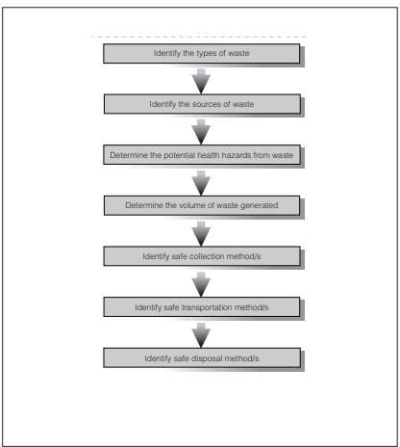

### Key components of solid waste management

Solid waste management can be divided into five key components:

1. Generation.
2. Storage.
3. Collection.
4. Transportation.
5. Disposal.

### Generation

Generation of solid waste is the stage at which materials become valueless to the owner and since they have no use for them and require them no longer, they wish to get rid of them. Items which may be valueless to one individual may not necessarily be valueless to another. For example, waste items such as tins and cans may be highly sought after by young children.

### Storage

Storage is a system for keeping materials after they have been discarded and prior to collection and final disposal. Where on-site disposal systems are implemented, such as where people discard items directly into family pits, storage may not be necessary. In emergency situations, especially in the early stages, it is likely that the affected population will discard domestic waste in poorly defined heaps close to dwelling areas. If this is the case, improved disposal or storage facilities should be provided fairly quickly and these should be located where people are able to use them easily. Improved storage facilities include:

* + - 1. Small containers: household containers, plastic bins, etc. Large containers: communal bins, oil drums, etc.
      2. Shallow pits.
      3. Communal depots: walled or fenced-in areas.

In determining the size, quantity and distribution of storage facilities the number of users, type of waste and maximum walking distance must be considered. The frequency of emptying must also be determined, and it should be ensured that all facilities are reasonably safe from theft or vandalism.

### Collection

Collection simply refers to how waste is collected for transportation to the final disposal site. Any collection system should be carefully planned to ensure that storage facilities do not become overloaded. Collection intervals and volumes of collected waste must be estimated carefully.

### Transportation

This is the stage when solid waste is transported to the final disposal site. There are various modes of transport which may be adopted and the chosen method depends upon local availability and the volume of waste to be transported. Types of transportation can be divided into three categories:

* + - 1. Human-powered: open hand-cart, hand-cart with bins, wheelbarrow, tricycle.
      2. Animal-powered: donkey-drawn cart.
      3. Motorized: tractor and trailer, standard truck, tipper-truck.

### Disposal

The final stage of solid waste management is safe disposal where associated risks are minimized. There are four main methods for the disposal of solid waste:

* + - 1. Land application: burial or landfilling.
      2. Composting.
      3. Burning or incineration.
      4. Recycling (resource recovery).

The most common of these is undoubtedly land application, although all four are commonly applied in emergency situations.

## Radioactive Pollution:

The spontaneous emission of particles and rays by an unstable nucleus is called Radioactivity and such substances are called Radioactive Substances eg. Radium, Uranium, Thorium. Radioactive pollution can be defined as the release of radioactive substances or high-energy particles into the air water, or earth as a result of human activity, either by accident or by design. Sometimes natural sources of radioactivity, such as radon gas emitted from beneath the ground, are considered pollutants when they become a threat to human health.

### The sources of Radioactive wastes are:

1. **Natural sources:** Solar radiation, Radio nuclides in the earth Crust, Human Internal radiation, environmental Radiations.
2. **Anthropogenic Sources:** The sources of such waste include:
   1. nuclear weapon testing or detonation.
   2. the nuclear fuel cycle, including the mining, separation, and production of nuclear materials for use in nuclear power plants or nuclear bombs.
   3. accidental release of radioactive material from nuclear power plants.

### Effects of radioactive pollution:

#### The effect of radioactive pollution depends upon:

1. Half –life
2. Energy releasing capacity
3. Rate of diffusion
4. Rate of deposition of the contaminant.
5. Various atmospheric and climatic conditions such as wind, temperature, rainfall also determine their effects.

### Effects of industrial effluents

Industries need a wide variety of raw materials and chemicals which are later discharged as effluents. Acids, alkalis, toxic metals, pesticides and other poisonous substances such as cyanide, dyes, oils, detergents, resins, rubbers are a few to mention. Heated effluents that impart thermal loading on receiving waters and effluents containing radioactive materials are also of prime concern. Some of the effluents such as from tanning and meat packing may also contain pathogenic bacteria. The nature and extent of pollution depends on the materials present in the effluent and on the quantity discharged.

* 1. **Nuclear Fuel Cycle**:

Most nuclear waste comes from the byproducts of the nuclear fuel cycle. The cycle typically is split into three sections: front end, service period, and back end. There can be intermediate stages that include the reprocessing of nuclear waste elements.

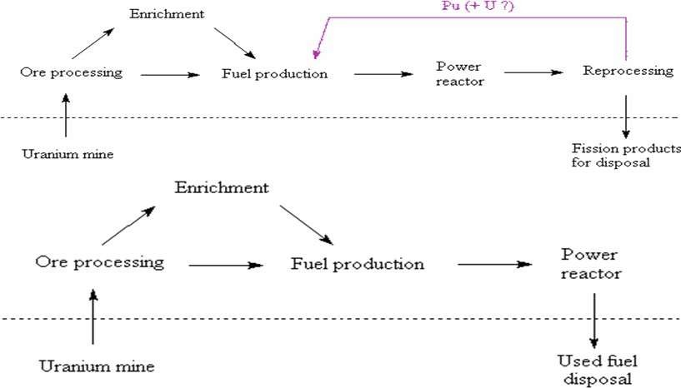

* 1. **Classifications of Nuclear Waste:**

Nuclear waste is segregated into several classifications.

1. Low level waste is not dangerous but sometimes requires shielding during handling.
2. Intermediate level waste typically is chemical sludge and other products from reactors.
3. High level waste consists of fissionable elements from reactor cores and transuranic wastes.
4. Transuranic waste is any waste with transuranic alpha emitting radionuclides that have half-lives longer than 20 years.
5. **Low Level Waste LLW**:
   * Low level waste is any waste that could be from a high activity area.
   * 90% volume of waste
   * It does not necessarily carry any radioactivity.
   * Split into four categories: A, B, C, and GTCC.
6. **Intermediate Level Waste ILW:**
   * Intermediate level waste requires shielding when being handled.
   * 7% volume of waste
   * Dependent on the amount of activity it can be buried in shallow repositories.
   * Not recognized in the United States.
7. **High Level Waste HLW:**
   * High level waste has a large amount of radioactive activity and is thermally hot.
   * 3% volume of waste
   * 95% of radioactivity
   * Current levels of HLW are increasing about 12,000 metric tons per year.
   * Most HLW consists of Pu-238, 239, 240, 241, 242, Np-237, U-236.
8. **Transuranic Waste TRUW**:

* Transuranic waste consists of all waste that has radionuclides above uranium.
* TRUWs typically have longer half-lives than other forms of waste.
* Typically, a byproduct of weapons manufacturing.
* Only recognized in the United States.

**5.6 Creation of Nuclear Waste**

* Nuclear waste is generated at all points of the fuel cycle.
* Front end waste consists primarily of low-level alpha emission waste.
* Service period waste typically includes LLW and ILW such as contaminated reactor housings and waste from daily operation.
* Back end waste normally is the most radioactive and includes spent fuel rods and reactor cores.

### 5.7 Control of Radioactive pollution:

The main objective in managing and disposing of radioactive (or other) waste is to protect people and the environment. This means isolating or diluting the waste so that the rate or concentration of any radionuclides returned to the biosphere is harmless. To achieve this for the more dangerous wastes, the preferred technology to date has been deep and secure burial. Transmutation, long-term retrievable storage, and removal to space have also been suggested.

* Nuclear devices should never be exploded in air. If these activities are extremely necessary, they should be exploded underground.
* In nuclear reactions, closed-cycle coolant system with gaseous coolants of very high purity may be used to prevent extraneous activation products.
* In nuclear and chemical industries, the use of radio-isotopes may be carried under a set of soil or water instead of power or gaseous forms.
* In Nuclear mines, wet drilling may be employed along the underground drainage.
* Nuclear reactors must be enclosed in broad concrete walls to prevent the radiations that emerge out.
* Workers should wear protective garments and glass spectacles should be screened from radiation.
* Extreme care should be exercised in the disposal of industrial waste contaminated with radionuclides.

# Industrial Safety

## Occupational Health and Industrial Safety

It is defined as “science and art devoted to the anticipation, recognition, evaluation, and control of those environmental factors or stresses arising in or from the work place, which may cause sickness, impaired health and well-being, or significant discomfort among workers or among the citizens of the community”.

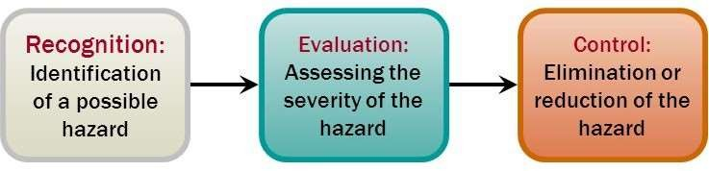

### Purposes of Occupational Health and Industrial Safety Program

* + 1. To determine whether the work environment and working conditions of workers are harmful to their health and well-being and prevent such conditions from occurring.
    2. To promote the best possible physical, mental and social health of people at work.
    3. To prevent occupational diseases caused by physical chemical and biological agents.

### Elements of the work environment

The basic elements in an occupational setting such as a manufacturing plant, industry, or offices are four. These are:

* + 1. The worker
    2. The tool
    3. The process
    4. The work environment

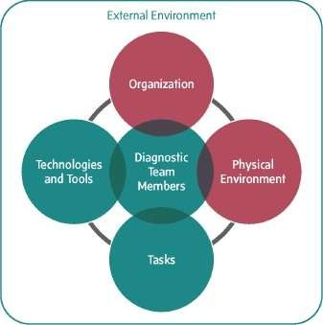

### Safety Program

**Safety Program to Minimize the RISK** from “danger, Injury, damage, loss, accidents”, and search all hazards at the workplace.

#### Organization, Management.

OSHMS, SHC, SHO, Policy, Rules and Regulations, SOP, Standard etc.

#### Assess the potential risk.

Attitude, Awareness and Action (AAA)

#### Fundamentals of control measures.

Technical knowledge to design/select, construct, operate, maintain etc.

#### Experience

Learn from past accidents and experience of others

#### Time

To set up system, do hazard identification, do risk assessment, do documentation, do safety review, training, etc.

#### You

Everyone (workers and management) should participate/contribute.

#### INDUSTRIAL SAFETY MEANS:

Control of hazards by abidance to best practice, or it is degree of protection of hazards.

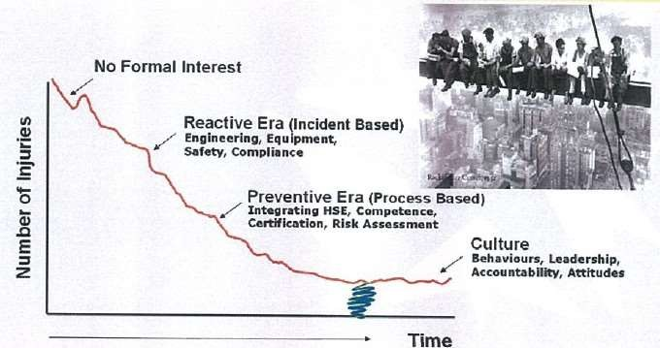

### Definitions of Terms: -

1. **Incident:** An event that results in death or injury to person where the injury requires medical attention (including first aid).

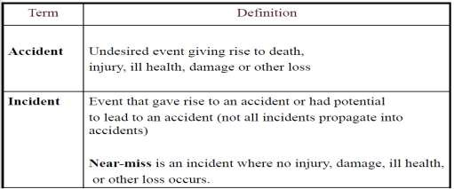

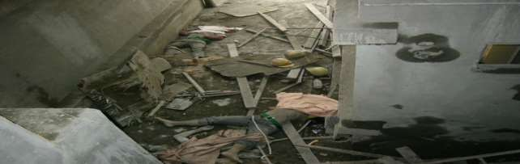

1. **Exposure: -** The measurement of time during which the subject is at risk from a hazard.
2. **Fatality: -** Death due to a work-related incident or illness regardless of the time between injury or illness and death.
3. **Harm: -** Includes death, injury, physical or mental ill health, damage to property, loss of production, or any combination of these.
4. **Hazard: -** A source or a situation with a potential to cause harm, including human injury or ill health, damage to property, damage to the environment, or a combination of these.
5. **Lost Time Injury (LTI): -** Work related injury or illness that renders the injured person unable to perform any of their duties or return to work on a scheduled work shift, on any day immediately following the day of the accident.
6. **Medical Treatment Case (MTC): -** Work related injury or illness requiring more than first aid treatment by a physician, dentist, surgeon or registered medical personnel.
7. **Personal Protective Equipment (PPE): -** All equipment and clothing intended to be utilized, which affords protection against one or more risks to health and safety. This includes protection against adverse weather conditions.
8. **Restricted Work Case: -** Work related injury or illness that renders the injured person unable to perform all assigned work functions during a scheduled work shift or being assigned to another job on a temporary or permanent basis on the day following the injury:
   1. **Risk: -** The likelihood (probability) of a specific hazardous event (e.g. accident) occurring and its consequences.
   2. **Risk Assessment: -** The process of analyzing the level of risk considering those in danger, and evaluating whether hazards are adequately controlled, taking into account any measures already in place.
   3. **Risk Management**: - The process of identifying hazards, assessing risk, taking action to eliminate or reduce risk, and monitoring and reviewing results.

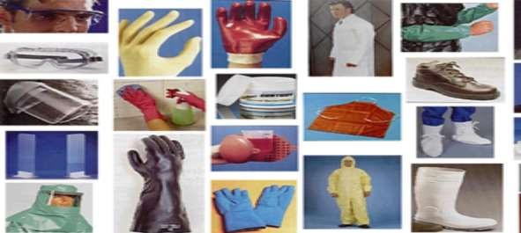

#### Difference between Risk & Hazard

The term "**risk**" is often confused with "hazard". A high voltage power supply, a sample of radioactive material, or a toxic chemical may present a hazard, meaning that they present the potential for harm. Risk indicates probability of hazard causing the harm.

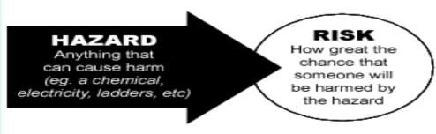

### Environmental Factors or Stresses: -

The various environmental factors or stresses that can cause sickness, impaired health, or significant discomfort in workers can be classified as chemical, physical, biological, or ergonomic.

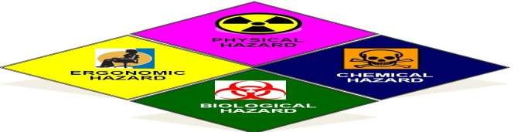

### Chemical hazards:

These arise from excessive airborne concentrations of mists, vapors, gases, or solids in the form of dusts or fumes. In addition to the hazard of inhalation, some of these materials may act as skin irritants or may be toxic by absorption through the skin.

When you work with chemical beware of:

* + - 1. Liquids like cleaning products, paints, acids, solvents – ESPECIALLY if chemicals are in an unlabeled container.
      2. Vapors and fumes that come from welding or exposure to solvents.
      3. Gases like acetylene, propane, carbon monoxide and helium.
      4. Flammable materials like gasoline, solvents, and explosive chemicals.
      5. Pesticides.

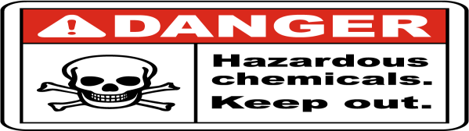

### Physical hazards:

Physical hazard has possible cumulative or immediate effects on the health of employees. Therefore, employers and inspectors should be alert to protect the workers from adverse physical hazards. Physical hazard includes:

* + - 1. Extremes of temperature.
      2. Ionizing radiation.
      3. Non ionizing radiation.
      4. Excessive noise.

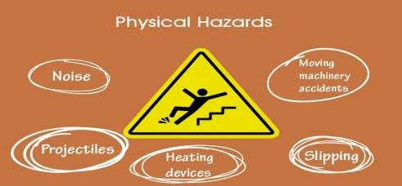

### Ergonomic hazards:

These include improperly designed tools, work areas, or work procedures. Improper lifting or reaching, poor visual conditions, or repeated motions in an awkward position can result in accidents or illnesses in the occupational environment. Designing the tools and the job to fit the worker is of prime importance. Engineering and biomechanical principles must be applied to eliminate hazards of this kind. Ergonomic Hazards include:

* + - 1. Improperly adjusted workstations and chairs.
      2. Frequent lifting.
      3. Poor posture.
      4. Awkward movements, especially if they are repetitive.
      5. Repeating the same movements over and over.
      6. Having to use too much force, especially if you have to do it frequently.
      7. Vibration.

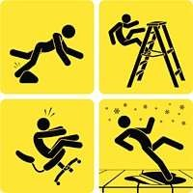

### Biological hazards:

These are any living organism or its properties that can cause an adverse response in humans. They can be part of the total environment or associated with a particular occupation. Work-related illnesses due to biological agents have been widely reported, but in many work- places their presence and resultant illness are not well recognized. It is estimated that the population at risk for occupational biohazards may be several hundred million workers worldwide.

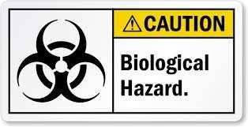

Exposure to many of the harmful stresses or hazards listed can produce an immediate response due to the intensity of the hazard, or the response can result from longer exposure at a lower intensity. In certain occupations, depending on the duration and severity of exposure, the work environment can produce significant subjective responses or strain. The energies and agents responsible for these effects are called environmental stresses. An employee is most often exposed to an intricate interplay of many stresses, not to a single environmental stress.