**قــســــــــــم الامــــــــــــــــــــــــــن الــــــــــــــــــــــــــــــــــــسيبرانــــــــــــــــــــــــــــــــــــي**

**Department of Cyber Security**

**Subject:**

**COMPUTER ORGANIZATION & LOGIC DESIGN**

**Class:**

**First**

**Lecture: ( 3 )**

**(Numbers System)**

**Lecturer:**

**Msc :Muntather AL-mussawee**

## Lec._3

**Convert Between Number Systems / التحويل بين أنظمة الأرقام For example: (4)10 in binary is (100)2**.

Here, 4 is represented in the decimal number system, where we can represent the number using the digits from 0-9. However, in a binary number system, we use only two digits, such as 0 and 1.

Now, let’s discuss how to convert 4 in binary number

دعونا نناقش كيفية تحويل رقم 4 الى النظام الثنائيsystem.

The following steps help to convert 4 in binary divide the number 4 by 2. Use the integer quotient obtained in this step as the dividend for the next step.

Continue this step, until the quotient becomes 0.

|  |  |  |  |  |
| --- | --- | --- | --- | --- |
| **Dividend** | **Remainde r** | **Rank** | | |
| 4/2 = 2 | 0 | 20 21  22 | Least Significant Bit (LSB) |  |
| 2/2 = 1 | 0 | Most Significant Bit (MSB) |
| 1/2 = 0 | 1 |
| **لذلك 4)10) =** .**2(001)** | |

**For example: (61)10** How to convert in binary number system **(?)2**.

|  |  |  |  |  |  |  |  |
| --- | --- | --- | --- | --- | --- | --- | --- |
| **Dividend** | **Remainder** | **Rank** | | | |  | **To check**  **Convert binarytodecimal** |
| 61/2 = 30 | 1 | 20 21  22 | (LSB) | |  |  | 1X1 |
| 30/2 = 15 | 0 |  | | 0X2 |
| 15/2 = 7 | 1 | 1X4 |
| 7/2 = 3 | 1 | 23 | | | |  | 1X8 |
| 3/2 = 1 | 1 | 24 | | | |  | 1X16 |
| 1/2 = 0 | 1 | 25 | | (MSB) | |  | 1X32 |
| **لذلك 61)10) =** .**2(101111)** | |  | | | |  | **Sum all** =61 |

**Octal and hexadecimal Number System – Conversions, Examples**

**Octal** Every digit has to be converted to a 3-bit binary number. Thus, we get the binary equivalent of the number.

**hexadecimal** Every digit has to be converted to a 4-bit binary number. Thus, we get the binary equivalent of the number.

Let’s understand this with the help of an example.

**Example: Convert** (16)8 **into a binary number.** Then to **hexadecimal**

**Solution:** (16)8 is an octal number.

With the above conversion, we can write

18=0012 and 68=1102

Thus, (16)8=(001110)2

So (16)8=(0E)16

**Example: Convert** (16)16 **into a binary number.** Then to **octal**

**Solution:** (16)16 is an hexadecimal number.

With the above conversion, we can write

116=00012 and 616=01102

Thus, (16)16=(00010110)2

So (16)16=(26)8

|  |
| --- |
| **Convert each hex digit to 4 binary digits and then convert each 3 binary digits** |
| **to octal digits**  **قم بتحويل كل رقم سداسي عشري إلى 4 أرقام ثنائية ثم قم بتحويل كل 3 أرقام ثنائية إلى أرقام ثماني** |

**Conversion of Octal to Decimal Numbers**

Converting octal to decimal is a simple process!

A number in the octal system is expanded with the base of eight, where each digit is multiplied with the power of 8, based on its position.

After the octal is converted to decimal, it has a base of 10.

**Example: Convert** (321)8 **to decimal form.**

(321)8=(3×82)+(2×81)+(1×80)

=(3×64)+(2×8)+(1×1)

=192+16+1 =20910

Thus, (321)8=(209)10

## Conversion of Decimal to Octal Number

In this conversion, the decimal number is divided by 8 each time a reminder is obtained from the previous digit. Let us understand this conversion with the help of an example.

**Example: Convert** 41610 **to octal.**

Divide 416 by the octal base number, 8.

**Division by 8**

**Quotient**

**R**

**emainder**

**416÷8**

**52**

**0**

**52**

**÷**

**8**

**6**

**4**

**÷**

**6**

**8**

**0**

**6**

We stop when the quotient value becomes 0. By writing the remainders in reverse order, we get the equivalent octal number. Thus, the octal representation of 41610 is 6408.

## Conversion of Octal to Hexadecimal Numbers

The simplest way is to first convert the octal number to a decimal, and then the decimal to a hexadecimal number.

Let us understand octal to hexadecimal conversion with the help of an example.

**Example: Convert** (70)8 **to hexadecimal.**

**Step 1: Octal to Decimal**

(70)8=(7×81)+(0×80)

(70)8=(56)10

**Step 2: Decimal to hexadecimal**

Now, we need to convert (56)10 to a hexadecimal number.

Divide the number 56 by 16 until the number in the quotient value becomes 0.

Write remainders in reverse order.

Therefore, (70)8=(38)16

## Octal Multiplication Table

You can multiply octal numbers in two ways. One way is to convert octal to decimal: perform the decimal multiplication to get the product and convert the result back to octal. The second way is simply using the octal multiplication table. Example:

× 0 1 2 3 4 5 6 7

1. 0 0 0 0 0 0 0 0
2. 0 1 2 3 4 5 6 7
3. 0 2 4 6 10 12 14 16
4. 0 3 6 11 14 17 22 25
5. 0 4 10 14 20 24 30 34
6. 0 5 12 17 24 31 36 43
7. 0 6 14 22 30 36 44 52 7 0 7 16 25 34 43 52 61

**Facts about the Octal Number System**

* In 1801, James Anderson criticized the French for basing the metric system on decimal arithmetic. He suggested the base 8 and he coined the term octal.
* The main advantage of using octal numbers is that it uses fewer digits than the decimal and hexadecimal number system. So, it has fewer computations and less computational errors.
* The octal number system is widely used in computer application sectors and digital numbering systems. The octal number is also used in the aviation sector in the form of a code.
* The octal system is similar to the hexadecimal system because they are both easily converted to binary, where octal is equal to three-digit binary and hexadecimal is equal to four-digit binary.

### Lec._4

**مقارنة بين النظام الثماني والسادس عشر**

|  |  |  |  |  |  |  |  |  |  |  |  |  |  |  |  |  |
| --- | --- | --- | --- | --- | --- | --- | --- | --- | --- | --- | --- | --- | --- | --- | --- | --- |
|  | 𝟖𝟑 | 𝟖𝟐 | 𝟖𝟏  **octal** | 𝟖𝟎 |  |  | 𝟏𝟎𝟑 | 𝟏𝟎𝟐 | 𝟏𝟎𝟏 | 𝟏𝟎𝟎 |  |  | 𝟏𝟔𝟐 | 𝟏𝟔𝟏  **hexadecimal** | 𝟏𝟔𝟎 |  |
| **Decimal** | | | |
| **0412** | | | | |  | **0266** | | | | |  | **10A** | | | | |
| **0413** | | | | |  | **0267** | | | | |  | **10B** | | | | |
| **1776** | | | | |  | **1022** | | | | |  | **3FE** | | | | |
| **1777** | | | | |  | **1023** | | | | |  | **3FF** | | | | |

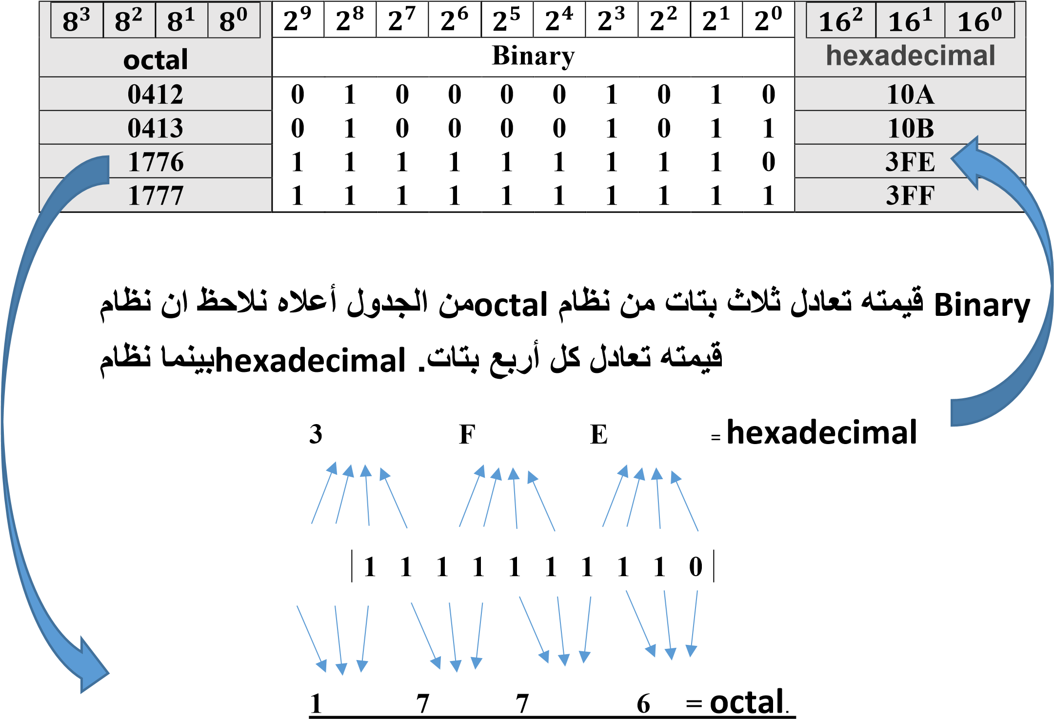

**التحقق:**

#### =1 x 83 + 7 x 82 + 7 x 81 + 6 x 80 octal نظام .1

= 6 x 1 + 56 + 448 + 512

= 1022 بالنظام **decimal**.

#### = 3 x 162 + F x 161 + E x hexadecimal نظام .2

**=**14 x 1 + 15 x 16 + 3 x 256

**بالنظام** 1022**=decimal**