[**Bladder Cancer**](http://www.lifenurses.com/2010/11/nursing-care-plans-for-bladder-cancer.html)

[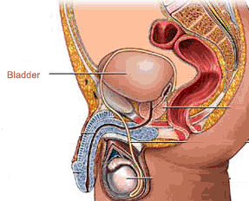](http://4.bp.blogspot.com/-QOaMgU1LcSE/VE6EGF-yxvI/AAAAAAAAALE/JTGVInftSJs/s1600/Bladder.gif)

Benign or malignant tumors may develop on the bladder. Bladder tumors can develop on the surface of the bladder wall (benign or malignant papillomas) or grow within the bladder wall (usually more virulent) and quickly invade underlying muscles.

Most bladder tumors are transitional cell carcinomas, arising from the transitional epithelium of mucous membranes. Less common are adenocarcinomas, epidermoid carcinomas, squamous cell carcinomas, sarcomas, tumors in bladder diverticula, and carcinoma in situ. Bladder tumors are most prevalent in men older than age 50 and are more common in densely populated industrial areas, but women are diagnosed at more advanced stages.

**Sign and symptoms**

The most common presenting symptom of bladder cancer is hematuria. Gross hematuria obviously warrants a thorough evaluation of the genitourinary system. When gross hematuria is painless and total (present during the entirety of the urinary stream),

, including frequency, urgency, and dysuria. The combination of these symptoms with hematuria is very suggestive and warrants full urologic evaluation.

patients may have symptoms of bladder-outlet obstruction or ureteral obstruction. A small subset, 5% to 10% of patients, have symptoms related to metastatic disease.

**Causes for Bladder cancer**

Environmental carcinogens are known to predispose a person to transitional cell tumors such as 2-naphthylamine, benzidine, tobacco, coffee, and nitrates.Thus, workers in certain industries (rubber workers, weavers, leather finishers, aniline dye workers, hairdressers, petroleum workers, and spray painters) are at high risk for such tumors.. Squamous cell carcinoma of the bladder is common in geographic areas where schistosomiasis is endemic, such as Egypt. What is more, it’s also associated with chronic bladder irritation and infection in people with renal calculi, indwelling urinary catheters, chemical cystitis caused by cyclophosphamide, and pelvic irradiation.

**Complications of bladder cancer**

If bladder cancer progresses, complications include bone metastases and problems resulting from tumor invasion of contiguous viscera.

**Nursing Assessment**

The patient typically reports gross, painless, intermittent hematuria and often with clots. Patients may complain of suprapubic pain after voiding, and also complain of bladder irritability, urinary frequency, nocturia, and dribbling. If he reports flank pain, he may have an obstructed ureter.

**Patient’s histor**y Gross, painless, intermittent hematuria is the most frequently reported symptom. Occult blood may be discovered during a routine urinalysis. Dysuria and urinary frequency are also reported. Burning and pain with urination are present only if there is infection. The patient may not seek medical attention until urinary hesitance, and flank pain occurs. Other symptoms may include suprapubic pain after voiding, bladder irritability, dribbling, and nocturia.

**Physical assessment** The physical examination is usually normal. A bladder tumor becomes palpable only after extensive invasion into surrounding structures.

**Psychosocial assessment** Diagnosis of cancer and treatment of cancer with radical cystectomy and creation of a urinary diversion system can threaten sexual functioning of both men and women. The procedure can cause impotence in men and psychological problems similar to those that accompany a hysterectomy and oophorectomy in women. In addition, a portion of the vagina may be removed, thus affecting intercourse. The psychological impact of a stoma and external urinary drainage system can cause changes in body image and libido.

**Nursing diagnosis**

Common nursing diagnosis found in nursing care plans for bladder cancer

* Acute pain
* Anxiety
* Disturbed body image
* Fear
* Impaired skin integrity
* Impaired urinary elimination
* Ineffective coping
* Ineffective therapeutic regimen management
* Risk for infection
* Sexual dysfunction

**Nursing Interventions**

**Acute Pain related to activity of disease process (cancer)**

Nursing Outcomes Evaluation Criteria: Client will

* verbalize relief or control of pain.
* Client will appear relaxed and be able to sleep and rest appropriately.

Nursing Intervention nursing diagnosis Acute Pain related to activity of disease process (cancer):

1. Assess pain level, location, characteristics, and intensity Rationale Helps evaluate degree of discomfort and effectiveness of analgesia or may reveal developing complications. Pains in Surgical causes usually subside gradually as healing begins. Continued or increasing pain may be a sign of infection.
2. Listen to the patient’s fears and concerns. Stay with him during periods of severe stress and anxiety, and provide psychological support Rationale Reduction of anxiety and fear can promote relaxation and comfort.
3. Encourage and maintain bed rest during acute phase, if indicated Rationale Minimizes stimulation and promotes relaxation
4. Administer analgesics, as indicated Rationale Reduce or control pain and decrease stimulation of the sympathetic nervous system

Anxiety related to underlying Pathophysiology response, change in health status

Nursing Outcomes

* verbalize awareness of feelings of anxiety and healthy ways to deal with them.
* Patients will Report that anxiety is reduced to a manageable level.
* Patients will express concerns about effect of disease on lifestyle and position within family and society.
* Patients will demonstrate problem-solving skills and effective coping strategies and Use resources/support systems effectively.

**Nursing Intervention Anxiety**

* Observe behavior indicative of anxiety which can be a clue to the client’s level of anxiety Rationale
* Explain purpose of tests and procedures in bladder cancer treatment Rationale Reduces anxiety attributable to fear of unknown diagnosis and prognosis.
* Encourage family and friends to treat client as before. Rationale Reassures client that role in the family and business has not been altered.
* Administer sedatives and tranquilizers, as indicated. Rationale May be desired to help client relax until physically able to reestablish adequate coping strategies.
* Review coping skills used in past and Identify coping skills the individual is using currently, such as anger, daydreaming, forgetfulness, eating, smoking, lack of problem solving. Rationale These may be useful for the moment, but may eventually interfere with resolution of current situation

**Nursing Diagnosis Impaired urinary elimination**

* Patients will Display continuous flow of urine, with output adequate for individual situation
* Patients will verbalize understanding of condition.
* Patients will achieve normal elimination pattern.
* Patients will demonstrate behaviors/techniques to prevent urinary infection.
* Manage care of urinary catheter, or stoma and appliance following urinary diversion.

**Treatment**

Treatment options for bladder cancer depend on a number of factors, including the type of cancer, grade of the cancer and stage of the cancer, which are taken into consideration along with your overall health and your treatment preferences.

Bladder cancer treatment may include:

* **Surgery,** to remove the cancer cells
* **Chemotherapy in the bladder (intravesical chemotherapy),** to treat cancers that are confined to the lining of the bladder but have a high risk of recurrence or progression to a higher stage
* **Chemotherapy for the whole body (systemic chemotherapy),** to increase the chance for a cure in a person having surgery to remove the bladder, or as a primary treatment when surgery isn't an option
* **Radiation therapy,** to destroy cancer cells, often as a primary treatment when surgery isn't an option or isn't desired
* **Immunotherapy,** to trigger the body's immune system to fight cancer cells, either in the bladder or throughout the body
* **Targeted therapy,** to treat advanced cancer when other treatments haven't helped

A combination of treatment approaches may be recommended by the doctor and members of your care team.

**Bladder cancer surgery**

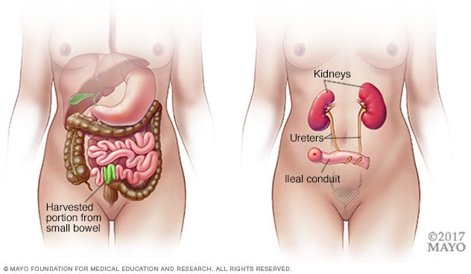**Ileal conduit**Enlarge image

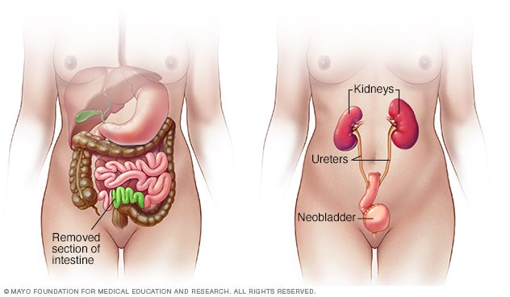**Neobladder reconstruction**Enlarge image

Approaches to bladder cancer surgery might include:

* **Transurethral resection of bladder tumor (TURBT).** TURBT is a procedure to diagnose bladder cancer and to remove cancers confined to the inner layers of the bladder — those that aren't yet muscle-invasive cancers. During the procedure, a surgeon passes an electric wire loop through a cystoscope and into the bladder. The electric current in the wire is used to cut away or burn away the cancer. Alternatively, a high-energy laser may be used.

Because doctors perform the procedure through the urethra, pt have any cuts (incisions) in your abdomen.

* **Cystectomy.** Cystectomy is surgery to remove all or part of the bladder. During a partial cystectomy, the surgeon removes only the portion of the bladder that contains a single cancerous tumor.

A radical cystectomy is an operation to remove the entire bladder and the surrounding lymph nodes. In men, radical cystectomy typically includes removal of the prostate and seminal vesicles. In women, radical cystectomy may involve removal of the uterus, ovaries and part of the vagina.

* **Neobladder reconstruction.** After a radical cystectomy, the surgeon must create a new way for urine to leave your body (urinary diversion). One option for urinary diversion is neobladder reconstruction. the surgeon creates a sphere-shaped reservoir out of a piece of the intestine. This reservoir, often called a neobladder, sits inside the body and is attached to the urethra. The neobladder allows most people to urinate normally. A small number of people difficulty emptying the neobladder and may need to use a catheter periodically to drain all the urine from the neobladder.
* **Ileal conduit.** For this type of urinary diversion, the surgeon creates a tube (ileal conduit) using a piece of your intestine. The tube runs from the ureters, which drain your kidneys, to the outside of your body, where urine empties into a pouch (urostomy bag) you wear on the abdomen.
* **Continent urinary reservoir.** During this type of urinary diversion procedure, the surgeon uses a section of intestine to create a small pouch (reservoir) to hold urine, located inside the body. the drain urine from the reservoir through an opening in your abdomen using a catheter a few times each day.

**Chemotherapy**

Chemotherapy uses drugs to kill cancer cells. Chemotherapy treatment for bladder cancer usually involves two or more chemotherapy drugs used in combination.

Chemotherapy drugs can be given:

* **Through a vein (intravenously).** Intravenous chemotherapy is frequently used before bladder removal surgery to increase the chances of curing the cancer. Chemotherapy may also be used to kill cancer cells that might remain after surgery. In certain situations, chemotherapy may be combined with radiation therapy.
* **Directly into the bladder (intravesical therapy).** During intravesical chemotherapy, a tube is passed through your urethra directly to your bladder. The chemotherapy is placed in the bladder for a set period of time before being drained. It can be used as the primary treatment for superficial bladder cancer, where the cancer cells affect only the lining