

**College of Health and Medical Technologies**

**Department of Radiology Technologies**

**Radiobiology**

**The first stage**

**Dr. Arshed AL-kafagi**

**Introduction to Radiobiology**

**Radiobiology**, A branch of science that deals with the action of ionizing radiation on biological tissues and living organisms, is a combination of two disciplines: radiation physics and biology.

All living organisms are composed of protoplasm which consists of organic and inorganic compounds dissolved or suspended in water.

Cells contain inorganic compounds (water and minerals) as well as organic compounds (proteins, carbohydrates, nucleic acids, lipids).

• The two main constituents of a cell are the cytoplasm, which supports all metabolic functions within the cell, and the nucleus, which contains the genetic information (DNA).

• Human cells are **somatic** cells and **germ** cells.

• Cells propagate through division; division of somatic cells is called **mitosis**, division of germ cells meiosis.

• When a **somatic cell** divides, two cells are produced, each carrying a chromosome complement identical to that of the original cell.

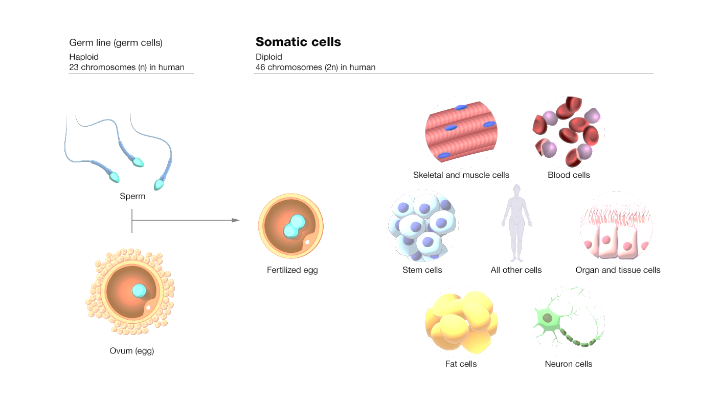

**Somatic cells are classified as:** -

1. **Stem cells**: exist to self-perpetuate and produce cells for a differentiated cell population (e.g., stem cells of the hematopoietic system, epidermis, mucosal lining of the intestine).
2. **Transit cells:** cells in movement to another population (e.g., a reticulocyte which is differentiating to become an erythrocyte).
3. **Mature cells:** cells that are fully differentiated and do not exhibit mitotic activity (e.g., muscle cells, nervous tissue).

* A group of cells that together perform one or more functions is referred to as tissue.
* A group of tissues that together perform one or more functions is called an organ.
* A group of organs that perform one or more functions is a system of organs or an organism.

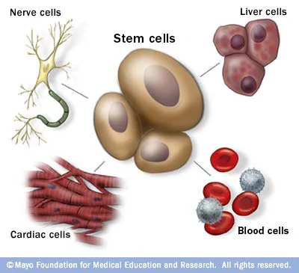

Linear energy transfer (LET) determines the beam quality of ionizing radiation.

LET focuses attention on the linear rate of energy absorption by the absorbing medium as a charged particle traverses the medium.

Typical LET values for commonly used radiations are:

* 1. **250 kVp x ray : 2 keV /µ m**
  2. **cobalt-60 gamma ray : 0.3 keV/µ m**
  3. **3 MeV x ray : 0.3 keV/µ m**
  4. **1 MeV electron : 0.25 keV/µ m**

\***kVp. The kilo voltage peak**

**\* keV. kilo-electron-volt.**

X rays and gamma rays are considered low LET (sparsely ionizing) radiations, while energetic neutrons, protons and heavy charged particles are high LET (densely ionizing) radiations.

The demarcation value between low and high LET is at about 10 keV/µ m.

**CELL CYCLE AND CELL DEATH**

The cell proliferation cycle is defined by two well-defined time periods:

(1) Mitosis M where division takes place, and

(2) the period of DNA synthesis S.

The S and M portions of the cell cycle are separated by two periods (gaps) G1 and G2 when DNA is not yet synthesized but other metabolic processes take place.

The time between successive divisions (mitoses) is called **cell cycle time**.

For mammalian cells growing in culture:

* the S phase is usually in the range of 6-8 hours
* M less than an hour
* G2 in the range of 2-4 hours.
* G1 from 1-8 hours

making the total cell cycle in the order of 10-20 hours. In contrast, the cell cycle for stem cells in certain tissues is up to about 10 days.

In general, cells are most radiosensitive in the M and G2 phases, and most resistant in the late S phase.

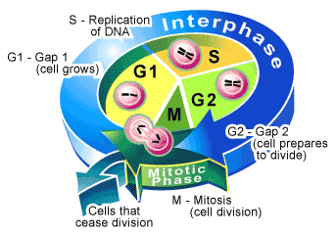

The cell cycle time of **malignant cells** is shorter than that of some normal **tissue cells**, but during regeneration after injury normal cells can proliferate faster.

Cell death for non-proliferating (static) cells is defined as the loss of a specific function,

while for stem cells it is defined as the loss of reproductive integrity (reproductive death).

A surviving cell that maintains its reproductive integrity and proliferates indefinitely is said to be **clonogenic**.

**IRRADIATION OF CELLS**

The biological effects of radiation result mainly from damage to the DNA which is the most critical target within the cell.

however, there are also other sites in the cell which, when damaged, may lead to cell death.

When directly ionizing radiation is absorbed in biological material, the damage to the cell may occur in one of two ways: **direct** or **indirect** action.

1. **Direct action in cell damage by radiation**

In direct action the radiation interacts directly with the critical target in the cell.

Direct action is the dominant process in interaction of high LET particles with biological materials.

The direct ionization of atoms in DNA molecules is the result of energy absorption via the photoelectric effect and Compton interactions. If this absorbed energy is sufficient to remove electrons from the molecule, bonds are broken, which can break one DNA strand or both . A single broken strand can usually be repaired by the cell, while two broken strands commonly result in cell death.

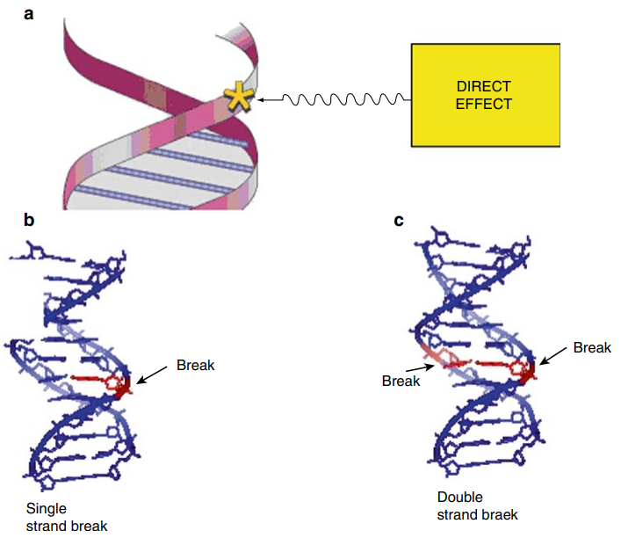

1. Radiobiology combines which two disciplines?

- a) Chemistry and Biology

- b) Physics and Chemistry

- c) Radiation Physics and Biology

- d) Biology and Genetics

- e) Physics and Genetics

2. What is the main constituent of protoplasm?

- a) Inorganic compounds only

- b) Organic compounds only

- c) Organic and inorganic compounds dissolved or suspended in water

- d) Water only

- e) Minerals and vitamins

3. Which of the following is not an organic compound found in cells?

- a) Proteins

- b) Carbohydrates

- c) Nucleic acids

- d) Lipids

- e) Water

4. **What supports all metabolic functions within the cell?**

- a) Nucleus

- b) Mitochondria

- c) Cytoplasm

- d) Ribosomes

- e) Endoplasmic reticulum

5. **What contains the genetic information (DNA) in a cell?**

- a) Cytoplasm

- b) Nucleus

- c) Mitochondria

- d) Ribosomes

- e) Endoplasmic reticulum

6. **Which cells propagate through mitosis?**

- a) Germ cells

- b) Somatic cells

- c) Both somatic and germ cells

- d) Mature cells

- e) Stem cells

7. **How many cells are produced from one somatic cell during mitosis?**

- a) One

- b) Two

- c) Three

- d) Four

- e) Eight

8. **Which type of cells exist to self-perpetuate and produce cells for a differentiated cell population?**

- a) Transit cells

- b) Mature cells

- c) Stem cells

- d) Somatic cells

- e) Germ cells

9. **What are cells called that are fully differentiated and do not exhibit mitotic activity?**

- a) Transit cells

- b) Stem cells

- c) Mature cells

- d) Germ cells

- e) Somatic cells

10. **What is a group of cells that together perform one or more functions referred to as?**

- a) Organ

- b) Tissue

- c) System

- d) Organism

- e) Protoplasm

11. **What determines the beam quality of ionizing radiation?**

- a) LET (Linear Energy Transfer)

- b) Protoplasm

- c) DNA

- d) RNA

- e) Mitosis

12. **Which type of radiation is considered low LET?**

- a) Energetic neutrons

- b) Protons

- c) Heavy charged particles

- d) X rays and gamma rays

- e) Alpha particles

13. **What is the demarcation value between low and high LET?**

- a) 1 keV/µm

- b) 5 keV/µm

- c) 10 keV/µm

- d) 20 keV/µm

- e) 50 keV/µm

14. **During which phase does DNA synthesis occur?**

- a) M phase

- b) G1 phase

- c) G2 phase

- d) S phase

- e) Cytokinesis

15. **Which phase is the shortest in the cell cycle?**

- a) S phase

- b) G1 phase

- c) G2 phase

- d) M phase

- e) Interphase

16. **Cells are most radiosensitive during which phases?**

- a) M and G2 phases

- b) S and G1 phases

- c) Late S phase

- d) G1 and G2 phases

- e) Early S phase

17. **What defines cell death for non-proliferating (static) cells?**

- a) Loss of DNA

- b) Loss of function

- c) Loss of metabolic activity

- d) Loss of mitotic activity

- e) Apoptosis

18. **What is a clonogenic cell?**

- a) A cell that loses reproductive integrity

- b) A cell that maintains reproductive integrity and proliferates indefinitely

- c) A cell that dies after radiation exposure

- d) A cell in the G0 phase

- e) A cell in the G2 phase

19. **What is the most critical target within the cell for radiation damage?**

- a) RNA

- b) DNA

- c) Cytoplasm

- d) Cell membrane

- e) Mitochondria

20. **Which process involves radiation interacting directly with the critical target in the cell?**

- a) Indirect action

- b) Direct action

- c) Mitotic activity

- d) Apoptosis

- e) Cell repair

21. **What type of radiation interaction is dominant in high LET particles?**

- a) Indirect action

- b) Direct action

- c) Mitosis

- d) Apoptosis

- e) Meiosis

22. **What is the result of energy absorption via the photoelectric effect and Compton interactions in DNA?**

- a) RNA synthesis

- b) DNA synthesis

- c) DNA ionization

- d) DNA repair

- e) DNA damage

23. **What can a single broken DNA strand usually be repaired by?**

- a) RNA

- b) Proteins

- c) The cell

- d) Cytoplasm

- e) Lipids

24. **Which cells have a shorter cell cycle time during regeneration after injury?**

- a) Malignant cells

- b) Normal tissue cells

- c) Stem cells

- d) Mature cells

- e) Transit cells

25. **How long is the G2 phase in mammalian cells growing in culture?**

- a) 1-2 hours

- b) 2-4 hours

- c) 4-6 hours

- d) 6-8 hours

- e) Less than an hour

26. **Which cells are most resistant to radiation?**

- a) G1 phase cells

- b) Early S phase cells

- c) Late S phase cells

- d) G2 phase cells

- e) M phase cells

27. **What is the total cell cycle time for mammalian cells in culture?**

- a) 5-10 hours

- b) 10-20 hours

- c) 20-30 hours

- d) 30-40 hours

- e) 40-50 hours

28. **Which phase of the cell cycle involves metabolic processes other than DNA synthesis?**

- a) M phase

- b) S phase

- c) G1 phase

- d) G2 phase

- e) G0 phase

29. **What defines cell death for stem cells?**

- a) Loss of function

- b) Loss of metabolic activity

- c) Loss of reproductive integrity

- d) Apoptosis

- e) Necrosis

30. **Which phase of the cell cycle is usually in the range of 6-8 hours?**

- a) M phase

- b) S phase

- c) G1 phase

- d) G2 phase

- e) Interphase

31. **Which cells exhibit the most mitotic activity?**

- a) Stem cells

- b) Transit cells

- c) Mature cells

- d) Germ cells

- e) Somatic cells

32. **What is the typical LET value for 250 kVp X-ray?**

- a) 0.25 keV/µm

- b) 0.3 keV/µm

- c) 2 keV/µm

- d) 10 keV/µm

- e) 20 keV/µm

33. **Which radiation type has a LET value of 0.3 keV/µm?**

- a) 250 kVp X-ray

- b) 1 MeV electron

- c) 3 MeV X-ray

- d) Cobalt-60 gamma ray

- e) Alpha particles

34. **Which type of cell cycle time can extend up to about 10 days?**

- a) Somatic cells

- b) Germ cells

- c) Transit cells

- d) Stem cells in certain tissues

- e) Mature cells

35. **What is the process called when a cell loses its specific function due to radiation?**

- a) Apoptosis

- b) Necrosis

- c) Function loss

- d) Reproductive death

- e) Cell death

36. **What phase follows directly after the S phase in the cell cycle?**

- a) G1 phase

- b) G2 phase

- c) M phase

- d) Cytokinesis

- e) Interphase

37. **What is the linear rate of energy absorption by the absorbing medium called?**

- a) Energy Transfer Rate (ETR)

- b) LET (Linear Energy Transfer)

- c) Radiation Absorption Rate (RAR)

- d) Energy Absorption Rate (EAR)

- e) Linear Absorption Rate (LAR)

38. **Which of the following is not a typical LET value for commonly used radiations?**

- a) 250 kVp X-ray: 2 keV/µm

- b) Cobalt-60 gamma ray: 0.3 keV/µm

- c) 3 MeV X-ray: 0.3 keV/µm

- d) 1 MeV electron: 0.25 keV/µm

- e) 3 MeV X-ray: 2 keV/µm

39. **What defines the period between successive cell divisions?**

- a) Interphase

- b) Cell cycle time

- c) M phase

- d) S phase

- e) Mitotic index

40. **In which phases are cells most radiosensitive?**

- a) G1 and S phases

- b) S and G2 phases

- c) G2 and M phases

- d) M and G1 phases

- e) Late S and M phases