1

**(Static)**

Force System Resultants: Moment of a Force Scalar Formulation/Moment of a Force-Vector Formulation

1. **Force System Resultants**

Objectives of Force System Resultants consist of :

* Moment of a force in two and three dimensions.
* Moment of a couple.
* Reduce simple distributed loading to a resultant force having a specified location.
  1. 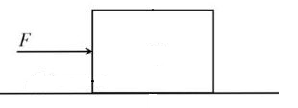**Moment of a Force - Scalar Formulation**

The force Move of body.

Rotate a body about an axis with distance perpendicular between them

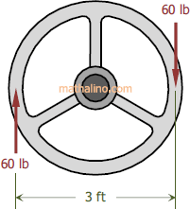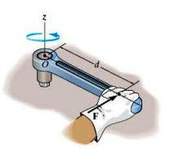this rotational known as the moment M, also referred to as torque.

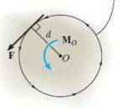Consider the force F and point O as shown in the figure, moment MO about axis passing through O and perpendicular to the plane, it has magnitude and direction.

**Magnitude of MO is:** MO= F*d (N.m or lb.ft)

Where: d = moment arm = perpendicular distance from the axis at point O to the line of action of force.

**Direction** **of MO is:**

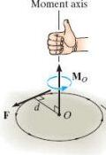The direction of MO is defined by its moment axis, perpendicular to the plane that contains the force F and its moment arm d .

**Right-hand rule** is used to establish the direction of MO

**Example 1 :**

The line of action of the force is illustrate as shown in the figure, the force tend to rotate the member shown in colored curl لفة او التواء او دوران

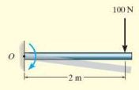Solution :

MO= F*d (N.m or lb.ft)

F=100N , d=2m

MO= 100 N * 2m = 200Nm

**Example 2 :**

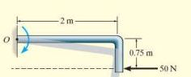The line of action of the force is illustrate in the figure, the force tend to rotate the member as shown colored curl

Solution :

MO= F*d (N.m)

F=50N , d=0.75m

MO= 50N * 0.75m = 37.5 N.m

**Resultant Moment:**

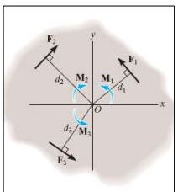For two-dimensional problems, all the forces lie within the x–y plane as shown in the figure , the resultant moment (MR)O about point O (the z axis) can be determined by:

(MR)O = Algebraic sum of the moments for all the forces

المجموع الجبري للعزوم

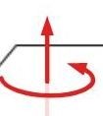Generally consider:

Counterclockwise moment → Positive moments عكس اتجاه عقرب الساعة

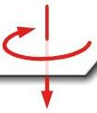

Clockwise moment → Negative moments باتجاه عقرب الساعة

Therefore:

C:\Users\Aseel\AppData\Local\Microsoft\Windows\Temporary Internet Files\Content.Word\xx.jpg

**Example 3 :**

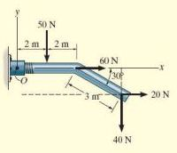Determine the resultant moment of the four forces acting on the rod shown in the figure about O

Solution:

The forces are F1=50N , F2=60N , F3=20N , F4=40N

The distances from forces to point O are:C:\Users\Aseel\AppData\Local\Microsoft\Windows\Temporary Internet Files\Content.Word\wessaa.jpg d1, d2 ,d3,d4

Assuming the positive moment in the counterclockwise direction

(MR)O = ∑Fd = F1 * d1 + F2 * d2+ F3 * d3+ F4 * d4

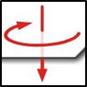For F1 , F1=50N , the distance=d1 = 2m

M1= F1*d1 = 50N * 2m → -50*2=-100Nm

For F2 , F2=60N , the distance=d2 = 0 → M2= F2*d2= 60N * 0 = 0

For F3 , F3=20N , the distance=d3 = from the triangle that has 3m hypotenuse وتر

**x**

2m

2m

When sin 30o= ==

d4

d3

40N

20N

30o

3m

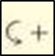Therefore d3= 3 * sin 30= 3* 1/2=1.5m

M3= F3*d3= 20 * 1.5m=+30 Nm

For F4 , F4=40N , the distance=d4=2+2+**x**, but cos30= → x=3*cos30o=3* =2.6m

→ d4=2+2+2.6=6.6m and M3= F3*d3=40N * 6.6m=264Nm → M4=-264Nm

Then : Resultant moment (MR)O =-100Nm+0+30Nm-264Nm =-334Nm =334Nm

* 1. **Cross Product:**

Cross-product method of vector multiplication of two vectors A and B yields the vector C:

C=A x B

**Magnitude:**

The magnitude of C is defined as the product of the magnitudes of A and B and the sine of the angle u between their tails ( 0°≤ θ ≤ 180° ).

Thus: C= A x B sinθ

**Direction:**

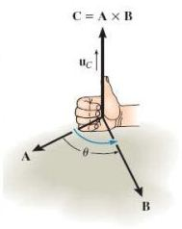Vector C has a direction that is perpendicular to the plane containing A and B such that C is specified by the **right-hand rule** as shown in Fig.

C= (A B sinθ)uc

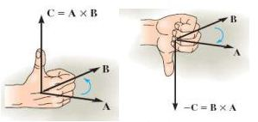Laws of Operation:

A X B ≠ B X A , A X B = - B X A

* 1. **Moment of a Force - Vector Formulation**

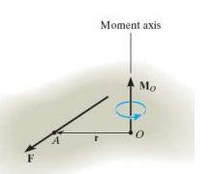The moment of a force F about point O , or actually about the moment axis passing through O and perpendicular to the plane containing O and F , Figure , can be expressed using the vector cross product, namely,

Mo=r x F

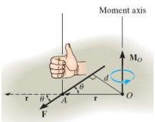The moment arm d = r sinθ , then:

MO = F(r sinθ ) = Fd

The direction and sense of MO determined by the right-hand rule.

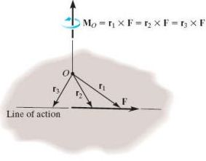**Principle of Transmissibility:**

MO = r1 x F = r2 x F = r3 x F

Example -1

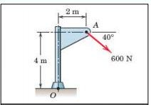Calculate the magnitude of the moment about the base point O of the 600-N force in five different ways.

Solution :

1. The moment arm to the 600-N force is

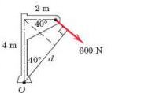

cos 40= $\frac{المجاور}{الوتر}$ = $\frac{d1}{4}$, sin 40== , and d=d1+d2

d = 4 cos 40o + 2 sin 40o = 4.35 m

By M = Fd the moment is clockwise and has the magnitude: MO = 600 Ib * (4.35)ft = 2610 N.m

1. 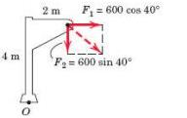Replace the force by its rectangular components at A,

F1= 600 cos40o = 460 N, F2 = 600 sin 40o = 386 N

The moment becomes:

MO = F1* 4 + F2 * 2 = 460*(4) + 386*(2) = 2610 N.m