1

(Static) Tutorial

1. **Force System Resultants**
   1. **Moment of a Force - Scalar Formulation**

Example 1

The line of action of the force is illustrate as shown in the figure, the force tend to rotate the member, orbit of the force about O is shown as colored curl.

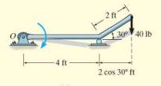Solution:

MO= F*d (N.m) or (Ib ft)

F= 40Ib , d= 4ft → MO= F*d = 40 * (4+2cos30) = 160

MO= 40 Ib * (4+ 2*0.86) ft=229 Ib ft

Example 2

The line of action of the force is illustrate as shown in the figure, the force tend to rotate the member, orbit of the force about O is shown as colored curl.

Solution: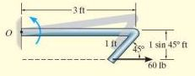

MO= F*d (N.m)

F= 60Ib , d= 1 sin45 ft

MO= 60 * (1 sin45)=60 Ib * (1 $\frac{1}{\sqrt{2}}$* ) ft =60 * 0.707= 42.42 Ib ft

Example 3

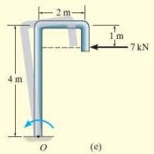The line of action of the force is illustrate as shown in the figure, the force tend to rotate the member, orbit of the force about O is shown as colored curl.

Solution:

MO= F*d (N.m)

F= 7 kN , d= 4-1=3

MO= F*d = 7 kN * 3ft=21 kN ft

* 1. **Moment of a Force - Vector Formulation**

Example 1 :

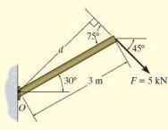Determine the moment of the force in the following figure about point O

Solution 1 : MO= F*d

45

30

45

d= 3 sin θ

30

θ=45 + 30 =75o

d= 3 sin 75=2.898m

MO= F*d = 5 kN * 2.898m=14.5 kN m

C:\Users\Aseel\AppData\Local\Microsoft\Windows\Temporary Internet Files\Content.Word\Untitled.png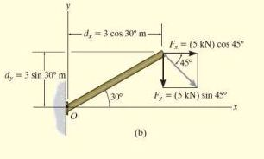Solution 2

Mo=Fxdy-Fydx

C:\Users\Aseel\AppData\Local\Microsoft\Windows\Temporary Internet Files\Content.Word\Untitled.png = - (5 cos45o kN)(3sin30om)-(5 sin45okN)(3 cos30om)

=-14.5KN.m=14.5KN.m

C:\Users\Aseel\AppData\Local\Microsoft\Windows\Temporary Internet Files\Content.Word\Untitled.png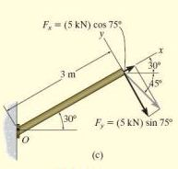Solution 3

Mo=-Fydx

= -(5 sin 75okN)(3m)

= -14.5kN.m=14.5kN.m 