1

(Static) Tutorial

Two dimension diagram

Example 1: Find the magnitude of the resultant and its direction

Solution :

**7**

1. magnitude of the resultant , Take Pythagoras theorem نظرية فيثاغورس

**θ**

R2=72 + 82 = 49 + 64= 113 → R=10.6

**8**

**R**

1. direction of the resultant Take sin law → $\frac{8}{sinθ}$ = $\frac{R}{sin90}$ → $\frac{8}{sinθ}$ = $\frac{10.6}{1}$

→ sinθ= $\frac{8}{10.6}$ =0.75 → θ = sin-1 (0.75) = 49o below negative x-axis

Example 2 : Find the magnitude of the resultant and its direction

Solution

4

30

1. magnitude of the resultant , Take Pythagoras theorem نظرية فيثاغورس

**R**

60

R2=42 + 42 = 16 + 16= 32 → R= 5.65

γ

α

4

60

2) direction of the resultant

γ= direction of resultant = 180 - 60 - α

Take sin law → $\frac{4}{sinα}$ = $\frac{R}{sin90}$ → $\frac{4}{sinα}$ = $\frac{5.65}{1}$ → $sinα$ = $\frac{4}{5.65}$ = 0.70 → α=sin-1(0.70)=45

γ= 180 - 60 – 45=75 direction of the resultant

H W

Example 3: Find the magnitude of the resultant and its direction

H W

Example 4Find the magnitude of the resultant and its direction

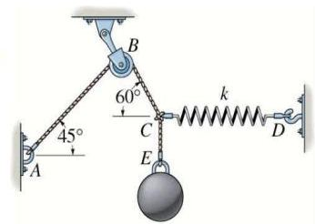**Equilibrium of a particle.**

**Example 1:** The sphere has a mass of 6 kg and is supported as shown. Determine magnitude of forces (FCBA , FCD)Draw a free-body diagram at the knot عقدةat C.

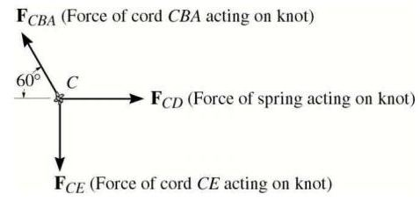

Solution :

The force due to sphere = W = 6 kg *9.81 m/s2=58.9 N.

force on cord(EC)= Weight of sphere (**Newton’s third law**)**=** 58.9 N.

analysis at Knot عقدةat C:

with x axis FCBA)x = FCBAcos60o = 0.5FCBA

with Y axis FCBA)y = FCBAsin60o = 0.86 FCBA

in the ward Y axis FCBA)y= FCE=58.9N → 0.86 FCBA= 58.9N → FCBA=68.48N

and in the ward X axis FCD=0.5FCBA = 0.5 * 68.48 = 34.24N

Example 2

The spring has a stiffness of k = 800 N/m and an unstretched length of 200 mm. Determine the force in cables BC and BD when the spring is held in the position shown.

FBCsinθ

Solution

C

400mm

to analysis the forces we need evaluate the values of angles

FBCcosθ

θ

B

tan θ==1 → θ=45o

(at spring) FAB

FBDcosα

α

tan α==0.75 → α=36.9o

DC

300mm

at spring: evaluate force FAB حتى نستفيد منها في استخراج باقي القوى

FBDsinα

FAB=k * s , unstretched length =lo = 200 mm

stretched length=l=500 (من الشكل) → s= l-lo=500-200=300mm

FAB=k * s=800N/m * 300mm $\frac{1}{1000}$* =800N/m * 0.3m=240N

At x axis → + FBDcosα + FBCcosθ-FAB=0 → FBDcos36.9 + FBCcos45-240N

0.79FBD+0.70FBC=240N → FBD=240N- 0.88 FBC………(1)

At Y axis ↑+ - FBDsinα + FBCsinθ=0 → - FBDsin36.9 + FBCsin45=0 → 0.6FBD=0.7FBC → FBC=0.8 FBD…(2)

Substitute eq. (2) in eq. (1) → FBD=240N- 0.88 FBC=240N-0.88 * 0.8 FBD

FBD =240N-0.7 FBD →1.7 FBD=240N→ FBD=141.17N substitute in (2) → FBC=0.8 * 141.17N=113N