1

**(Static)**

**Equilibrium of a Particle (2d , 3d)**

1. **Condition for the equilibrium of a particle.**

A particle is said to be in equilibrium if it remains at rest if originally at rest, or has a constant velocity if originally in motion. To maintain equilibrium, it is necessary to satisfy **Newton's first law** of motion which requires the resultant force acting on a particle to be equal to zero. This condition may be stated mathematically as:

$$\sum{F=0}$$

Where ΣF is the vector sum of all the forces acting on the particle.

1. **The free body diagram**

A drawing that shows the particle with all the forces that act on it is called a free body diagram (FBD). We will consider a springs connections often encountered in particle equilibrium problems

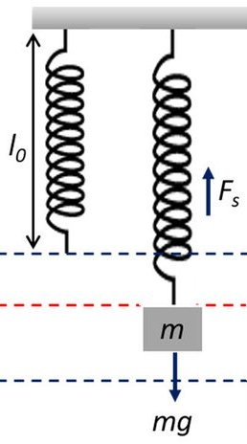**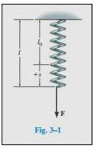Springs**: If a linearly elastic spring of undeformed length l0 is used to support a particle, the length of the spring will change in direct proportion to the force F acting on it, Fig 3.1. A characteristic that defines the elasticity of a spring is the spring constant or stiffness k. The magnitude of force exerted on a linearly elastic spring is stated as:

F=K S Where S=l-lo

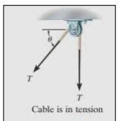**Cables and Pulleys**: All cables (or cords), unless otherwise mentioned, will be assumed to have **negligible weight** and they **cannot stretch**. Also, a cable can support only a tension or “pulling” force, and this force always acts in the direction of the cable. It will be shown that the tension force developed in a continuous cable which passes over a frictionless pulley must have a constant magnitude to keep the cable in equilibrium. Hence, for any angle θ, shown in Figure , the cable is subjected to a constant tension T throughout its length.

Example 1 :

The sphere in fig has a mass of 6 kg and is supported as shown. Draw a free body diagram of the sphere , the cord CE , and the knot at C.

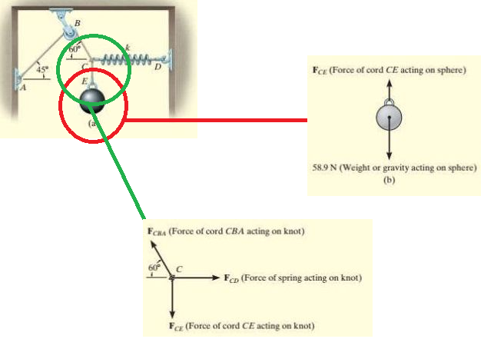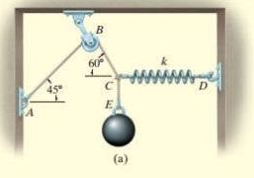

→

1. **Coplanar Force Systems نظام القوى في مستوى واحد**

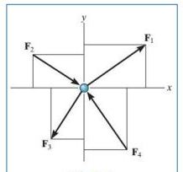If a particle is subjected to a system of coplanar forces that lie in the **x–y plane**, as in Figure , then each force can be resolved into its two components. For equilibrium, these forces must sum to produce a zero force resultant, i.e.,

+ =0

generally represented the equations as angles and magnitudes of forces shown on the particle’s free-body diagram.

Example 1: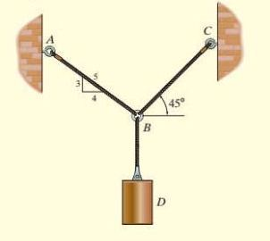 Determine the tension in cables BA necessary to support the 60-Kg cylinder in fig.

Solution :

60Kg convert to newton → 60 * 9.81=588.6 N

+ → Tc cos45o –TA * () =0→ Tc cos45o =TA () → TA=0.88Tc……(1)

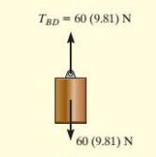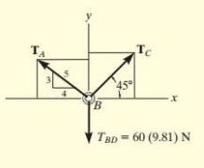 + ↑ ∑Fy=0 Tc  sin 45o +TA () =588.6 N…..(2)

Substitute eq. 1 in eq. 2 → Tc sin45o +0.88Tc * () =588.6 N

0.7Tc+0.528 Tc=588.6N→ Tc=476N

→ Tc=476N substitute in eq. (1) → TA=420 N

1. **Three-Dimensional Force Systems**

For particle equilibrium: ΣF = 0 , in the case of a three-dimensional force system, we can resolve the forces into their respective i, j, k components, so that:

ΣFx = 0 ΣFy =0 ΣFz = 0

Means algebraic sum of the components of all the forces acting on the particle along each of the coordinate axes must be zero.

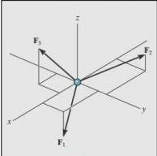

Example 1

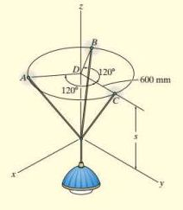The 10-kg lamp is suspended from three equal-length cords. Determine its smallest vertical distance s from the ceiling if the force developed in any cord is not allowed to exceed 50 N.

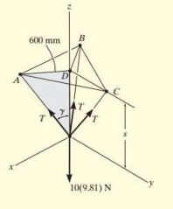**Solution** : Free body diagram : Due to symmetry , the figure , the distance DA=DB=DC =600m .

ΣFx = 0 ΣFy = 0 , the tension T in each cord will be the same and the angle between each cord and the Z axis is γ .

ΣFz = 0 3[(50N) cosγ] – 10(9.81)N =0

γ=cos-1=49.16o

From the shaded triangle in the figure

Tan49.16= $\frac{600mm}{s}$ → s=519mm

Example 2

A 90-lb load is suspended from the hook. If the load is supported by two cables and a spring having a stiffness k = 500lb/ ft, determine the force in the cables and the stretch of the spring for equilibrium. Cable AD lies in the x-y plane and cable AC lies in the x-z plane.

**Solution**: FB force in the spring → determine stretch in the spring. Equilibrium analysis at A and the cable forces are concurrent at this point. Components along each positive axis is "positive."

∑Fx=0 : FD sin30o-(4/5)FC=0…….(1)

∑Fy=0 : -FD cos30o-FB=0……...…(2)

∑Fz=0 : (3/5)FC – 90 Ib=0………..(3)

From eq. 3 → FC=150Ib

And from eq. (1) → FD=240Ib

And from eq. (2) → FB = 207Ib

The stretch of the spring is therefore FB=KSAB → 207.8=500 SAB  → SAB=0.416ft