1

**(Static)**

**Tutorial**

1. **Units**

**Example 1:**

a-Convert 2 km/h to m/s ? , b-How many ft /s is this?

Solution:

1. 1 km = 1000 m and 1 h = 3600 s

2 $\frac{Km}{h}$ = 2 $\frac{1000m}{3600s}$ = $\frac{2000m}{3600s}=0.55 m/s$

1. 1m=3.3 ft

$0.55\frac{m}{s}=0.55\frac{(3.3ft)}{s}=1.815ft/s$

1. **Force vectors**

Example 1 :

Consider two forces of magnitudes 5 N and 7 N acting on a particle, with an angle of 90◦ between them. What is the magnitude and direction of the resultant force?

Solution :

Firstly the forces need to be placed in the form of triangle as seen:

1. The magnitude of the resultant force F :

F2=72+52=74 → F= → F=8.6N

1. The direction of the resultant F : tanα= $\frac{5}{7}$ = 0.71 → α=tan-1 (0.71)=36o

Example 2 :

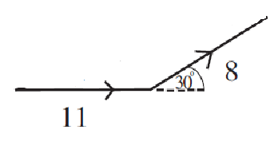Consider two forces of magnitudes 11 N and 8 N acting on a particle, with an angle of 30◦ between them. What is the magnitude and direction of the resultant force?

Solution :

Solution. In order to calculate the required magnitude it is necessary to use the cosine rule. Pythagoras’ theorem cannot be used as the forces are not perpendicular.

F2=82+112-2 * 8 *11cos150= 337.42

 F= $\sqrt{337.42}$ → F= 18.37N

In order to calculate the required angle, α , which F makes with the positive x-axis, the sine rule is needed.

$\frac{sinα}{8}=\frac{{sin150}^{o}}{F}$ → sinα= α=13o

Example 3 :

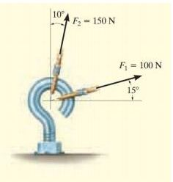The screw eye in Figure below is subjected to two forces, F1 and F2. Determine the magnitude and direction of the resultant force

Solution:

The two unknowns are FR and angle θ (theta).

Using the law of cosines:

(FR)2=(100)2 +(150)2 -2* (100)(150)cos(115o)

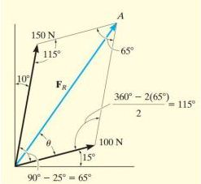(FR)2=10000+22500-30000cos(115o)

FR=212.6

Applying the law of sines to determine θ

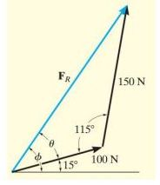 $\frac{150}{sinθ}=\frac{212.6}{sin115}$ → sinθ=

θ=Sin-1(0.6394)= 39.80

Thus, the direction Φ (phi) of FR, measured from the horizontal, is:

Φ = 39.8 0 + 150 = 54.80

Example 2:

Resolve the horizontal 600-lb force in Figure (a) below into components acting along the u and v axes and determine the magnitudes of these components.

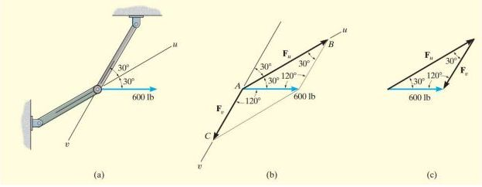

Solution: The two unknowns are the magnitudes of Fu and Fv. Applying the law of sines

$$\frac{F_{u}}{{sin120}^{o}}=\frac{600}{{sin30}^{o}}$$

Fu =1039 Ib

$$\frac{F_{v}}{{sin30}^{o}}=\frac{600}{{sin30}^{o}}$$

Fv =600 Ib

HW 1 :

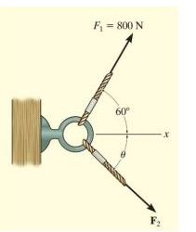It is required that the resultant force acting on the eyebolt in Figure below be directed along the positive x axis and that F2 have a minimum magnitude. Determine this magnitude, the angle θ, and the corresponding resultant force.

1. 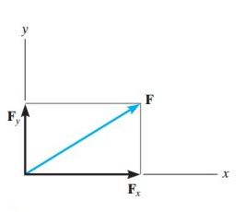**Rectangular Components :Two Dimensions**

Vectors Fx and Fy are rectangular components of F

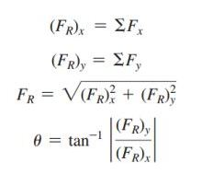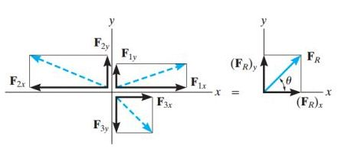The resultant force is determined from the algebraic sum of its components.

Example 1:

The end of the boom O in Figure (a) below is subjected to three concurrent and coplanar forces. Determine the magnitude and direction of the resultant force.

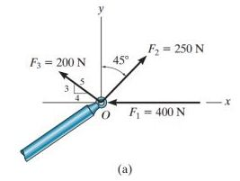Solution:

Each force is resolved into its x and y components, Figure (b), Summing the x-components and y-components:

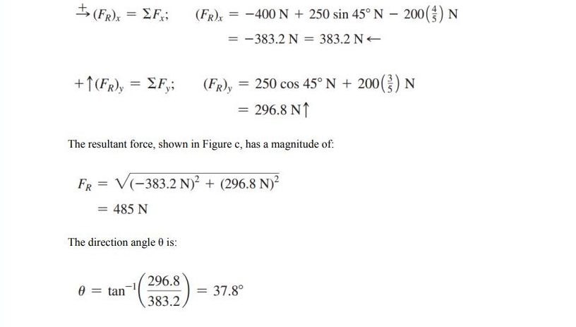

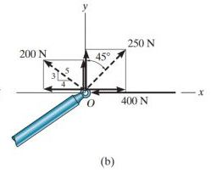

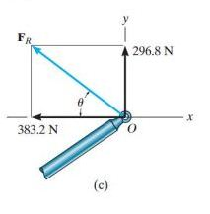

HW 2 :

Determine the magnitude of the resultant force and its direction measured counterclockwise from the positive x axis.

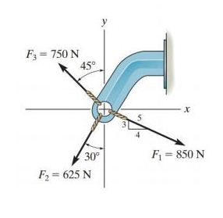

1. **Rectangular Components: Three Dimensions**

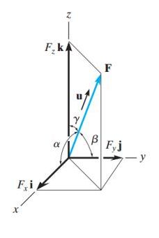The magnitude of F is determined from the positive square root of the sum of the squares of its components.

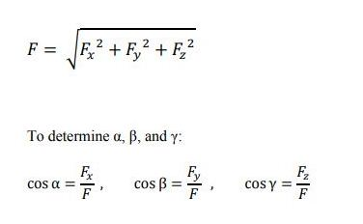

If only two of the coordinate angles are known, the third angle can be found using this equation: cos α + cos β + cos γ = 1

Example 1 :

if Fx=Fy=Fz= 300 , find the force resultant (F) and the angles (α,β,γ)

solution:

300N=

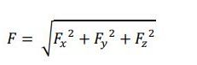

=?

=300N

F= $\sqrt{{(300)}^{2}+{(300)}^{2}+{(300)}^{2}}$

300N=

F= $\sqrt{270000}$ =519.6

Cosα= $\frac{F_{x}}{F}$ = $\frac{300}{519.6}$ =0.57736 → cosα=0.57736 → α=cos-1 (0.57736)= 54.734

Cos β= $\frac{F_{y}}{F}$ = $\frac{300}{519.6}=0.57736$ → β=54.734=γ