

Subject : “Analog Communications “

Lecture No.: 2

Lecture title: Amplitude Modulation And Demodulation

Lecturer name: Aya Althahab

# 1. Amplitude Modulation

Amplitude modulation is the process of changing the amplitude of a relatively high frequency carrier signal in proportion with the instantaneous value of the information signal. Here frequency and phase are kept constant. In other word, AM is defined as a process in which the amplitude of the carrier wave 𝒄(𝒕) is varied about a mean value, linearly with baseband signal 𝒎(𝒕).AM modulators are two input devices. One input is a single, relatively high frequency carrier signal of constant amplitude, and the second input is comprised of relatively low frequency information signals that may be a single frequency or a complex waveform made up of many frequencies

.

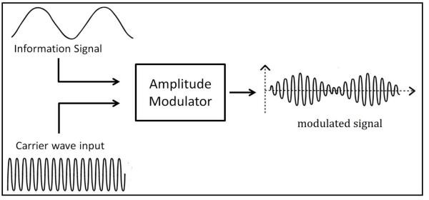

# 2. Mathematical Expression

Following are the mathematical expressions for these waves.

### Time-domain Representation of the Waves

Let the modulating signal be,

**m(t)=Amcos(2πfmt)**

and the carrier signal be,

c(t)=Accos(2πfct)

Where,

Am and Ac are the amplitude of the modulating signal and the carrier signal respectively.

fm and fc are the frequency of the modulating signal and the carrier signal respectively.

Then, the equation of Amplitude Modulated wave will be

**s(t)=[Ac+Amcos(2πfmt)]cos(2πfct)**

# 3. AM divided into different types :

1. **Double Sideband Large Carrier (DSB-LC):** This is the most widely used type of AM modulation. In fact, all radio channels in the AM band use this type of modulation.
2. **Double Sideband Suppressed Carrier (DSB-SC):** This is the same as the AM modulation above but without the carrier.
3. **Single Sideband (SSB):** In this modulation, only half of the signal of the DSBSC is used.
4. **Vestigial Sideband (VSB):** This is a modification of the SSB to ease the generation and reception of the signal.

# 3.1 Double Sideband Large Carrier (DSB-LC)

There are several types of amplitude modulation and the most commonly used is AM double sideband large carrier (DSB-LC) scheme. It is also called conventional AM. The following figure illustrates the relationship among the carrier, the modulating signal and the modulated signal for conventional AM.

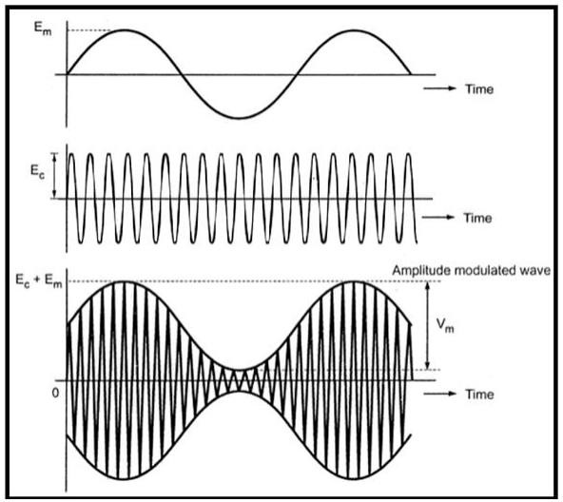

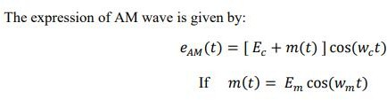

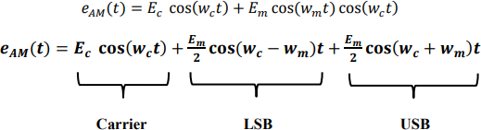

Where:

𝐸𝑐: Carrier voltage

𝐸𝑚 : Modulating voltage

𝑚(𝑡): Modulating signal

3.1.(a) Generation of Double Sideband Large Carrier (DSB-LC)

A process of generating a DSB-LC is shown in figure 1. DSB-LC modulation can be achieved by using a non-linear device, such as a diode. This is shown in figure 2.

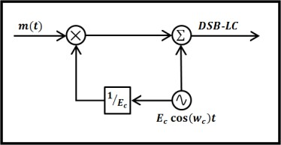

Figure(1) Generation of DSB-LC

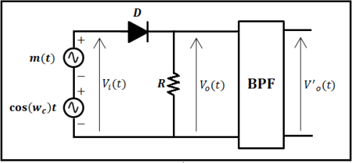

Figure (2) Amplitude modulator using a diode.

# 3.1. (b) Spectrum of DSB-LC

Amplitude modulation DSB-LC simply shifts the spectrum of 𝒎(𝒕) to the carrier frequency 𝒇𝒄.

The resultant modulated signal consists of three frequencies:

1. The carrier frequency 𝒇𝒄.
2. Upper sideband frequency (𝒇𝒄 + 𝒇𝒎).
3. Lower sideband frequency (𝒇𝒄- 𝒇𝒎).

These three components of the modulated wave constitute the spectrum of the AM modulated wave when the modulating wave is a single frequency. The bandwidth of the modulated waveform is twice the information bandwidth.

𝐁𝐖 = 𝐦𝐚𝐱𝐢𝐦𝐮𝐦 𝐟𝐫𝐞𝐪. −𝐦𝐢𝐧𝐢𝐦𝐮𝐦 𝐟𝐫𝐞𝐪

𝐁𝐖 = ( 𝒇𝒄 + 𝒇𝒎 ) − ( 𝒇𝒄 − 𝒇𝒎 )

𝐁𝐖 = 𝟐 𝒇𝒎

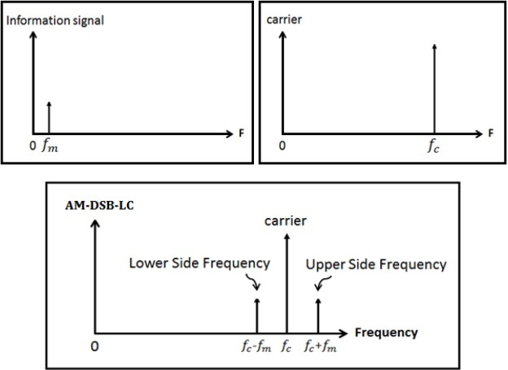

# 4 . Modulation index

The modulation index is defined as the ratio of the amplitude of the modulating signal to that of the unmodulated carrier. It is a value between 0 and 1 which describes the “degree of modulation” of the carrier. The modulation index should always greater than zero and less than one. If (m=0), the resultant modulated waveform is just a constant envelope of amplitude 𝐸𝑐 (there is no modulation of the carrier wave). If (m > 1), the resultant waveform is over modulated and is distorted (the maximum modulation that can occur without distortion, when modulation index equal one)



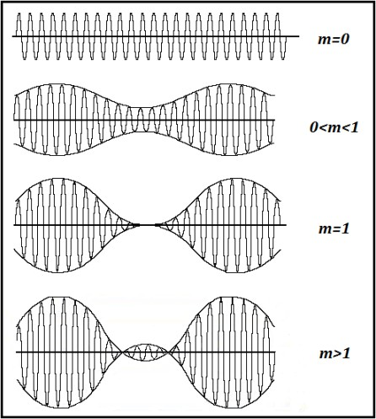

𝑉𝑚𝑎𝑥 and 𝑉𝑚𝑖𝑛 are the peak voltage of the modulated signal envelope. It is much easier to measure 𝑉𝑚𝑎𝑥 and 𝑉𝑚𝑖𝑛 on an oscilloscope than it is to measure 𝐸𝑚 or

𝐸𝑐.

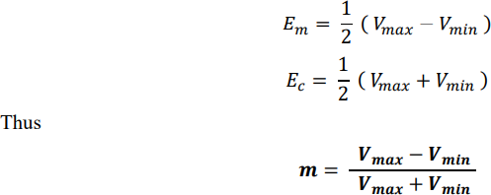

# 3.1.( c) Power of DSB-LC

There are three components for any DSB-LC waveform, the upper sideband, the lower sideband and the carrier frequency. If the powers in the three of these are added up, the total power in the modulated signal will be

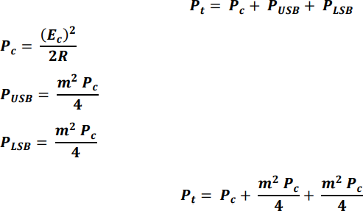

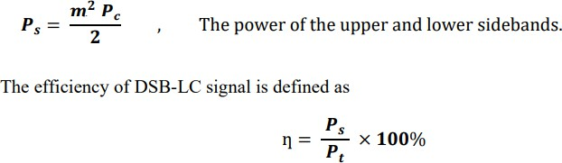

# Demodulation of DSB-LC

In DSB-LC signals, the desired signal waveform is available in the envelope of the modulated signal. The use of synchronous detection will, of course, yield the desired waveform but it is possible to demodulate AM signals by much simpler techniques. The simplest and most popular method is that one which detects the envelope of the modulated waveform directly and is called the envelope detector.

## 5.The Envelope Detector:

Any circuit whose output follows the envelope of the input signal waveform will serve as an envelope detector. The simplest form of an envelope detector is a nonlinear charging circuit with a fast charge time and a slow discharge time. It can easily be constructed using a diode in series with a capacitor, as shown in figure 3. A resistor placed across the capacitor controls the discharge time.

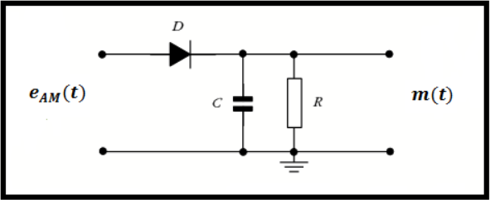

Figure (3) Envelope Detector

# Double Sideband Suppressed Carrier (DSB-SC)

Double-sideband suppressed-carrier transmission (DSB-SC) is transmission in which frequencies produced by amplitude modulation (AM) are symmetrically spaced above and below the carrier frequency and the carrier level is reduced to the lowest practical level, ideally being completely suppressed. The expression of DSB- SC modulation is given by:

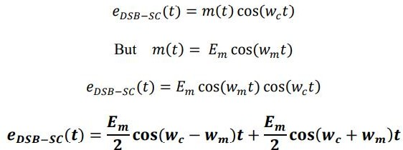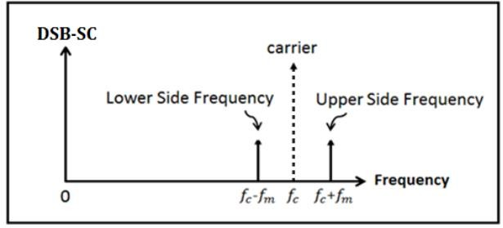

The bandwidth of the modulated waveform is twice the information bandwidth.

𝐁𝐖 = 𝐦𝐚𝐱𝐢𝐦𝐮𝐦 𝐟𝐫𝐞𝐪. −𝐦𝐢𝐧𝐢𝐦𝐮𝐦 𝐟𝐫𝐞𝐪

BW = ( 𝑓𝑐 + 𝑓𝑚 ) − ( 𝑓𝑐 − 𝑓𝑚 ) BW = 2 𝑓𝑚

# 3.2.(a) Generation of Double Sideband Suppressed Carrier (DSB-SC)

A process of generating a DSB-SC is shown in figure (4)

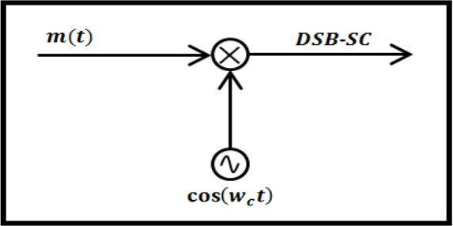

Figure (4) Generation of DSB-SC

The double-side band suppressed carrier (DSB-SC) form of amplitude modulation is usually generated using the ring modulator, which uses two Centre tapped transformers, four diodes followed by a band pass filter. This is shown in figure (5)

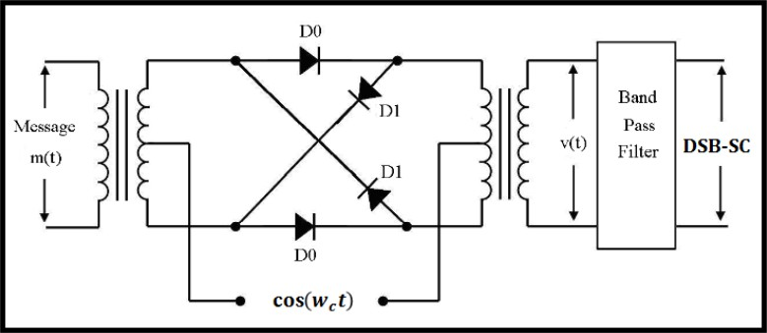

Figure(5) The ring modulator used for the generation of (DSB-SC)

# 3.2.(b) Power of DSB-SC

There are two components for any DSB-SC waveform, the upper sideband and the lower sideband frequency. If the powers in the two of these are added up, the total power in the modulated signal will be

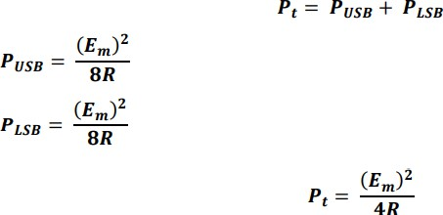

# 3.2.(c) Demodulation of DSB-SC

The DSB-SC wave is applied to a product modulator in which it is multiplied with the locally generated carrier cos(𝑤𝑐𝑡), which is exactly coherent or synchronized in both frequency and phase with the original carrier wave used to generate the DSB- SC wave. This method of detection is therefore called as coherent detection or synchronous detection. The output of the product modulator is applied to the low pass filter (LPF) which eliminates all the unwanted frequency components and produces the message signal.

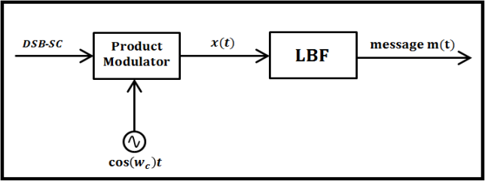

Figure (6) Coherent Detection of DSB-SC modulated wave.

# Single Sideband (SSB)

We have seen that both DSB-LC and DSB-SC signals required a transmission band width equal to twice the bandwidth of the message signal 𝑚(𝑡). Since either the upper sideband (USB) or the lower sideband (LSB) contains the complete information of the message signal, we can conserve bandwidth by transmitting only one sideband. The modulation is called Single Sideband (SSB) modulation.

# 3.3.(a) Generation of Single Sideband (SSB)

There are two common methods to generate a Single Sideband (SSB) signal.

1. **Filtering Method**

One method of producing an SSB signal is to remove one of the sidebands via Band Pass Filter (BPF), leaving only either the upper sideband (USB), the sideband with the higher frequency, or less commonly the lower sideband (LSB), the sideband with the lower frequency. Most often, the carrier is reduced or removed entirely (suppressed), being referred to in full as single sideband suppressed carrier (SSB- SC). Figure (7) shows the generation of a single sideband (SSB) signal using the filter method.

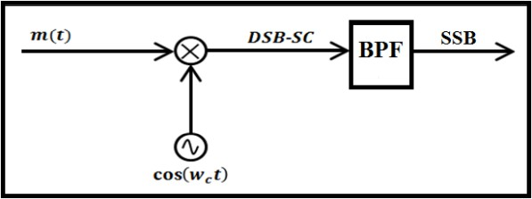

Figure (7) Generation of SSB signal using filter method

## 3.3 (b) Phasing Method

An alternate method of generation known as a Hartley modulator, uses phasing to suppress the unwanted sideband. To generate an SSB signal with this method, two versions of the original signal are generated, mutually 90° out of phase for any single frequency within the operating bandwidth. Each one of these signals then modulates carrier waves (of one frequency) that are also 90° out of phase with each other. By either adding or subtracting the resulting signals, a lower or upper sideband signal results. Figure (8) shows the generation of a single sideband (SSB) signal using the phasing method.

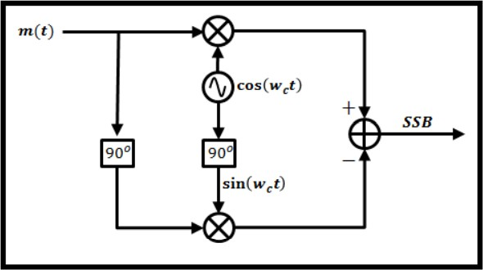

Figure (8) Generation of SSB signal using phasing method.

# 3.4 Power of SSB

The power of the SSB modulated signal is less than what would be obtained using DSB modulation.

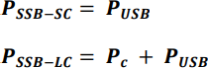

# 3.5 Demodulation of SSB

Demodulation of SSB signals can be accomplished by using a synchronous detector as used in the demodulation of DSB-SC.

# Vestigial Sideband (VSB)

The vestigial sideband (VSB) modulation works by combining some small part of one of the sidebands together with the entire other one. DSB transmits the both entire sidebands, SSB transmits only one entire sideband, and VSB transmits one entire sideband and some vestige of the other. The bandwidth used by VSB will lie between that calculated for DSB and SSB.The situations where VSB is desirable are where the input signal is very wide and there is a need to conserve frequency or spectrum space. The bandwidth of a VSB signal is between 1 and 2 times the original modulating signal bandwidth, depending on how much of the vestige sideband is transmitted.

# Frequency Division Multiplexing (FDM)

One of the basic problems in communication engineering is the design of a system which allows many individual signals from users to be transmitted simultaneously over a single communication channel. The most common method is to translate individual signals from

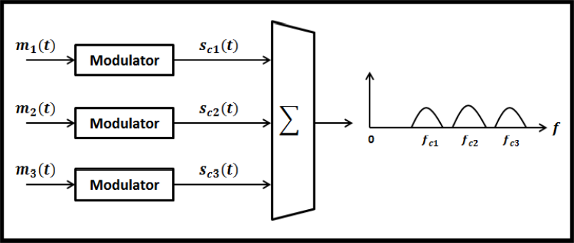one frequency region to another frequency region. Frequency translation can be accomplished by multiplying a low frequency modulating signal with a high frequency carrier signal. Frequency-division multiplexing (FDM) is a scheme in which numerous signals are combined for transmission on a single communications line or channel. Each signal is assigned a different frequency (sub-channel) within the main channel. Figure (9) show the transmitter and receiver of a 3-FDM system.

Figure (9) FDM transmitter

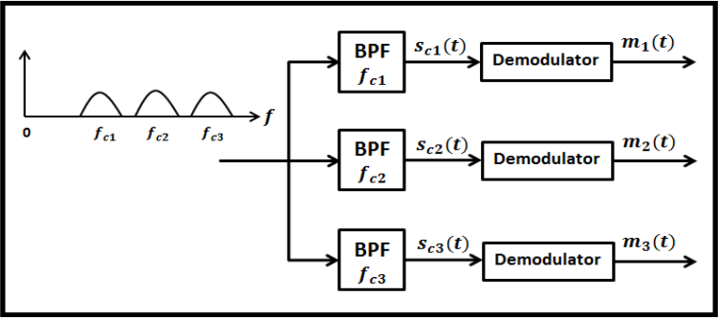

Example 1: For a particular DSB-SC modulator with a carrier frequency of 1000 rad/sec, a load resistance of 50 Ω, and a modulating signal 𝑚(𝑡) = 10 cos(20𝑡). Find the following:

1. The peak voltage (𝑬𝒎).
2. The modulating frequency.
3. The DSB-SC bandwidth.
4. The USB bandwidth and frequencies
5. The LSB bandwidth and frequencies
6. The total power.

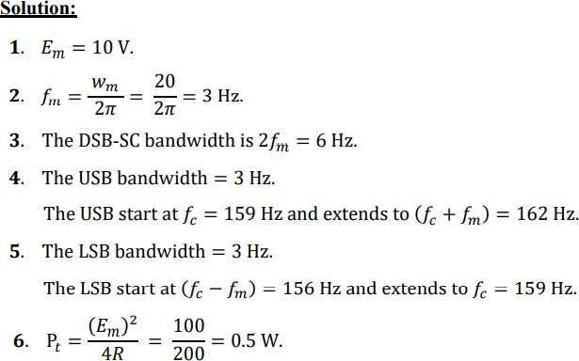

Example 2: An AM/DSB modulated signal is given by:

𝒆𝑨𝑴(𝒕) = 𝟑[ 𝟏 + 𝟎. 𝟓 𝐬𝐢𝐧(𝟏𝟐. 𝟓𝟔𝟔 ∗ 𝟏𝟎𝟑𝒕) ] 𝐬𝐢𝐧(𝟔. 𝟐𝟖 ∗ 𝟏𝟎𝟔𝒕)

Calculate the following

* 1. Amplitude and frequency of each sideband.
  2. Carrier power, sideband power, total power and the efficiency.
  3. Sketch the wave form of above AM/DSB signal in time domain and in frequency domain.

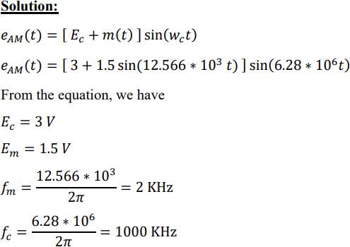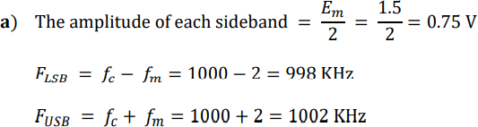

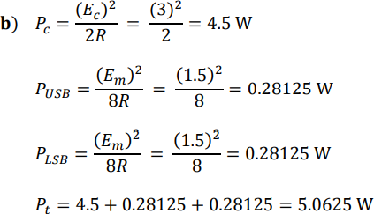

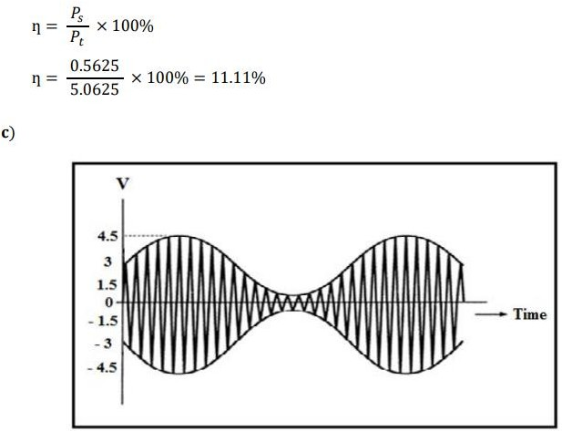

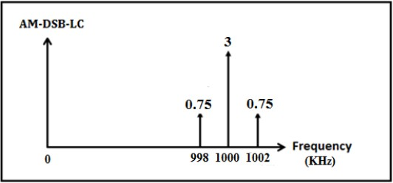

Example 3: A signal 𝒎(𝒕) is band-limited to a frequency range of 0-10 KHz. This frequency is translated by multiplying it by the signal 𝒄(𝒕) = 𝐜𝐨𝐬(𝟐𝝅𝒇𝒄𝒕). Find 𝑓𝑐 so that the bandwidth of the translated signal is 1% of the frequency 𝑓𝑐

.



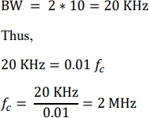

Example 4: An AM broadcast station transmits an average carrier power of 40 KW. If this station uses a modulation index of 0.707 for DSB-LC modulation, calculate:

1. Total average power.
2. Transmission efficiency.
3. Peak amplitude of the output if the antenna is represented by a 50Ω resistive load.

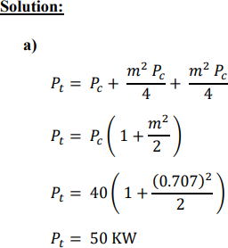

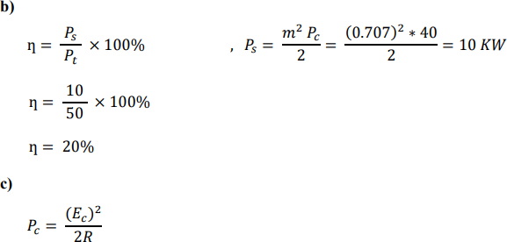

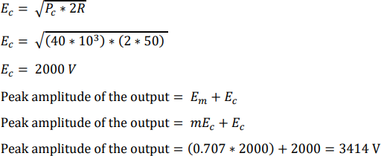

**h.w/**

1. For a particular broadcast AM radio station with a carrier frequencyof 40 cos(1000𝑡), a load resistance of 50 Ω, and a modulating signal

𝑚(𝑡) = 10 cos(20𝑡). Find the following:

* 1. The modulated signal, 𝑒𝐴𝑀(𝑡).
  2. The peak carrier voltage, 𝐸𝑐
  3. The carrier frequency, 𝑤𝑐
  4. The peak modulating voltage, 𝐸𝑚.
  5. The modulation frequency, 𝑤𝑚.
  6. The LSB bandwidth and frequencies.
  7. The USB bandwidth and frequencies.
  8. The DSB-LC bandwidth.
  9. The modulation index.
  10. The total average power.

1. A sinusoidal carrier signal of frequency 1000 KHz and amplitude of 80 V, is amplitude modulated by an audio signal with a frequency of 4KHz producing 50%modulation. Calculate the frequency and amplitude of the upper sideband and lower sideband.