1

**Electronic Circuit**

**Lecture 6 ( ${10}^{th}$ Week)**

**Feedback and Oscillator Circuits**

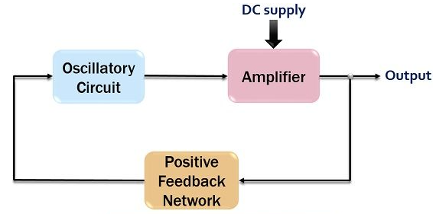

* 1. **FEEDBACK CONCEPTS**

A typical feedback connection is shown in Fig. 14.1 . The input signal Vs is applied to a mixer network, where it is combined with a feedback signal Vf. The difference of these signals Vi is then the input voltage to the amplifier. A portion of the amplifier output Vo is connected to the feedback network (β), which provides a reduced portion of the output as feedback signal to the input mixer network.

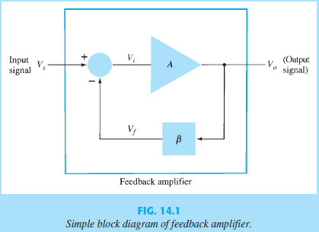

* 1. **FEEDBACK CONNECTION TYPES**

There are four basic ways of connecting the feedback signal. Both voltage and current can be fed back to the input either in series or parallel. Specifically, there can be:

1. Voltage-series feedback ( Fig. 14.2 a).

2. Voltage-shunt feedback ( Fig. 14.2 b).

3. Current-series feedback ( Fig. 14.2 c).

4. Current-shunt feedback ( Fig. 14.2 d).

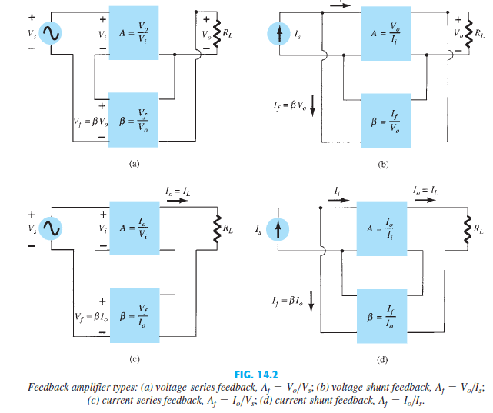

voltage refers to connecting the output voltage as input to the feedback network; current refers to tapping off some output current through the feedback network. Series refers to connecting the feedback signal in series with the input signal voltage; shunt refers to connecting the feedback signal in shunt (parallel) with an input current source.

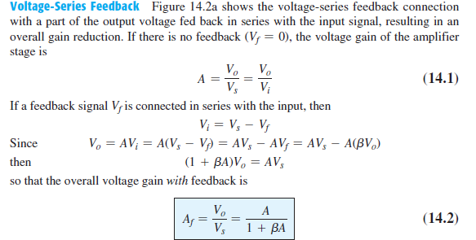

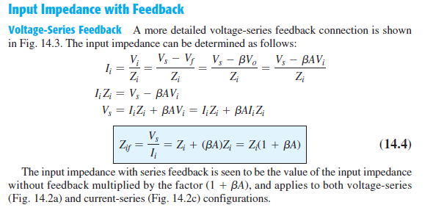

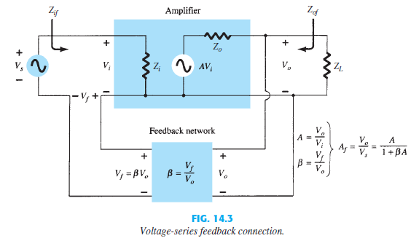

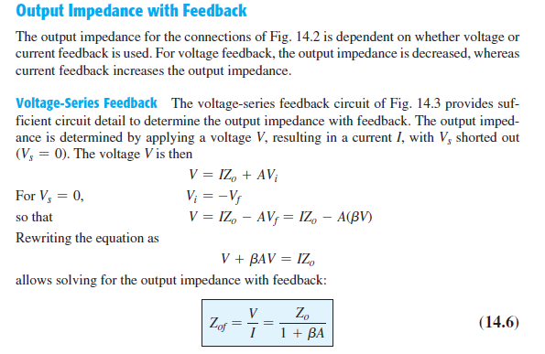

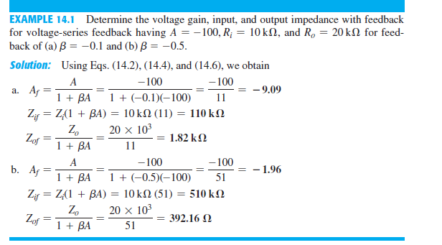

* 1. **OSCILLATOR OPERATION**

The use of positive feedback that results in a feedback amplifier having closed-loop gain |Af| greater than 1 and satisfies the phase conditions will result in operation as an oscillator circuit. An oscillator circuit then provides a varying output signal. If the output signal varies sinusoidally, the circuit is referred to as a sinusoidal oscillator. If the output voltage rises quickly to one voltage level and later drops quickly to another voltage level, the circuit is generally referred to as a pulse or square-wave oscillator. To understand how a feedback circuit performs as an oscillator, consider the feedback circuit of Fig. 14.18 . When the switch at the amplifier input is open, no oscillation occurs. Consider that we

have a Fictitious voltage at the amplifier input V i . This results in an output voltage Vo = AVi after the amplifier stage and in a voltage Vf = β(AVi) after the feedback stage. Thus, we have a feedback voltage Vf = βAVi, where A is referred to as the loop gain. If the circuits of the base amplifier and feedback network provide βA of a correct magnitude and phase, Vf can be made equal to Vi . Then, when the switch is closed and the fictitious voltage Vi is removed, the circuit will continue operating since the feedback voltage is sufficient to drive the amplifier and feedback circuits, resulting in a proper input voltage to sustain the loop operation. The output waveform will still exist after the switch is closed if the condition βA = 1 (14.32) is met. This is known as the Barkhausen criterion for oscillation.

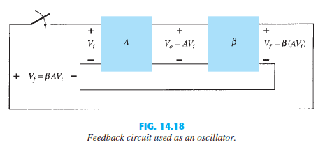

In reality, no input signal is needed to start the oscillator going. Only the condition βA 1 must be satisfied for self-sustained oscillations to result. In practice, βA is made greater than 1 and the system is started oscillating by amplifying noise voltage, which is

always present. Saturation factors in the practical circuit provide an “average” value of βA of 1. The resulting waveforms are never exactly sinusoidal. However, the closer the value βA is to exactly 1, the more nearly sinusoidal is the waveform. Figure 14.19 shows how the noise signal results in a buildup of a steady-state oscillation condition

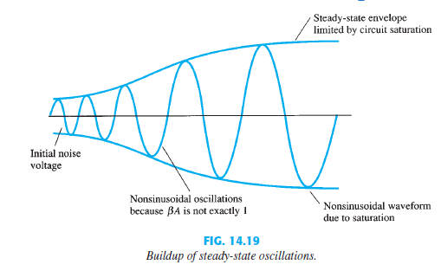

* 1. **PHASE-SHIFT OSCILLATOR**

An example of an oscillator circuit that follows the basic development of a feedback circuit is the phase-shift oscillator. An idealized version of this circuit is shown in Fig. 14.20 . Recall that the requirements for oscillation are that the loop gain βA is greater than unity and that the phase shift around the feedback

network is 180° (providing positive feedback). In the present idealization, we are considering the feedback network to be driven by a perfect source (zero source impedance) and the output of the feedback network to be connected into a perfect load (infinite load impedance). The idealized case will allow development of the theory behind the operation of the phase-shift oscillator. Practical circuit versions will then be considered

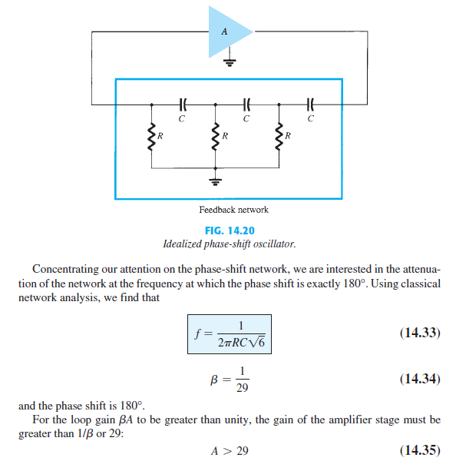

When considering the operation of the feedback network, one might naively select the values of R and C to provide (at a specific frequency) 600-phase shift per section for three sections, resulting in a 180° phase shift, as desired. This, however, is not the case, since each section of the RC in the feedback network loads down the previous one. The net result that the total phase shift be 180° is all that is important. The frequency given by Eq. (14.33) is that at which the total phase shift is 180°. If one measured the phase shift per RC section, each section would not provide the same phase shift (although the overall phase shift is 180°). If it were desired to obtain exactly a 60° phase shift for each of three stages, then emitter-follower stages would be needed for each RC section to prevent each from being loaded from the following circuit.

