**قــســــــــــم الامــــــــــــــــــــــــــن الــــــــــــــــــــــــــــــــــــسيبرانــــــــــــــــــــــــــــــــــــي**

**Department of Cyber Security**

**Subject:**

**COMPUTER ORGANIZATION & LOGIC DESIGN**

**Class:**

**First**

**Lecture: (2)**

**Digital Computer**

**Msc :Muntather AL-mussawee**

## COMPUTER ARCHITECTURE Digital Computer

## 

The digital computer is a digital system that performs various computational tasks. Digital computers use the binary number system, which has two

digits: 0 and 1. A binary digit is called a bit. Information is represented in digital computers in groups of bits. By using various coding techniques, groups of bits can be made to represent not only binary numbers but also other discrete symbols, such as decimal digits or letters of the alphabet. By judicious use of binary arrangements and by using various coding techniques, the groups of bits are used to develop complete sets of instructions for performing various types

of computations.

A computer system is sometimes subdivided into two functional entities

1. The hardware of the computer consists of all the electronic components and electromechanical devices that comprise the physical entity of the device.
2. Computer software consists of the instructions and data that the computer manipulates to perform various data-processing tasks.

The system software of a computer consists of a collection of programs whose purpose is to make more effective use of the computer. The programs included in a systems software package are referred to as the operating system.

**Computer Hardware**

The hardware of the computer is usually divided into three major parts, as shown in Fig(1):

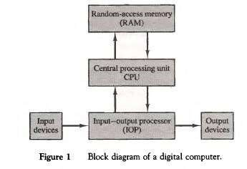

The central processing unit (CPU) contains arithmeticand logic unit for manipulating data, a number of registers for storing data, and control circuits for fetching and executing instructions.

The memory of a computer contains storage for instructions and data. It is called a random- access memory (RAM) because the CPU can access any location in memory at random and retrieve the binary information within a fixed interval of time.

The input and output processor (I/OP) contains electronic circuits for communicating and controlling the transfer of information between the computer and the outside world. The input and output devices connected to the computer include keyboards, printers, terminals, magnetic disk drives, and other communication devices.

## Computer Organization

Computer organization is concerned with the way the hardware components operate and the way they are connected together to form the computer system. The various components are assumed to be in place and the task is to investigate the organizational structure to verify that the computer parts operate as intended.

## Computer Design

Computer design is concerned with the hardware design of the computer. Once the computer specifications are formulated, it is the task of the designer to develop hardware for the system. Computer design is concerned with the determination of what hardware should be used and how the parts should be connected. This aspect of computer hardware is sometimes referred to as computer implementation.