Lecture 11 Dental Equipment Technologies Dr.Muna Merza

**Dental Pindex Machine**

**Dental Pindex Machine**

In the pindex system, a reverse drill press is used to create a master cast with dies that can be removed & replaced repeatedly with great precision the impression is poured without positioning & attaching dowel pins before hand. It's used in the crown and bridge lab. The machine accurately drills parallel holes from the underside of the trimmed cast.

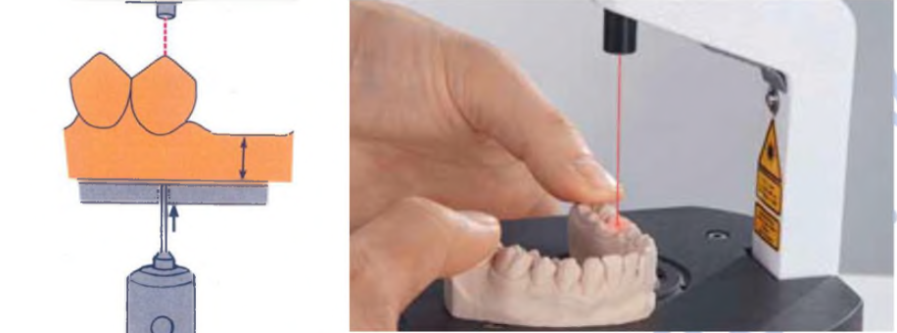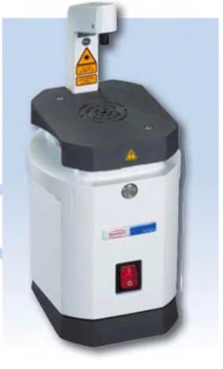

Parts:

A. ON/OFF button

B. Focus the laser beam.

C. worktable

D. Motor

E. Base

F. dust bucket

G. drill spindle

H. drill bit

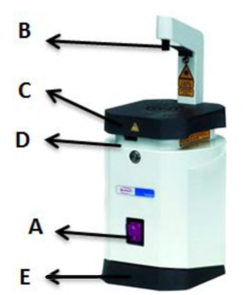

G H

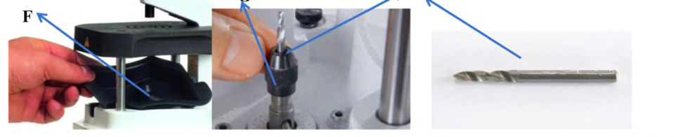

**Dental Hammer Device:**

Essential tool for a quick cleaning off of models. It has airflow regulation; ergonomic shape; made in corrosion-free materials; small dimensions. It has been designed to reduce to the maximum vibrations and sound level. Three chisel heads with different sizes and shapes are included. Used for the deflasking in the acrylic lab and for cutting investment after casting procedure in the crown & bridge lab and the chrome cobalt lab.

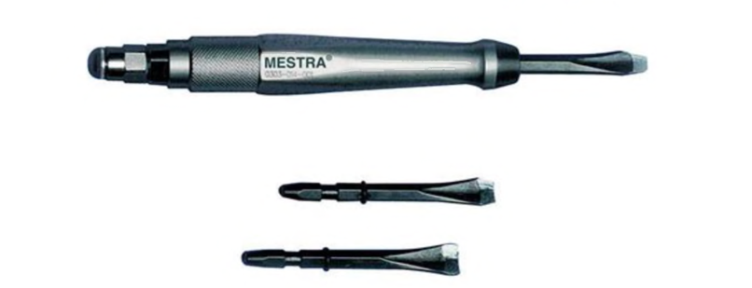

**Parts:**

1) On / Off controls

2) Air pressure connection

3) Chisel head

