Lecture 12 Dental Equipment Technologies Dr.Muna Merza

**Electronic spatula for wax modeling**

Is an electronic spatula for wax modeling with one or two heating heads, specially designed

to be used by professionals in the field of dental prosthesis.

Its ergonomics, ease of use, and small size make it an optimal tool for this type of work.

The accuracy of the electronic controls is also remarkable since it maintains the temperature in

the spatula head within a narrow error range.

The working temperature is shown on the digital display in the controls box.

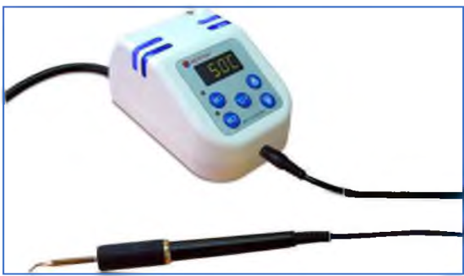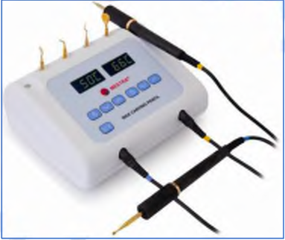

**Parts:**

A. Point

B. Handle

C. Main switch

D. Magnetic holder

E. Connection hole

F. Case for points



