Lecture 13 Dental Equipment Technologies Dr.Muna Merza

**Induction Wax Modelling and Dipping Wax Unit**

**Induction Tool Heater:**

The Induction Tool Heater is a simple desktop device to heat metallic spatulas and similar tools used for wax modelling in the Dental Lab. Just insert the head of the tool you want to heat into the hole at the front of the device, and in a few seconds, it will reach the optimal working

temperature. This way you don’t need to use the traditional Bunsen burner and you will prevent its drawbacks: gas tanks, fumes, fire hazard, etc.

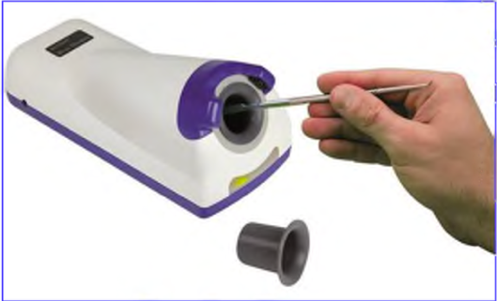

**Parts:**

A. Sensors

B. Induction cavity

C. Display

D. Sensitivity adjustment -

E. Disposable shield

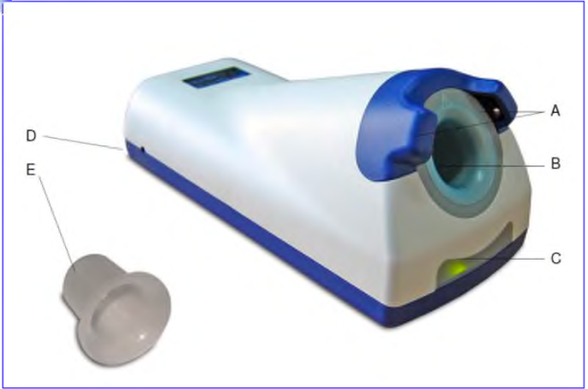

**Dipping wax heater (Wax heater bowls):**

Is a practical wax immerse heater which has been specially designed for use in the dental prosthesis sector.

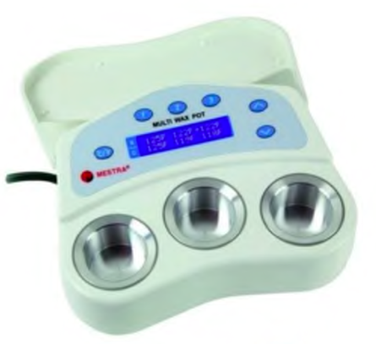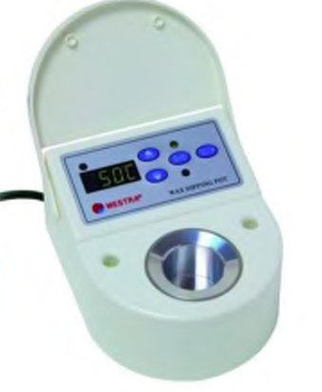

**Parts:**

1. Lid
2. Heating pilot light
3. Display
4. Tank
5. Set Point temperature pilot light.
6. Set Point actual temperature key.
7. oC - oF Key
8. Actual temperature pilot light
9. Up-down keys

