Lecture 7 Dental Equipment Technologies Dr.Muna Merza

**Dental Ceramic Furnace**

**Dental Ceramic Furnace**

Used in crown & bridge laboratory for the firing of ceramics on metal-ceramic restoration, all ceramics, ceramic - zirconium, ceramic - aluminum, and ceramic - titanium restoration.

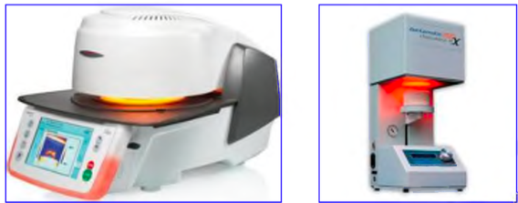

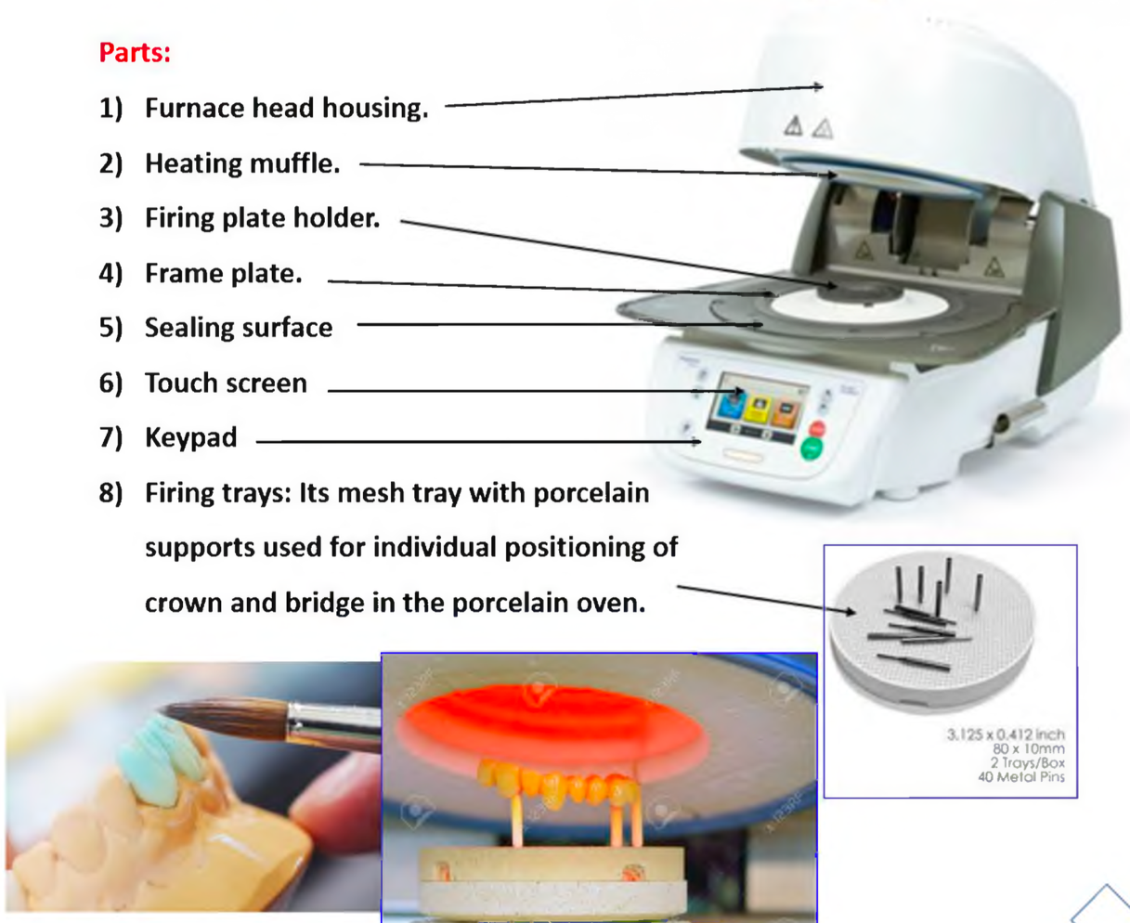

**Dental torch tool for soldering and casting.**

There are two types of torches tips.

**1. Multi orifice tip torch:** The tip most widely used in the casting procedure for metal-ceramic

alloys are probably the multi orifice type. Its main advantage is the distribution of heat over a wide area for more uniform heating of the alloy, which is particularly helpful in casting high-fusing base metal alloys. The Source of the flame torch is gas and air pressure or gas and oxygen.

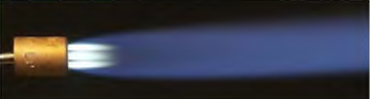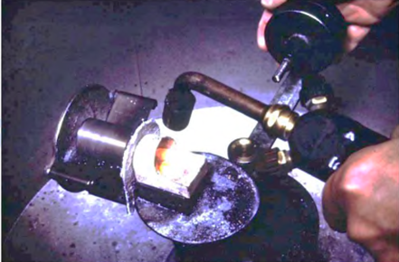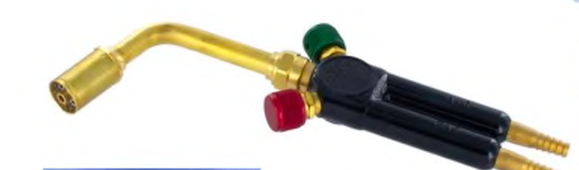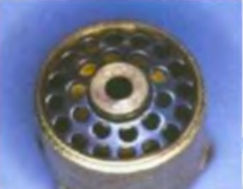

**2. Single orifice tip torch** may concentrate more heat in one area, but the area is smaller than

that produced by the multi orifice tip, used for the soldering procedure. The Source of the flame torch is gas and air pressure or gas and oxygen.

