Lecture 14 Dental Equipment Technologies Dr.Muna Merza

**General Measurement Instrument and Hopper Duplicator**

**General Measurement Instrument:**

This instrument with different shape use in prosthesis laboratories & have two types:

1. Distance & thickness measurement tools.
2. Volume measurement tools.

**Tools & instrumentst that are used for measuring thickness and distance:**

1. Ruler: used for distance

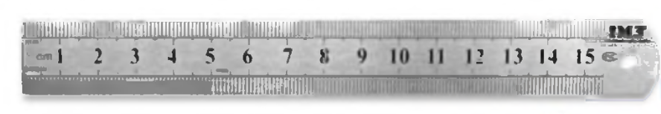

1. Vernier: used for measuring thickness, distance and depth Made from stainless steel

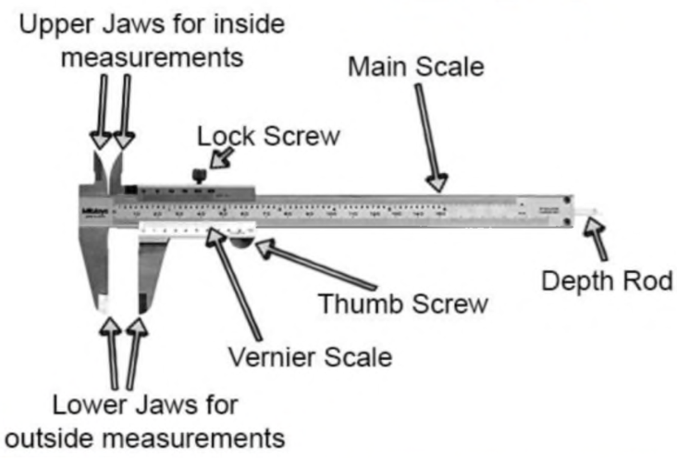

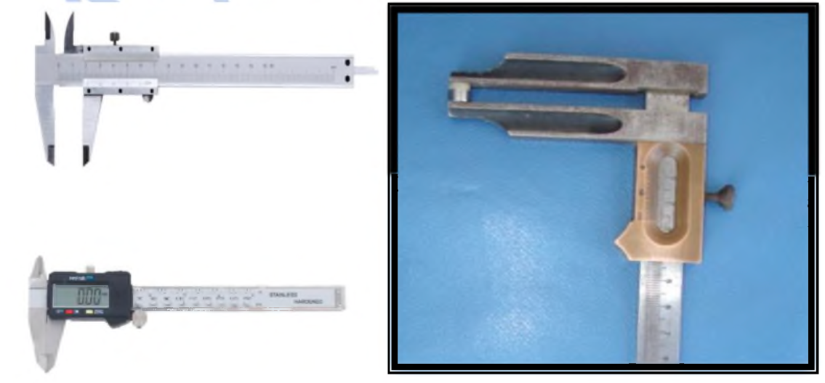

3- Iwanson caliper device:

This device have head & ruler start from (0 - 10 mm), made of stainless steel, they are 2 types:

Type (I) Wax caliper device.

Type (II) Metal caliper device.

The difference between type I & Il the head of wax caliper device is round end to measure the wax in crown & bridge, while the head of metal caliper device is pointed end to measure the metal in crown & bridge.

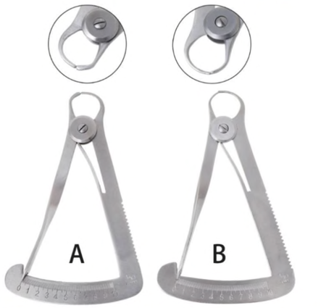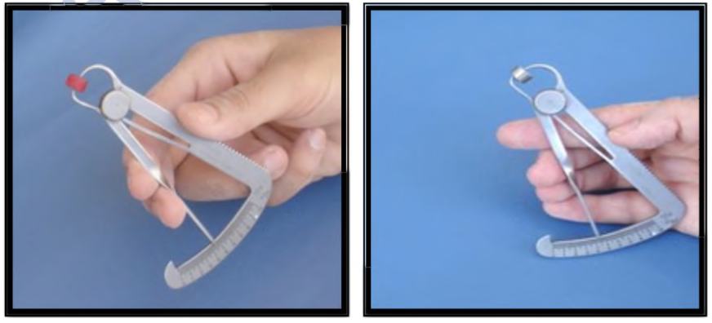

4- Volume measurement tools include:

1. Glass measuring cylinder
2. Glassflask
3. Beaker
4. Measuring spoon with different size.

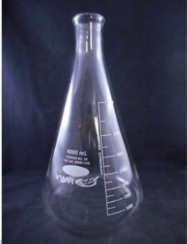 2

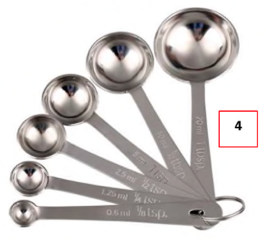

**Hopper Duplicator:**

This instrument maintains the relationship of the teeth to the cast during the rebasing procedure ((rebasing removed the old denture base & replaced by a new denture base material with preservation of the relation of denture teeth)). The parts of hopper duplicator (upper and lower members separated which contact with secrow). Note the occlusal index on the lower member of duplicator.

