Lecture 10 Dental Equipment Technologies Dr.Muna Merza

**Dental-Arch Trimmer**

**Dental-Arch Trimmer Machine**

This dental-arch trimmer optimizes the model-making process improving quality and reliability during the fabrication of sectioned models. Saving more than 60% in time.

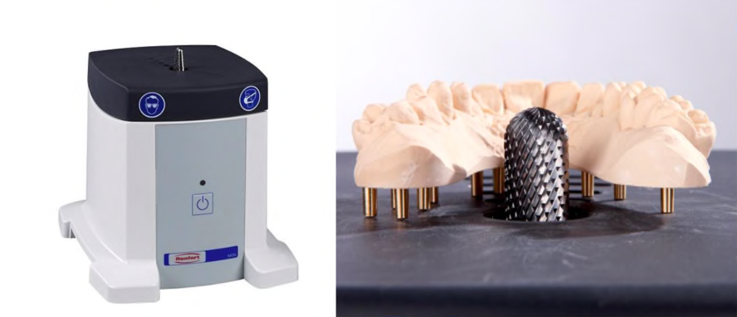

**Used:** Only use the unit for trimming dental stone or resin dental arches. And used in the crown and bridge lab.

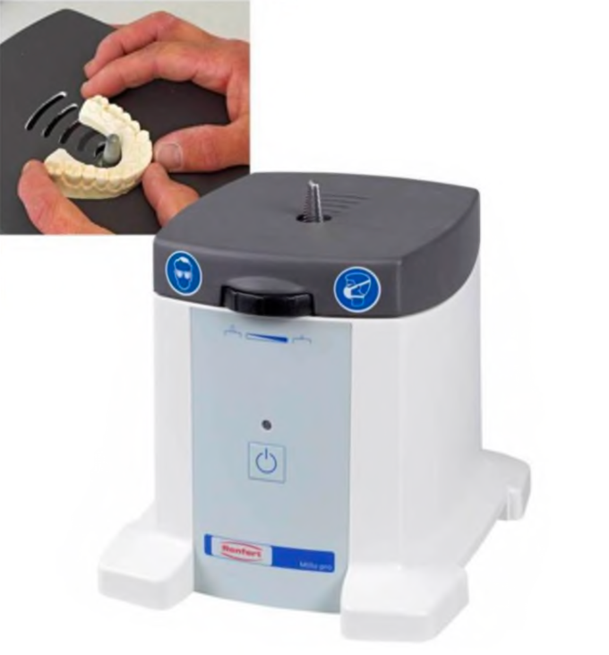

**Parts:**

A. ON/OFF button

B. ON/OFF LED display

C. Height adjustment.

D. Connector for extractor

E. Plug-in socket for connecting an extractor.

F. Safety cut-out

G. Cuter bur.

H. Mains cable

I. Workable

**G**



