**ا. د سعد عبد الرحيم الجبوري**

**Ureters ,Urinary Bladder And Renal Tubules**

* **Two ureters.**These narrow tubes carry urine from the kidneys to the bladder. Muscles in the ureter walls continually tighten and relax forcing urine downward, away from the kidneys. If urine backs up, or is allowed to stand still, a kidney infection can develop. About every 10 to 15 seconds, small amounts of urine are emptied into the bladder from the ureters. 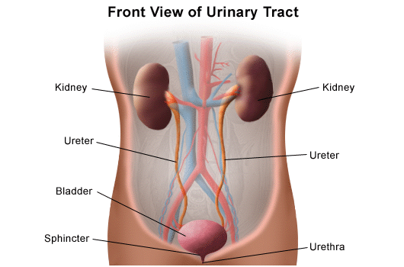

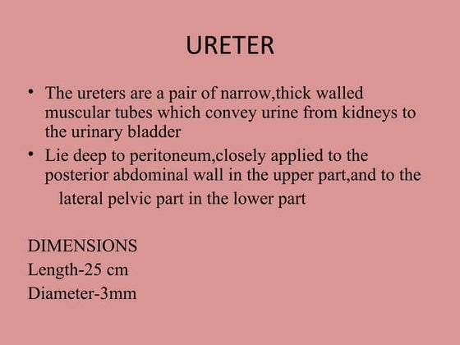

**Bladder.**This triangle-shaped, hollow organ is located in the lower abdomen. It is held in place by ligaments that are attached to other organs and the pelvic bones. The bladder's walls relax and expand to store urine, and contract and flatten to empty urine through the urethra. The typical healthy adult bladder can store up to two cups of urine for two to five hours.

Upon examination, specific "landmarks" are used to describe the location of any irregularities in the bladder. These are:

* + Trigone: a triangle-shaped region near the junction of the urethra and the bladder
  + Right and left lateral walls: walls on either side of the trigone
  + Posterior wall: back wall
  + Dome: roof of the bladder

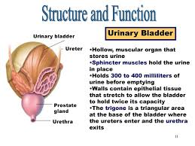

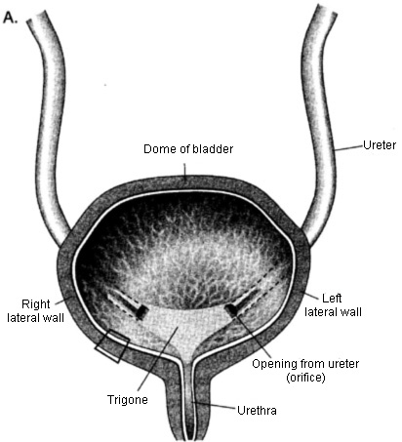

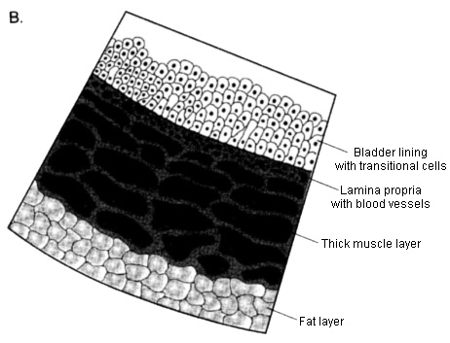

* **Two sphincter muscles.**These circular muscles help keep urine from leaking by closing tightly like a rubber band around the opening of the bladder.
* **Nerves in the bladder.**The nerves alert a person when it is time to urinate, or empty the bladder.
* **Urethra.**This tube allows urine to pass outside the body. The brain signals the bladder muscles to tighten, which squeezes urine out of the bladder. At the same time, the brain signals the sphincter muscles to relax to let urine exit the bladder through the urethra. When all the signals occur in the correct order, normal urination occurs. The Urethra:
* The urethra is the canal transmission of the urine from the bladder to the outside. It differs
* between the two genders. The female urethra is short 4 cm long, while in the male, it is
* roughly 15-25 cm long in the adult. The external or urethral sphincter surrounds it.
* The male urethra is a channel it has three parts:
* 1. Prostatic portion
* 2. Perineal & membranous portion
* 3. Penile or spongy portion

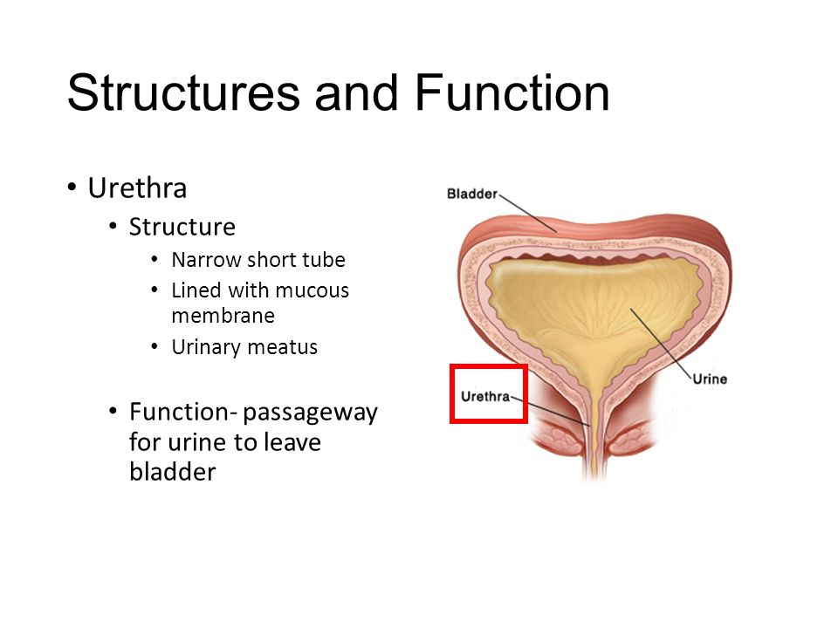

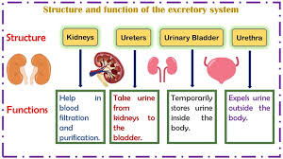

Facts about urine

* Normal, healthy urine is a pale straw or transparent yellow color.
* Darker yellow or honey colored urine means you need more water.
* A darker, brownish color may indicate a liver problem or severe dehydration.
* Pinkish or red urine may mean blood in the urine.

**Renal Tubules: Types, Functions, and Structures**

The renal tubules are a crucial part of the nephron, the functional unit of the kidney. They play a key role in the reabsorption of water, ions, and nutrients, as well as the secretion of waste products.

**Types of Renal Tubules**

The renal tubule is divided into several segments, each with distinct roles:

1. **Proximal Convoluted Tubule (PCT):**
   * Located immediately after the glomerular capsule (Bowman's capsule).
   * Highly coiled and lined with cuboidal epithelial cells with microvilli (brush border) to increase surface area for reabsorption.
2. **Loop of Henle:**
   * A U-shaped structure that extends into the medulla of the kidney.
   * Divided into :
     + **Descending limb:** Thin segment permeable to water.
     + **Ascending limb:** Thick segment impermeable to water but actively transports ions.

Plays a critical role in concentrating urine.

1. **Distal Convoluted Tubule (DCT):**
   * Located after the loop of Henle.
   * Less coiled than the PCT.
   * Involved in fine-tuning reabsorption and secretion under hormonal control (e.g., aldosterone and parathyroid hormone).
2. **Collecting Duct:**
   * Receives filtrate from multiple nephrons.
   * Runs through the medulla and is involved in final water reabsorption and urine concentration.
   * Regulated by antidiuretic hormone (ADH).

**Functions of Renal Tubules**

The renal tubules perform several critical functions:

1. **Reabsorption:**
   * Reabsorbs ~99% of the filtrate produced by the glomerulus.
   * PCT reabsorbs glucose, amino acids, ions (Na⁺, K⁺, Cl⁻, HCO₃⁻), and water.
   * Loop of Henle reabsorbs water (descending limb) and ions (ascending limb).
   * DCT and collecting duct reabsorb water and ions under hormonal regulation.
2. **Secretion:**
   * Secretes waste products (e.g., urea, creatinine, drugs, and toxins) into the tubular fluid.
   * Helps regulate blood pH by secreting H⁺ ions and reabsorbing HCO₃⁻.
3. **Urine Concentration:**
   * The countercurrent multiplier system in the loop of Henle and the action of ADH in the collecting duct help concentrate urine.

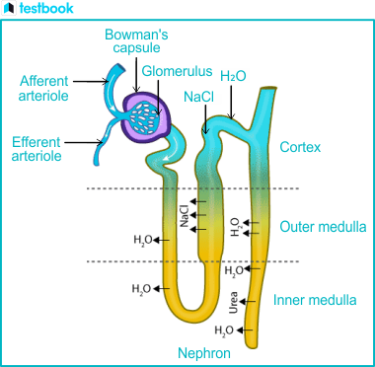

**Structure of Renal Tubules**

The structure of renal tubules is specialized to facilitate their functions:

1. **Epithelial Lining:**
   * PCT: Cuboidal cells with microvilli for increased surface area.
   * Loop of Henle: Thin squamous cells in the descending limb and thicker cells in the ascending limb.
   * DCT: Cuboidal cells with fewer microvilli.
   * Collecting Duct: Columnar cells responsive to ADH.
2. **Microvilli and Transport Proteins:**
   * Microvilli in the PCT increase surface area for reabsorption.
   * Transport proteins (e.g., Na⁺/K⁺ ATPase, aquaporins) facilitate active and passive transport of substances.
3. **Blood Supply:**
   * The peritubular capillaries and vasa recta surround the tubules, enabling efficient exchange of substances between the blood and tubular fluid.

**Summary**

The renal tubules are essential for maintaining homeostasis by regulating fluid, electrolyte, and acid-base balance. Their segmented structure allows for specialized functions, including reabsorption, secretion, and urine concentration. Dysfunction in any part of the renal tubules can lead to disorders such as renal tubular acidosis, electrolyte imbalances, or impaired urine concentration.