ا.د سعد عبد الرحيم الجبوري

**Renal Circulation: Anatomy, Physiology, Regulation**

1. Introduction to Renal Circulation:

Renal circulation, fundamentally defined as the blood supply to the kidneys and its subsequent return to the systemic circulation, is a critical physiological system responsible for maintaining overall bodily homeostasis . This intricate network ensures that the kidneys receive an adequate blood flow to perform their vital functions, which extend far beyond simple waste removal. The inflow of blood to the kidneys is facilitated by the renal arteries, which directly branch from the abdominal aorta, while the outflow of filtered blood occurs via the renal veins, which drain into the inferior vena cava . Despite their relatively modest size, the kidneys receive approximately 20% of the total cardiac output, a testament to their high metabolic demand and the essential nature of their filtration processes . This substantial allocation of blood underscores the importance of efficient filtration and processing for the removal of waste products and the maintenance of a stable internal environment.

The primary functions of renal circulation are multifaceted and essential for life . Foremost among these is the excretion of metabolic waste products, such as urea and creatinine, from the bloodstream, preventing their toxic buildup in the body . Beyond waste removal, the renal circulation plays a pivotal role in the regulation of blood volume and, consequently, systemic blood pressure . The kidneys also meticulously maintain the balance of various electrolytes, including sodium, potassium, and calcium, which are crucial for nerve and muscle function . Furthermore, they are instrumental in regulating the acid-base balance of the blood, ensuring that the body's pH remains within a narrow physiological range . In addition to these direct regulatory functions, the kidneys, through their circulation, are involved in the production of several crucial hormones, including renin (involved in blood pressure regulation), erythropoietin (stimulating red blood cell production), and calcitriol (the active form of vitamin D, essential for calcium absorption) . The high percentage of cardiac output directed to these organs highlights that their role transcends mere tissue maintenance, focusing on filtration that necessitates a high volume of blood flow for effective waste clearance. The diverse functions, including endocrine roles and the maintenance of blood pressure and electrolyte balance, reveal a complexity beyond just filtration. The production of renin, for instance, directly links renal circulation to systemic blood pressure regulation, establishing the kidneys as key players in cardiovascular health.

A comprehensive understanding of renal circulation is of paramount importance for several reasons . Firstly, it is fundamental to grasping the intricacies of normal kidney physiology, providing the necessary context for understanding how these vital organs function under healthy conditions . Secondly, this knowledge is crucial for the accurate diagnosis and effective management of a wide spectrum of kidney diseases and hypertension, as disruptions in renal blood flow are often central to their development and progression . Finally, a deep understanding of renal circulation provides a critical foundation for the development of targeted therapies aimed at treating both renal and cardiovascular disorders, paving the way for innovative approaches to improve patient outcomes .

2. Anatomy of the Renal Vascular System:

The renal vascular system is a complex and highly organized network of blood vessels that ensures efficient blood flow to and from the kidneys . Blood enters each kidney through a single renal artery, which originates directly from the abdominal aorta, the body's largest artery . After being filtered and processed, the blood leaves the kidney via the renal vein, which then drains into the inferior vena cava, the major vein carrying blood from the lower body back to the heart . The point at which the renal artery enters and the renal vein and ureter leave the kidney is known as the renal hilum .

Upon entering the kidney at the hilum, the main renal artery promptly branches into several segmental arteries . Typically, there are five named segmental arteries: superior, inferior, anterior superior, anterior inferior, and posterior, each supplying a distinct region of the kidney . These segmental arteries further subdivide into interlobar arteries, which penetrate the renal capsule and extend through the renal columns, the cortical tissue located between the renal pyramids in the medulla . At the boundary between the renal cortex and medulla, the interlobar arteries branch to form the arcuate arteries . These arteries are named for their arch-like course along the base of the medullary pyramids. Arising from the arcuate arteries are the interlobular arteries, also known as cortical radiate arteries, which radiate outwards into the renal cortex, perpendicular to the arcuate arteries . The branching pattern of the renal artery ensures a widespread distribution of blood throughout the kidney, effectively reaching every nephron, the functional unit of the kidney, for filtration. This hierarchical subdivision from the main renal artery down to the interlobular arteries demonstrates an efficient system for delivering blood to these functional units, maximizing the surface area available for the crucial process of filtration.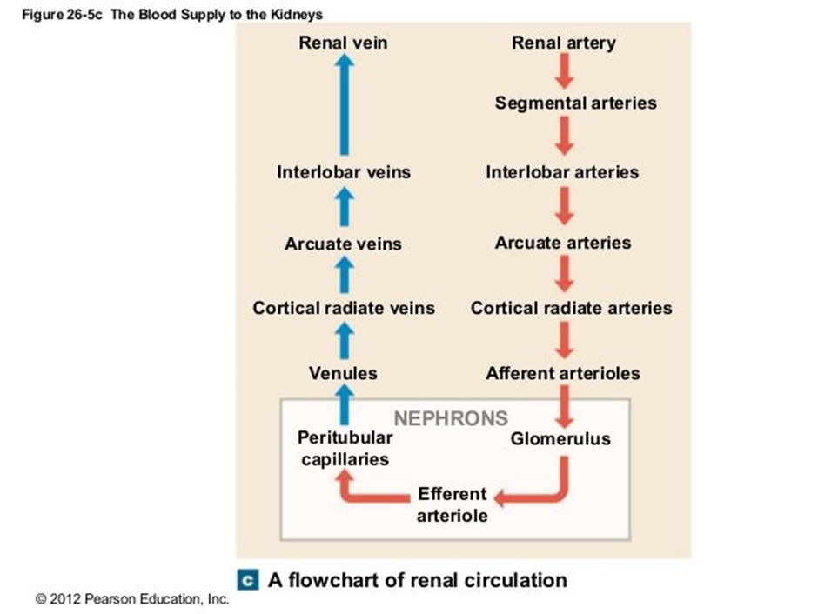

The interlobular arteries then give rise to numerous afferent arterioles . Each afferent arteriole supplies a single glomerulus, which is a specialized network of capillaries located within Bowman's capsule, the initial segment of a nephron . The glomerulus is the primary site of blood filtration in the kidney . The glomerular filtration barrier, which facilitates the passage of water and small solutes from the blood into Bowman's capsule while retaining larger molecules like proteins and blood cells, is composed of three layers: the fenestrated endothelium of the glomerular capillaries, the glomerular basement membrane, and the podocytes, specialized cells lining Bowman's capsule .

Blood leaves the glomerulus via the efferent arteriole . A key structural feature is the difference in diameter between the afferent arteriole, which is generally wider, and the efferent arteriole, which is narrower . This difference in diameter plays a critical role in generating and maintaining the glomerular hydrostatic pressure necessary for filtration. The efferent arteriole thus plays a crucial role in regulating the pressure within the glomerulus and, consequently, the glomerular filtration rate.

The efferent arterioles then branch further to form a second capillary network. In cortical nephrons, which constitute the majority of nephrons, the efferent arterioles form the peritubular capillaries . These capillaries surround the renal tubules, the elongated structures extending from Bowman's capsule, and are involved in the processes of tubular reabsorption and secretion . In contrast, the efferent arterioles of juxtamedullary nephrons, which have glomeruli located closer to the corticomedullary junction and longer loops of Henle extending deep into the medulla, form the vasa recta . The vasa recta are long, straight capillaries that run parallel to the loop of Henle and are essential for the countercurrent mechanism, which is critical for the kidney's ability to concentrate urine . The presence of this dual capillary system, comprising peritubular capillaries in the cortex and vasa recta in the medulla, reflects the distinct functional requirements of these two regions of the kidney in the complex process of urine formation. Peritubular capillaries support the selective reabsorption and secretion of substances in the cortex, while the vasa recta are specifically adapted for maintaining the high osmotic gradient in the medulla, which is necessary for the reabsorption of water and the production of concentrated urine.

The venous drainage of the kidney largely mirrors its arterial supply, but with some notable differences . Blood from the peritubular capillaries and vasa recta drains into the interlobular veins, also sometimes referred to as stellate veins, located in the renal cortex . These interlobular veins then empty into the arcuate veins, which are situated at the corticomedullary junction, running parallel to the arcuate arteries . The arcuate veins s ubsequently drain into the interlobar veins, which pass between the renal pyramids in the medulla, running alongside the interlobar arteries . Finally, the interlobar veins converge to form the renal vein, which exits the kidney at the hilum and carries the filtered blood back to the systemic circulation via the inferior vena cava . It is important to note that, unlike the arterial system, there are no segmental veins in the renal venous drainage .

Table 1: Anatomy of Renal Blood Vessels

|  |  |  |  |
| --- | --- | --- | --- |
| Vessel Type | Origin | Destination | Key Function(s) |
| Renal Artery | Abdominal Aorta | Segmental Arteries | Carries oxygenated blood to the kidney |
| Segmental Arteries | Renal Artery | Interlobar Arteries | Distributes blood to different regions of the kidney |
| Interlobar Arteries | Segmental Arteries | Arcuate Arteries | Supply blood to the renal cortex and medulla |
| Arcuate Arteries | Interlobar Arteries | Interlobular Arteries | Run along the base of the medullary pyramids |
| Interlobular Arteries | Arcuate Arteries | Afferent Arterioles | Supply blood to individual nephrons |
| Afferent Arterioles | Interlobular Arteries | Glomerulus | Carry blood to the glomerular capillaries for filtration |
| Glomerulus | Afferent Arterioles | Efferent Arterioles | Site of blood filtration |
| Efferent Arterioles | Glomerulus | Peritubular Capillaries / Vasa Recta | Carry blood away from the glomerulus |
| Peritubular Capillaries | Efferent Arterioles (Cortical Nephrons) | Interlobular Veins | Involved in reabsorption and secretion in the renal cortex |
| Vasa Recta | Efferent Arterioles (Juxtamedullary Nephrons) | Interlobular Veins | Maintain the medullary concentration gradient |
| Interlobular Veins | Peritubular Capillaries / Vasa Recta | Arcuate Veins | Drain blood from the cortex |
| Arcuate Veins | Interlobular Veins | Interlobar Veins | Collect blood from the arcuate region |
| Interlobar Veins | Arcuate Veins | Renal Vein | Drain blood from the renal cortex and medulla |
| Renal Vein | Interlobar Veins | Inferior Vena Cava | Carries deoxygenated, filtered blood away from the kidney |
|  |  |  |  |

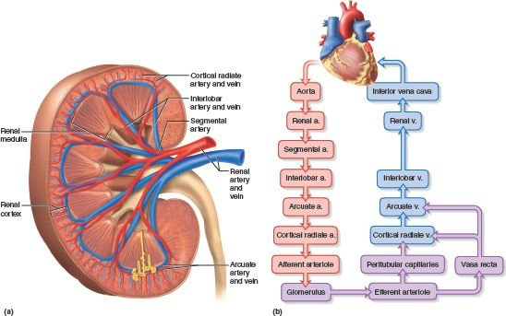

3-Physiological Processes within Renal Circulation:

The network of blood vessels within the kidneys facilitates three fundamental physiological processes that are essential for urine formation and the maintenance of bodily homeostasis: glomerular filtration, tubular reabsorption, and tubular secretion .

1-Glomerular filtration is the initial step in urine formation and occurs in the glomerulus, the capillary network within Bowman's capsule . This is a passive process driven by the hydrostatic pressure of the blood within the glomerular capillaries . This pressure forces water and small solutes, such as ions, glucose, amino acids, urea, and creatinine, across the filtration membrane from the blood into Bowman's capsule, forming the glomerular filtrate 1. Normally, large proteins and blood cells are retained within the bloodstream due to their size and charge, preventing their passage into the filtrate . The volume of filtrate formed per minute by the kidneys is known as the glomerular filtration rate (GFR), a crucial indicator of kidney function . The net filtration pressure, which determines the GFR, is a result of the balance between the glomerular hydrostatic pressure (the pressure of blood pushing against the capillary walls), the colloidal osmotic pressure (the pressure exerted by proteins in the blood that tends to draw water back into the capillaries), and the capsular hydrostatic pressure (the pressure exerted by the fluid already present in Bowman's capsule that opposes filtration) . Factors that affect the GFR include changes in any of these pressures, as well as the permeability and surface area of the glomerular filtration membrane . Glomerular filtration is a high-volume, non-selective process that marks the beginning of urine formation, setting the stage for the subsequent selective retrieval of essential substances and the further removal of waste products. The sheer volume of filtrate produced daily underscores the necessity for efficient reabsorption of vital molecules, and the non-selective nature of this initial filtration implies that the body must actively recover what it needs in later stages.