PULMONARY FUNCTION TEST(PFT)

PFTs help in diagnosis and differentiation of many respiratory diseases (restrictive and obstructive lung disorders, diagnose exercise induced asthma, differentiate chronic bronchitis from Bronchial Asthma (BA) )

Types of obstructive lung disease include: •

Chronic obstructive pulmonary disease (COPD) • Emphysema • Asthma • Cystic fibrosis

. Restrictive Respiratory Diseases: They cause a restriction or limitation of the lung/chest expansion.

Causes include:

A. Respiratory Muscle Paralysis: - Diseases of the central nuclei such as poliomyelitis that affects the anterior horn cells. -

Peripheral nerve injuries or diseases affecting the phrenic nerve and intercostal nerves. - Neuromuscular junction diseases such as myasthenia gravis in which there is a deficiency in Ach.

Myopathies (Muscle Diseases).

B. Thoracic wall diseases or deformities as :fracture ribs, scoliosis, kyphosis, pigeon chest, funnel chest, ….etc.

C. Pleural diseases such as pleurisy, , pneumothorax, hydrothorax, pleural fibrosis.

D. Lung diseases such as pulmonary fibrosis, pulmonary edema, pneumonia,…etc.

Lung Volumes and Capacities:

Pulmonary Function Test (PFT) tracings have:

Four Lung volumes: tidal volume, inspiratory reserve volume, expiratory reserve volume, and residual volume

Five capacities: inspiratory capacity, expiratory capacity, vital capacity, functional residual capacity, and total lung capacity.

• Tidal Volume (TV): volume of air inhaled or exhaled with each breath during quiet breathing. It is about 500 ml in an adult male. •

Inspiratory Reserve Volume (IRV): maximum volume of air inhaled from the end-inspiratory tidal position (3000 ml). •

Expiratory Reserve Volume (ERV): maximum volume of air that can be exhaled from resting end-expiratory tidal position(1100 ml). •

Residual Volume (RV): Volume of air remaining in lungs after maximum exhalation (1200 ml). It is indirectly measured (FRC-ERV) , i.e. It can not be measured by spirometry.

Lung capacity

is defined as the combination of two more lung volumes.

1. Inspiratory Capacity (I.C): the volume of air that can be inspired by maximal inspiration following a normal expiration. It equals to TV+IRV and has average of 3500ml in an adult male.

2. Expiratory Capacity (E.C): the volume of air that can be expired by maximal expiration following a normal inspiration. It equals to TV+ERV and has average of 1600ml in an adult male.

3. Functional Residual Capacity (F.R.C): the volume of air remaining in the chest at the end of normal expiration. It equals to ERV+RV and has average of 2300ml in an adult male.

4. Vital Capacity (V.C): the volume of air that can be expired by a maximal expiration following a maximal inspiration. It equals to IRV+TV+ERV with average of 4600ml in an adult male.

5. Total Lung Capacity (T.L.C): the volume of air presents in the chest at the end of the maximal or deepest inspiration. It equals to IRV+RV+ERV with average of 5800ml in an adult male.

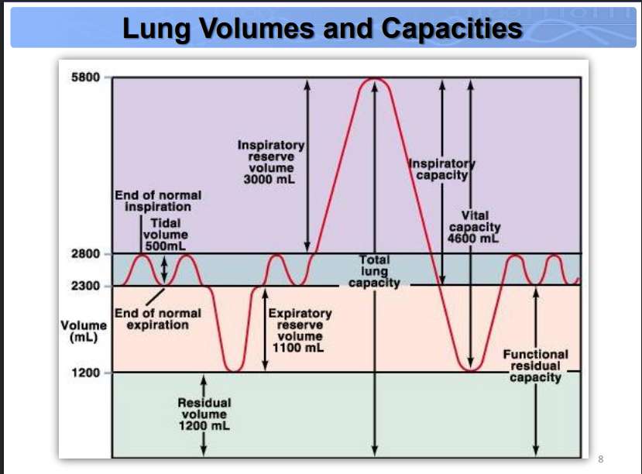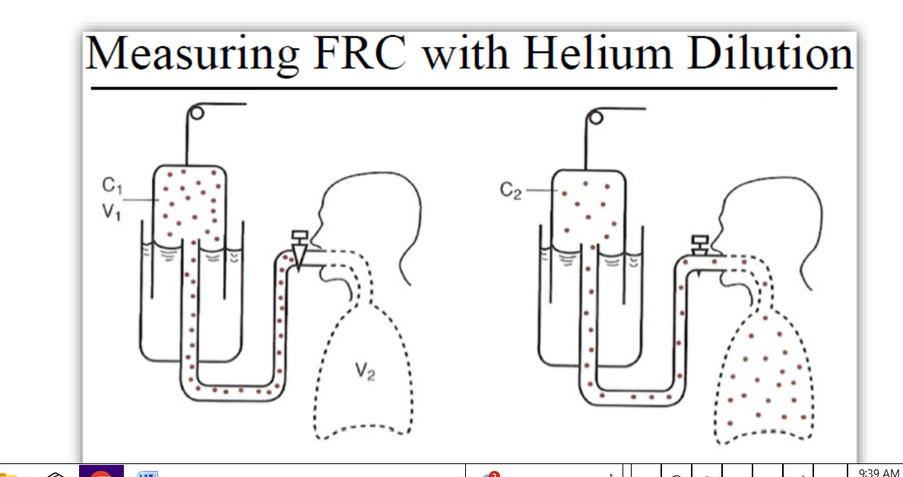

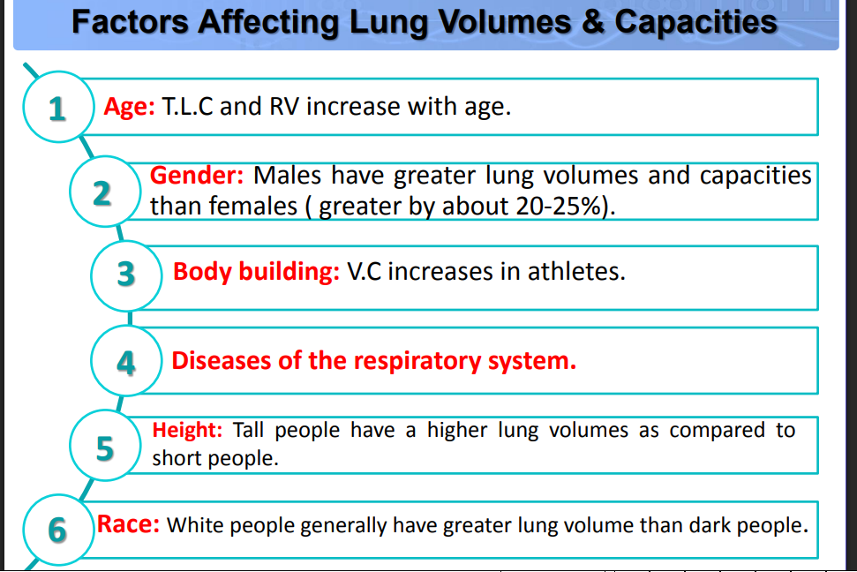

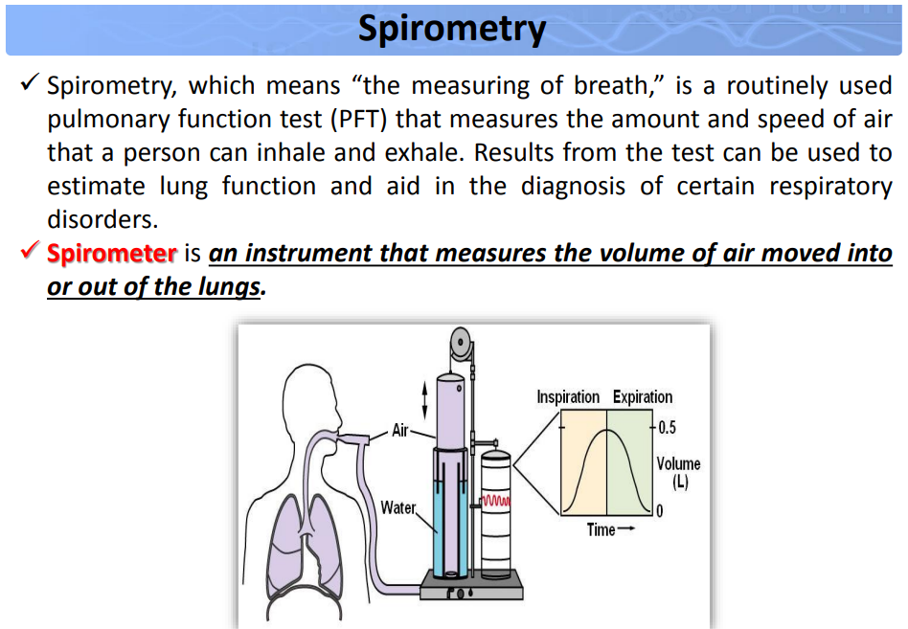

Indications for Spirometry

Diagnostic : 1. To establish baseline lung function. 2. To evaluate symptoms like dyspnea, signs or abnormal laboratory tests. 3. To detect or screen individuals at the risk of pulmonary diseases. 4. To measure the effect of disease on pulmonary function. 5. To assess pre-operative risk.

Monitoring : 1. To assess therapeutic intervention. 2. To describe the course of diseases that affect lung functions. 3. To monitor people exposed to injurious agents and surveillance of occupation related lung disease. 4. To monitor for adverse reactions to drugs with known pulmonary toxicity. 5. To assess patients as part of a rehabilitation program.

What to Do Before the Test?

1. Exclude contraindication Hemoptysis of unknown origin. •
2. Current chest infection or within in last 6 weeks. • Pneumothorax. • Recent myocardial infarction. • Unstable angina in last 24 hours. • Recent surgery (eye, chest, abdomen) (< 3m). • Recent CVA (< 3m). 2. Stop Asthma Medications: Medications may be continued if the test aims to assess the patient condition on treatment.
3. 3. Other Precautions: • Physical and mental rest. • No coffee or smoking for 30 mins. • Empty the bladder in females or those with history of urinary incontinence.
4. 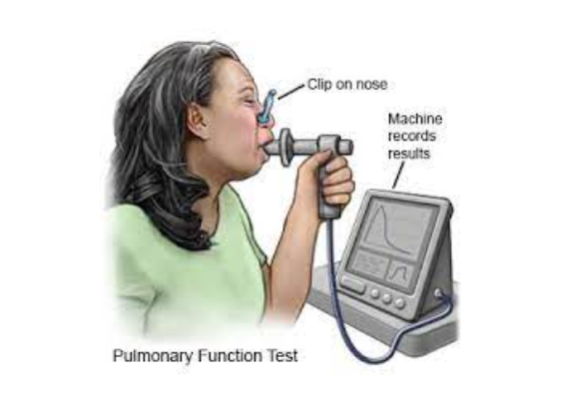**Normal values in spirometry: the most common parameters**

It is important to keep in mind that the so-called *normal* values in spirometry may vary from patient to patient, according to parameters such as age, sex, body weight or height. Doctors usually calculate the reference values on the basis of these parameters and use them as reference for the test results. A result is considered normal if the value falls over 80% of the predicted score, while lower percentages are indicators of respiratory issues.

1. **FVC, Forced Vital Capacity**

FVC measures the volume of air that a patient can exhale with a maximal forced expiration effort after a deep inhaling, simply put, how much air a patient can breathe out by blowing as fast as possible.

Average values in healthy patients aged 20-60 range from 5.5 to 4.75 liters in males and from 3.75 to 3.25 liters in females.

1. **FEV1, Forced Expiratory Volume in 1 Second**

This parameter measures the amount, or volume, exhaled by a patient in the first second of the expiration after a full inspiration.

Average values in healthy patients aged 20-60 range from 4.5 to 3.5 liters in males and from 3.25 to 2.5 liters in females.

1. **FEV1/FVC Ratio**

This parameter is calculated by dividing FEV1 by FVC, and is usually express as both a numerical (absolute) value and a percentage. This value is especially important for the detection of COPD, Cronic Obstructive Pulmonary Disease, as it can indicate resistance or obstructions to the expiratory airflow.

Healthy adults aged 20-60 should expect the percentage to be between 70% and 85%.

1. **Spirogram**

This is a flow/volume graph showing a visual record of the expiration. The breath flow is usually shown on the X axis and expressed in liters per second, while the breath volume is shown on the Y axis and expressed in liters.

Non-medical personnel may find it hard to interpret the chart but, in general, a healthy patient’s curve will show a jump right after the start of the expiration, then a steady and quick raise to a sharp peak, and finally a smooth and slow fall.

Patients with respiratory problems may instead get different visuals, such as slow start or slow rises in the flow, an inconstant flow with several peaks, or even an abrupt interruption of the curve

What to Do During the Test?  
⎫ Patient is sitting comfortably, not leaning forwards, legs not  
crossed, feet firm on floor.  
⎫ No tight clothes or collars.  
⎫ Explain the procedure to the patient.  
⎫ Nasal clip is optional.  
⎫ Ask the patient to do a Forced Expiratory Maneuver (FEM):  
• Take a maximal inspiration.  
• Hold the breath and seal your lips tightly around the mouth piece.  
• Blow as fast as possible (blast expiration) until the lungs feel  
completely empty (at least 6 sec., up to 12 sec in obstructivedisease)  
• Repeat the test 3 times and record the highest reading.  
• Continue watching, explanation and encouragement throughout  
the procedure.

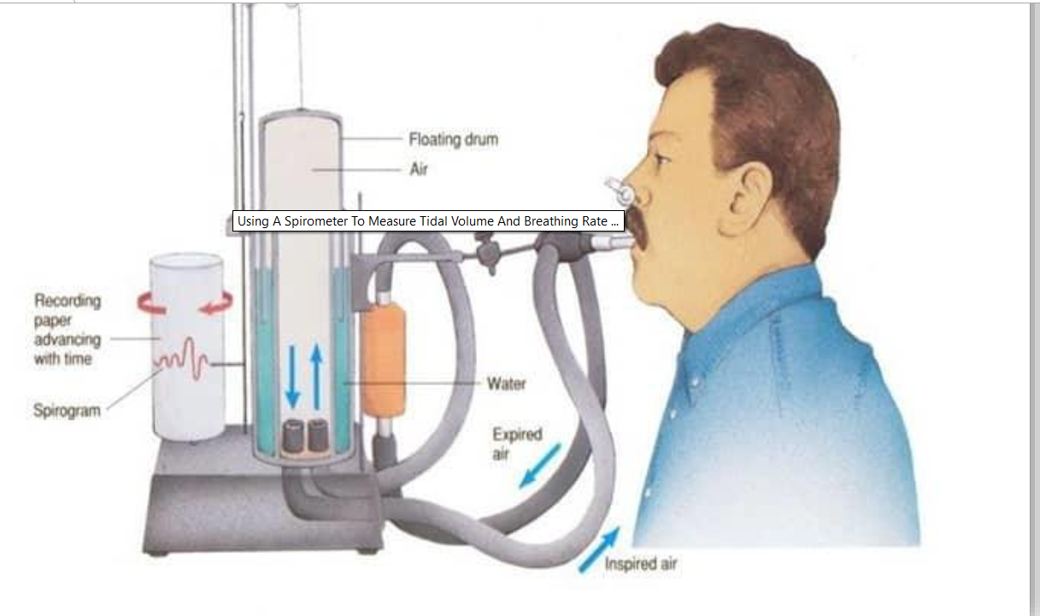

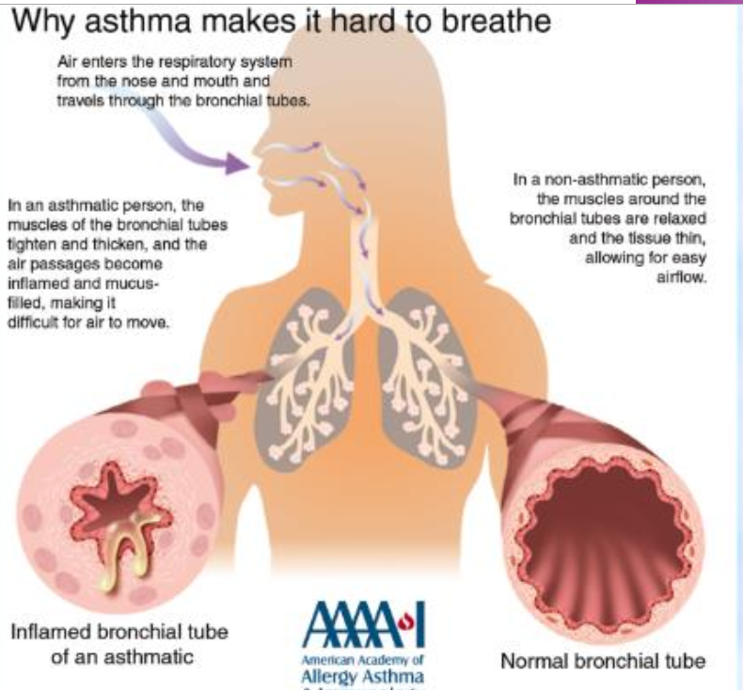

https://www.youtube.com/watch?v=SgaTDsGgeow