 

Department of Electrical Engineering techniques

Ministry of Higher Education and

Scientific Research – Iraq

AL-Mustaqbal University

**DC Generators**

**المحاضرة الثالثة والرابعة**

|  |  |
| --- | --- |
| **Week3و4** | **Armature Core**  **Armature Windings** |

**اعداد**

**الدكتور جابر غايب القاضي**

**Armature Core**

It houses the armature conductors or coils and causes them to rotate and hence cut the magnetic flux of the field magnets. In addition to this, its most important function is to provide a path of very low reluctance to the flux through the armature from a *N*-pole to a *S*-pole.

It is cylindrical or drum-shaped and is built up of usually circular sheet steel discs or laminations approximately 0.5 mm thick. It is keyed to the shaft.

The slots are either die-cut or punched on the outer periphery of the disc and the keyway is located on the inner diameter as shown. In small machines, the armature stampings are keyed directly to the shaft. Usually, these laminations are perforated for air ducts which permit axial flow of air through the armature for cooling purposes. Such ventilating channels are clearly visible in the laminations.

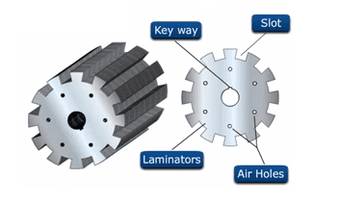

Fig 8. Armature core.

Up to armature diameters of about one meter, the circular stampings are cut out in one piece as shown in Fig above. But above this size, these circles, especially of such thin sections, are difficult to handle because they tend to distort and become wavy when assembled together. Hence, the circular laminations, instead of being cut out in one piece, are cut in a number of suitable sections or segments which form part of a complete ring.

A complete circular lamination is made up of four or six or even eight segmental laminations. Usually, two keyways are notched in each segment and are dovetailed or wedge-shaped to make the laminations self-locking in position.

The purpose of using laminations is to reduce the loss due to eddy currents. Thinner the laminations, greater is the resistance offered to the induced e.m.f., smaller the current and hence lesser the I2 R loss in the core.

**Armature Windings**

The armature windings are usually former-wound.These are first wound in the form of flat rectangular coils and are then pulled into their proper shape in a coil puller. Various conductors of the coils are insulated from each other. The conductors are placed in the armature slots which are lined with tough insulating material. This slot insulation is folded over above the armature conductors placed in the slot and is secured in place by special hard wooden or fiber wedges.

The winding of the machine is classified into two types.  They are closed type winding and Open type winding. The classification of winding is shown in the figure below.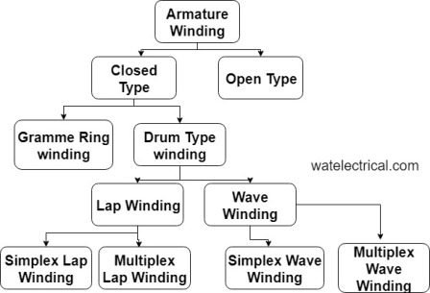Fig 8. Classification of armature windings.

**Lap armature Winding**

* The basic connection of lap winding is shown in fig.
* For lap winding the number of parallel paths is exactly **equal to** the number of **poles P**.
* Number of parallel patha(A) = Numberof Poles(P)

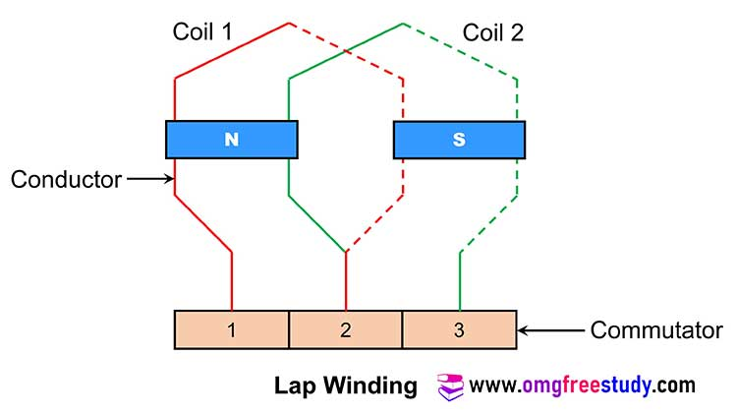

* The lap winding mostly is useful for low voltage and high current machines.
* In this type of winding large number of parallel paths that means the lap wound armature winding is capable of supplying larger load currents.
* Hence the generators of high current capacity use the lap wound armature winding. But these generators are generated low capacity voltage.
* In lap winding the armature conductors are divided into P groups (number of poles). All the conductors in a group are connected in series and all such groups are connected in parallel.

**Wave Armature Winding**

The basic connection of wave winding is shown in fig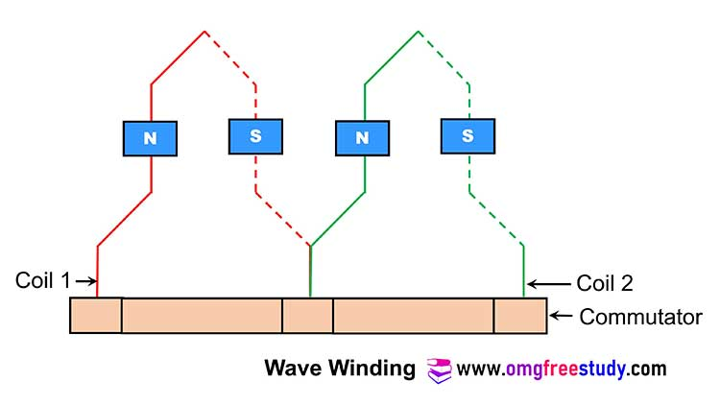

* This type of winding will create only **two parallel** paths independent of the number of poles.
* Number of parallel path (A) = 2
* Wave winding is useful for high voltage low current capacity machines
* Note that the number of parallel paths for wave winding will be less than that for lap winding.
* Hence this winding does not have the capability of supplying larger load currents. So the generators with wave winding are low current ratings and these generators are capable of producing high voltage.
* Thus in wave winding, all the conductors are connected in series to form a single closed circuit.

**Comparison of Lap and Wave Windings:**

**Que. Compare** **lap winding and wave winding on the basis of : i) Number of parallel paths in the winding. ii) voltage generating capability  iii) Current sourcing capability iv) Number of brush sets.**

|  |  |  |
| --- | --- | --- |
| **Parameters** | **Lap winding** | **Wave winding** |
| Number of parallel paths in the winding. | A =P (A= No. of parallel path & P= No. of poles) | A=2 always  (A= No. of parallel path) |
| voltage generating capability | Low | High |
| Current sourcing capability | High | Low |
| Number of brush sets. | Equal to number of pole | Equal to 2 always |