**محاضرة 9**

**Parallel operation of dc generator**

**What Are The Conditions For Paralleling The DC Generator?**

**Condition for parallel operation of DC generator:**

**For the successful parallel operation of DC generators, several conditions must be met.**

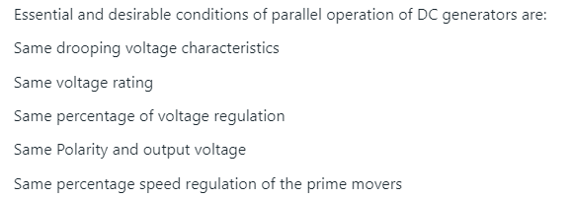

.



* **Same terminal voltage:** generators must have the same terminal [voltage](https://testbook.com/electrical-engineering/concept-of-voltage-and-its-units) to ensure that no circulating current exists between them upon connection.
* **Identical polarity:** they should possess identical polarity, preventing potential short circuits.
* **The speed-voltage characteristic of the generators should be compatible**, allowing them to share load proportionally.
* **Phase sequence:** the phase sequence and frequency (in the case of AC [generators](https://testbook.com/physics/types-of-generators)being rectified) must match perfectly.

Fulfilling these conditions ensures a smooth and efficient paralleling process, preventing damage to the generators and ensuring stable operation.

**Connection of Parallel DC Generators**

Connecting DC generators in parallel involves linking the positive terminals of all generators together and doing the same with the negative terminals, ensuring they feed into a common busbar or distribution point. Before connecting, it's crucial to match the voltage levels of each generator to avoid circulating currents that can cause inefficiencies or damage.

Synchronization equipment and procedures are often employed to ensure that all conditions for paralleling are met.

After a successful connection, the generators can operate cohesively, responding to variations in load demand while maintaining system stability.

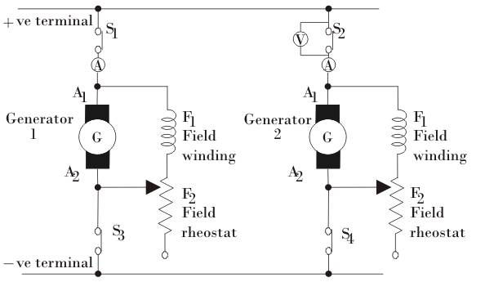

1. The generators in a [power plant](https://www.electrical4u.com/power-plants-types-of-power-plant/), connected by heavy thick copper bars, called bus-bars which act as positive and negative terminals. To connect the generators in parallel, Positive terminal of the generators are connected to the positive terminal of the bus-bars and negative terminals of generators are connected to negative terminal of the bus-bars, as shown in the figure.
2. To connect a second generator to an existing one, first, bring the speed of the second generator’s prime mover to the rated speed. Then, close switch S4.
3. The [circuit breaker](https://www.electrical4u.com/electrical-circuit-breaker-operation-and-types-of-circuit-breaker/) V2 ([voltmeter](https://www.electrical4u.com/working-principle-of-voltmeter-and-types-of-voltmeter/)) connected across the open switch S2 is closed to complete the circuit. The excitation of the generator 2 is increased with the help of field [rheostat](https://www.electrical4u.com/materials-used-for-rheostats/) till it generates [voltage](https://www.electrical4u.com/voltage-or-electric-potential-difference/) equal to the voltage of bus-bars.
4. Next, close the main switch S2 to parallel the second generator with the existing one. At this point, generator 2 is not yet supplying power because its induced e.m.f. equals the bus-bar voltage. This state is called “floating,” meaning the generator is ready but not supplying [current](https://www.electrical4u.com/electric-current-and-theory-of-electricity/).

5.  
In order to deliver current from generator 2, it is necessary that its induced e.m.f. E should be greater than the bus-bars voltage V. By strengthening the field current, the induced e.m.f. of generator 2 could be improved and the current supply will get started. To maintain bus-bar voltage, the field of generator 1 is weakened so that value remains constant.

Field current I given byhttps://www.electrical4u.com/images/november15/1450708931.GIFWhere, Ra is [resistance](https://www.electrical4u.com/what-is-electrical-resistance/) of [armature winding](https://www.electrical4u.com/armature-winding-pole-pitch-coil-span-commutator-pitch/).

لمولدات في محطة الطاقة متصلة بقضبان نحاسية سميكة ثقيلة تسمى قضبان التوصيل والتي تعمل كأقطاب موجبة وسالبة. لتوصيل المولدات بالتوازي، يتم توصيل الطرف الموجب للمولدات بالطرف الموجب لقضبان التوصيل ويتم توصيل الأطراف السالبة للمولدات بالطرف السالب لقضبان التوصيل، كما هو موضح في الشكل.

لتوصيل مولد ثانٍ بمولد موجود، أولاً، قم بجعل سرعة المحرك الرئيسي للمولد الثاني تصل إلى السرعة المقدرة. ثم أغلق المفتاح S4.

يتم إغلاق قاطع الدائرة V2 (الفولتميتر) المتصل عبر المفتاح المفتوح S2 لإكمال الدائرة. يتم زيادة إثارة المولد 2 بمساعدة مقاوم الحقل حتى يولد جهدًا يساوي جهد قضبان التوصيل.

بعد ذلك، أغلق المفتاح الرئيسي S2 لتوصيل المولد الثاني بالمولد الموجود بالتوازي. في هذه المرحلة، لم يقم المولد 2 بتزويد الطاقة بعد لأن قوته الدافعة الكهربائية المستحثة تساوي جهد قضيب التوصيل. تُسمى هذه الحالة "عائمة"، أي أن المولد جاهز ولكنه لا يزود التيار.

من أجل توصيل التيار من المولد 2، من الضروري أن تكون القوة الدافعة الكهربائية المستحثة E أكبر من جهد القضبان الناقلة V. من خلال تعزيز تيار المجال، يمكن تحسين القوة الدافعة الكهربائية المستحثة للمولد 2 وسيبدأ إمداد التيار. للحفاظ على جهد القضبان الناقلة، يتم إضعاف مجال المولد 1 بحيث تظل القيمة ثابتة.