 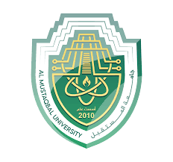

Department of Electrical Engineering techniques

Ministry of Higher Education and

Scientific Research – Iraq

AL-Mustaqbal University

**DC Generators**

**المحاضرة الاولى والثانية**

|  |  |
| --- | --- |
| **Week 1,2** | **Basic construction of electrical machines**  **Construction of D.C. generator** |

**اعداد**

**الدكتور جابر غايب القاضي**

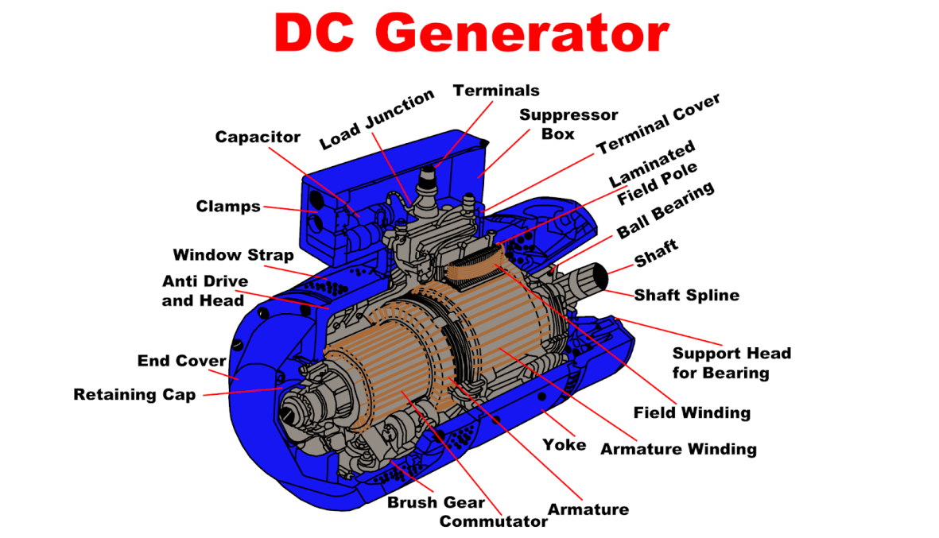

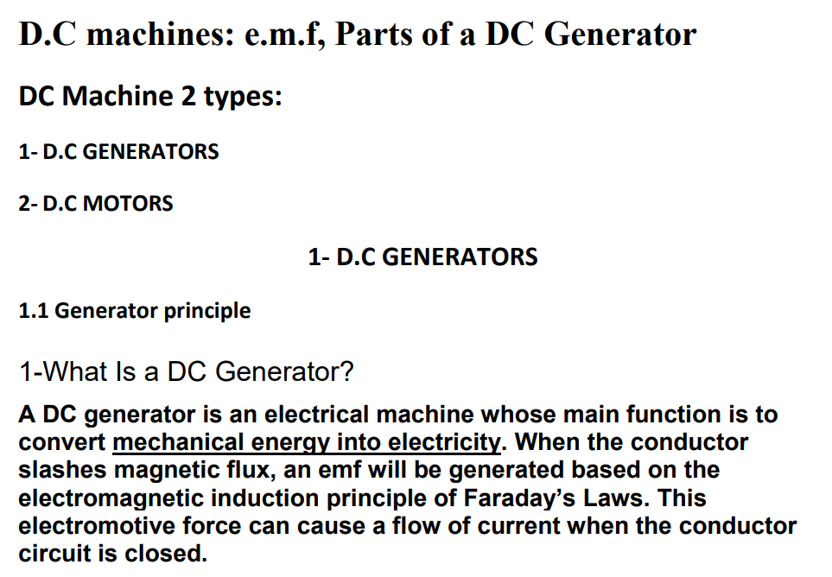

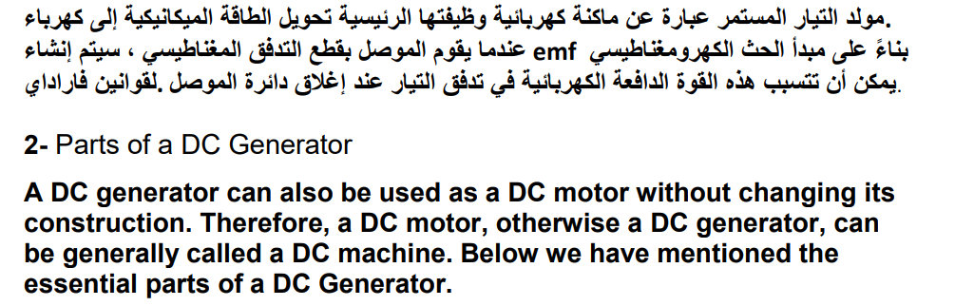

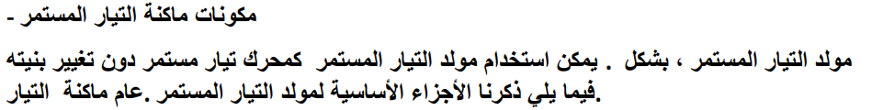

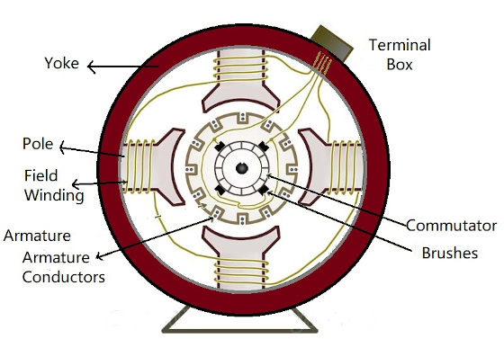

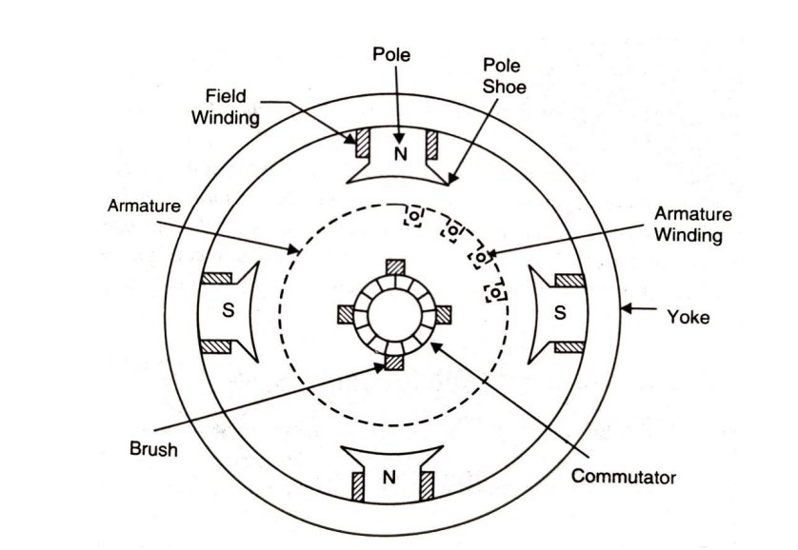

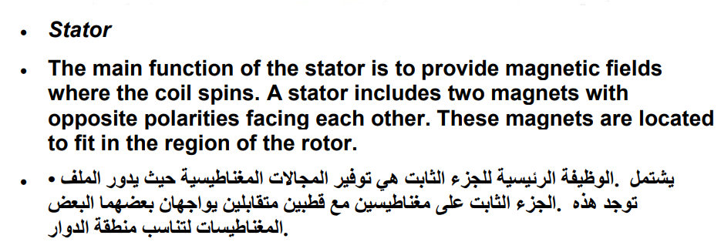

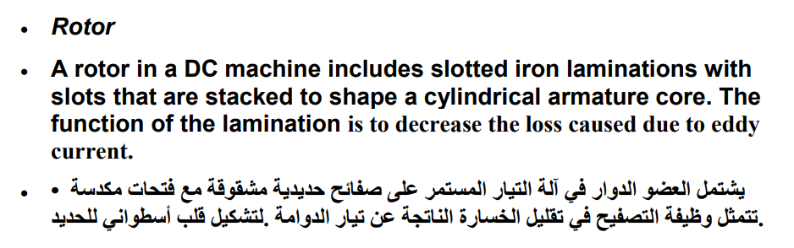

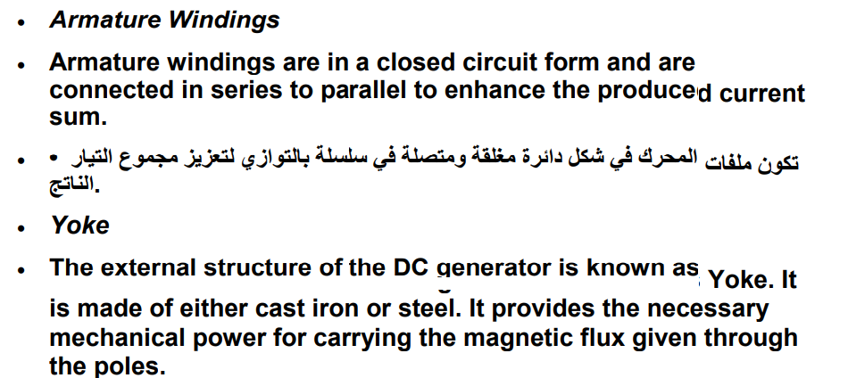

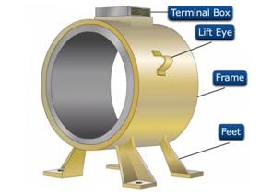

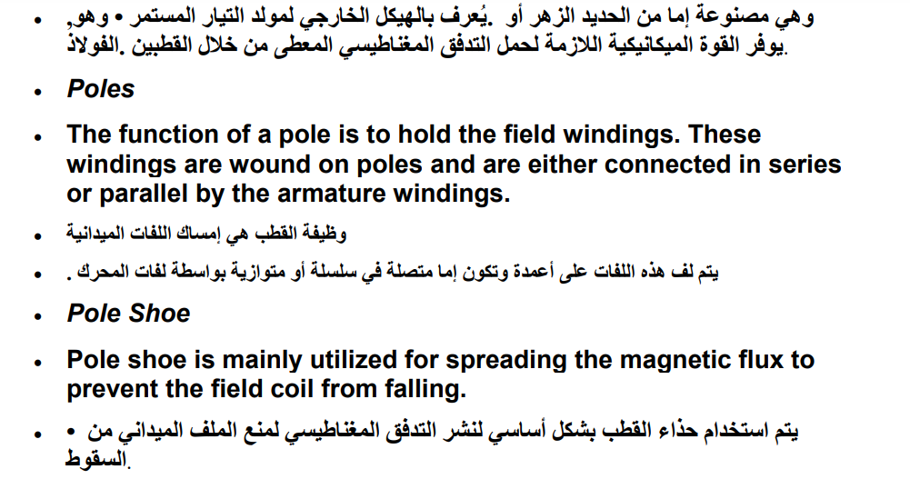

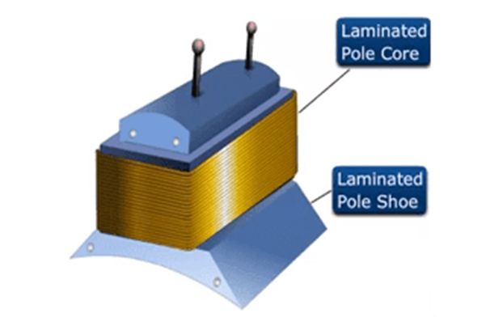

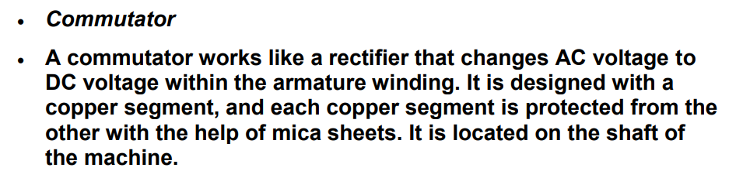

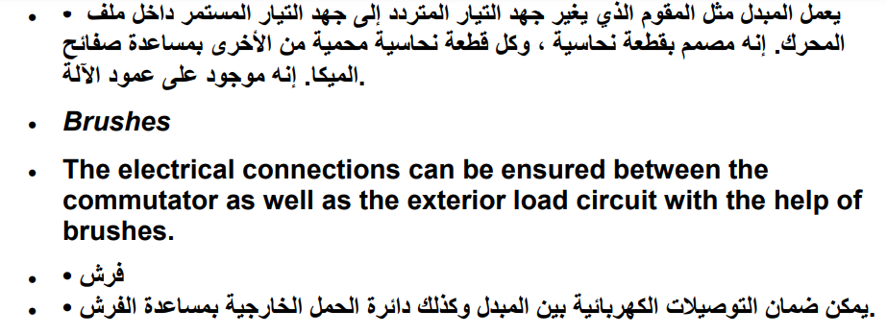

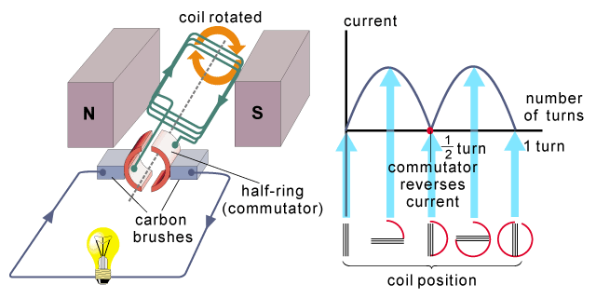

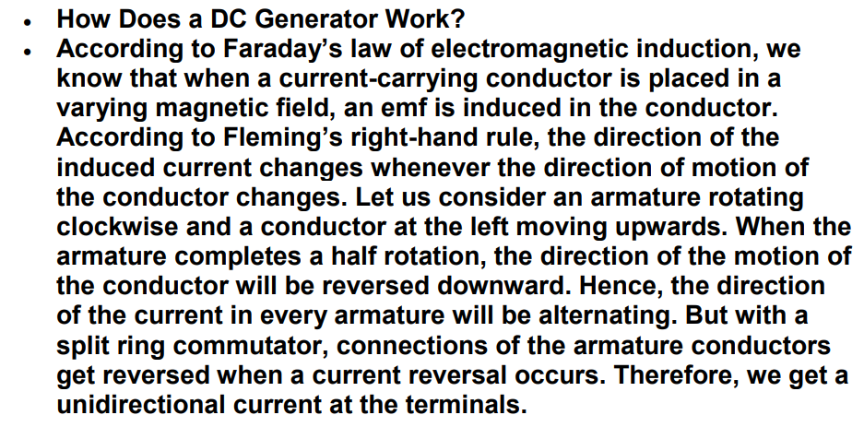

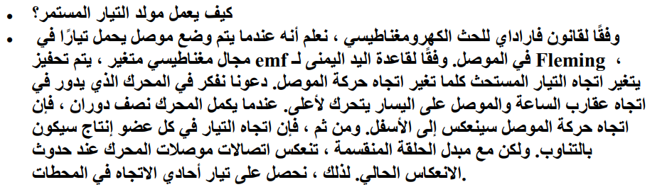

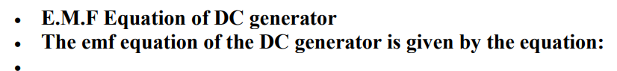

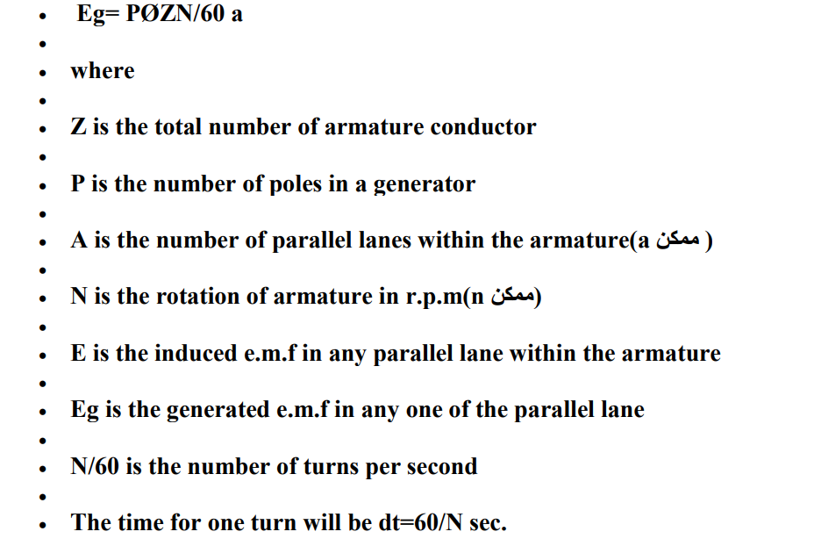

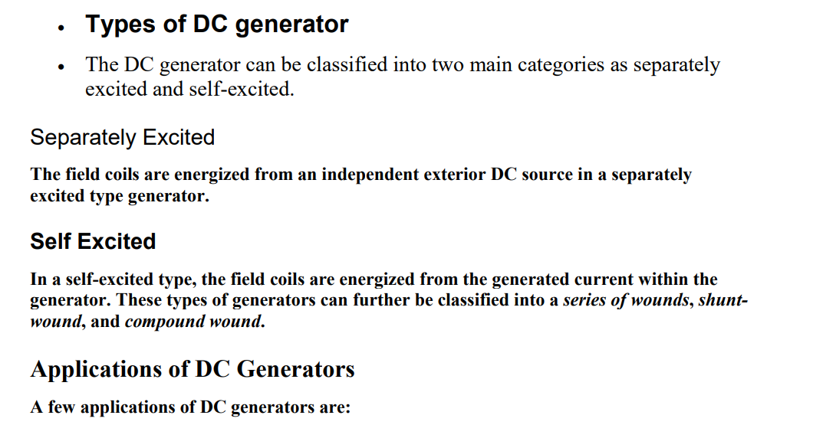

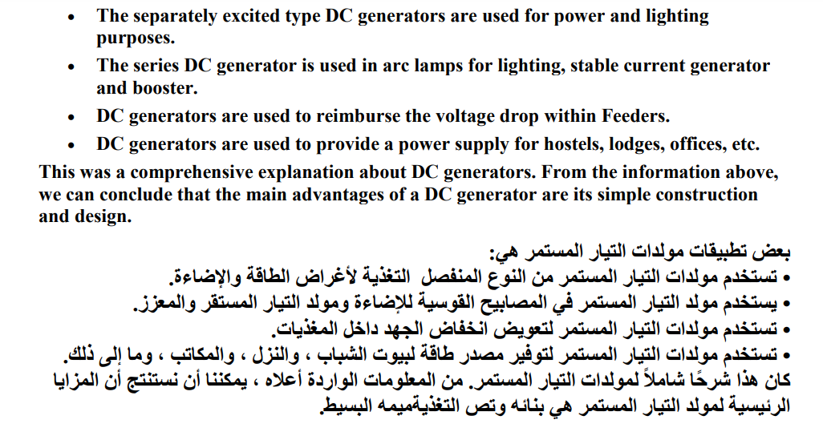

**Types of DC Machines**

**There are 2 main types of DC machines first one is a generator and the second one is a dc motor, dc motor uses dc current and provides mechanical power and dc generator generates dc voltage. As we discuss when current-carrying conductor when placed in field emf induced forces apply on it.  There are two main categories by which the dc machine gets excited first one is self-excited and the second one is separately excited.**

** In self-excited machines field current produced by the machines itself while in separately excited machines the field current is provided by the separated source.  Due to these two excitations methods, the dc machines are further divided into different types that are described here.**

* **Compound DC machine.**
* **Shunt DC machine.**
* **Separately excited DC machine.**
* **Series DC machine.**

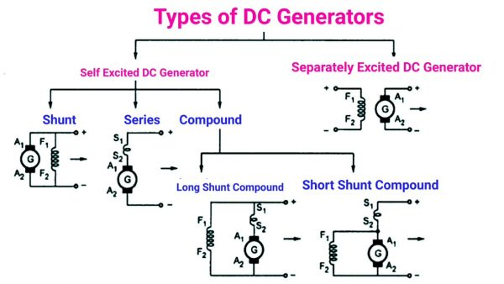

**Fig 10. Classification of DC machine.**