 

Department of Electrical Engineering techniques

Ministry of Higher Education and

Scientific Research – Iraq

AL-Mustaqbal University

**DC Generators**

**المحاضرة 12,13,14**

**أمثلة وحلول**

**. Characteristics of D.C. Generators**

**اعداد**

**الدكتور جابر غايب القاضي**

**Example 1:** The magnetization curve of a d.c. shunt generator at 1500 r.p.m. is.

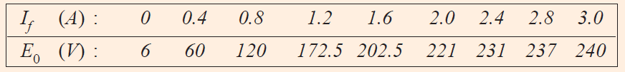

For this generator find **(i)** no load e.m.f. for a total shunt field resistance of 100 Ω **(ii)** the critical field resistance at 1500 r.p.m. and **(iii)** the magnetization curve at 1200 r.p.m. and therefrom the open-circuit voltage for a field resistance of 100 Ω

**Solution**

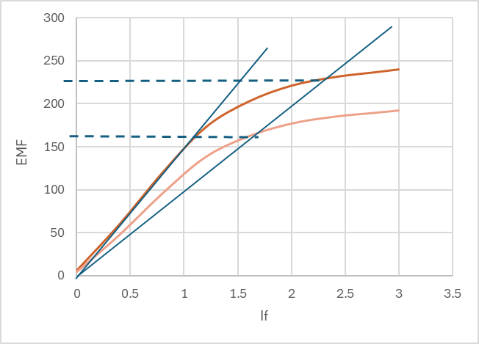

I

II

A

C

T

O

N1=1500 rpm (Curve I)

N2=1200 rpm (Curve II)

Point A (EMF , If) at full load

1. From figure Emf = **227.5 V**
2. Rc = 225/1.5=**150 Ω** at 1500 rpm

$\frac{N_{2}}{N_{1}}=\frac{1200}{1500}=0.8$

The values of these voltages are tabulated below :

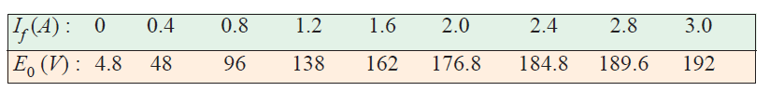

Then emf = **166 V** at Rf=**100 Ω**

**Example 2:** The open-circuit characteristic of a separately-excited d.c. generator driven at 1000 r.p.m. is as follows :

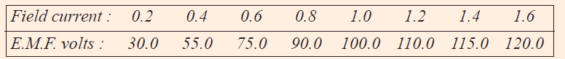

If the machine is connected as shunt generator and driven at 1,000 r.p.m. and has a field resistance of 100 Ω, find

**(a)** open-circuit voltage and exciting current

**(b)** the critical resistance and

**(c)** resistance to induce 115 volts on open circuit.

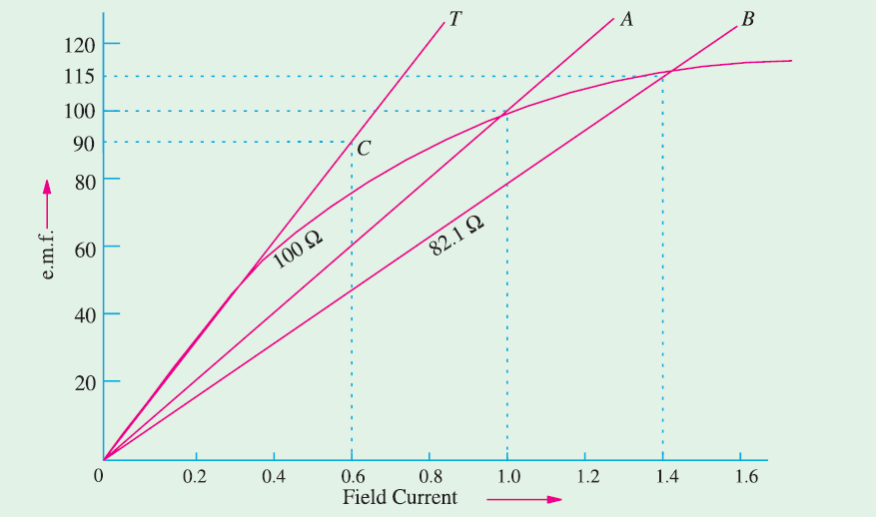**Solution**

**(*a*)** *O.C.* voltage = **100 V**; Exciting current = **1 A**

**(*b*)** Line *OT* is tangent to the initial part of the *O.C.C.*

It represents critical resistance. As seen from point *C*,

value of critical resistance is 90/0.6 = **150** Ω

**(*c*)** Line *OB* represents shunt resistance for getting 115 V on open-circuit.

Its resistance = 115/ 1.4 = **82.1** Ω 

**Example 3:** A shunt generator gave the following open-circuit characteristic

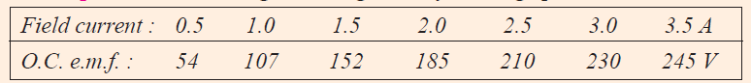

The armature and field resistances are 0.1 Ω and 80 Ω  respectively. Calculate

**(a)** the voltage to which the machine will excite when run as a shunt generator at the same speed. **(b)** The volts lost due to armature reaction when 100 A are passing in the armature at a terminal voltage of 175 V.

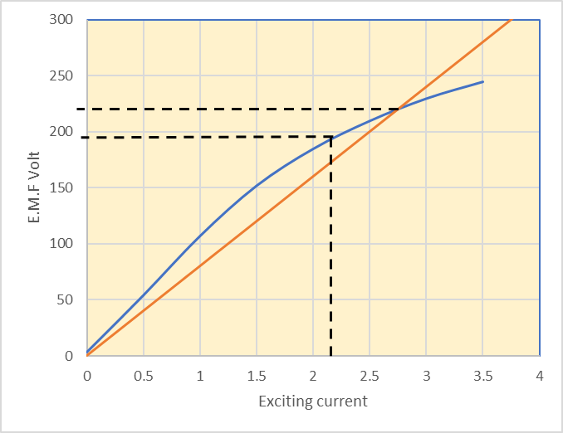**Solution**

**(*a*)** *OA* represents 80 Ω line. The maximum voltage to which the generator will build up is given by *OM* = **222 V.**

F

C

M

A

**(*b*)** With 175 V terminal on load

80Ω

Ish= 175/80 = **2.2** A

Voltage corresponding to this field current is given by *OC* = **195 V**.

O

Voltage lost due to armature reaction and armature drop = 195 175 = **20** **V**.

Now, armature drop = 0.1 × 100 = **10 V**

Let ‘*x*’ be the volts lost due to armature reaction.

Then 10 + *x* = 20 ∴ *x* = **10 V**