 

Department of Electrical Engineering techniques

Ministry of Higher Education and

Scientific Research – Iraq

AL-Mustaqbal University

**DC Generators**

**المحاضرة الاولى والثانية**

|  |  |
| --- | --- |
| **Week 3** | **أمثلة محلولة** |

**اعداد**

**الدكتور جابر غايب القاضي**

**E.M.F equation in generator**

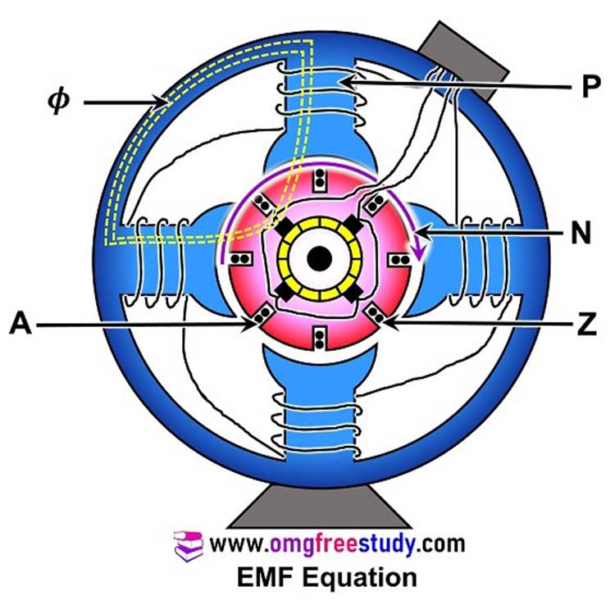When the armature of a DC generator rotates in magnetic field, an emf is induced in the armature winding, this induced emf is known as generated emf. It is denoted by Eg.

Let

$∅$ = Magnetic flux per pole in Wb.

$Z$ = Total number of armature conductors.

$P$ = Number of poles in the machine.

$A$ = Number of parallel paths.

$N$ = Speed of armature in RPM.

Fig 1. Elements of EMF equation .

|  |  |  |  |  |  |
| --- | --- | --- | --- | --- | --- |
| Eg | $$=$$ | Generated E.M.F | $$=$$ | E.M.F per parallel path. | (1) |

Therefore, the magnetic flux cut by one conductor in one revolution of the armature being:-

|  |  |  |  |
| --- | --- | --- | --- |
| Flux cut by one conductor | $$=$$ | $$P ∅$$ | (2) |

Time taken to complete one revolution is given as:

|  |  |  |  |
| --- | --- | --- | --- |
| $$t$$ | $$=$$ | $$\frac{60}{N}$$ | (3) |

Therefore, the average induced E.M.F in one conductor will be:

|  |  |  |  |
| --- | --- | --- | --- |
| $$e$$ | $$=$$ | $$\frac{P ∅}{t}=\frac{P ∅ N}{60} volt$$ | (4) |

The number of conductors connected in series in each parallel path = Z/A.

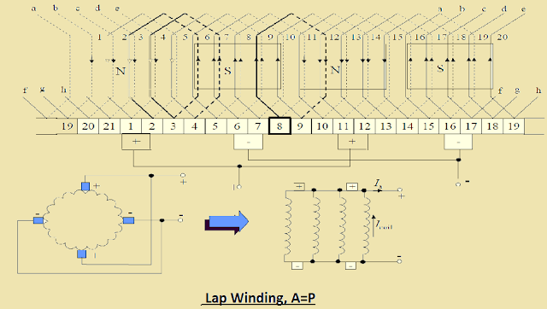

Fig 2. Paths in lap winding DC machine.

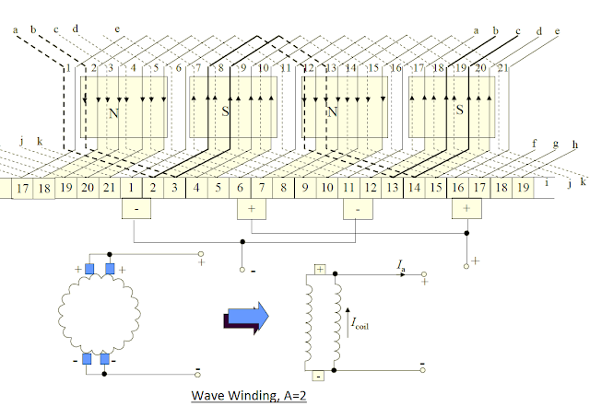

Fig 3. Path in wave winding DC machine.

Therefore, the average induced E.M.F across each parallel path or the armature terminals is given by the equation shown below:

|  |  |  |  |
| --- | --- | --- | --- |
| $$Eg$$ | $$=$$ | $$\frac{Z P ∅ N}{A 60} volt$$ | (5) |

If the angular velocity were been given then:-

|  |  |  |  |
| --- | --- | --- | --- |
| $$Eg$$ | $$=$$ | $$\frac{2π}{2π}×\frac{ Z P ∅ N}{A 60}=\frac{2πN}{60}×\frac{ Z P ∅ }{2π A}=\frac{ ω Z ∅ P }{2π A} volt$$ | (6) |

Where $ω$ is the angular velocity in radians/second.

**Example 1:** A four-pole generator, lap-wound armature winding has 51 slots, each slot containing 20 conductors. What will be the voltage generated in the machine when driven at 1500 rpm assuming the flux per pole to be 7.0 mWb ?

**Solution**

∅ = 7 10−3 Wb. *Z* = 51 20 = 1020. *A* = *P* = 4. *N* = 1500 r.p.m.

$$Eg=\frac{Z P ∅ N}{A 60}=\frac{1020 × 7 × {10}^{-3}× 1500}{60}= 178.5 V$$

**Example 2:** An 8-pole d.c. shunt generator with 778 wave-connected armature conductors and running at 500 r.p.m. supplies a load of 12.5 Ω resistance at terminal voltage of 250 V. The armature resistance is 0.24 Ω and the field resistance is 250 Ω. Find the armature current, the induced e.m.f. and the flux per pole?

**Solution**

Load current = *V*/*R* = 250/12.5 = **20 A**

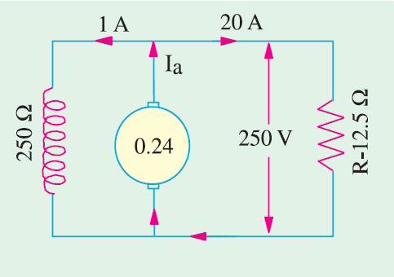Shunt current = 250/250 = **1 A**

Armature current = 20 + 1 = **21 A**

Induced e.m.f. = 250 + (21 . 0.24) = **255.04 V**

$$Eg=\frac{Z P ∅ N}{A 60}$$

$$255.04 =\frac{778×8× ∅ ×500}{2×60}$$

$$∅=9.83 mWb$$

**Example 3:** In a 120 V compound generator, the resistances of the armature shunt and series windings are 0.06 Ω, 25 Ω and 0.04 Ω respectively. The load current is 100 A at 120 V. Neglect brush contact drop and ignore armature reaction. Evaluate the following:

1. The induced e.m.f. and the armature current when the machine is connected as long-shunt.
2. The induced e.m.f. and the armature current when the machine is connected as short-shunt.

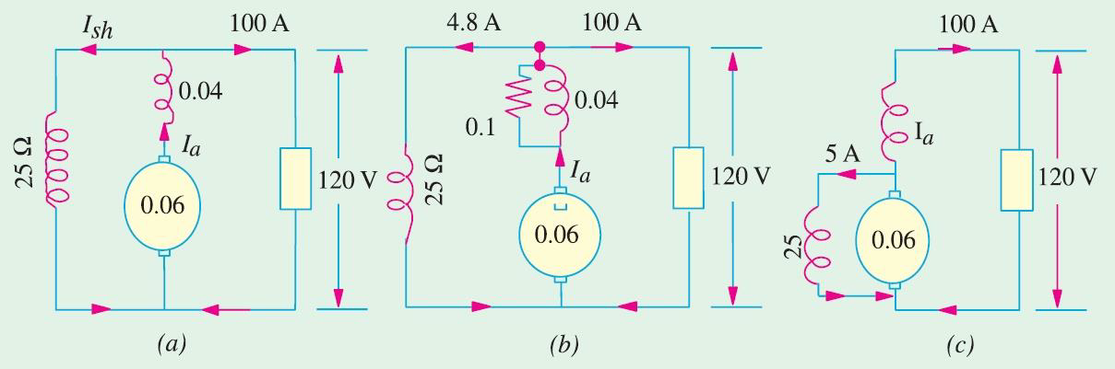 

**Solution**

**(*i*)** Long Shunt [Fig.(*a*)]

$I_{sh}$ = 120/25 = **4.8 A**, *I* = **100 A**,

$I_{a}=I+I_{sh}$ = **104.8 A**

Voltage drop in series winding = 104.8 **×** 0.04 = **4.19 V**

Armature voltage drop = 104.8 **×** 0.06 = **6.29 V**

∴ $Eg$ = 120 + 4.19 + 6.29 = **130.5 V**

**(*ii*)** Short Shunt [Fig. (*c*)]

Voltage drop in series winding = 100 **×** 0.04 = **4 V**

Voltage across shunt winding = 120 + 4 = **124 V**

∴ $I_{sh}$ = 124/25 = **5 A** ; ∴ $I_{a}$ = 100 + 5 = **105 A**

Armature voltage drop = 105 **×** 0.06 = **6.3 V**

$Eg$ = 120 + 6.3 + 4 = **130.4 V**.

**واجب بيتي**

### 1-DC Generator Problem 1

**A four-pole generator, having wave-wound armature winding has 51 slots, each slot containing 20 conductors. What will be the voltage generated in the machine when driven at 1500 rpm assuming the flux per pole to be 7.0 mWb ?**

**2-An 8-pole d.c. generator has 500 armature conductors, and a useful flux of 0.05 Wb per pole. What will be the e.m.f. generated if it is lap-connected and runs at 1200 rpm ? What must be the speed at which it is to be driven produce the same e.m.f. if it is wave-wound?**

**3-A DC shunt generator has an induced voltage on open-circuit of 127 volts. When the machine is on load, the terminal voltage is 120 volts. Find the load current if the field circuit resistance is 15 ohms and the armature-resistance is 0.02 ohm. Ignore armature reaction.**

**4-An 8-pole d.c. shunt generator with 778 wave-connected armature conductors and running at 500 r.p.m. supplies a load of 12.5 Ω resistance at terminal voltage of 50 V. The armature resistance is 0.24 Ω and the field resistance is 250 Ω. Find the armature current, the induced e.m.f. and the flux per pole.**

### **5-**DC Generator Problem 5

**In a 120 V compound generator, the resistances of the armature, shunt and series windings are 0.06 Ω, 25 Ω and 0.04 Ω respectively. The load current is 100 A at 120 V. Find the induced e.m.f. and the armature current when the machine is connected as (i) long-shunt and as (ii) short-shunt. How will the ampere-turns of the series field be changed in (i) if a diverter of 0.1 ohm be connected in parallel with the series winding ? Neglect brush contact drop and ignore armature reaction.**