### 

### 

**Al-Mustaqbal University**

**College of Engineering and Technology**

**Department of Medical Instrumentation Techniques Engineering**

**Class: Forth Class**

**Subject: Computer Applications/4**

**Lecturer: Dr.Myasar Mundher Adnan**

**Lecture** **Address: Functions**

**2024 - 2025**

### **COUNTIFS - Counting with Multiple Conditions**

**=COUNTIFS(criteria_range1, criteria1, [criteria_range2], [criteria2], …)**

* **criteria_range1: The first range of cells to be counted based on the first condition.**
* **criteria1: The first condition to count based on.**
* **criteria_range2: The second range of cells to be counted based on the second condition.**
* **criteria2: The second condition to count based on.**

**If we want to apply multiple conditions, we use COUNTIFS because it allows counting based on more than one condition.**

### **Example:**

**Count the number of employees who work Full-Time and have a salary greater than 1300.**

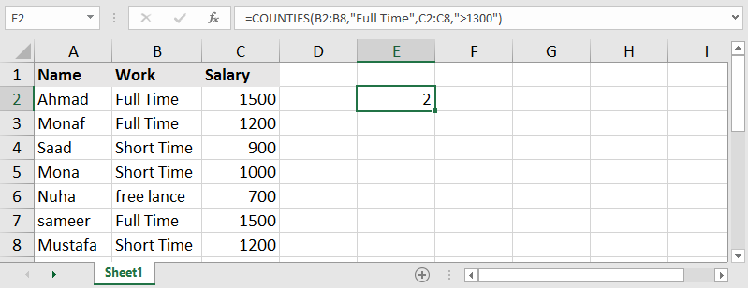

### **Example: Counting Employees with Salaries Between 500 and 1300**

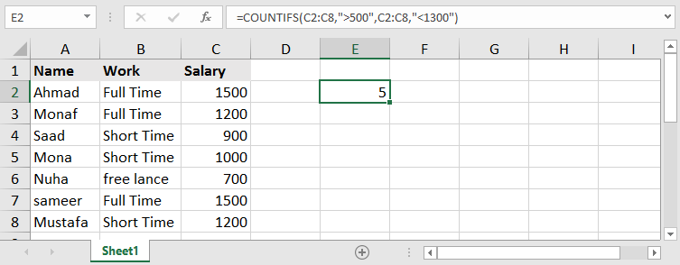

### **Conditional Summation - SUMIF**

**=SUMIF(range, criteria, [sum_range])**

**This function belongs to the SUM family but only sums values when a specific condition is met.**

* **range → The range of cells where the condition is checked.**
* **criteria → The condition that must be met for summation to occur.**
* **sum_range → The range of cells containing values to sum when the condition is met.**

### **Example:**

**Calculating the total salaries of employees who work full-time (Time Full)**

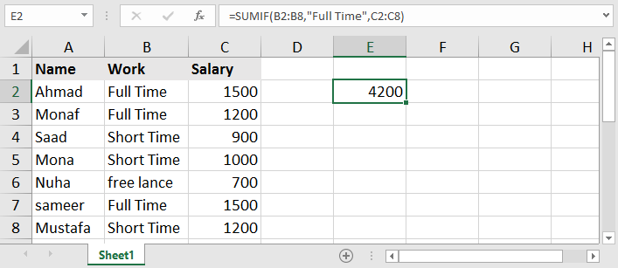

### **Example: Calculating the total salaries of employees earning more than 1000**

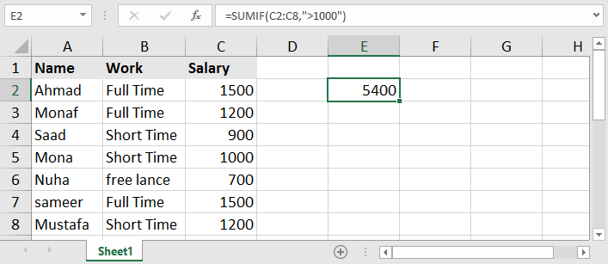

**We can omit the third part of the SUMIF formula if the conditional range is the same as the sum range.**

**Summing with Multiple Conditions - SUMIFS**

**Formula:  
=SUMIFS(sum_range, criteria_range1, criteria1, [criteria_range2], [criteria2])**

**This function sums values only when multiple conditions are met.**

* **sum_range: The range of cells to be summed if the conditions are met.**
* **criteria_range1: The first range of cells where a condition is applied.**
* **criteria1: The first condition that must be met.**
* **criteria_range2: The second range of cells where another condition is applied.**
* **criteria2: The second condition that must be met.**

**Example: Calculating the total salaries of male employees who work full-time.**

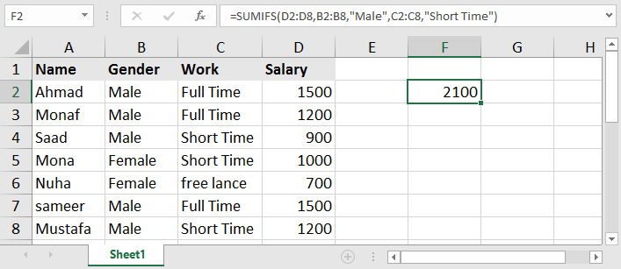

**Example: Calculating the total quantity of sold HP laptops.**

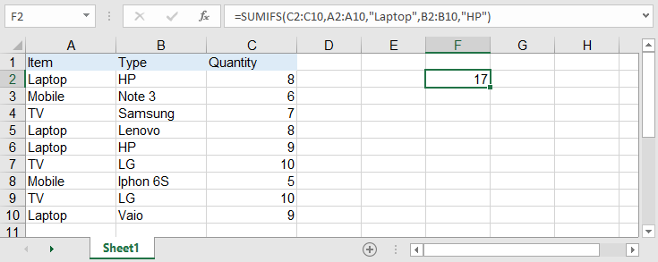

### **Functions for Searching a Specific Value:**

**Microsoft Excel provides multiple functions for searching a specific value. We will start by reviewing some of them, highlighting their advantages and accuracy.**

#### **LOOKUP Function:**

**Formula:  
=LOOKUP(lookup_value, lookup_vector, [result_vector])**

* **lookup_value: The value to search for.**
* **lookup_vector: The range of cells where the value will be searched.**
* **result_vector: The range of cells from which the result will be returned if the searched value is found or exceeded in the first range.**

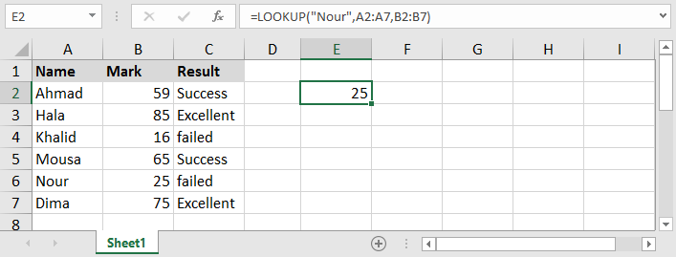

### **Note 1:**

**When searching for a specific numeric value within a table, the result will be returned if the value is exceeded, not just when it is equal.**

**For example, if we search for the value 65 in a table containing 60 and 70, the function will return the value corresponding to 60 because it exceeded it but did not reach the next higher value.**

### **Note 2:**

**When searching for a numerical value within a range, it is essential to ensure that the range is sorted in ascending order for the function to work correctly.**

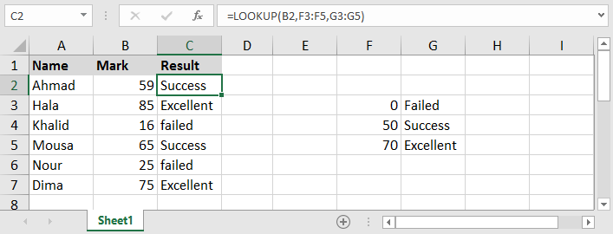

### **Vertical Lookup Function: VLOOKUP**

**=VLOOKUP(lookup_value, table_array, col_index_num, range_lookup)**

* **lookup_value: The value to search for.**
* **table_array: The table range that contains both the search column and the result column.**
* **col_index_num: The column number of the result, relative to the selected table range.**
* **range_lookup: This determines the type of match:** 
  + **Use TRUE to return an approximate match.**
  + **Use FALSE to return an exact match.**

### **Note:**

**If we omit the last part [range_lookup], the function will behave as if TRUE was selected, returning an approximate result**

### **Horizontal Lookup Function: HLOOKUP**

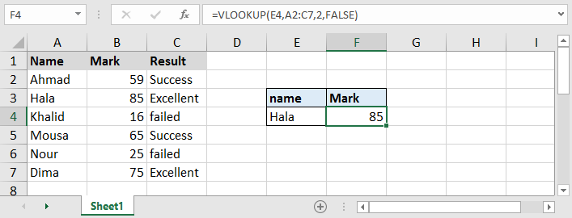

**=HLOOKUP(lookup_value, table_array, row_index_num, [range_lookup])**

**What if the data is arranged horizontally? In this case, we cannot use the VLOOKUP function for searching. Instead, we need the HLOOKUP function to perform the task. This function works exactly like VLOOKUP but with a slight difference.**

* **lookup_value: The value to search for.**
* **table_array: The table range that contains both the search row and the result row.**
* **row_index_num: The row number of the result, relative to the selected table range.**
* **range_lookup: This determines the type of match:**
* **Use TRUE to return an approximate match.**
* **Use FALSE to return an exact match.**

### **Note:**

**If we omit the last part [range_lookup], the function will behave as if TRUE was selected, returning an approximate result.**

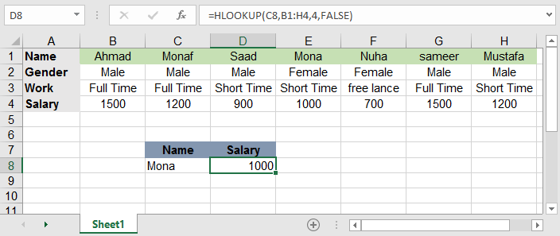

**As with the VLOOKUP function, caution must be taken to ensure that the row containing the lookup value is the first row when defining the table. This is necessary for the function to return the correct result (i.e., it must be at the top).**