1

**Types of thermal equilibrium diagrams**

Equilibrium may be defined as state of balance of stability. When a metal solidifies, equilibrium will occur under conditions of **slow cooling** where the reduction in temperature is small in relation to the time elapsed (gone).

Cooling rate= $\frac{ΔT}{time}$

* Equilibrium required time to diffuse alloy elements and lead to similar composition in each grain of metal.
* Complete diffusion seldom takes place in casting because **solidification** usually takes place **before diffusion** is complete.

There are number of different types of thermal equilibrium diagrams:

1. Two metals completely soluble in each other in both liquid and solid states.
2. Two metals completely soluble in each other in the liquid but not in the solid state (Eutectic alloy).
3. Two metals completely soluble in each other in the liquid and partially soluble in the solid state.
4. Iron / Carbon equilibrium diagram.
5. **Two metals completely soluble in each other in both liquid and solid states**

The graph has been created using different points of all the alloys. When these points are marked on a graph and joined up we get a thermal equilibrium diagram as in figure 1 below.

**Figure 1.** Creating a thermal equilibrium diagram.

As you can see there are three areas: (**liquid state** , **Solid state** , **Pasty state** (consists of solid and liquid phases) ).

The line where the liquid begins to solidify is known as the **Liquidus line**

The line where the liquid completely solidify is known as the **Solidus line**

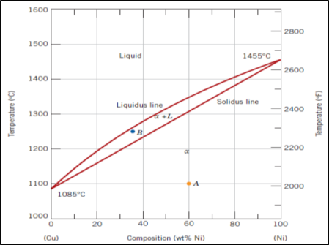**Q/ What is the temperature at which 60% Copper is fully solidifies in alloy of Copper and Nickel?**

Solution :

60% Copper → 40% Ni

Draw vertical line from 40% Ni until it hits the solidus line and at this point, alloy has fully solidified → Temperature≈1230oC

1. **Two metals completely soluble in each other in the liquid but not in the solid state , (Eutectic alloy).**

An eutectic alloy has lowest melting point and is formed when two different solid phases separate simultaneously at constant temperature from single liquid phase.

In the liquid state, two metals are soluble in each other but when cooling is complete, the grain of the solid alloy consist of two distinguishable metals which can be seen under a microscope to be like a layer of one metal on top of a layer of the other metal.

Example of **Eutectic alloy** is **Cadmium-Bismuth alloy**.

* Cadmium and Bismuth are completely soluble in the liquid state, but are completely insoluble in the solid state.
* Most noticeable point is the **eutectic point** where the liquid alloy changes to solid without going through a pasty state.
* Eutectic point is the **lowest melting point** of any composition for the alloy.
* Everything above liquidus line in the liquid state, totally soluble in each other.
* In the eutectic point, there is only eutectic composition alloy.
* **100%** Cadmium has large amount of solid Cadmium, decreases in alloys nearer to eutectic.
* Moves away from eutectic composition, grains of either Cadmium or Bismuth appear in the eutectic matrix.
* **For 80%** Cadmium and **20%** Bismuth alloy, when the temperature decrease, crystal nuclei of pure cadmium begin to form, the microstructure is (liquid + Cadmium).
* Dendrites of cadmium are deposited and the remaining liquid becomes increasingly richer in bismuth.

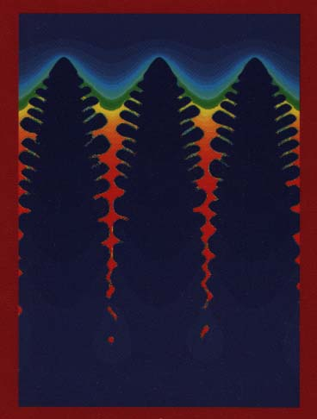

1. **Two metals completely soluble in each other in the liquid but only partially soluble in the solid state**

Lead-tin alloys are of this type. Figure (2 a) shows the equilibrium diagram for lead-tin alloys.

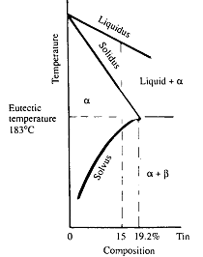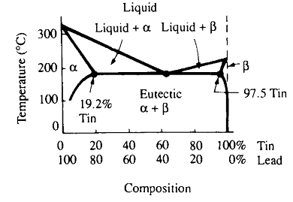

-a- -b-

Figure (2) a:Lead-tin alloys phase diagram, b: alloys have (0-19.2%Sn)

* Liquidus line is between (liquid+α) and L areas.
* Solidus line for (0-19.2%Sn) is between (liquid+α) and α areas.
* α, ß, and (α+ β) areas represent solid forms of the alloy.
* Solvus line is solubility limits of solute, that decrease with decrease of temperature.
* Solvus line is between *α* and (α+β), and transition is from one solid to another solid as shown in figure ( 2 b) and the liquidus, solidus and solvus lines.
* 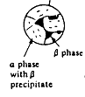α phase, having low concentration (19.2 %) of tin (Sn) in lead, mixed with small solid solution crystals.
* 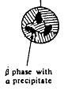β phase, having high concentration (97.5) of tin in lead.
* The eutectic composition for tin – lead alloy is 61.9 % Sn and 38.1 % Pb

**The Allotropy of Iron**

Allotropy is the ability to exist in different physical forms (differing in color, hardness, melting point etc.). Iron is allotropic:

* Iron has **BCC** crystal (**α** phase) at room temperature.
* **BCC** crystal transforms to **FCC** crystal (**γ** phase) at temperature named (Critical Point) ≈910oc.
* 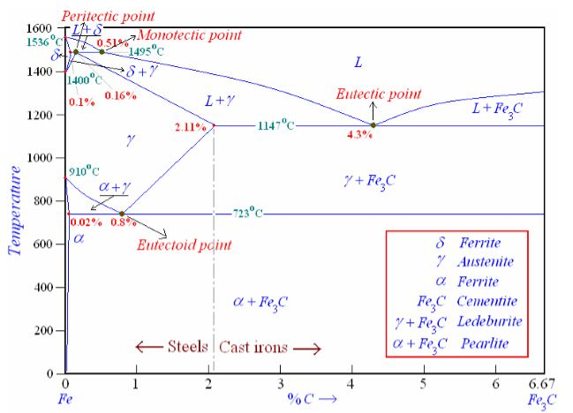**FCC** crystal changes to BCC crystal (**δ**) phase at second critical point**,** at 1390oc.