1

(Static) Tutorial

**Moment of a Couple**

**Example 1 :**

Determine the resultant moment of the three couples acting on the beam.

Solution :

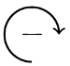M1= 400N x 2m = 800 Nm C:\Users\Aseel\AppData\Local\Microsoft\Windows\Temporary Internet Files\Content.Word\AZXA.PNG

M2= 200N x 0.2m = 40Nm

M3= 300N x 5m = 1500Nm

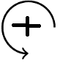 M=∑ F . D = 800 Nm - 40Nm - 1500Nm = -740 Nm

M couple = 740 Nm

Example 2 :

By transformation of a couple replace the 70N force by a force and a couple at A.

Solution :

|  |
| --- |
| 70 NX 6m =4200 N cm |

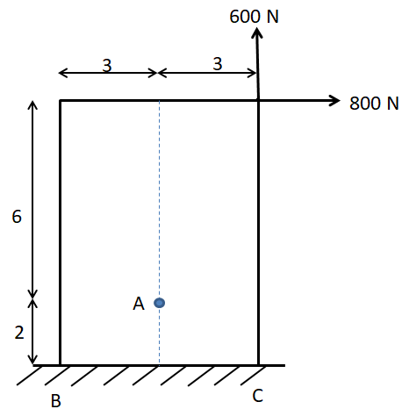Example 3

Replace the forces 800 and 600 N by forces and couples at A

Solution :

M1 = 800 x 6 =4800N.cm

M2 = 600 x 3 =1800N.cmC:\Users\Aseel\AppData\Local\Microsoft\Windows\Temporary Internet Files\Content.Word\AZXA.PNG

ΣM=−4800N.cm + 1800N.cm = -3000 N.cm=3000N.m